**Questions:**

### Create a null vector of size 10 but the fifth value which is 1.[10 marks]

### 

### 

### Ask user to input two numbers a, b. Write a program to generate a random array of shape (a, b) and print the array and avg of the array.[10 marks]

### 

### 

### Create a vector of size 10 with values ranging from 0 to 1, both excluded.[10 marks]

### 

### 

### Can you create a identity matrix of shape (3,4). If yes write code for it.[10 marks]

### 

### 

### Create a 5x5 matrix with row values ranging from 0 to 4.[10 marks]

### 

### 

### Write a program to input an array of numbers from the user (at least 10 elements in list), sort them and perform slicing operations to get elements between indexes such as 2-5, 5-8, 2-9. **[15 marks]**

### 

### 

1. Create an array of random integer numbers as a numpy array, sort them and perform operations such as reshaping of the array into matrix of feasible dimensions. (e.g., if we have an array of 1 * 10, then we can reshape it into 2 * 5 or 5 * 2 matrix.) [Hint: Use the array of reshape (row * column)] **[15 marks]**

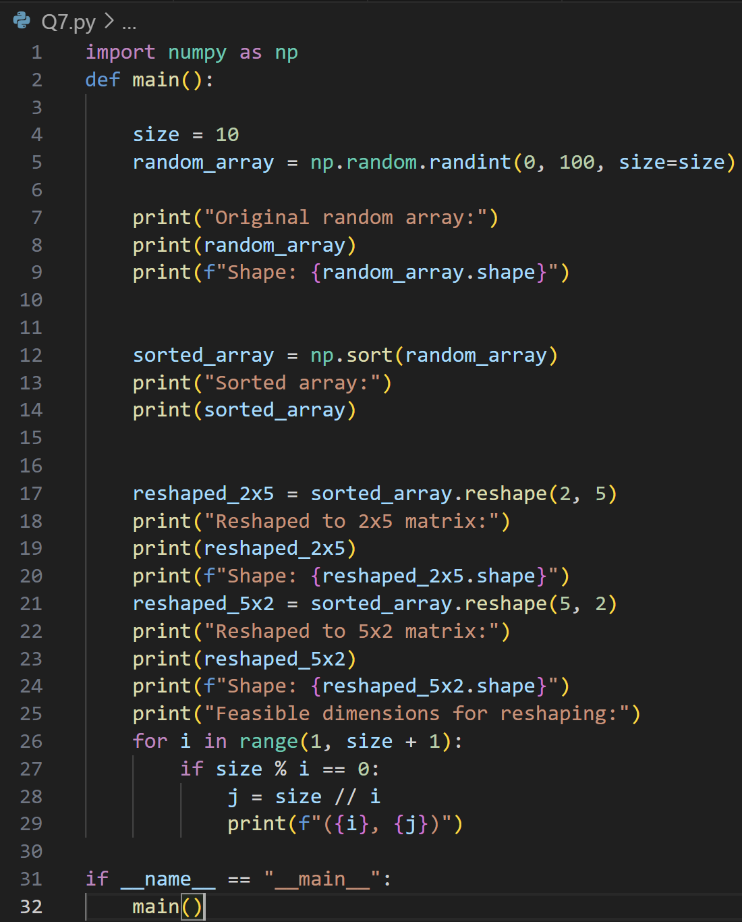

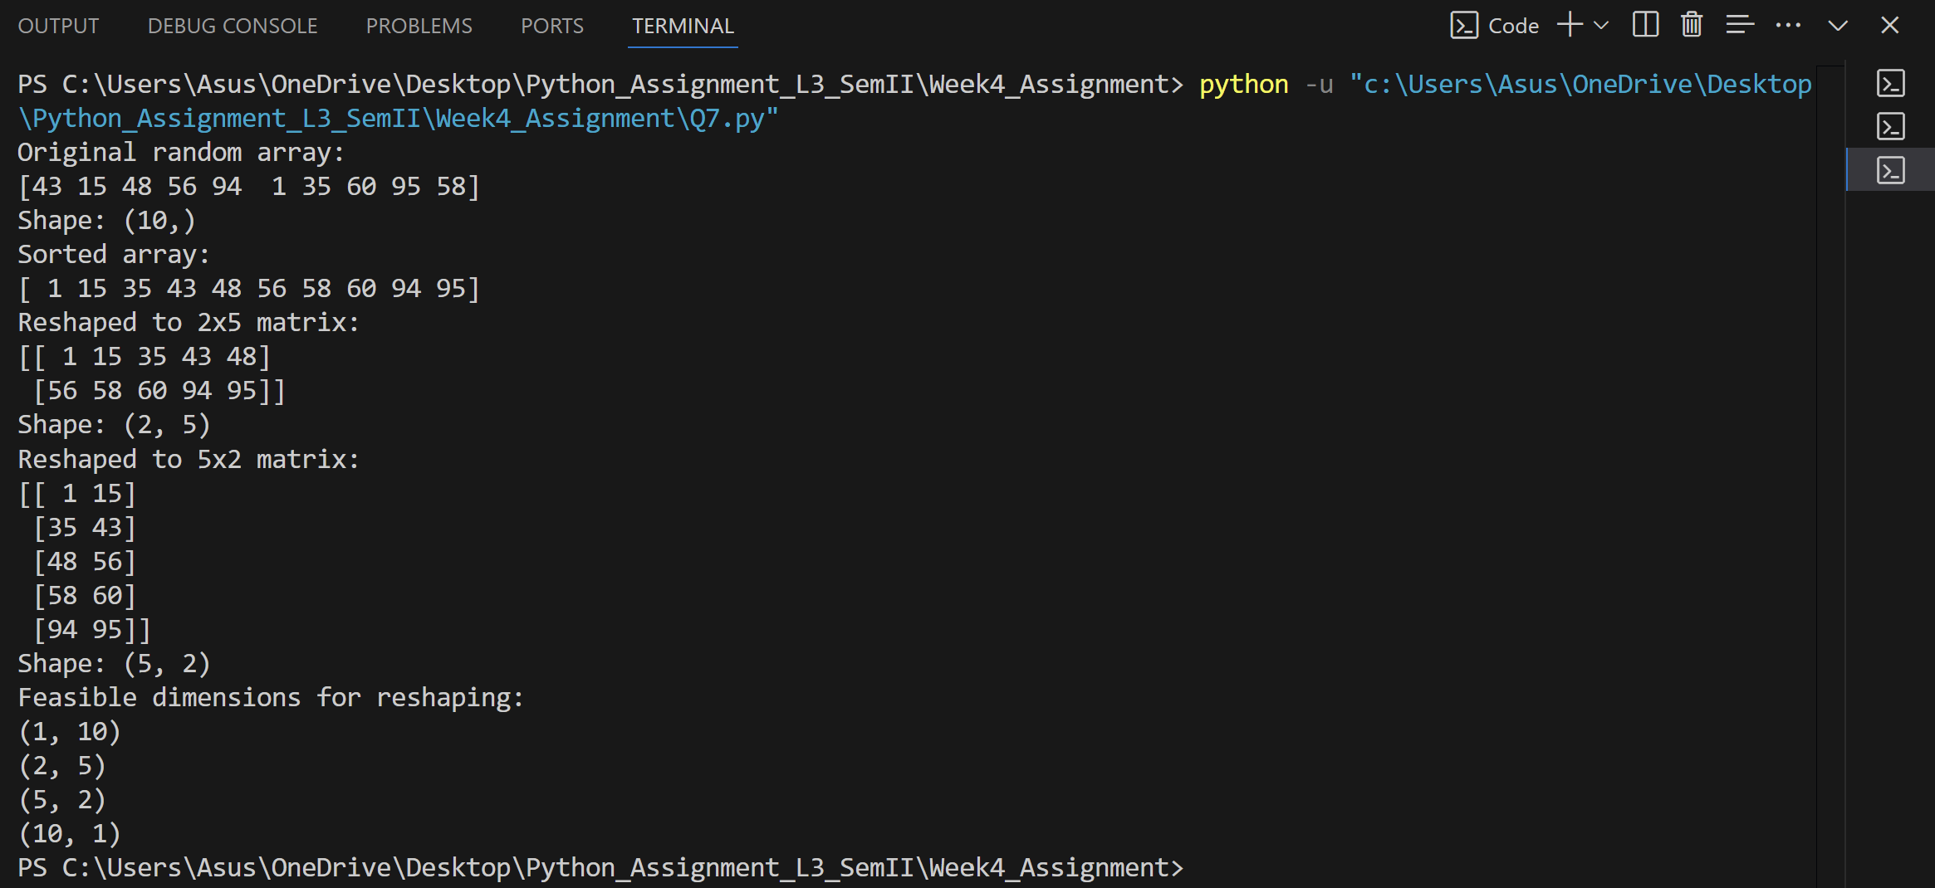

1. Write a Pandas program to add, subtract, multiple and divide two Pandas Series.[10 marks]

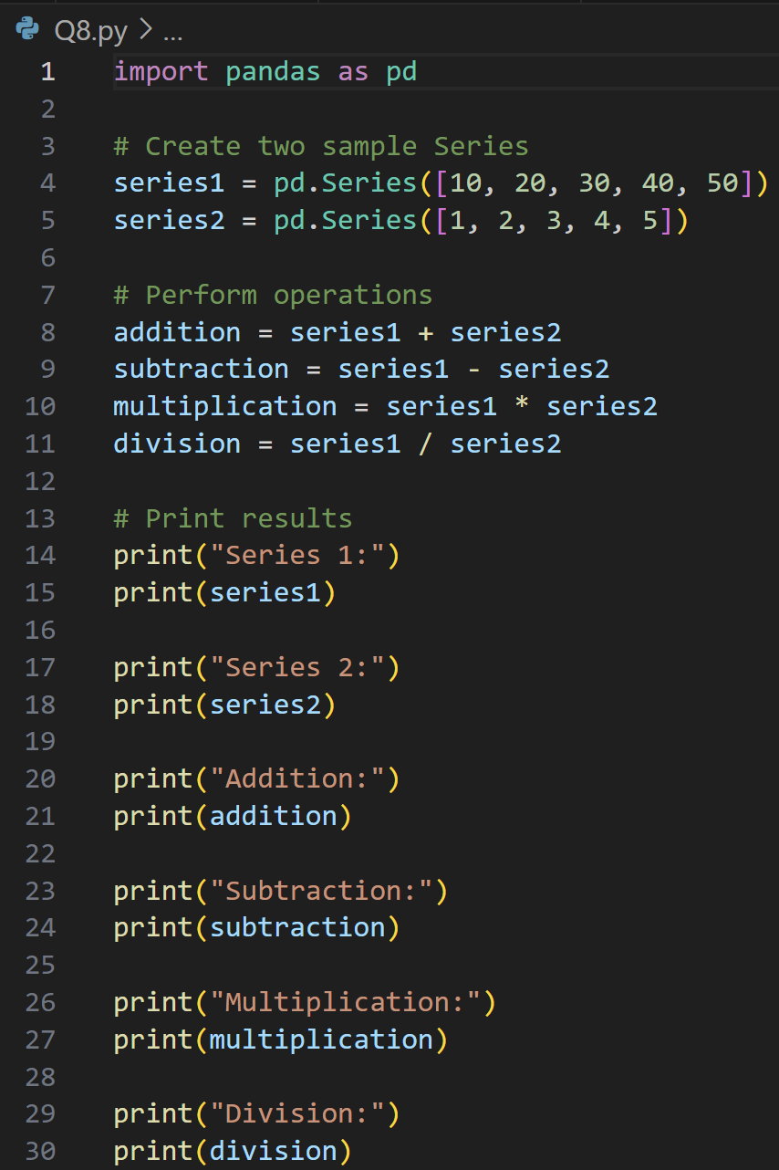

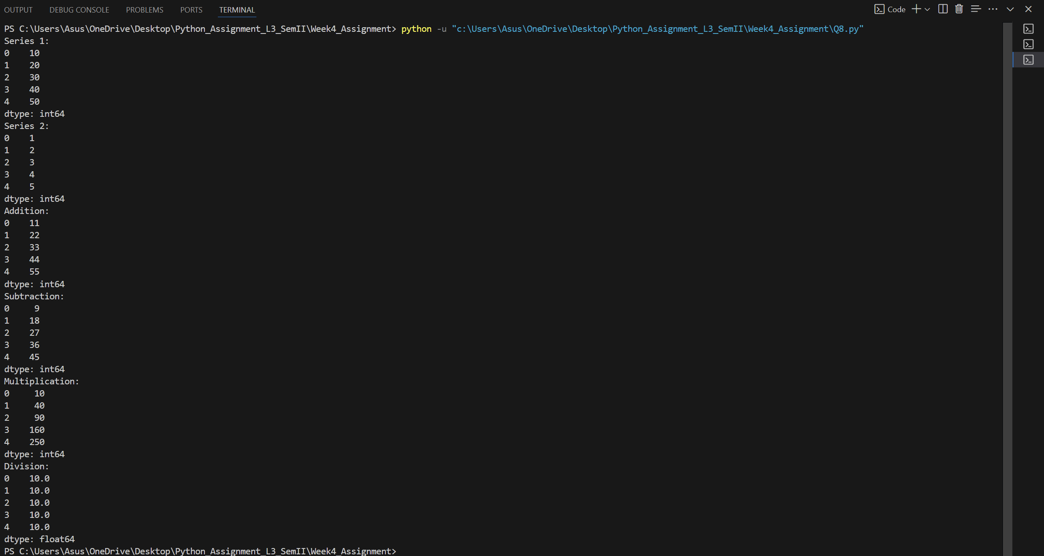

9. Given the table below, **[10 marks / 1 each]**

|  |  |  |  |  |  |  |
| --- | --- | --- | --- | --- | --- | --- |
| **EmployeeID** | **Name** | **Department** | **Age** | **Salary** | **JoinDate** | **ExperienceYears** |
| 101 | John Smith | IT | 30 | 70000 | 2018-07-15 | 5 |
| 102 | Alice Brown | HR | 28 | 60000 | 2020-03-10 | 3 |
| 103 | Bob White | IT | 35 | 80000 | 2016-11-01 | 7 |
| 104 | Emma Green | Finance | 40 | 90000 | 2012-05-25 | 11 |
| 105 | Charlie Red | HR | 25 | 55000 | 2021-06-01 | 2 |

1. Write a query to select only the Name and Salary columns.
2. How would you filter out all employees in the "IT" department?

### Write code to select employees who are older than 30 and find the average salary of employees in each department.

1. Write code to count the number of employees in each department.
2. Add a new column Bonus which is 10% of each employee's salary.
3. Replace all occurrences of "HR" in the Department column with "Human Resources."
4. Find the employee(s) with the longest tenure (based on JoinDate).
5. Create a new column SalaryCategory where salaries above 75,000 are categorized as "High" and the rest as "Low."
6. Write a program to check if there are any duplicate EmployeeIDs and remove them if found.
7. Use Pandas to calculate the median Age of all employees.

