FUZEBOX AEOS
Platform Architecture & 180-Day Development Plan
Conceptual, Logical, Physical Architecture — v0.6
v1 posture: observational. No run-time intervention.
Run-time enforcement is v2.
Prepared by: Danny Goldstein (CTO)
Date: April 23, 2026
Classification: Confidential — Internal.

1. Executive Summary
This document defines the conceptual and logical architecture of the FuzeBox AEOS platform and the 180-day development plan to reach production multi-tenant GA. It is the architectural spine; implementation specifics live in the requirements document that accompanies it.
v1 architectural posture
FuzeBox observes, never intervenes. Agents run on the customer's chosen platforms. The platform receives telemetry, classifies, ledgers, analyzes, and surfaces recommendations. Customers act on recommendations; FuzeBox does not. Run-time enforcement — blocking calls, dynamic instruction injection, pre-execution governance — is explicitly v2.
The platform is one product delivered as six differentiated services — Assessment, Process Discovery, Telemetry, Intelligence, Recommendations, Governance — on one substrate service — Auth + RBAC + Org — with one Client SDK (the Agent Adapter SDK) and three shared platform capabilities. The differentiated services carry the IP. The substrate is commodity. The SDK is a build-time tool, not a run-time service. The foundation is shared by all.
The customer-facing product is a single UI whose primary surface is the Economic Ledger. Every other surface supports the Ledger. Recommendations from the Intelligence and Governance services surface in the Ledger UI as actionable items the customer accepts, rejects, or defers.
Three deployment modes are supported: pooled multi-tenant on AWS, siloed single-tenant on AWS, and on-premise on any Kubernetes substrate.
The 180-day plan runs in four phases: Consolidation (Days 1-15), Foundation Hardening (Days 16-60), Multi-Tenant GA (Days 61-120), Scale & Certify (Days 121-180).

2. Architectural Principles
The non-negotiables. Every design decision traces back to one of these.

2.1 Observe, don't intervene
v1 does not participate in the execution path. Agents run on the customer's chosen platform. FuzeBox receives telemetry, analyzes, and surfaces recommendations. The customer decides what to do. Run-time intervention is a v2 concern and is not designed for in v1.

2.2 API-first, UI as one client, LLM-friendly surface
Every service exposes a clean, well-versioned API. The customer-facing UI is one client; rPotential, marketplace deployments, and customer-built consoles are others. The API surface must be LLM-friendly so product managers can vibe-code prototypes during our SDLC.

2.3 Open-source where commodity, proprietary where moat
Runtime and observability are commodity; we adopt and extend. Scoring, Ledger, Recommendations, and Attestation are moat; we build.

2.4 Vendor-neutral, tenant-scoped
The platform has no preference among vendor runtimes. Governance and analysis are specific to the tenant — the same vendor call under different tenants is classified and scored against different policies.

2.5 No cross-tenant data, anonymized benchmarks only with consent
Tenant data stays within tenant. Industry benchmarks are produced from cross-tenant data only after anonymization at the tenant boundary and only with explicit customer consent. No exceptions.

2.6 Three deployment modes, one codebase
The same service binaries run in all three modes. Differences are in packaging and configuration:
- Pooled multi-tenant — shared infrastructure, logical isolation; AWS
- Siloed single-tenant — dedicated data plane per tenant, shared control plane; AWS
- On-premise — fully isolated in customer infrastructure; any Kubernetes-compliant substrate

3. Conceptual Architecture

3.1 The platform
Five bands. Customer UI on top, then the differentiated services, then the substrate service, then the Client SDK (which is not a service — it runs on the customer's side), then the platform capabilities at the bottom.
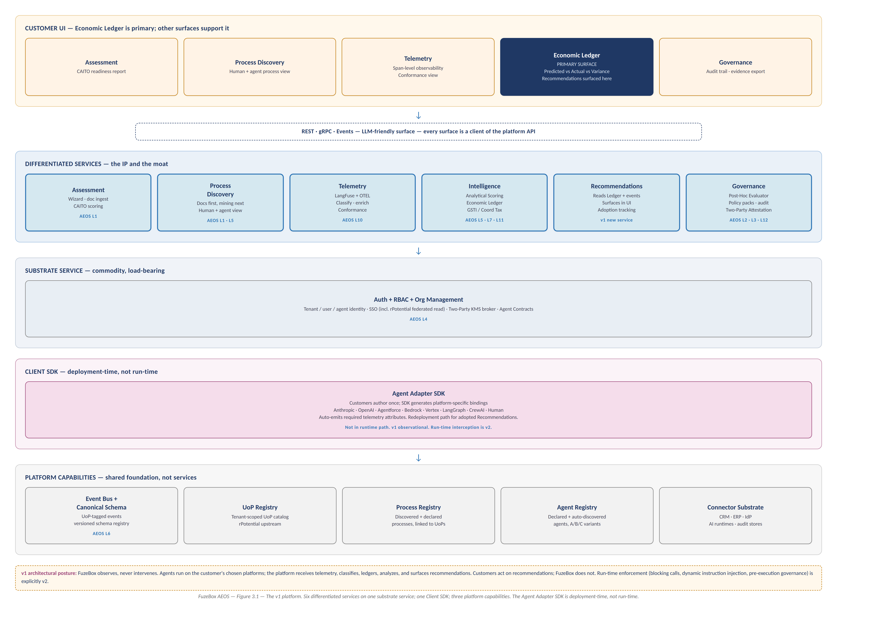
Figure 3.1 — The v1 platform. Six differentiated services on one substrate service; one Client SDK; three platform capabilities. The Agent Adapter SDK is deployment-time, not run-time.

3.2 Mapping to AEOS layers
The AEOS Core IP White Paper describes 12 layers across 4 zones. This document reassigns L2 (Policy & Regulatory) and L3 (Skills Authority) from the white paper's Zone 1 to Governance — both are policy concerns, not assessment concerns. L4 (Agent Contracts) remains with Auth as an identity primitive that references Governance-owned policy. L7 (UEF Decision Engine) is analytical in v1 rather than run-time. L8 (Adapter Gateway) is a deployment-time SDK in v1. L9 (Dynamic Instruction Runtime) is deferred to v2.
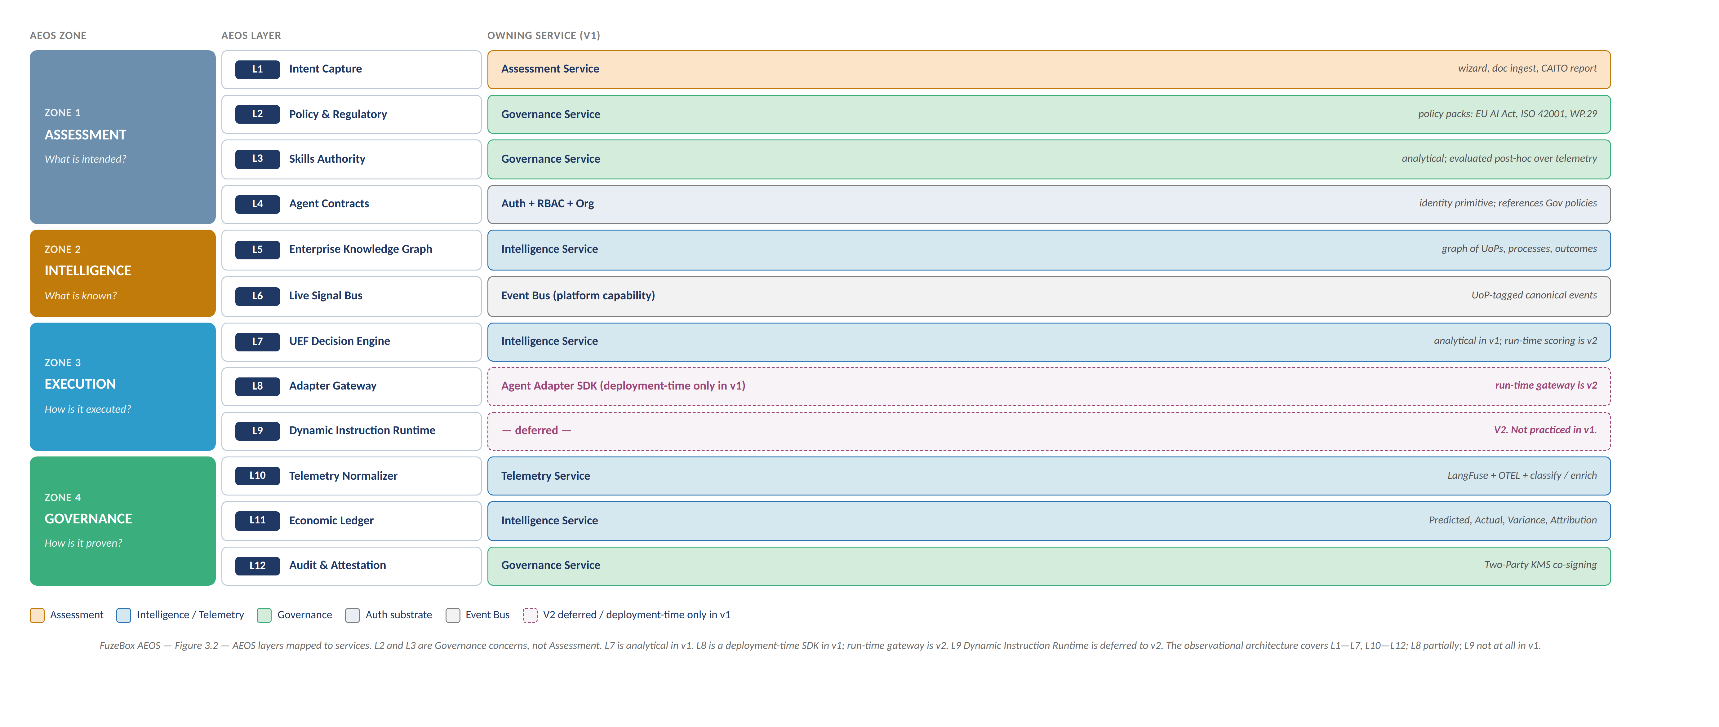
Figure 3.2 — AEOS layers mapped to v1 services. L8 partial and L9 fully deferred to v2.

3.3 The three irreplaceable IP assets
The Core IP White Paper names three architectural assets that are jointly with rPotential irreplaceable. In v1 they are all observational rather than interventional; the patent claims survive because the novel structures (algorithms, ledger schema, boundary definition language) are present in the platform regardless of whether they gate execution.
Irreplaceable Asset | Patent Family | Owning Service | v1 mode
GSTI + Coordination Tax Algorithms | Family 1 / 8 | Intelligence (Scoring Engine) | Analytical — computed post-hoc
Execution Economic Ledger | Family 2 / 8 | Intelligence (Ledger) | Unchanged — was always observational
Integration Abstraction + Boundary Controls | Family 3 / 8 | Governance (Post-Hoc Evaluator) | Boundaries defined and evaluated analytically

3.4 The UoP flow
The platform operates as a review loop, not a control loop. Customer executes independently. FuzeBox observes, evaluates, ledgers, recommends. Customer acts on recommendations by redeploying via the Adapter SDK. Loop closes.
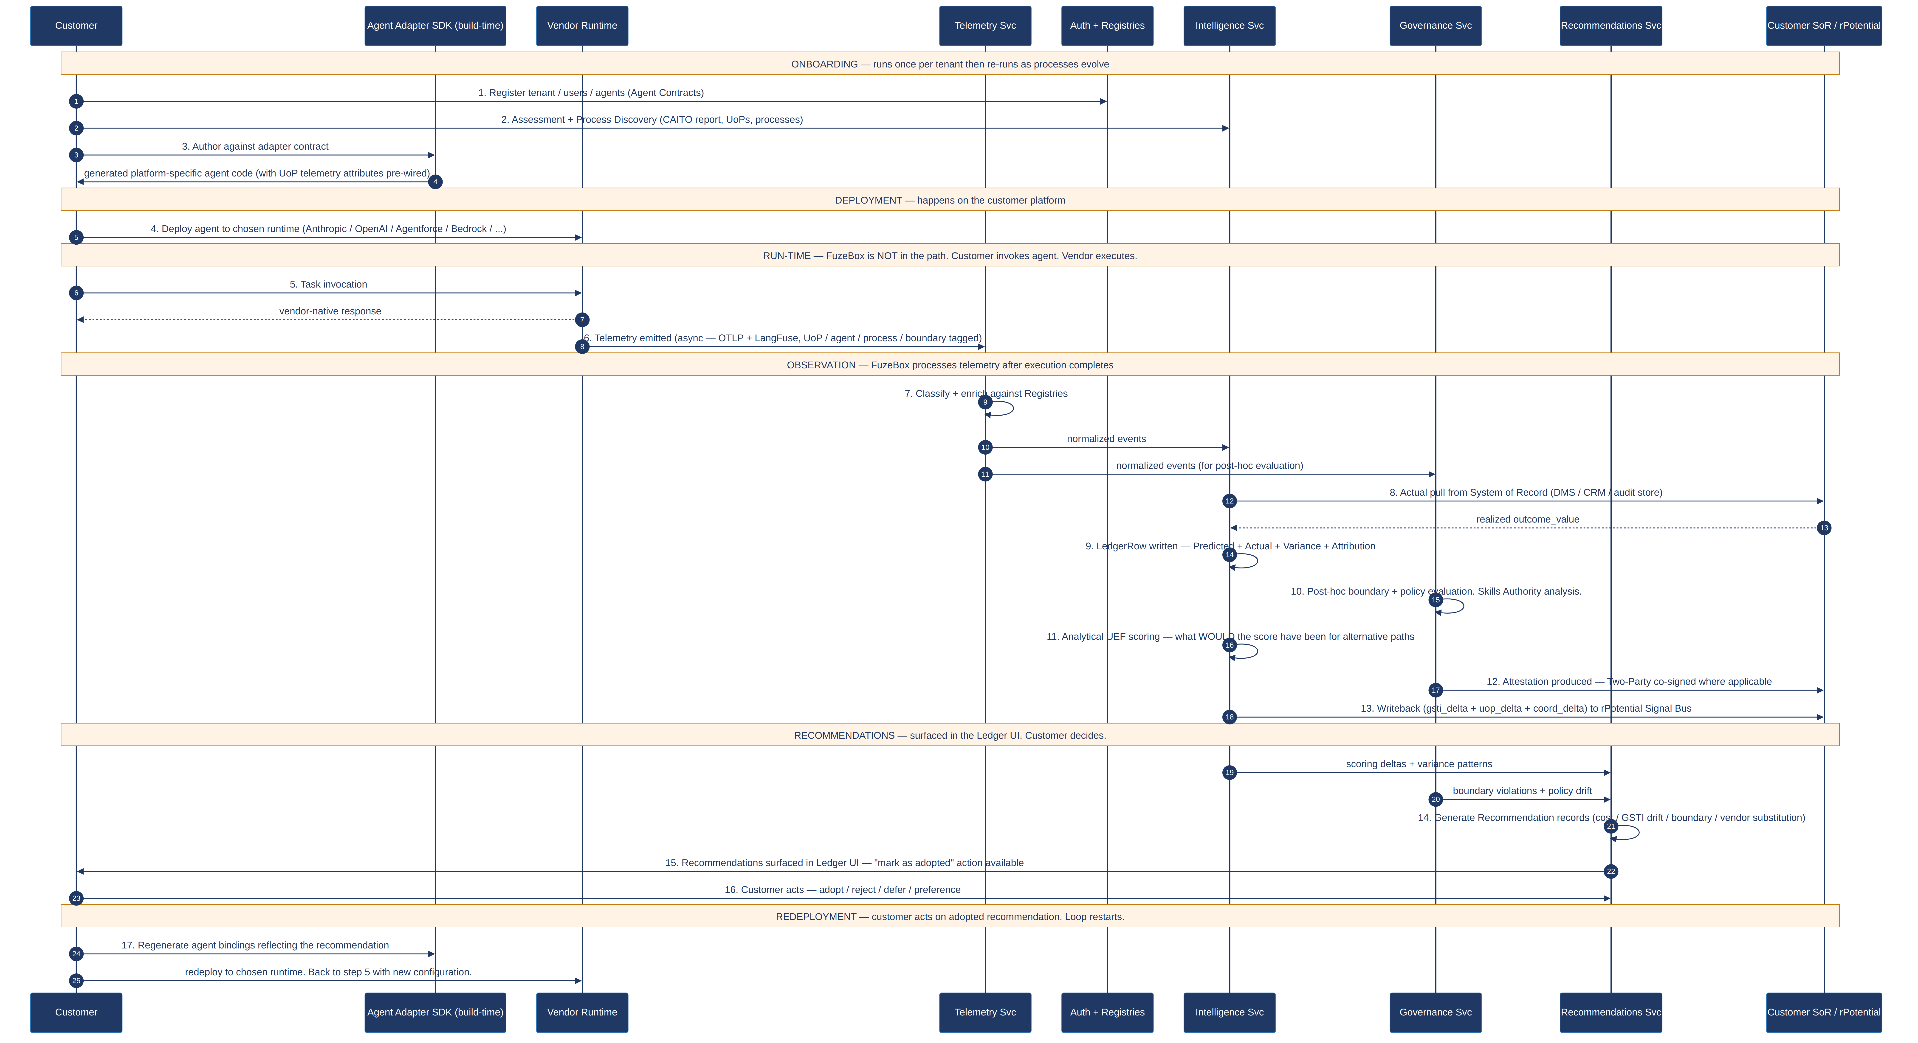
Figure 3.3 — The end-to-end UoP flow. FuzeBox is not in the execution path. The platform observes, analyzes, and surfaces recommendations. The customer acts on them.

3.5 Deployment modes
Mode | Tenancy | Cloud | Target customer
Pooled | Multi-tenant, logical isolation | AWS | Mid-market, marketplace
Siloed | Single-tenant, shared control plane | AWS | Enterprise, regulated
On-Prem | Single-tenant, fully isolated | Any K8s | Sovereign, top-tier banks

4. Logical Architecture
Each service is specified by purpose, AEOS layers owned, API surface, internal components, data ownership, dependencies, and build-versus-buy posture.

4.1 Platform capabilities

4.1.1 Event Bus + Canonical Schema
A single event bus carries every domain event. A versioned canonical schema defines the shape. AEOS L6.
- API: publish event, subscribe by type and filter, fetch schema.
- Owns: the canonical schema registry. Events in flight, not persistent state.
- Build vs buy: buy — Kafka; schema is ours.

4.1.2 Semantic Registries
Three tenant-scoped registries: UoP, Process, Agent. Every service reads; writes are scoped.
- UoP Registry: tenant-scoped catalog, rPotential upstream where partnership applies.
- Process Registry: processes declared or discovered, linked to UoPs.
- Agent Registry: agents declared or auto-discovered from telemetry, linked to processes and UoPs; carries A/B/C variant metadata.
- Build vs buy: build. Patent-adjacent.

4.1.3 Connector Substrate
Shared integration layer: tenant-scoped credentials, rate limiting, retry, normalization.
- Consumers: Assessment, Process Discovery, Telemetry, Intelligence, Governance, Auth.
- Categories: IdP, CRM, ERP, DMS/vertical, AI runtime telemetry, audit stores.
- Build vs buy: mixed — buy the runtime (secrets vault, durable workflow engine); build connector definitions per integration.

4.2 Substrate service

4.2.1 Auth + RBAC + Org Management
Identity substrate. AEOS L4.
- API: tenant/org/user/role CRUD, SSO federation, Agent identity + Contract issuance, API keys, KMS provisioning.
- Owns: all identity records. Agent Contracts as identity structures; skill-policy content inside is owned by Governance.
- Dependencies: none upstream; every other service depends on this.
- Build vs buy: buy the identity plane (WorkOS/Auth0 class) and fine-grained auth (OpenFGA class); build Agent Contract semantics and KMS broker.

4.3 Differentiated services

4.3.1 Assessment Service
AI-backed wizard that ingests documents and conducts a conversation. Produces the CAITO readiness report on-screen. Optionally pulls rPotential data via federated SSO as a shortcut. AEOS L1.
- API: start session, ingest document, answer question, retrieve report.
- Components: Wizard Orchestrator, Document Ingest Pipeline, rPotential Federated Shortcut (optional), CAITO Scoring, Report Generator.
- Owns: assessment sessions, ingested documents, wizard answers, CAITO scores per dimension.
- Dependencies: Auth (identity + SSO), Connector Substrate (documents + rPotential read).
- Emits to: UoP Registry, Intelligence (baseline scores), Process Discovery (seed processes).
- Build vs buy: build the CAITO logic; buy/OSS the document ingest pipeline.

4.3.2 Process Discovery Service
Maps UoPs to processes. Document-driven first; connector-driven mining next. Maintains the combined human + agent process view. AEOS L1 + L5.
- API: start discovery, ingest document, configure connector, list processes, annotate, link to UoPs and agents, retrieve combined view.
- Components: Document-Driven Discovery, Connector-Driven Mining (Phase 2/3), Hybrid Reconciler, Human-Agent Process Renderer.
- Owns: discovered processes, process-to-UoP and process-to-agent mappings, mining runs.
- Dependencies: Assessment (seeds), Connector Substrate (live data), UoP Registry.
- Emits to: Process Registry, Intelligence, Governance, Telemetry (classification context).
- Build vs buy: build document-driven; evaluate PM4Py or commercial for connector-driven mining in Phase 2; build the combined-view renderer.

4.3.3 Telemetry Service
Ingests, classifies, and enriches agent telemetry. Accepts OTLP and LangFuse inbound. Requires customer-attached metadata per published spec. Hosts the Telemetry Conformance surface. AEOS L10.
- API: OTLP receiver, LangFuse-compatible ingest, query by tenant/UoP/agent/process/time, metadata schema endpoint, conformance report.
- Components: Ingest Gateway, Classification + Enrichment Engine, Quarantine Queue, Normalizer, Span Store, Conformance Tracker.
- Owns: raw and normalized spans, quarantine queue, ingestion schema, per-tenant conformance metrics.
- Dependencies: customer-instrumented agents (direct push), three Registries.
- Emits to: Intelligence, Governance, Recommendations.
- Build vs buy: use LangFuse open-source embedded in our product; OpenTelemetry Collector for ingest; ClickHouse for the Span Store; build the classification, enrichment, and conformance logic.
Customer instrumentation contract
Every span must carry: fuzebox.tenant.id, fuzebox.uop.id, fuzebox.agent.id, fuzebox.process.id, fuzebox.vendor, fuzebox.span.role. Optional-but-encouraged: fuzebox.boundary.id, fuzebox.actor.id, fuzebox.predicted.cost_usd, fuzebox.predicted.outcome_value_usd. Missing required attributes quarantine the span.
Customers using the Agent Adapter SDK get compliant telemetry for free — the SDK auto-emits the required attributes during bindings generation. The Telemetry Conformance surface in the UI shows how much of a tenant's telemetry is well-tagged versus quarantined. Analytical value depends on conformance, and customers can see their score.

4.3.4 Intelligence Service
The economic brain. Owns the Ledger, the analytical Scoring Engine, the BI surface that powers the Ledger UI. In v1 the Scoring Engine runs post-hoc — it computes what the UEF score would have been for the executed path and for alternative paths over completed work. Also hosts the Anonymized Benchmarks capability (per-tenant opt-in, consent required). AEOS L5 + L7 + L11.
- API: append LedgerRow, query Ledger, compute analytical score, compute derived metrics, trigger Actual pull, writeback, produce benchmark, emit scoring deltas to Recommendations.
- Components: Analytical Scoring Engine, Scoring Calibration, Ledger, Actual Reconciler, Writeback Engine, BI Surface, Derived Metrics Engine, Anonymized Benchmarks Service.
- Owns: LedgerRows, Predicted/Actual/Variance values, derived metrics, Scoring calibration state, local workforce graph, benchmark cohorts.
- Dependencies: Telemetry, Connector Substrate, three Registries.
- Emits to: customer UI (Ledger), Governance (LedgerRow references), Recommendations (scoring deltas + variance patterns), rPotential Signal Bus (where applicable).
- Build vs buy: build everything except the analytical store (ClickHouse class) and UI charting library.

4.3.5 Recommendations Service
Generates and tracks improvement recommendations surfaced in the Ledger UI. Reads Ledger + scoring deltas from Intelligence and boundary/policy events from Governance. Applies recommendation templates to produce actionable items the customer can adopt, reject, or defer. Tracks adoption to tune future recommendations. v1 scope is lean: templated pattern detection and a tracking surface; ML-driven pattern discovery and simulation are Phase 3 trajectory.
- API: list recommendations for tenant, get details, mark adopted/rejected/deferred, set tenant preferences (e.g. vendor pinning for a UoP), retrieve adoption analytics.
- Components: Pattern Detector (templated, v1), Recommendation Generator, Preference Store, Adoption Tracker, Recommendation API.
- Recommendation templates in v1: cost optimization (path Y cheaper than path X), GSTI drift warning, boundary violation pattern, vendor substitution opportunity, skill preservation alert.
- Owns: Recommendation records, tenant preferences (suppression rules, vendor pins), adoption history.
- Dependencies: Intelligence (scoring deltas, variance), Governance (boundary events, policy drift), Registries.
- Emits to: customer UI (Ledger recommendation panel).
- Build vs buy: build. Pattern templates are rules in v1; ML-driven pattern discovery is Phase 3.
Customer preference handling
Every recommendation can be adopted, rejected, or deferred. Customers can also set preferences that suppress future recommendations — e.g. 'pin UoP X to vendor Anthropic regardless of cost score' for contractual or trust reasons. The Adoption Tracker records all three outcomes and uses the signal to tune future recommendations, preventing the 'why are you showing me the same bad advice every week' problem.

4.3.6 Governance Service
Analytical governance in v1. Owns policy, skills authority, boundary definitions, post-hoc evaluation, and audit/attestation. Evaluates telemetry against policy after the fact; produces violation events for Recommendations and audit artifacts for compliance. AEOS L2, L3, L12.
- API: boundary CRUD, policy pack management, evaluate boundary (over telemetry batch or stream), skill authority query, audit query, evidence export.
- Components: Boundary Registry, Policy Pack Catalog, Skills Authority (analytical), Post-Hoc Evaluation Engine, Attestation Engine, Two-Party Co-Signer.
- Owns: boundary definitions, policy packs, skill allow-lists, evaluation records, attestation bundles.
- Dependencies: Auth (identity, Agent Contracts), Registries, Telemetry (enriched events), Intelligence (LedgerRow references).
- Emits to: Recommendations (boundary violations, policy drift), customer UI (audit), external auditors (evidence).
- Build vs buy: build. Policy pack authorship is internal with external counsel review for jurisdictional packs.
V2 deferred: Dynamic Instruction Runtime
AEOS L9 (Dynamic Instruction Runtime) and the run-time enforcement side of L8 are deferred to v2. In v1 Governance does not block execution, inject instructions into running agents, or gate the Adapter SDK's outbound calls. The patent claims for Family 6 still exist but are not practiced until v2.

4.4 Client SDK

4.4.1 Agent Adapter SDK
A deployment-time tool. Customers author agent logic once against the FuzeBox adapter contract; the SDK generates platform-specific bindings for the target runtime. The generated code runs natively on the target platform; FuzeBox has no code in the execution path. When the customer adopts a Recommendation, they regenerate bindings through the SDK and redeploy. The SDK auto-emits required telemetry attributes so SDK-generated agents are telemetry-conformant by default.
- Surface: CLI + libraries in Python and TypeScript; reference adapters for Anthropic, OpenAI, Agentforce, Bedrock, Vertex, LangGraph, CrewAI, Human Workflow.
- Owns: the adapter contract specification, the reference adapter implementations, the bindings generator.
- Not in the runtime path: the SDK produces code that the customer deploys. After deployment the SDK is not involved in execution. Telemetry from the deployed code flows directly to the Telemetry Service.
- Build vs buy: build the contract and the generator; use vendor SDKs for bindings where available.
- v2 trajectory: the SDK becomes a run-time interception point. v1 output is pure; v2 adds optional run-time hooks for governance enforcement and dynamic instruction. v1 does not preclude this path.

5. Cross-Cutting Concerns

5.1 Canonical data model
Core types shared across all services, versioned in a dedicated schema repository:
- Tenant, Org, User: identity trio.
- UoP: tenant-scoped Unit of Potential. Patent-adjacent (Family 1).
- Process: tenant-scoped business process with stages, decision points, actor mix, linked UoPs.
- Agent, AgentContract: runtime entity + identity structure. Patent-adjacent (Family 1).
- Boundary: (Tenant, Vendor, Context). Evaluated analytically over telemetry in v1. Patent-central (Family 3).
- Span: OpenTelemetry span with canonical FuzeBox attributes.
- LedgerRow: Predicted + Actual + Variance + Attribution + Correction + deltas. Patent-central (Families 2, 8).
- Recommendation: current state, proposed state, predicted delta, confidence, status (new/adopted/rejected/deferred).
- Attestation: signed evidence bundle, co-signed by fuzebox-kms-primary and rpotential-kms where applicable. Patent-central (Family 8).

5.2 Multi-tenancy
One code path across all three deployment modes. Every durable row, every cache key, every event carries tenant_id. Packaging and configuration differ; service code does not branch on mode.

5.3 Identity federation
Three federation scenarios: enterprise IdP SSO (standard OIDC/SAML via the buy-side identity platform); rPotential federated read (narrowly-scoped OAuth, customer-granted, revocable, stored in the Connector Substrate credential vault); agent identity (FuzeBox-issued, distinct from the vendor credentials used at run-time, linkage maintained in Agent Registry).

5.4 Two-Party KMS and attestation
Patent Family 8 requires attestations be co-signed by both parties where the partnership applies. The Two-Party Co-Signer in Governance orchestrates: assemble bundle → fuzebox-kms-primary sign → transmit to rpotential-kms → receive co-signed bundle → anchor in audit store.
In on-prem mode, egress to rpotential-kms is subject to customer policy. Where disallowed, bundles sign fuzebox-only and are marked single-party. Single-party bundles are valid for internal audit but lack the Family 8 attestation property.

5.5 Data residency and cross-tenant rule
Tenant data stays within tenant. No aggregation across tenants unless (a) anonymized at the tenant boundary and (b) the tenant has consented. The benchmark service is the only mechanism that produces cross-tenant output, and it operates on anonymized cohorts only.
Residency is enforced at the platform capability level: Event Bus, Span Store, Ledger, Audit Store are all tenant-scoped. Pooled: shared infrastructure, logical separation. Siloed: dedicated per tenant. On-prem: tenant-hosted.

5.6 Platform observability
The platform dog-foods its own telemetry discipline. FuzeBox services emit OTEL spans tagged with platform.service, platform.deployment_mode, platform.tenant, platform.environment. These flow to an internal observability stack separate from the customer Telemetry Service.

5.7 Compliance roadmap
- SOC 2 Type 1 (day 120): control design.
- SOC 2 Type 2 (day 270): operational effectiveness. Outside the 180-day window but designed backwards from.
- EU AI Act Article-12 evidence export (day 180): policy pack + export format.
- ISO 42001 readiness (day 180): policy pack + controls mapped; no certification yet.
- WP.29 (day 180): policy pack for automotive customers.

6. Physical Architecture
This section maps the logical services defined in §4 onto concrete AWS infrastructure and on-premise equivalents. It describes what runs where, not how it is implemented. Database schemas, code organization, and calculation internals are out of scope and belong in the requirements document.
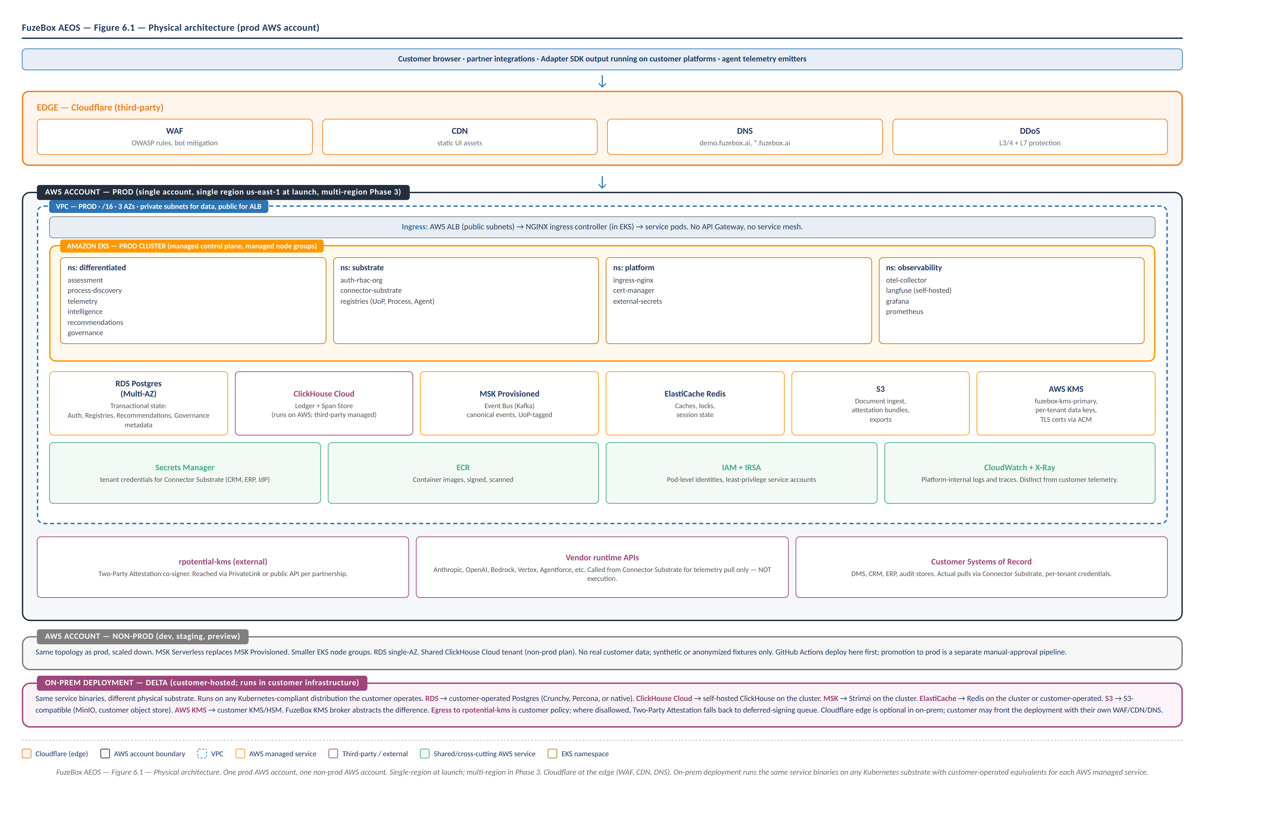
Figure 6.1 — Physical architecture. One prod AWS account, one non-prod AWS account. Cloudflare at the edge. On-prem runs the same service binaries on any Kubernetes substrate with customer-operated equivalents.

6.1 Deployment foundation
Two AWS accounts. One for production; one for all non-production environments (development, staging, preview). Account separation is the primary blast-radius boundary between prod and non-prod data planes. Cross-account access is via AWS IAM Identity Center (SSO) with role assumption; no long-lived credentials cross the boundary.
Single region at launch (us-east-1). Multi-region is a Phase 3 concern driven by customer data-residency requirements, not a v1 requirement.
On-prem is a third deployment mode that runs in customer infrastructure. It is not an AWS account.

6.2 Kubernetes topology
Amazon EKS is the target for pooled and siloed deployment modes. Managed control plane; managed node groups for the data plane. On-prem runs on any Kubernetes-compliant distribution the customer operates.
Services are grouped into four Kubernetes namespaces for operational clarity and blast-radius management:
- differentiated: Assessment, Process Discovery, Telemetry, Intelligence, Recommendations, Governance.
- substrate: Auth + RBAC + Org, Connector Substrate, the three Registries.
- platform: ingress-nginx, cert-manager, external-secrets operator.
- observability: OpenTelemetry Collector, self-hosted LangFuse, Grafana, Prometheus.
No service mesh in v1. Inter-service mTLS comes from EKS pod identity and AWS PrivateLink where needed. Cross-service observability comes from the OTEL instrumentation every service ships with. A service mesh (Istio, Linkerd, Consul) is evaluated only if a specific need arises.

6.3 Data plane
Managed services where available; self-hosted only where we must. The data plane maps to services as follows:
- RDS Postgres (Multi-AZ): transactional state for Auth, the three Registries, Recommendations metadata, Governance metadata. One database per service logically; instance consolidation decided per deployment scale.
- ClickHouse Cloud: the Ledger and the Span Store. Third-party managed, runs on AWS. Chosen over self-hosted ClickHouse because we are not differentiated by operating ClickHouse.
- MSK Provisioned (prod): the Event Bus. Kafka. Carries UoP-tagged canonical events between services. MSK Serverless is used in the non-prod account.
- ElastiCache Redis: caches, distributed locks, session state.
- S3: document ingest storage, attestation bundles, evidence exports, anonymized benchmark artifacts.
- Secrets Manager: tenant-scoped credentials for the Connector Substrate &mdash; customer IdP tokens, CRM/ERP API keys, rPotential federated-read tokens.

6.4 Networking
One VPC per AWS account. The prod VPC spans three availability zones. Private subnets host the data plane (EKS worker nodes, RDS, ElastiCache); public subnets host only the Application Load Balancer.
Ingress path: Cloudflare &rarr; AWS ALB (public subnets) &rarr; NGINX ingress controller (in EKS) &rarr; service pods. No AWS API Gateway; no service mesh. Cloudflare provides WAF, CDN, DNS, and DDoS protection at the edge.
Egress: NAT Gateway for outbound internet. Egress destinations include vendor runtime APIs for telemetry pulls (never execution), customer Systems of Record for Actual pulls, and the rpotential-kms endpoint for Two-Party Attestation co-signing. Where latency or cost matters, AWS PrivateLink endpoints replace public egress.

6.5 Secrets and KMS
AWS KMS is the canonical key broker for the AWS-hosted deployment modes. Key hierarchy:
- fuzebox-kms-primary: one key per deployment, owned by FuzeBox operations. Signs attestations on the FuzeBox side of Two-Party Attestation.
- per-tenant data keys: one KMS key per tenant, used to envelope-encrypt tenant data at rest across RDS, ClickHouse, S3.
- ACM certificates: managed via AWS Certificate Manager, rotated automatically.
The KMS broker component in the Auth service abstracts the underlying provider. In AWS modes the broker wraps AWS KMS. In on-prem mode the broker wraps the customer's KMS or HSM. Service code does not know the difference.

6.6 Observability
Two distinct observability stacks run in the platform. One is customer-facing (the Telemetry Service and its UI surface, part of the product). The other is platform-internal (for FuzeBox SRE use, not exposed to customers).
Self-hosted Grafana is the visualization layer for both. Prometheus handles platform metrics. The OpenTelemetry Collector ingests all platform-internal spans. CloudWatch and AWS X-Ray collect AWS-managed-service logs and traces and feed Grafana via exporters.
Customer telemetry &mdash; the UoP-tagged spans that drive the Ledger &mdash; flows through the Telemetry Service's own OTEL Collector pipeline into ClickHouse. That data is never mixed with platform-internal observability data.

6.7 CI/CD
GitHub Actions. One repository per service (new repos for v1 &mdash; we do not extend the POC/demo codebase). Each repo has its own pipeline that builds, scans, signs, and pushes container images to Amazon ECR.
Deployment promotion is non-prod first, then prod with manual approval. Non-prod deploys on every merge to main. Prod deploys require a release tag and approval from a designated reviewer. ArgoCD or Flux is the target GitOps controller for the actual cluster apply; choice deferred to Phase 1 implementation.
IaC is Terraform. One Terraform workspace per AWS account. Service-specific Helm charts live in each service repo; cross-cutting platform resources live in a dedicated platform-infra repo.

6.8 Deployment mode deltas
The same service binaries run across all three modes. Packaging and managed-service substitutions differ. The table below captures what changes per mode; what is not in the table is the same across all three.
Concern | Pooled (AWS prod) | Siloed (AWS prod) | On-prem
Kubernetes | Shared EKS cluster, tenant namespace per customer | Dedicated EKS cluster per tenant | Any K8s-compliant distribution the customer operates
Event Bus | MSK Provisioned (shared) | MSK Provisioned (dedicated) | Strimzi (self-hosted on cluster)
Ledger / Span Store | ClickHouse Cloud (shared) | ClickHouse Cloud (dedicated) | Self-hosted ClickHouse on the cluster
Transactional state | RDS Postgres (shared instances, logical separation) | RDS Postgres (dedicated instances) | Customer-operated Postgres
Cache | ElastiCache Redis (shared) | ElastiCache Redis (dedicated) | Redis on cluster or customer-operated
Object store | S3 (shared bucket, prefix-per-tenant) | S3 (dedicated bucket) | S3-compatible (MinIO or customer object store)
KMS | AWS KMS, per-tenant data keys | AWS KMS, dedicated per-tenant keys | Customer KMS or HSM via broker abstraction
Edge | Cloudflare | Cloudflare | Optional &mdash; customer fronts deployment if desired
Egress to rPotential | Direct; PrivateLink available | Direct; PrivateLink available | Customer policy; deferred-signing fallback where disallowed

7. 180-Day Development Plan
Summarized here; detailed plan tracked in Jira by the program management function.

7.1 Phase 0 — Consolidation Sprint (Days 1-15)
Execute the consolidation directive. Everything on demo.fuzebox.ai. Exit criteria: ten directives Green; Ledger shows real runs; UoP-tagged telemetry; demo rehearsed.

7.2 Phase 1 — Foundation Hardening (Days 16-60)
Demo-wired → production-wired. First real tenant. Assessment + Process Discovery as MVS. Governance in post-hoc evaluation mode with EU AI Act and ISO 42001 policy packs. Agent Adapter SDK ships with 8 reference adapters and auto-emitting telemetry. Canonical schema v1 published. First Recommendation templates live.
Exit criteria: one customer, live, pooled mode, real LedgerRows, real Actual pulls, at least one adopted Recommendation. SOC 2 Type 1 kickoff. Adapter SDK published.

7.3 Phase 2 — Multi-Tenant GA (Days 61-120)
Second and third tenants. Siloed mode operational. Connector-driven Process Discovery. Recommendations coverage expanded across all five template categories. SOC 2 Type 1 attestation.
Exit criteria: three tenants across pooled and siloed. 90 days of continuous LedgerRows per tenant. First EU AI Act Article-12 export for a customer audit.

7.4 Phase 3 — Scale and Certify (Days 121-180)
On-prem deployment live. Ten+ tenants. SOC 2 Type 2 evidence window open. Adapter SDK open-sourced with reference bindings in Python and TypeScript. Recommendations Service begins pattern-discovery work beyond templates.
Exit criteria: ten tenants, three deployment modes live, OSS release, SOC 2 Type 2 window open.

8. Team and Resourcing
Outline at v0.6. Detailed resourcing tracked by program management.

8.1 Service ownership
Service / Capability | Primary Owner | Secondary
Auth + RBAC + Org | John, Danny | Trigent
Agent Adapter SDK | John, Danny | Trigent
Assessment | John, Danny | Trigent
Process Discovery | John, Danny | Trigent
Telemetry | John, Danny | Trigent
Intelligence | John, Danny | Trigent
Recommendations | John, Danny | Trigent
Governance | John, Danny | Trigent
Event Bus + Schema | John, Danny | Trigent
Registries | John, Danny | Trigent
Connector Substrate | John, Danny | Trigent

8.2 Contractor integration
Trigent: Telemetry productionization, Process Discovery connector mining, Scoring calibration. Arkos: front-end per Consolidation Directive; no infra or data-plane ownership. Luca: Vercel/Railway handover to Dulay on payment; not a forward dependency.

9. Risk Register
Risk | Likelihood | Impact | Mitigation
Observational-only means we surface bad patterns but can't prevent them; customer inaction erodes value story | High | High | Make recommendations actionable and cheap to adopt (one-click regenerate via SDK); track adoption rate as a platform health metric; v2 enforcement roadmap communicated to customers
Actual pull from customer systems of record blocks Ledger | High | High | Phase 1 uses doc/survey entry as fallback; Phase 2 builds connectors for top-5 DMS/CRM/ERP
Customers fail to instrument agents with required metadata | High | High | Adapter SDK auto-emits required attributes; Telemetry Conformance surface gives customers visibility; quarantine queue surfaces bad spans
On-prem operational complexity exceeds capacity | Medium | High | Defer on-prem to late Phase 3; pilot first before broad availability
SOC 2 Type 1 blockers discovered late | Medium | High | Kick off readiness in Phase 1; compliance firm engaged day 30
Adapter SDK fragments before adoption | Medium | Medium | Publish Apache 2.0; ship reference bindings; align with OTEL semantic conventions
Analytical scoring produces unreliable recommendations | Medium | High | Templated patterns first (v1); per-tenant calibration against realized outcomes; adoption feedback tunes future recommendations
Team cannot execute six services in 180 days | Medium | Very High | Phase 0 leverages existing consolidation surfaces; MVS per service in Phase 1; contractors close the gap

10. Appendix

10.1 Patent family to service mapping
Family | Claim domain | Services | v1 status
1 | Skills Authority with Hybrid Execution Scoring | Auth (Agent Contracts), Intelligence (analytical Scoring), Governance (Skills Authority) | Practiced analytically
2 | Execution Economic Ledger | Intelligence, Telemetry | Practiced
3 | Integration Abstraction with Boundary Controls | Governance (Post-Hoc Evaluator), Adapter SDK | Boundaries defined; evaluated post-hoc
4 | Enterprise Autonomy Index / Human Preservation | Intelligence (Derived Metrics) | Practiced
5 | Autonomy Attestation | Governance (Attestation Engine) | Practiced
6 | Dynamic Instruction Runtime | Deferred to v2 | NOT practiced in v1
7 | UoP Library / Labor Graph federation | Assessment, UoP Registry | Practiced
8 | Combined Cross-Vendor Observation + Ledger + Attestation | Telemetry + Intelligence + Governance | Practiced
9 | TBD — MuSIC / BAC-adjacent | Adapter SDK reference bindings | TBD

10.2 Glossary
- AEOS: Agent Execution Operating System. The 4-zone / 12-layer architecture.
- Boundary: (Tenant, Vendor, Context) triple carrying governance rules. Evaluated post-hoc in v1.
- CAITO: Readiness framework used in Assessment.
- Coordination Tax: Per-workflow scalar combining handoffs, wait states, approvals, friction.
- GSTI: Gen-AI Skill Transformation Index. Per-skill scalar combining strategic weight, drift risk, adjacency, scarcity.
- LedgerRow: The atomic economic record. Predicted + Actual + Variance + Attribution + Correction.
- MVS: Minimum Viable Service.
- Recommendation: An actionable improvement surfaced in the Ledger UI. Customer adopts, rejects, or defers.
- Two-Party Attestation: Evidence bundle co-signed by fuzebox-kms-primary and rpotential-kms where applicable.
- UEF: Universal Execution Function. The Scoring Engine. Analytical in v1; run-time in v2.
- UoP: Unit of Potential. Tenant-scoped economic primitive.

