Participants – Roshan bangar 111803040
Aditya Abhang 111803034

github link: https://github.com/Roshan23699/school_management_system

ER model digram and Schema for School Management System is:
Functional dependencies -
1) Student table – Candidate Key(Roll no, division, standard) -> email; Name-> address id, mobile
2) Address – Candidate Key(Address Id) -> house no; district -> city; state -> district
3) Subject – Candidate key(subject id, standard) -> type; subject id -> subject name
4) Homework – Candidate Key(ass no, subject id, standard) -> last date, description
5) Result – Candidate Key(Roll no, division, standard, subject id) ->mark
6) Teacher – Candidate key(Teacher id) ->email, teacher name, mobile
7) Teaches – Candidate Key(teacher id, subject id, standard, division)
8) Role – Candidate key(id) - > type
9) login – Candidate key( id) -> username, password
10) User – Candidate key(id) -> username, password, email

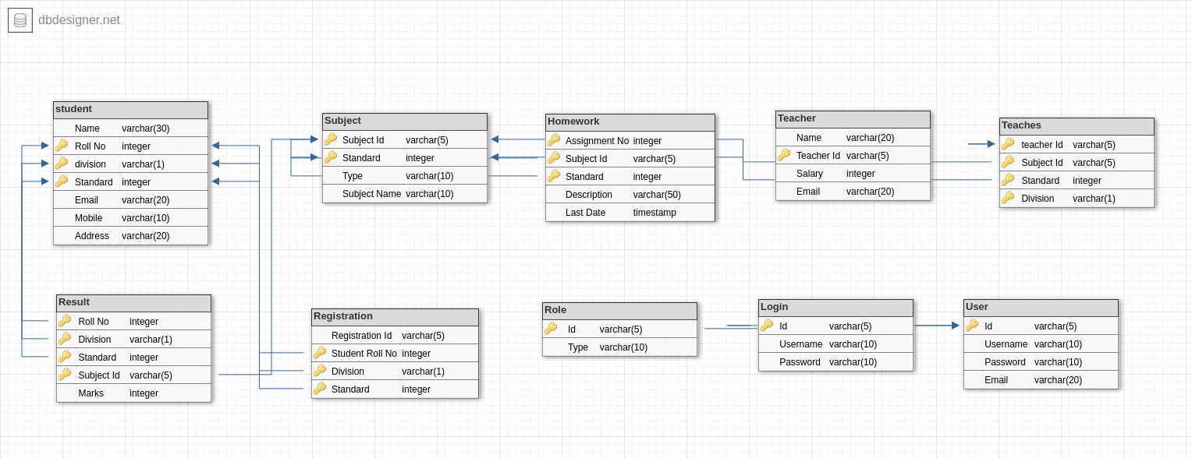

First Normal Form:
Conditions for First Normal Form – There Should be no multivalued and composite attributes i.e. every value of each column(attribute) should be atomic.
Here Address attribute in Student table is composite attribute. So new table is created Address and reference is given to Student table.
Compostie Attribute – 1) student table – addrees attribute is composite
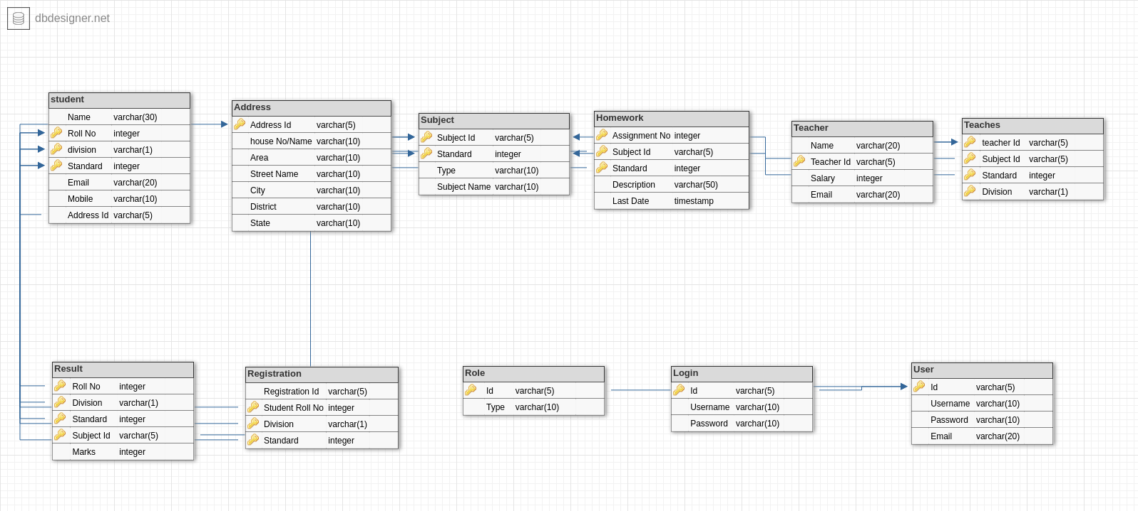
Second Normal Form:
Conditions for Second Normal Form – a) Schema should be in first normal form.
b) There should be no partial functional dependecy in table i.e. if K is candidate key of table, a ϲ K, b is non prime then there should be no a -> b.

Partial dependencies -
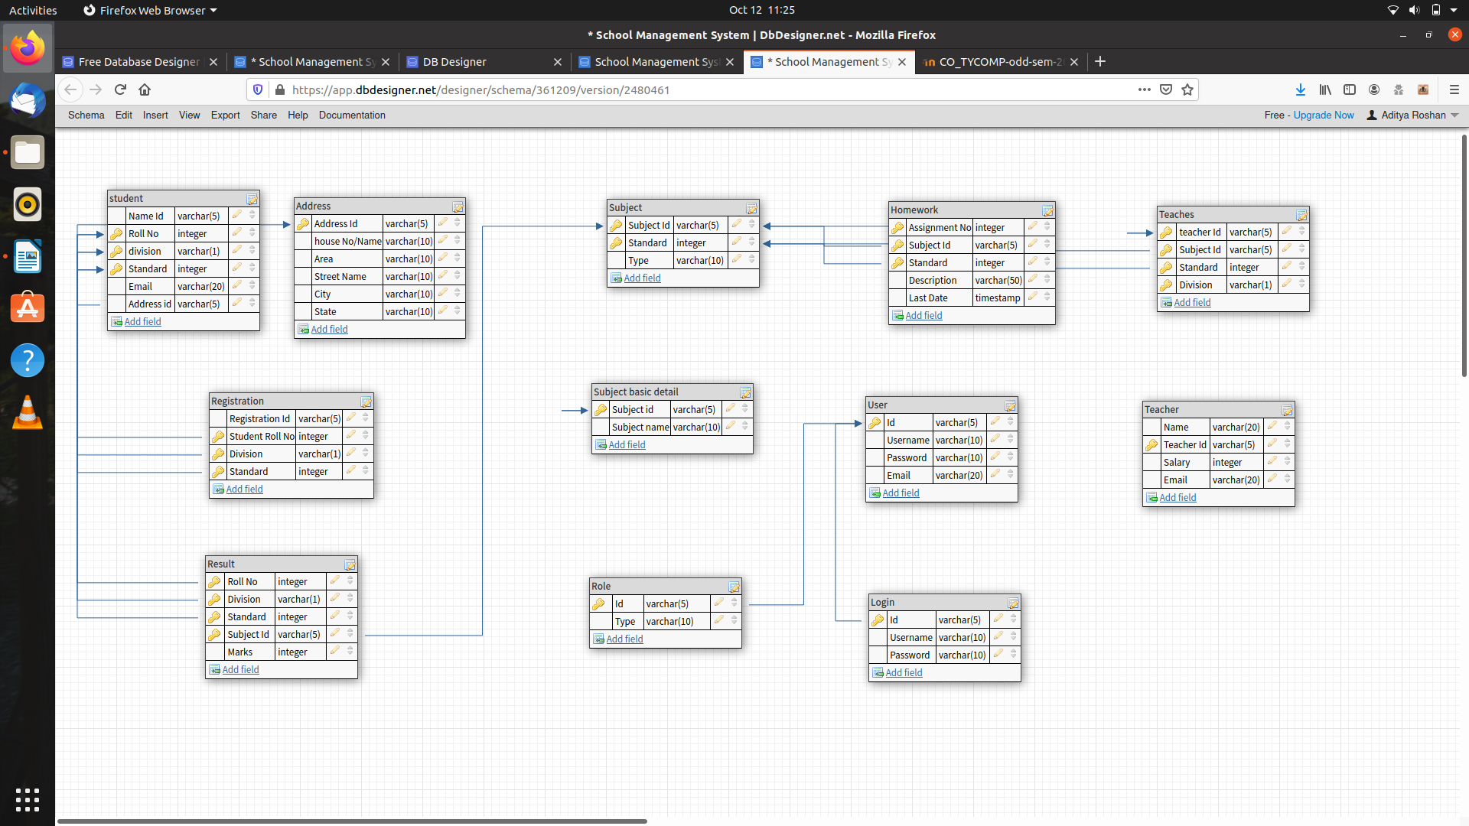
1) Subject – Candidate key(subject id, standard) -> type; subject id -> subject name

Third Normal Form:

Condtions for third normal form : a) It should be in second normal form.
b) There should be no tranistive dependency i.e. non prime attribute should depend upon any other non prime attribute.

Transitive Dependencies -
1) Student table – Candidate Key(Roll no, division, standard) -> email; Name-> address id, mobile
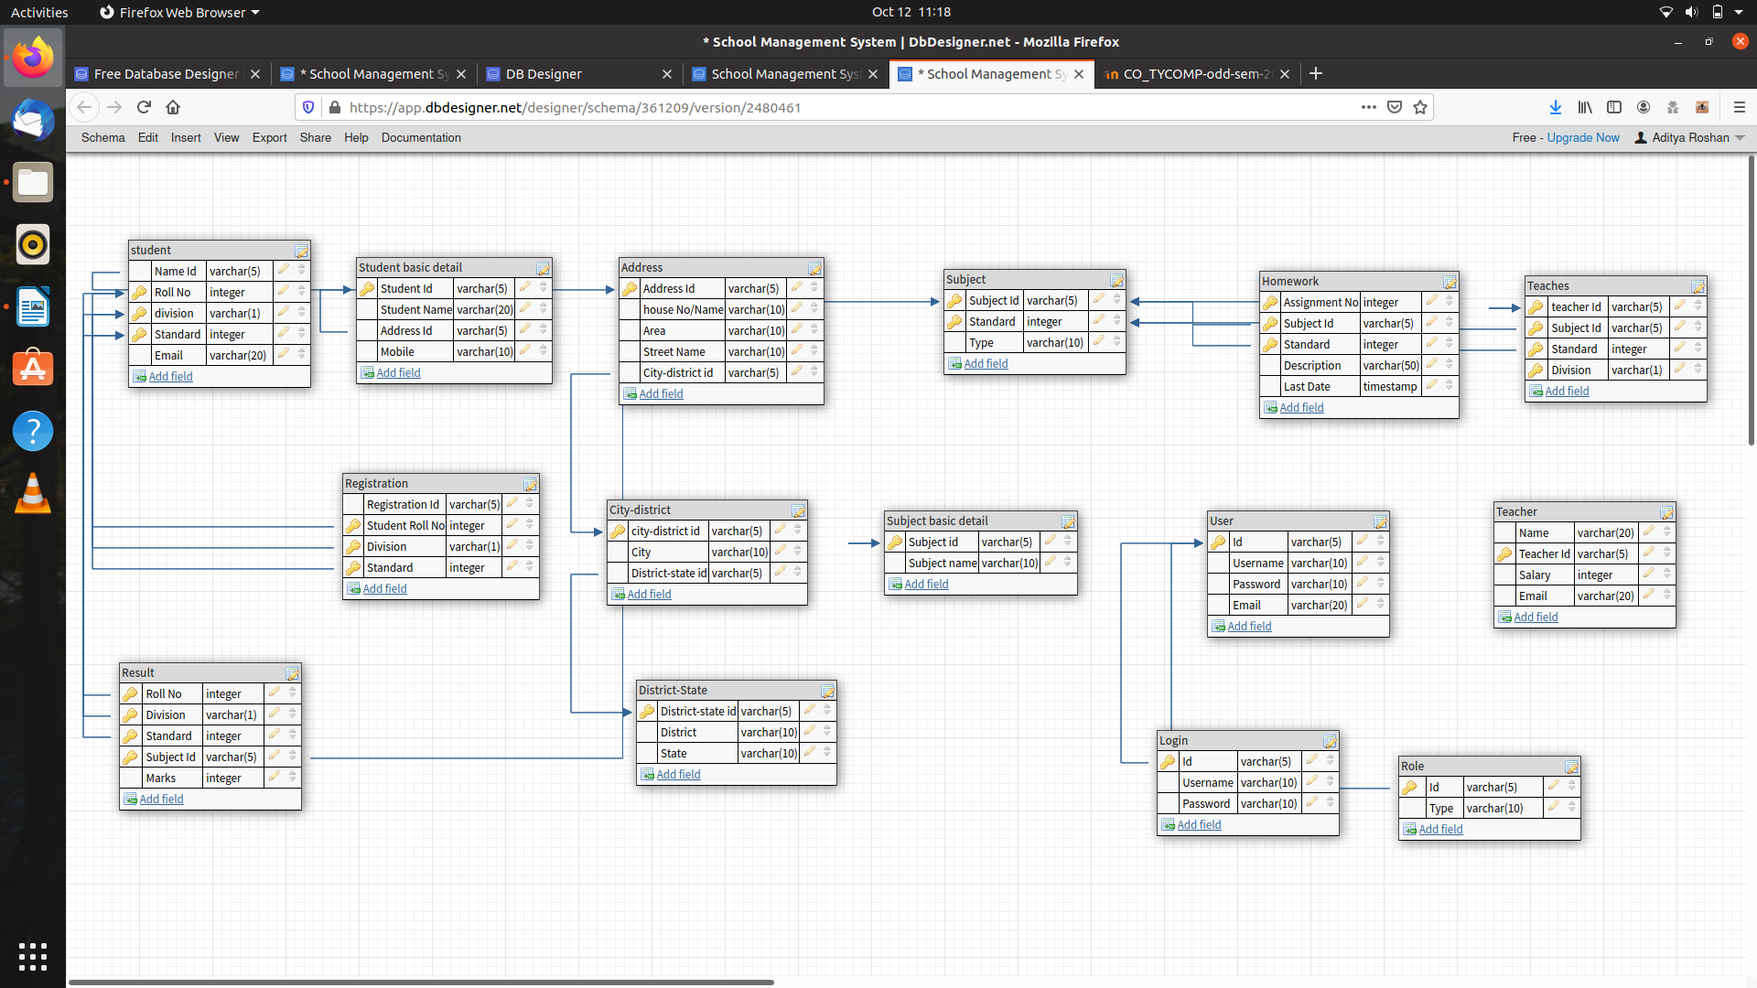
2) Address – Candidate Key(Address Id) -> house no; district -> city; state -> district

