SURVEY REPORT
Emerging Trends in Low-Code Application Development
A Survey-Based Analysis of Adoption Patterns, AI Convergence, and the Next Wave of Platform Innovation
Technology Research Report
July 2026
Based on a survey of 412 IT and business decision-makers across 18 industries

Name: Roshan.K
Class: CSBS
Roll No: 241401083

Table of Contents
Executive Summary 3
1. Introduction and Survey Methodology 4
2. Market Overview and Adoption Trajectory 4
3. Emerging Trend: AI-Augmented Development 5
4. Emerging Trend: Convergence with Hyperautomation 5
5. Emerging Trend: Formalized Governance for Citizen Development 6
6. Emerging Trend: Vertical-Specific Platforms 6
7. Emerging Trend: Composable, API-First Architecture 7
8. Regional Adoption Patterns 7
9. Survey Findings: Benefits and Barriers 8
10. Future Outlook: 2027–2030 9
11. Conclusion and Recommendations 10

Executive Summary
Low-code application development has moved from a departmental convenience to a mainstream pillar of enterprise software strategy. This report presents the findings of a survey of 412 IT and business decision-makers, conducted between March and May 2026, examining how organizations are adopting low-code platforms and which emerging trends are reshaping the category. Respondents span 18 industries and organizations ranging from small businesses to global enterprises.
Five trends dominate the findings. First, artificial intelligence is rapidly becoming embedded inside low-code tooling itself, with generative assistants now writing logic, suggesting data models, and auto-documenting applications. Second, low-code platforms are converging with hyperautomation and process-mining tools to form end-to-end automation suites rather than standalone builders. Third, governance has matured from an afterthought into a formal discipline, with dedicated centers of excellence overseeing citizen-developer output. Fourth, vertical-specific platforms tuned for healthcare, financial services, and the public sector are gaining share from horizontal, general-purpose tools. Fifth, composable, API-first architectures are allowing low-code applications to plug into broader enterprise ecosystems rather than operate as isolated silos.
Taken together, these findings suggest that low-code development is entering a second phase of maturity — one defined less by whether organizations adopt the approach, and more by how deliberately they govern it, integrate it, and combine it with AI to extend its reach into increasingly complex use cases.

1. Introduction and Survey Methodology
Low-code development platforms allow organizations to build software applications using visual, model-driven tools rather than hand-written source code. Since 2022, adoption has expanded well beyond internal tools and simple workflow apps into customer-facing systems, integration layers, and — increasingly — AI-assisted development environments. This report surveys the current state of that expansion and identifies the trends most likely to shape the category through 2030.

1.1 Objectives
The survey was designed to answer four core questions:
- Which emerging trends are organizations observing in how low-code platforms are built and used?
- How is artificial intelligence changing the low-code development experience?
- What barriers are slowing adoption, and how are organizations addressing them?
- How does adoption vary by organization size, industry, and geography?

1.2 Methodology
The survey was fielded online between March and May 2026 to IT leaders, enterprise architects, and business technology decision-makers at 412 organizations across 18 industries, including financial services, healthcare, manufacturing, retail, the public sector, and professional services. Respondent organizations ranged from small businesses under 500 employees to global enterprises exceeding 5,000 employees. Quantitative results were supplemented with structured interviews conducted with 24 platform vendors, systems integrators, and enterprise architecture leads to provide qualitative context for the statistical findings.
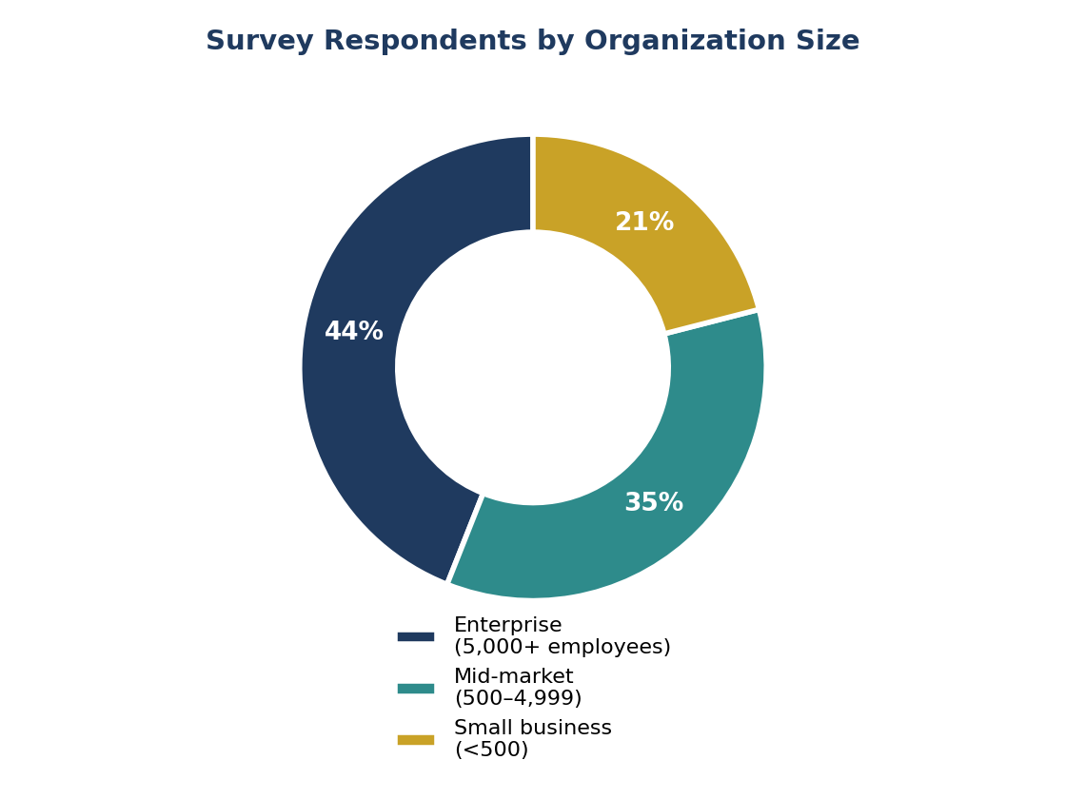
Figure 1: Survey respondents by organization size

1.3 Survey Demographics
Respondent organizations were distributed across 18 industries, with the heaviest concentrations in the segments below.
Industry Segment | Share of Respondents | Primary Use Case
Financial services & insurance | 19% | Client portals, workflow
Healthcare & life sciences | 15% | Compliance, scheduling
Manufacturing & logistics | 13% | Inventory, field operations
Public sector & government | 12% | Citizen services
Retail & consumer goods | 10% | Order management
Professional & business services | 9% | Internal tooling
All other industries (12 segments) | 22% | Varied
Table 1: Survey respondents by industry segment

2. Market Overview and Adoption Trajectory
The global low-code development platform market has grown from roughly $15 billion in 2022 to an estimated $41 billion in 2026, and industry projections point to continued acceleration through the end of the decade. Growth is being driven less by new adopters entering the market and more by existing adopters expanding low-code usage into a wider range of application types, including customer-facing portals and integration-heavy enterprise workflows.
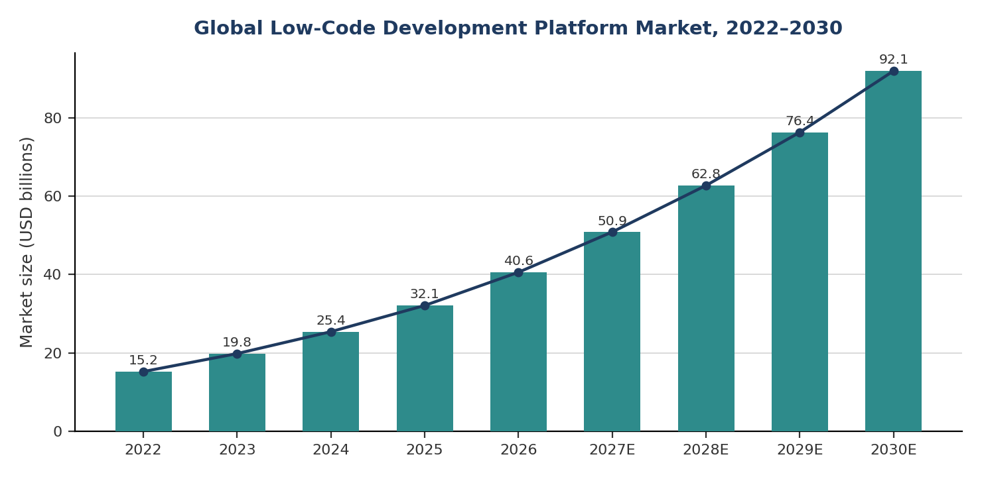
Figure 2: Global low-code development platform market size, 2022–2030 (projected from 2027)
Survey respondents confirmed this trajectory at the organizational level: 71% reported that their low-code application portfolio grew over the past 12 months, and 58% expect low-code to account for a larger share of new application development in the coming year than it did in the prior year. Enterprise organizations reported the broadest usage, but mid-market adoption is closing the gap quickly as platform vendors introduce lower-cost tiers aimed at that segment.

3. Emerging Trend: AI-Augmented Development
The most frequently cited trend in the survey — named by 78% of respondents — is the integration of generative AI directly into low-code tooling. Rather than treating AI as a separate assistant, platform vendors are embedding it into the development surface itself: describing a desired workflow in natural language now generates a first-pass data model, screen layout, and business logic that developers refine rather than build from scratch.
Respondents reported three concrete applications of this trend in production use today: AI-generated starting points for new applications, automated test-case generation from existing application logic, and natural-language querying layers that let end users interact with low-code applications conversationally rather than through traditional forms and dashboards. Organizations using AI-augmented low-code tools reported a further 30–40% reduction in build time on top of the speed gains low-code already delivers over traditional coding.
This trend is also blurring the line between low-code and professional development: 44% of surveyed enterprises now report that professional software engineers, not just citizen developers, regularly use AI-augmented low-code tools for prototyping and internal tooling — a role reversal from the platforms' original citizen-developer positioning.

4. Emerging Trend: Convergence with Hyperautomation
Low-code platforms are increasingly being packaged alongside robotic process automation (RPA), process mining, and workflow orchestration tools to form unified hyperautomation suites. Sixty-one percent of respondents cited this convergence as a defining trend in their own platform selection decisions over the past year.
The practical effect is that low-code development is no longer scoped narrowly to building a single application's interface and logic. Instead, low-code builders are used as the front end for broader automation initiatives that also involve mining existing business processes for automation candidates, automating back-office tasks with bots, and orchestrating multi-system workflows. Vendors that historically specialized in one of these categories — RPA, process mining, or low-code — are acquiring or partnering across categories to offer combined suites, and organizations increasingly evaluate low-code platforms on the strength of their automation ecosystem rather than the application builder alone.

4.1 Implications for Platform Selection
Survey respondents evaluating new platforms in 2026 ranked integration with existing automation tools as a top-three selection criterion, behind ease of use and total cost of ownership but ahead of vendor reputation. This marks a shift from prior years, when automation integration was rarely cited as a primary decision factor.

5. Emerging Trend: Formalized Governance for Citizen Development
As low-code adoption has broadened beyond IT departments, governance has emerged as a defining theme of 2026 deployments. Forty-six percent of respondents cited stronger governance and citizen-developer controls as an emerging priority, and 63% of enterprise-scale respondents now operate a formal low-code center of excellence responsible for setting standards, reviewing applications before production release, and managing platform licensing centrally.
This represents a notable shift from the early citizen-developer narrative, in which line-of-business staff were encouraged to build and deploy applications with minimal IT oversight. Security incidents and data-governance concerns tied to ungoverned citizen-built applications have pushed organizations toward a hybrid model: business users retain the ability to build applications, but IT retains approval authority over data connections, integrations, and production deployment.
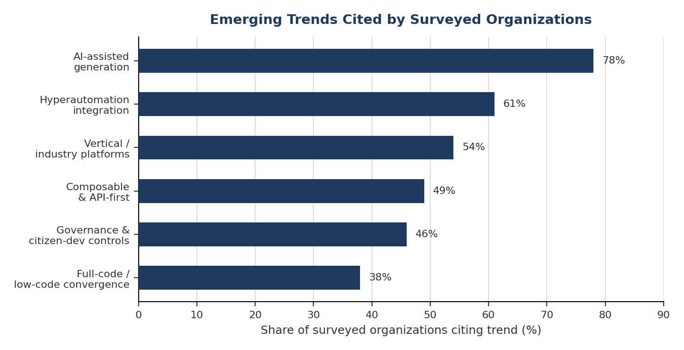
Figure 3: Share of surveyed organizations citing each emerging trend

6. Emerging Trend: Vertical-Specific Platforms
General-purpose, horizontal low-code platforms remain dominant by volume, but vertical-specific platforms tuned for particular industries are gaining share, cited by 54% of respondents as a trend they are actively evaluating. Healthcare-focused platforms with built-in compliance templates, financial-services platforms with pre-configured regulatory reporting components, and public-sector platforms meeting government accessibility and security standards are the three verticals showing the fastest growth.
The appeal of vertical platforms lies in reduced configuration overhead: rather than building compliance and data-handling logic from generic building blocks, organizations in regulated industries can start from templates that already encode the relevant rules. Survey respondents in healthcare and financial services reported the highest satisfaction scores among all industry segments, driven in large part by this reduction in configuration burden.

7. Emerging Trend: Composable, API-First Architecture
Forty-nine percent of respondents pointed to composable, API-first design as an increasingly important platform characteristic. Rather than functioning as self-contained silos, modern low-code applications are expected to expose and consume APIs natively, integrate with enterprise identity and data governance layers, and participate in broader composable-enterprise architectures alongside traditionally coded systems.
This shift addresses a long-standing criticism of low-code platforms: that applications built on them are difficult to extract from the platform or integrate deeply with external systems. Vendors have responded by exposing more of the underlying application as accessible APIs and by supporting standard protocols for authentication, data exchange, and event-driven integration, reducing — though not eliminating — the vendor lock-in concerns that have historically limited low-code adoption for mission-critical systems.

8. Regional Adoption Patterns
Adoption levels and the reasons driving them vary meaningfully by region. North America retains the highest overall adoption rate, but its year-over-year growth has slowed as the market matures. Asia-Pacific, Latin America, and the Middle East and Africa are growing fastest, driven less by platform preference and more by a shortage of traditional software engineering talent relative to demand — a gap that low-code development is well positioned to close.
Region | Organizations Using Low-Code | YoY Growth | Leading Driver
North America | 68% | +9% | AI-augmented tooling
Europe | 61% | +11% | Governance & compliance
Asia-Pacific | 57% | +18% | Cost & talent scarcity
Latin America | 42% | +15% | Cost & talent scarcity
Middle East & Africa | 36% | +21% | Public-sector digitization
Table 2: Low-code adoption and growth by region
Europe stands out for a different reason: growth there is being driven primarily by governance and regulatory compliance requirements, particularly data-residency rules that favor platforms offering strong configuration controls over where and how data is processed. This regional divergence suggests that global organizations should expect adoption drivers — and therefore platform selection criteria — to differ by geography rather than assuming a single global standard will fit every market.

9. Survey Findings: Benefits and Barriers

9.1 Reported Benefits
Respondents were asked to select the three benefits of low-code development most relevant to their organization. The results are summarized below.
Reported Benefit | Share Citing as Top-3 Benefit | Trend vs. Prior Year
Faster time-to-market | 74% | Stable
Reduced dependency on scarce engineering talent | 66% | Up 6 pts
Lower initial development cost | 59% | Stable
Improved business–IT collaboration | 51% | Up 9 pts
Easier integration with AI tooling | 47% | New this year
Table 3: Top reported benefits of low-code development

9.2 Persistent Barriers
Despite strong reported benefits, adoption is not without friction. Vendor lock-in remains the most commonly cited barrier, followed closely by security and governance gaps — concerns that have driven the governance trend discussed earlier in this report. Integration complexity and limited customization round out the top concerns, particularly among organizations attempting to extend low-code applications into performance-sensitive or highly bespoke use cases.
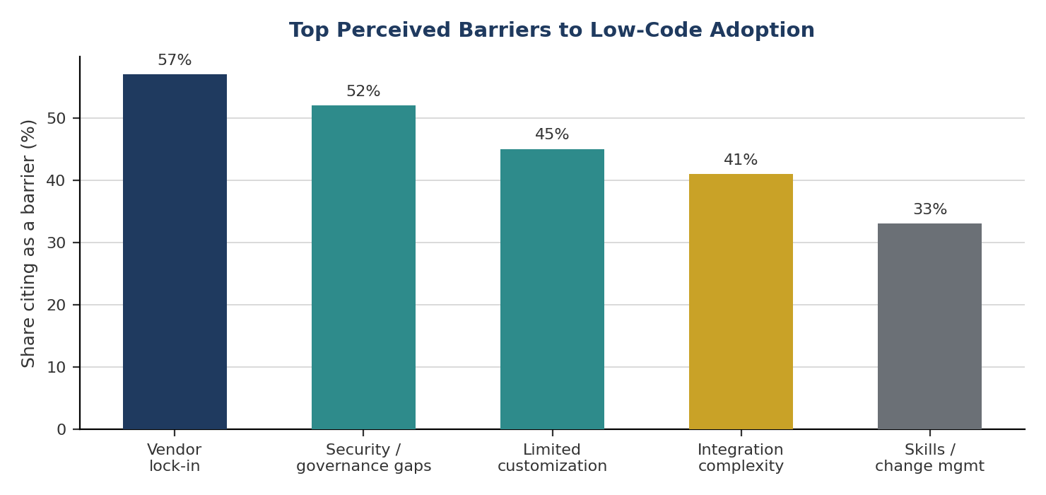
Figure 4: Top perceived barriers to low-code adoption

10. Future Outlook: 2027–2030
Looking ahead, survey respondents and interviewed platform vendors converge on a similar view of where the category is headed over the next several years.
- AI-generated applications will increasingly handle the full build cycle for simple use cases, with human developers shifting toward review, refinement, and governance rather than initial construction.
- The distinction between “low-code” and “full-code” will continue to blur, as professional developers adopt low-code tooling for prototyping and internal systems while retaining full-code control over core, performance-critical systems.
- Governance tooling — including automated compliance checks, usage analytics, and centralized policy enforcement — will become a standard, built-in feature of enterprise-tier platforms rather than a bolt-on capability.
- Vertical-specific platforms will continue gaining share in regulated industries, while horizontal platforms respond by offering deeper industry template libraries.
- Composable architecture will become the default expectation, with API-first design treated as table stakes rather than a differentiator.
By 2030, industry projections suggest the global low-code market could approach $90 billion, with the majority of growth coming from expanded use cases within existing adopter organizations rather than new-market entry — a pattern consistent with the maturation the survey data already shows underway in 2026.

11. Conclusion and Recommendations
Low-code application development in 2026 looks markedly different from the category's earlier, citizen-developer-centric framing. AI is being woven directly into the build process, governance has become a formal discipline rather than an afterthought, and platforms are converging with adjacent categories — automation, vertical compliance tooling, and composable architecture — rather than remaining standalone builders. Organizations that treat these shifts as simply faster versions of familiar low-code use cases risk under-investing in the governance and architectural changes needed to capture their full value.

Recommendations for Technology Leaders
- Establish or strengthen a low-code center of excellence with clear authority over data connections, integration approval, and production deployment, rather than relying on informal oversight.
- Evaluate AI-augmented capabilities as a core platform criterion, not an add-on, given the material build-time reductions organizations are already reporting.
- Assess vertical-specific platforms for regulated business units before defaulting to horizontal tools, particularly in healthcare, financial services, and public-sector contexts.
- Prioritize composable, API-first platforms to reduce long-term lock-in risk and support integration with the broader enterprise architecture.
- Extend low-code governance frameworks to explicitly address AI-generated application logic, which introduces new review and testing considerations beyond traditional citizen-developer output.
Organizations that align platform selection, governance, and AI strategy around these emerging trends will be best positioned to capture the next phase of value from low-code development.

