Objective Questions:
- What is the distribution of account balances across different regions?
Answer
This Query identify the average Balance, Minimum Balance, and Max Balance regions wise.

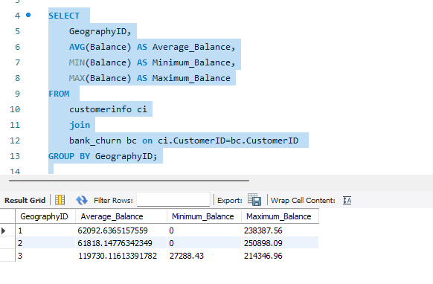

GeographyID | GeographyLocation
1 | France
2 | Spain
3 | Germany

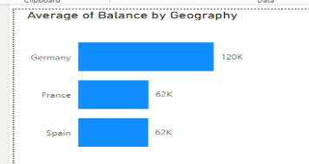

- Identify the top 5 customers with the highest Estimated Salary in the last quarter of the year. (SQL)
Answer

Top 5 customers with the highest Estimated Salary in the last quarter of the year.
Here I used subquery to identify the Recent year.
YEAR(BankDOJ) – used to extract year from the BankDOJ

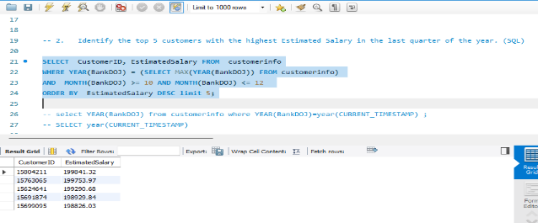

- Calculate the average number of products used by customers who have a credit card. (SQL)
Answer

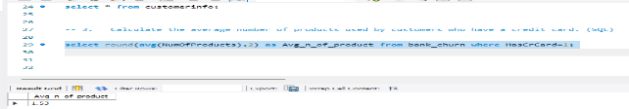

- Determine the churn rate by gender for the most recent year in the dataset.
Answer
Churan Rate calculate on power_bi using new Measure column

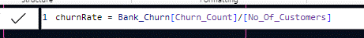
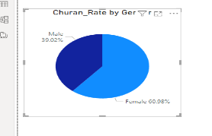

- Compare the average credit score of customers who have exited and those who remain. (SQL)
Answer

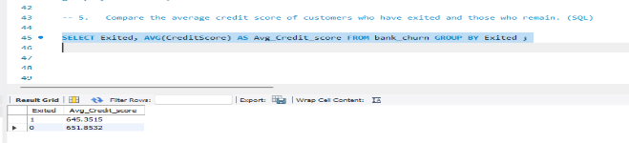
ExitID | ExitCategory
1 | Exit
0 | Retain

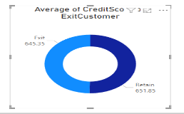

- Which gender has a higher average estimated salary, and how does it relate to the number of active accounts? (SQL)
Answer
Gender wise Avg_Estimated _Salary

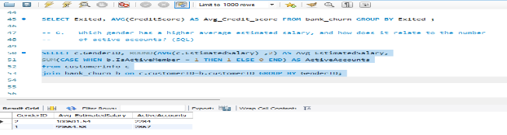

Which gender has a higher average estimated salary

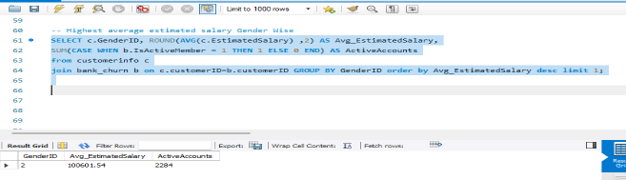

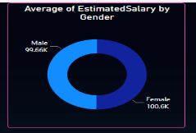

- Segment the customers based on their credit score and identify the segment with the highest exit rate. (SQL)
- Segmenting Customers Based on Credit Score: The first step is to divide customers into different segments based on their credit score. This can be achieved using SQL queries that group customers by their credit score ranges.
  - Eg. Credit score:
    - Excellent: 800–850
    - Very Good: 740–799
    - Good: 670–739
    - Fair: 580–669
    - Poor: 300–579

- Calculating Exit Rate: Once customers are segmented based on their credit scores, the next step is to calculate the exit rate for each segment.

- Identifying Segment with the Highest Exit Rate: This can be done by sorting the segments based on their exit rates in descending order and selecting the segment with the highest exit rate.
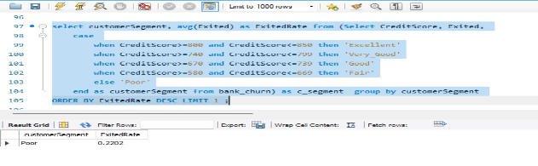

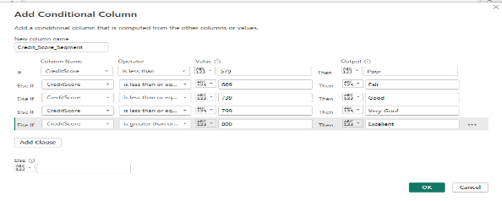

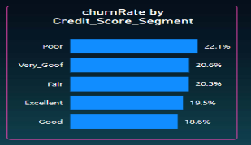

- Find out which geographic region has the highest number of active customers with a tenure greater than 5 years. (SQL)

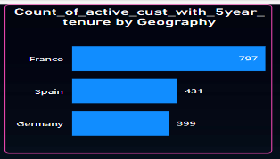

In this SQL query I used subquery to Identify the customerID who, active customers with tenure greater than 5 years.
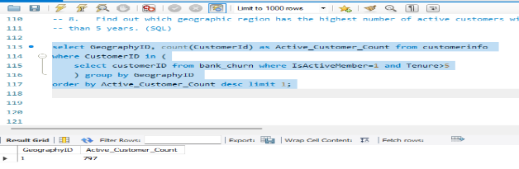

- What is the impact of having a credit card on customer churn, based on the available data?

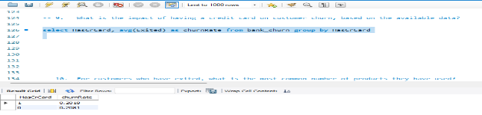

The result of this query will show the churn rate for customers with and without a credit card. By comparing these churn rates, you can analyse the impact of having a credit card on customer churn based on the available data
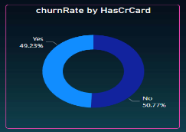

- For customers who have exited, what is the most common number of products they have used?

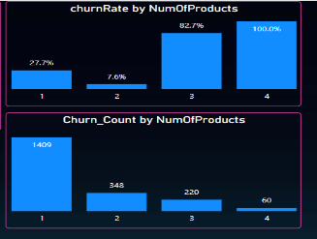

  - In this there is two chart 1st one churnRate By NumOfProduct where we can see, those customers used 4 products, churned 100%.
  - And 2nd, It counts the number of exited customers by numOfProduct and then determines the most common number of products used by customers.
  - 1 and 2 products are used by most customer with less exit rate.

In below query, count the customer who churn the bank by no_of_product and order by desc.

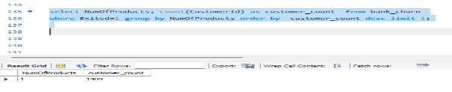

- Examine the trend of customers joining over time and identify any seasonal patterns (yearly or monthly). Prepare the data through SQL and then visualize it.

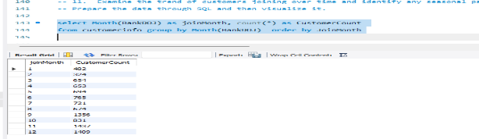

In this query , firstly I extract month from BnakDOJ and count the customer and group the data over month.

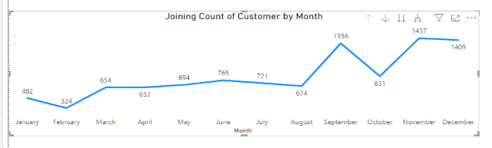

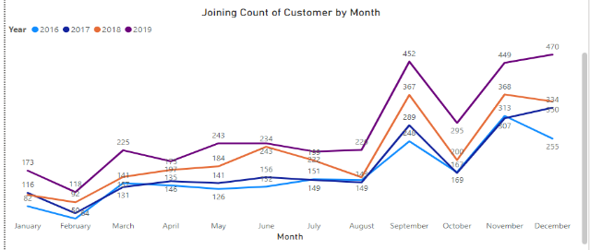
- Analyze the relationship between the number of products and the account balance for customers who have exited.

Scatter Plot - Number of Products in field to the "Values" area of the scatter plot, "Balance" field to the "Y-axis" area of the scatter plot. And exited in the filter for the filter the customer who have exited.
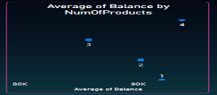

Lower number of products tend to have higher account balances and higher exited customer here showing, customer used no_of_product 1 but the balance was higher and the also higher Exited
And also, who’s customer takes 4 no_of_products and higher balance but exited less

- Identify any potential outliers in terms of balance among customers who have remained with the bank.

Scatter Plot - Balance in field to the "Values" area of the scatter plot, and exited in the filter for the filter the customer who have not exited.
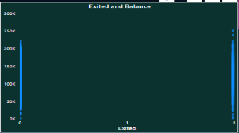

There is many of customers that have zero balance and above 2.2L balance and those customers have remained with the bank.

- How many different tables are given in the dataset, out of these tables which table only consists of categorical variables?

There are 7 tables are given in the dataset out of these tables, 5 tables only consist of categorical variables.

- Using SQL, write a query to find out the gender-wise average income of males and females in each geography id. Also, rank the gender according to the average value. (SQL)

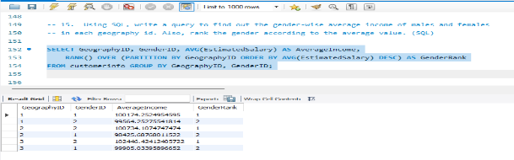
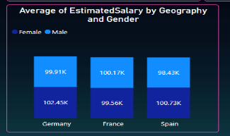

- Using SQL, write a query to find out the average tenure of the people who have exited in each age bracket (18-30, 30-50, 50+).

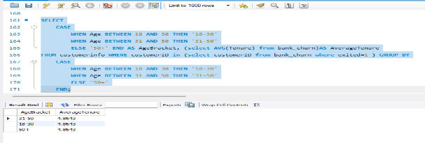

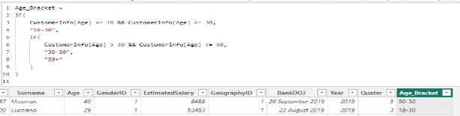

Using this above query make a column called Age_bracket.
New Measure for calculating Average tenure who’s customer exited

Visualization on Power-BI

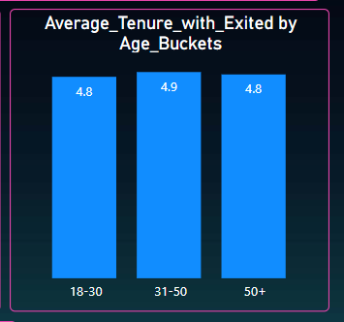
- Is there any direct correlation between salary and the balance of the customers? And is it different for people who have exited or not?

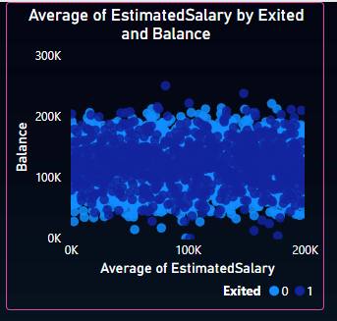

By visualizing the data in a scatter plot with different colours for exited and non-exited customers, analyze the correlation between salary and balance and determine it differs for customers who have exited or not.

- Is there any correlation between the salary and the Credit score of customers?

By visualizing the data in a scatter plot, we can easily assess the relationship between salary and credit score and determine correlation between the two variables with exited customer.

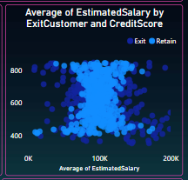

- Rank each bucket of credit score as per the number of customers who have churned the bank.

Rank the CreditScore_Segment by churn

Visualisation on power-bi

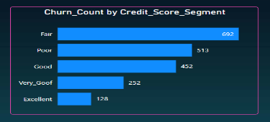
- According to the age buckets find the number of customers who have a credit card. Also retrieve those buckets that have lesser than average number of credit cards per bucket.

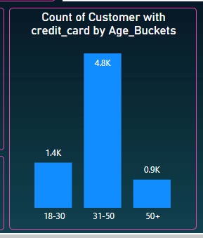

- Rank the Locations as per the number of people who have churned the bank and average balance of the customers.
Visualization
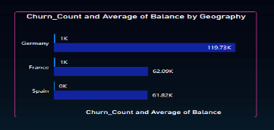

- As we can see that the “CustomerInfo” table has the CustomerID and Surname, now if we have to join it with a table where the primary key is also a combination of CustomerID and Surname, come up with a column where the format is “CustomerID_Surname”.
I used =CONCATENATE(A3,"_",B3), this formula to concatenate two column, CustomerID and Surname on excel

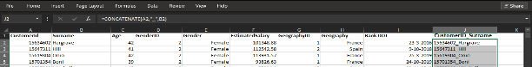

- Without using “Join”, can we get the “ExitCategory” from ExitCustomers table to Bank_Churn table? If yes do this using SQL.

Yes, you can retrieve the "ExitCategory" from the "ExitCustomers" table and merge it with the "Bank_Churn" table without using a JOIN statement using a subquery.

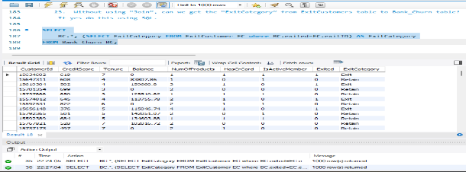
- Were there any missing values in the data, using which tool did you replace them and what are the ways to handle them?

Excel:
- Identify missing values in your dataset by looking for blank cells
- Replace missing values using Excel functions like IF, ISBLANK
- Replace missing values with a specific value (e.g., 0 or "Unknown")
Power BI:
- Identify missing values in the data using the data model view.
- Use Power Query Editor to handle missing values by filtering them out, replacing them with specific values
- Power BI provides functionalities like Replace Values, Fill Down, Fill Up, or Fill Up/Down
- You can also use DAX functions like BLANK, IF, or ISBLANK to handle missing values in calculated columns or measures.

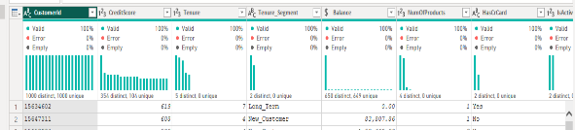

SQL:
- Identify missing values in your dataset using SQL SELECT statements for checking NULL values.
- Replace missing values
- If you need to impute missing values based on certain criteria, you can use SQL CASE statements combined with aggregation functions like AVG, MEDIAN, or MODE to calculate replacement values.

- Write the query to get the customer IDs, their last name, and whether they are active or not for the customers whose surname ends with “on”.

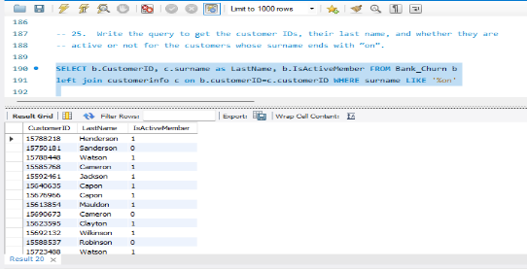

Subjective Question:

- Customer Behaviour Analysis: What patterns can be observed in the spending habits of long-term customers compared to new customers, and what might these patterns suggest about customer loyalty?
Answer
In this Create a calculated column to classify customers into long-term and new customers based on their tenure.
Can define long-term customers as those with a tenure above (e.g., 5 years or equal to 5)

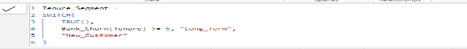

Spending habits of long-term and new customers over time.
- Calculate spending habits based on the difference between estimated salary and bank balance.
For calculated spending habits, 1st I merge the table for estimatedSalary to Bank_churan and then difference between estimated salary and bank balance

- Visualization on line chart, Tenure for time and spending habit on the basis of tenures
- Spending habits on the basis of tenures and Customer has Credit card or not

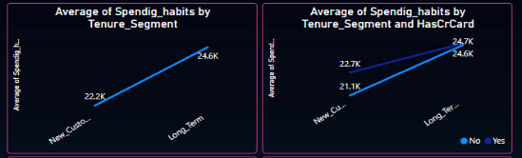

About the observed patterns in spending habits

- The Long-term customers has higher spending levels and the new customers has lowest spending habits.
- The Long-term customers that have credit card and have no credit card are almost same spending levels.

Visualization without segment
Spending habits on the basis of tenures and Customer has Credit card or not

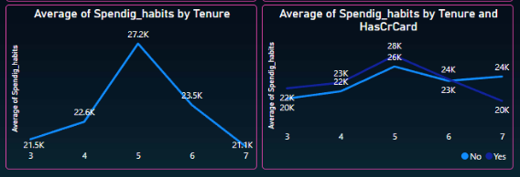

About the observed patterns in spending habits
- The Long-term customers that have credit card has lower spending levels and the Long-term customers that have no credit card has moderate spending habits.
- In the 5 Tenure customer that have credit card or not have credit card are no more difference in spending habits.
These insights to make recommendations for targeted marketing strategies, loyalty programs, or customer retention efforts aimed at maximizing customer lifetime value.

- Product Affinity Study: Which bank products or services are most commonly used together, and how might this influence cross-selling strategies?
Answer

We found that customers commonly use certain bank products or services together. eg. credit card and also having multiple products, such as savings accounts or loans.
According to researchgate.net, the most commonly used banking products and services are: debit card (84.30%), credit card (50.98%), bank loans (48%), and electronic banking service (39.22%).

Cross-selling strategies
- A customer has a personal checking account and the banking associate suggests that they get a debit card
- The bank associate assists a customer with signing up for mobile banking

- Geographic Market Trends: How do economic indicators in different geographic regions correlate with the number of active accounts and customer churn rates?

In the datasets, there is no available of economic indicator.

- Here I Aggregate the count of customer by geographic to calculate the number of active accounts or not Active and customer churn count for each region and age buckets.
- Here we can compare the geographic distribution of active accounts or not Active and churn count with demographic factors such as age, gender, to identify any patterns or trends.

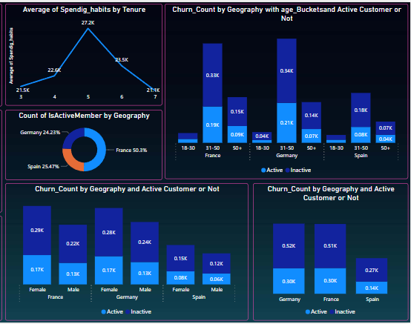

According to the visual, there is age bucket, geographic region, Gender and Active or Inactive.
The customer churns the bank more who are Inactive Customers.

- Risk Management Assessment: Based on customer profiles, which demographic segments appear to pose the highest financial risk to the bank, and why?
- Aggregate the customer data by demographic segments to calculate average credit score.
- demographic segments like age groups, gender, geographic regions.
- Identify financial risk:
low credit scores, or low account balances.
- Higher risk:
Look for patterns or trends such as:
  - Here age groups 50+ have average credit scores or higher debt levels.
  - Every geographic region where female customer higher churn rate.
  - Have more inactive accounts, have higher churn rates.

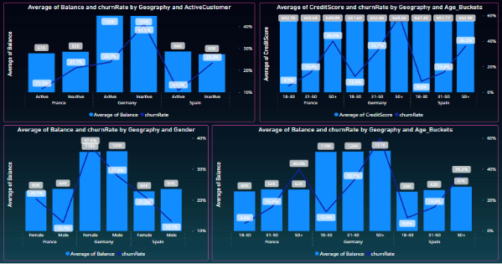

- Customer Tenure Value Forecast: How would you use the available data to model and predict the lifetime (tenure) value in the bank of different customer segments?

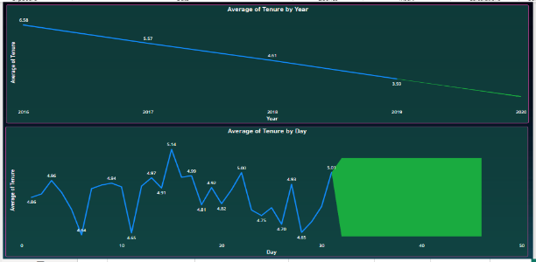

With the confidence interval is 95 % forecast the tenure value for 1year
There is Forecast value is 2.61 and upper band value is 2.64 lower band value is 2.58.
And also forecast for day.
- Marketing Campaign Effectiveness: How could you assess the impact of marketing campaigns on customer retention and acquisition within the dataset? What extra information would you need to solve this?
- According to the data, there is no data available for the marketing campaign, so I don’t able to analyse the impact of marketing campaigns on customer retention and acquisition within the dataset.
- For calculating the retention rate, need the information how many customers participated in Campaign whose already account with the bank and how many customers remain with the bank after Campaign.
- And for Customer acquisition need the information how many new customers participated in the Campaign and how many joined the bank after the Campaign.
- For calculate total conversion rate information need how many total customers participated in the Campaign and how many customers remain with bank and new joined customers.
- And Take feedback from the customer after the Campaign it will also help to understand the customers.
- Customer Exit Reasons Exploration: Can you identify common characteristics or trends among customers who have exited that could explain their reasons for leaving?

- Analyse the distribution of exit reasons
- Analyse the visualizations to identify any common characteristics or trends among customers who have exited the bank.

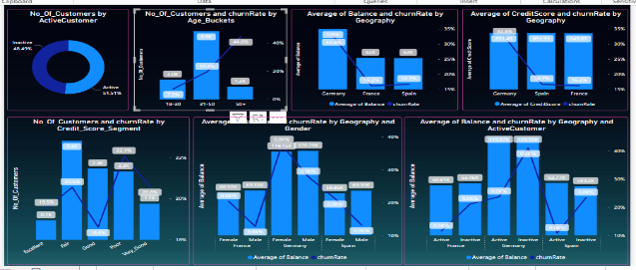

- As, I analysed the customer from Germany geographic regions and inactive customer has higher exit rates or age groups above 50 have higher exit rates.
- There are also differences in exit rates between male and female customers, in every geographic region the female customers have higher exit rates.
- In almost all geographic region the average credit scores have no more different
- There are also pattern inactive and female customer have higher exit rates.

- Are 'Tenure', 'NumOfProducts', 'IsActiveMember', and 'EstimatedSalary' important for predicting if a customer will leave the bank?

Tenure:
- It refers to the number of years the customer has been with the bank.
- Customers who have been with the bank for a longer time may have developed stronger relationships and loyalty, it means making them less likely to leave.
- Therefore, tenure is an important in predicting if a customer will leave the bank.
NumOfProducts:
- Refers to the number of products that a customer has purchased through the bank.
- Customers who have multiple products or services with the bank may have deeper ties and higher engagement, making them less likely to churn.
- Therefore, the number of products owned by a customer can be important for predicting if they will leave the bank.
IsActiveMember:
- IsActiveMember indicates whether a customer is an active member of the bank, based on certain criteria set by the bank.
- Active members are more engaged with the bank, regularly using its services and products.
- Therefore, being an active member is likely to reduce the churn.
EstimatedSalary:
- EstimatedSalary represents the approximate salary of the customer.
- Customers with higher salaries may have more financial stability and may be less likely to switch banks.
- Therefore, estimated salary can also play a role in predicting if a customer will leave the bank.

In summary, 'Tenure', 'NumOfProducts', 'IsActiveMember', and 'EstimatedSalary' are all important variables for predicting if a customer will leave the bank. Customers with longer tenure, more produ

- Utilize SQL queries to segment customers based on demographics and account details.

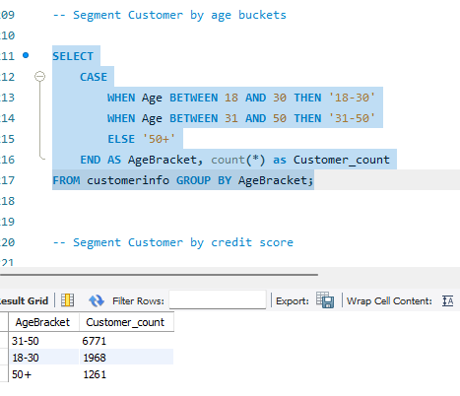

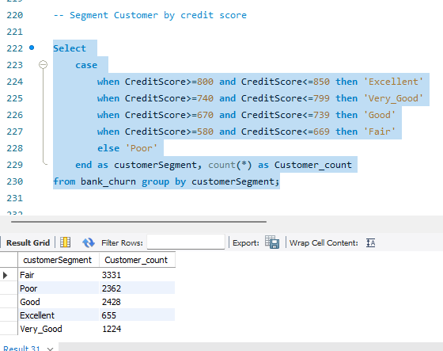

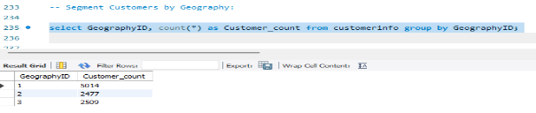

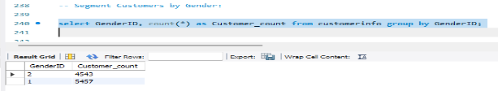

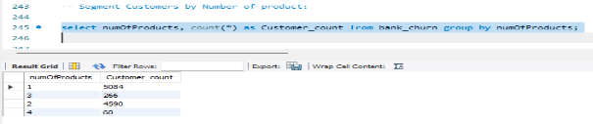

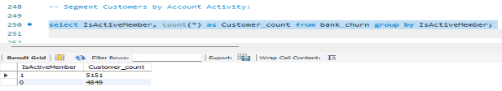

- How can we create a conditional formatting setup to visually highlight customers at risk of churn and to evaluate the impact of credit card rewards on customer retention?

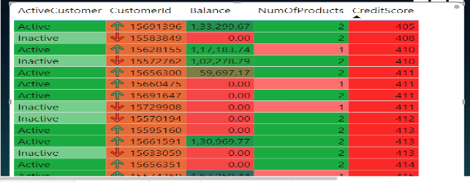

I applied conditional formatting, for customer who have zero account balance and inactive and have single number of product and low credit score, it means the customer at risk of churn.

Credit card rewards are the indicator:
- This could be through a binary indicator (1 for customers enrolled in credit card rewards program, 0 for those not enrolled) or through specific reward program tiers or benefits. Determine the desired impact of credit card rewards on customer retention.
For example, you might expect customers enrolled in credit card rewards programs to have higher retention rates compared to those not enrolled.
- And then visual indicator or formatting style to distinguish customers enrolled in credit card rewards programs from those not enrolled.
- Review the formatted report to visually identify at-risk customers and evaluate the impact of credit card rewards on customer retention.
- Analyse any patterns or trends in customer behaviour to understand the effectiveness of credit card rewards programs in retaining customers and mitigating churn risk.

- What is the current churn rate per year and overall, as well in the bank? Can you suggest some insights to the bank about which kind of customers are more likely to churn and what different strategies can be used to decrease the churn rate?

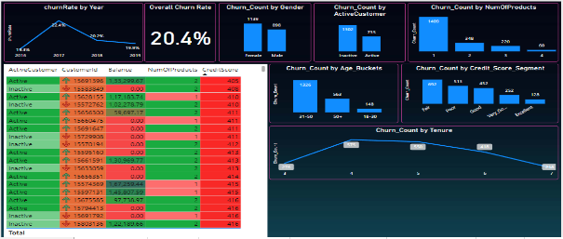

Common Characteristics of Churning Customers:
- Customers with low account balances more likely to churn
- Customers who have been with the bank for a short tenure or have low engagement levels (inactive members) also be at higher risk of churn.
- Low Credit Score.
- Customer with single product.
Decrease Churn Rate:
- Improve Customer Experience: Enhance the overall customer experience by providing personalized services, proactive communication, and quick resolution of issues.
- Marketing campaigns to re-engage inactive customers or offer incentives to retain high-value customers. Implement loyalty programs or rewards schemes.
- Offer bundled products or cross-sell additional services to increase the value proposition for customers and their relationship with the bank.

- Create a dashboard incorporating all the KPIs and visualization-related metrics. Use a slicer in order to assist in selection in the dashboard.

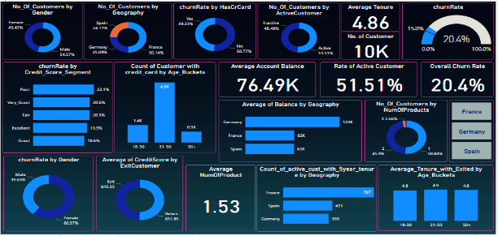
- How would you approach this problem, if the objective and subjective questions weren't given?

If the specific objective and subjective questions were not provided, and the task was to analyze the dataset without predefined questions.
I would approach the problem in a more exploratory and open-ended manner.
Data Exploration:
- Exploring the available datasets containing customer demographics, transaction details, exit information, and other relevant data.
- Examine the structure of the datasets, the types of variables available.
Analysis:
- Analysis to summarize the key characteristics and trends within the data.
- Visualize the data using bar charts, column chart or other.
- Look for patterns, trends, and correlations within the data that may provide valuable insights.
- Explore relationships between demographic factors (such as age, gender, geography) and customer behaviour (such as transaction frequency, account balances, churn rates).
- Perform segmentation analysis to divide customers into meaningful groups based on common characteristics.

- In the “Bank_Churn” table how can you modify the name of the “HasCrCard” column to “Has_creditcard”?

