**NITTE MEENAKSHI INSTITUTE OF TECHNOLOGY**

(AN AUTONOMOUS INSTITUTION, AFFILIATED TO VISVESVARAYA TECHNOLOGICAL UNIVERSITY, BELGAUM, APPROVED BY AICTE & GOVT.OF KARNATAKA)



**DEEP LEARNING COURSE PROJECT REPORT**

titled

**“NEURAL NETWORKS FROM THE SCRATCH”**

*Submitted in partial fulfilment of the requirement for the award of Degree of*

*Bachelor of Engineering*

*in*

*Computer Science and Engineering*

*Submitted by:*

|  |  |
| --- | --- |
| **Harshith Narahari** | **1NT15CS064** |
| **Roshan Badrinath** | **1NT15CS140** |

Under the Guidance of

**DR. SAROJADEVI H.**

**Professor, Dept. of CSE, NMIT**



**Department of Computer Science and Engineering**

2018-19

|  |  |  |
| --- | --- | --- |
|  | **Nitte Meenakshi Institute of Technology**  (AN AUTONOMOUS INSTITUTION AFFILIATED TO VISVESVARAYA TECHNOLOGICAL UNIVERSITY, BELGAUM)  PB No. 6429, Yelahanka, Bangalore 560-064, Karnataka  Telephone: 080- 22167800, 22167860  Fax: 080 – 22167805 |  |

**Department of Computer Science and Engineering**

**CERTIFICATE**

This is to certify that the Deep Learning course project on “Neural Networks from the scratch” is an authentic work carried out by **Harshith Narahari (1NT15CS064)** and **Roshan Badrinath (1NT15CS140)** bona fide students of **Nitte Meenakshi Institute of Technology**, Bangalore in partial fulfilment for the award of the degree of ***Bachelor of Engineering*** in COMPUTER SCIENCE AND ENGINEERING of Visvesvaraya Technological University, Belagavi during the academic year ***2018-2019.***

|  |  |
| --- | --- |
| **Name and Signature of Guide** | **Name and Signature of the HOD** |
| _______________________  Dr. Saroja Devi. H | **__________________________**  Dr. M. N. Thippeswamy |

**DECLARATION**

We hereby declare that

(i) This Presentation does not contain text, graphics or tables copied and pasted from the Internet, unless specifically acknowledged, and the source being detailed in the report and in the References sections.

(ii) All corrections and suggestions indicated during the preparation have been incorporated in the report.

(iii) Content of the report has been checked for the plagiarism requirement

|  |  |  |
| --- | --- | --- |
| **Name** | **USN** | **Signature** |
| Harshith Narahari | 1NT15CS064 |  |
| Roshan Badrinath | 1NT15CS140 |  |

**Date:**

**ACKNOWLEDGEMENT**

The satisfaction and euphoria that accompany the successful completion of any task would be incomplete without the mention of the people who made it possible, whose constant guidance and encouragement crowned our effort with success. We express our sincere gratitude to our Principal **Dr. H. C. Nagaraj**, Nitte Meenakshi Institute of Technology for providing facilities.

We thank our HoD, **Dr. Thippeswamy M.N.** for the support and encouragement to carry out this course project. We wish to express our gratitude to our project guide **Dr. Saroja Devi H.**, for teaching the course on Introduction to Deep Learning and to facilitate development of this project work on deep learning.

We also thank all our friends, teaching and non-teaching staff at NMIT, Bangalore, for all the direct and indirect help provided in the completion of the project work and this report.

|  |  |  |
| --- | --- | --- |
| **Name** | **USN** | **Signature** |
| Harshith Narahari | 1NT15CS064 |  |
| Roshan Badrinath | 1NT15CS140 |  |

**Date:**

**ABSTRACT**

Artificial neural networks are computing systems that are used in machine learning and deep learning for regression and classification problems. Backpropagation is the algorithm that is used to train the neural network. The main aim of this algorithm is to get the best set of weights and biases that fit the dataset. Optimization is the process of updating weights efficiently. Gradient based optimization is the most popular optimization method.

In this project, a library, similar to *Keras API*, is developed in *Python* for implementing neural networks. The library provides functionality to create deep feed-forward neural networks with variable neurons in each layer. The library offers variety of activation functions and optimization functions.

The popular ‘*Iris flower dataset*’ is used to test the performance of the neural network. Various optimization algorithms were used such as GD, SGD, NAM, AdaGrad, RMSProp and Adam. It was observed that NAM converges faster than SGD and Adam converges faster than AdaGrad and RMSProp.

**TABLE OF CONTENTS**

1 INTRODUCTION 1

1.1 BACKGROUND 1

1.2 MOTIVATION 2

1.3 OBJECTIVES 2

1.4 ORGANIZATION OF THE REPORT 2

2 LITERATURE SURVEY 3

2.1 ARTIFICIAL NEUTRAL NETWORK 3

2.2 TRAINING A NEURAL NETWORK 4

2.3 OPTIMIZATION METHODS 5

2.3.1 GRADIENT DESCENT (GD) 5

2.3.2 STOCHASTIC GRADIENT DESCENT (SGD) 6

2.3.3 MOMENTUM & NESTROV'S ACCELERATED MOMENTUM (NAM) 7

2.3.4 ADAGRAD 7

2.3.5 RMSPROP 7

2.3.6 ADAM 8

3 IMPLEMENTATION DETAILS 9

3.1 DATASET DETAILS 9

3.2 NEURAL NETWORK IMPLEMENTATION 9

4 RESULTS AND ANALYSIS 12

4.1 GRADIENT DESCENT AND STOCHASTIC GRADIENT DESCENT 12

4.2 NESTROV’S ACCELERATED MOMENTUM 13

4.3 ADAGRAD, RMSPROP AND ADAM 14

5 CONCLUSION 15

6 REFERENCES 16

**LIST OF FIGURES**

|  |  |
| --- | --- |
| **Fig No.** | **Description** |
| 1.1 | Relation between AI, ML and DL |
| 2.1 | A perceptron model |
| 2.2 | Feed-forward neural network |
| 2.3 | Backpropagation algorithm |
| 2.4 | Evolution map of optimizers |
| 3.1 | Class diagram for Model class |
| 3.2 | Code for creating a simple feed-forward neural network. |
| 4.1 | GD and SGD |
| 4.2 | SGD and NAM |
| 4.3 | AdaGrad, RMSProp and Adam |

**LIST OF ACRONYMS**

|  |  |  |
| --- | --- | --- |
| **Sl. No.** | **Acronym** | **Full Form** |
| 1. | AdaGrad | Adaptive Gradient |
| 2. | Adam | Adaptive Moment Estimation |
| 3. | AdaMax | Adam Maximum |
| 4. | AI | Artificial Intelligence |
| 5. | ANN | Artificial Neural Network |
| 6. | CNN | Convolutional Neural Network |
| 7. | DL | Deep Learning |
| 8. | EWMA | Exponential Weighted Moving Average |
| 9. | GD | Gradient Descent |
| 10. | ML | Machine Learning |
| 11. | MSE | Mean-Square Error |
| 12. | Nadam | Nestrov and Adam |
| 13. | NAM | Nestrov’s Accelerated Momentum |
| 14. | ReLU | Rectified Linear Unit |
| 15. | RMSProp | Root Mean Square Propagation |
| 16. | RNN | Recurrent Neural Network |
| 17. | SGD | Stochastic Gradient Descent |

# INTRODUCTION

## BACKGROUND

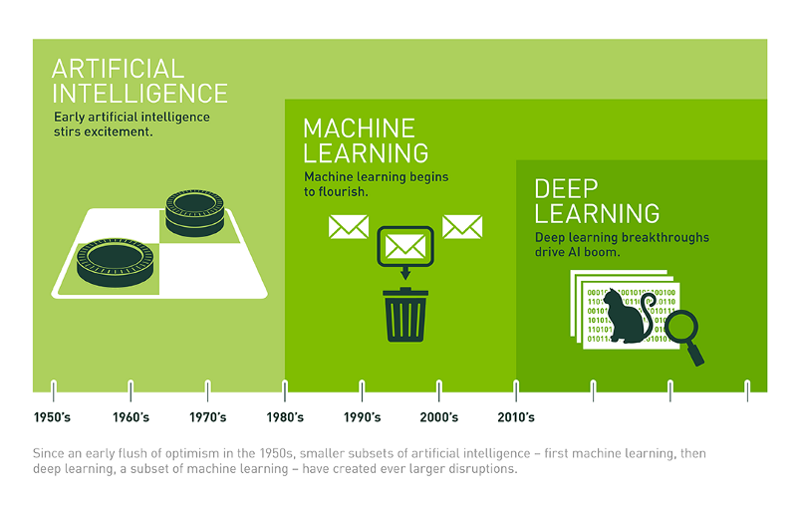

**Fig 1.1:** Relation between AI, ML and DL. [1]

Artificial intelligence is the intelligence displayed by machines in contrast to the natural intelligence displayed by humans and other animals. The field of AI is very broad and has been there for a long time. The foundation of AI was laid in 1950. [1]

Machine Learning is a subset of AI, where computers systems are trained without any explicit set of instructions. An example of an ML task is an email spam filter. The ML algorithm is fed with large number of labeled email dataset. The main task of the algorithm is to find features to differentiate ‘spam’ and ‘not spam’. Then a set of unlabeled data is fed to the algorithm for prediction.

Deep Learning is a subset of ML, which is based on neural networks. Neural networks are conceptual model of the brain which has been around since 1950 but was largely ignored until recently. Deep neural networks, i.e. more than 3 layers, are associated with deep learning. Deep learning also comprises of variants of neural networks such as CNN and RNN.

## MOTIVATION

The learning process for a neural network is implemented by the backpropagation algorithm. This algorithm depends on the connections between successive layers, activation function for each layer and loss function of the neural network. The main task of this algorithm is to update the trainable parameters of the neural network. This process is also called as optimization. There are several optimization methods which have been implemented. A clear understanding of the performance of various optimization algorithm is necessary.

## OBJECTIVES

The main objectives of the project would be:

* To create a library in Python to implement fully connected deep neural networks.
* To classify Iris flower dataset using an MLP.
* To compare the performance of various gradient based optimization methods such as GD, SGD, Nestrov’s Accelerated Momentum, AdaGrad, RMSProp, and Adam.

## ORGANIZATION OF THE REPORT

This project report contains 6 chapters. This introduction describes about the relation between AI, ML and DL and its evolution over the years. It also describes the motivation and objective of this project.

* Chapter 2 describes the literature survey which was undertaken in order to get the project started. It describes an ANN, training in ANN and different optimization algorithms.
* Chapter 3 describes the implementation details of the project. It provides information about the dataset and the implementation of the neural network library.
* Chapter 4 describes the results achieved using various optimization methods and some analysis based the results. It also compares different optimization methods which are implemented.

# LITERATURE SURVEY

## ARTIFICIAL NEUTRAL NETWORK

An Artificial Neural Network is an information processing paradigm and a computing system which is inspired by the way the biological nervous system, including the animal brain processes information. It consists of a large number highly interconnected processing units (also called neurons) which work together to achieve a common objective. Similar to people, ANNs learn by example. The advantageous features of ANNs are adaptive learning, self-organization, and real-time operational capability.

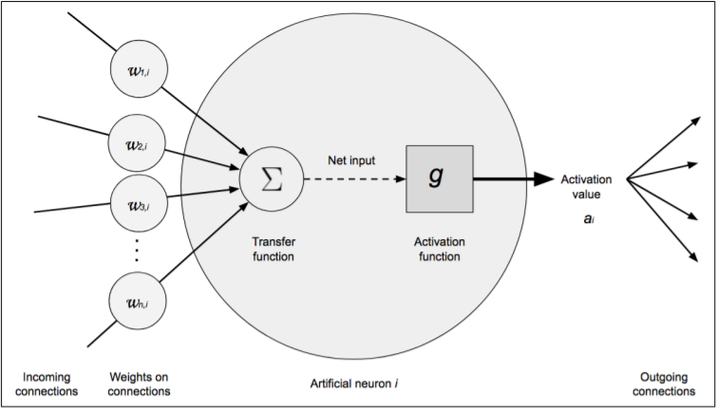

**Fig 2.1:** A perceptron model showing inputs, weights, net-sum and activation function [2].

A perceptron is a neuron where the inputs are associated with weights. It consists of 4 parts:

* Input values, which are inputs given to the neuron.
* Weights and bias, which represent the amount of importance each input value holds in determining the result
* Net Sum, which is the sum of all the input and weight product values.
* Activation Function, which is a node that has a normalising effect on the neuron output, thus helping to prevent a large value as output after moving through many layers of a neural network. It also helps the neuron to learn the non-linear and linear decision boundaries. *Sigmoid*, *ReLU* (Rectified Linear Unit) and *Tanh* are the most widely used activation functions.

ANNs can be extended to have many layers of different dimensions and structure. **Deep learning**, a part of ML, deals with such neural networks. CNNs and RNNs are examples of deep learning algorithms.

A simple feed-forward neural network consists of a single input layer, one or more hidden layers and an output layer, where each layer is made up of multiple neurons.

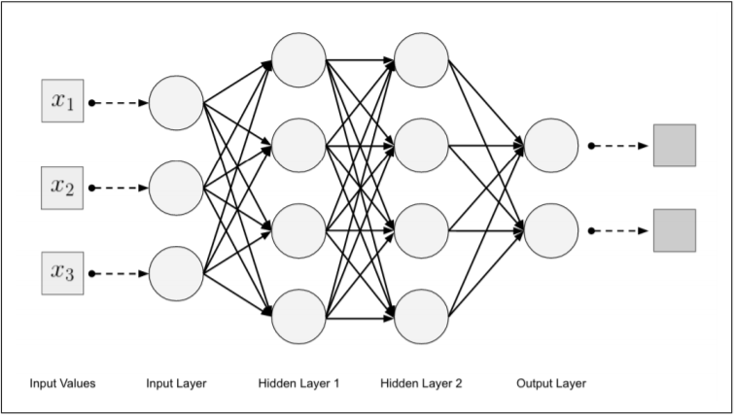

**Fig 2.2:** A feed-forward neural network with 2 hidden layer [2].

## TRAINING A NEURAL NETWORK

Training in an artificial neural network is done using Backpropagation algorithm. The input to the algorithm is the dataset and the output is a trained neural network i.e. a neural network with updated weights. The output vector obtained after each forward movement is called the cost vector. A loss function (also called as cost function or error function) is used to find the error between the cost vector and theoretical values.

The matrix which stores all the first order partial derivatives is called the Jacobian matrix (denoted by ‘J’). The Jacobian depends on the input to the neuron and the partial derivative of the loss function (denoted by ‘E’) with respect to the net-sum (denoted by ‘net’). The partial derivative is also called as gradient (denoted by ‘δ’, delta).

The gradient for the output layer ‘*j*’ is as follows [3]:

$$δ_{j}= \frac{∂E}{∂{net}_{j}} \frac{∂{net}_{j}}{δw_{ij}}$$

The gradient for the hidden layer ‘*j*’ is as follows [3]:

$$δ_{j}= \sum_{k ϵ all neurons in the next layer}{\frac{∂E}{∂{net}_{k}} \frac{∂{net}_{k}}{∂{net}_{j}}}$$

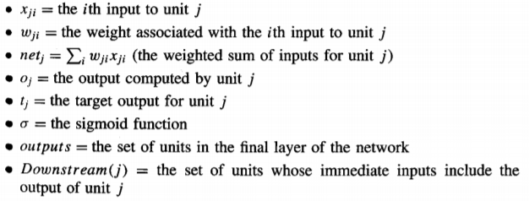

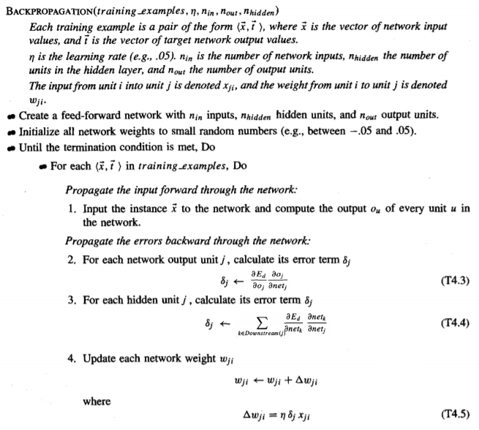

**Fig 2.3:** Backpropagation algorithm [3]

## OPTIMIZATION METHODS

Optimization methods are used to minimize the error of the loss function. This is used when the weights and biases are updated in the backpropagation algorithm. Gradient based optimization method is the most popular optimization method. It is a first order optimization methods.

### GRADIENT DESCENT (GD)

Gradient descent is an optimization algorithm used to find minima of a function. It is used to update weights on a neural network. Gradient descent is the optimization method used in *Fig 2.4.* The weights are updated only after calculating gradient (δ) for all records of the dataset.

### STOCHASTIC GRADIENT DESCENT (SGD)

The drawback of gradient descent is that it is time consuming as the weights are updated only after the gradient (δ) is calculated for all records in the dataset. If the size of the dataset is ‘n’, the time complexity of gradient descent is *O(n).*

Stochastic gradient descent is a variant of gradient descent algorithm. The weights are updated after calculating the gradient of each record in the dataset. The time complexity decreases to *O(1)* in SGD. If the dataset is very big, it is sometimes inefficient to calculate gradient (δ) for each record. The solution for this problem is to implement a *mini-batch SGD*. A batch comprises of certain number of records. The weights are updated after calculating gradient (δ) for each batch instead of each record.

The update rule for SGD is same as GD and is as follows:

$$w_{t+1}= w_{t}- αJ(w_{t})$$

In the above equation ‘ $J\left(w_{t}\right)= \frac{∂L}{∂w_{t}}$’ is the Jacobian and ‘α’ is the learning late. Over the years, many variant of SGD were developed to make the optimization more efficient.

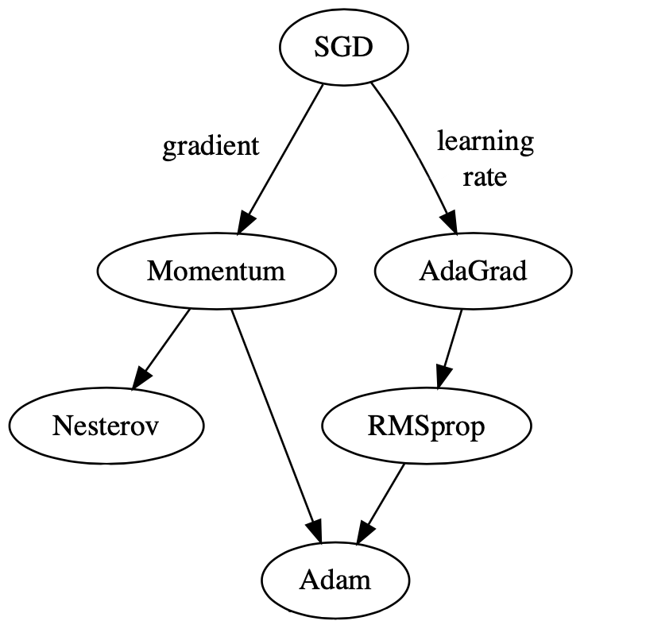

**Fig 2.4:** Evolution map of optimizers. [4]

### MOMENTUM & NESTROV'S ACCELERATED MOMENTUM (NAM)

The concept of *Exponential Weighted Moving Average* (EWMA) [5]is used to update the weights in gradient descent with momentum. EWMA is used to smoothen the minimization process and helps reach the minima efficiently. The update rule for gradient descent with momentum is as follows:

$$V_{t}= βV_{t-1}+\left(1-β\right)J(w_{t})$$

$$w_{t+1}= w_{t}- αV_{t}$$

The equation for ‘ $V_{t}$’ is EWMA of the current and past gradient and is initialized to 0. It is observed that $V_{t} and β$ are analogous to *Velocity* and *Momentum* in *Physics.*

Nestrov’s Accelerated Momentum (NAM) [6] is slightly different from the vanilla momentum update method. Here, EWMA of *projected gradients* are calculated to further minimize oscillations while reaching the minima. The *Velocity* update rule is as follows:

$$V_{t}= βV_{t-1}+\left(1-β\right)J(w_{t }- αV_{t-1})$$

The default value of *β* is 0.9.

### ADAGRAD

The vanilla SGD has a uniform learning rate for the complete training process. It is better to have a larger learning rate during the beginning and smaller learning rate during the ending of the training process. AdaGrad divides the learning rate by the square root of cumulative sum of second order gradients. A small constant ‘*ε*’ (epsilon), also called as *fuzz factor*, is added to avoid division by zero. The constant ‘*ε*’ ranges from *e­-6* to *e-8*. The update rule is as follows [4]:

$$S_{t}= S_{t-1}+{J(w_{t})}^{2}$$

$$w_{t+1}= w_{t}- \frac{α J(w_{t})}{\sqrt{S_{t}}+ ε}$$

The term ‘*S*’ is initialized to 0. The default value of ‘*α*’ is 0.01 and ‘*ε*’ is e-7.

### RMSPROP

In AdaGrad, it was observed that the learning rate always decreases. RMSProp is an extension of AdaGrad, where EWMA is used instead of cumulative sum of second order gradients. The ‘ $S_{t}$’ update rule is as follows [4]:

$$S_{t}= {βS}_{t-1}+{(1-β)J(w_{t})}^{2}$$

Here, the constant ‘*β*’ is the decay factor. It ranges from 0.9 to 0.999.

### ADAM

An efficient optimization method can be derived from the combination of momentum based gradient descent and RMSProp. Adam is one such optimization method where EWMA of first order gradients (from momentum based GD) and second order gradients (from RMSProp) is considered. The terms ‘ $V_{t}$’ and ‘ $S_{t}$’ are called as first order moments and second order moments respectively [4].

EWMA fails to accurately predict gradient values initially due to initialization of ‘ $V_{t}$’ and ‘ $S_{t}$’ to 0. This can be prevented by adding a bias correction.

$$w_{t+1}= w_{t}- \frac{α V_{t}^{'}}{\sqrt{S_{t}^{'}}+ ε}$$

$V_{t}^{'}= \frac{V_{t}}{1- β_{1}^{t}}$ $S_{t}^{'}= \frac{S_{t}}{1- β_{2}^{t}}$

$V_{t}= β_{1}V_{t-1}+\left(1-β_{1}\right)J(w_{t})$ $S_{t}= β_{2}S_{t-1}+\left(1-β_{2}\right){J(w_{t})}^{2}$

The terms ‘ $V_{t}$’ and ‘ $S_{t}$’ are initialized to 0. The constants $β_{1}$ and $β_{2}$ are momentum and decay factor respectively. They are initialized to 0.9 and 0.999 respectively. The terms $V_{t}^{'}$ and $S_{t}^{ '}$ are bias correction terms.

# IMPLEMENTATION DETAILS

## DATASET DETAILS

The popular ‘*Iris flower dataset*’ [7] is used in this project. The dataset consists of 150 records and 6 columns namely; *dataset order, sepal length, sepal width, petal length, petal width and species.*

The class variable is *species* with labels *Iris* s*etosa, Iris virginica* and *Iris versicolor.* The dataset consists of 50 records for each species. The independent variables are *sepal length, sepal width, petal length, and petal width.* They are measured in centimeters. One class is linearly separable from the other 2, but other 2 are not. Hence a perceptron cannot be used for this classification problem.

## NEURAL NETWORK IMPLEMENTATION

A library analogous to *Keras API* is implemented in *Python.* The library is named as ‘*neural_networks*’. The sub-modules are ‘*preprocessing*’, ‘*activation*’, ‘*loss*’, ‘*training*’ and ‘*optimization*’.

The ‘*preprocessing*’ sub-module consists of a function to perform one-hot encoding. The sub-modules ‘*activation*’ and ‘*loss*’ consists of activation functions and its derivatives, and loss function and its derivatives respectively. The ‘*training*’ sub-module provides functions to initialize vectors and calculate gradient (δ).

The ‘*optimization*’ sub-module consist the implementation of various gradient based optimization methods such as GD, SGD, NAM, AdaGrad, RMSProp and Adam.

The ‘*neural_networks*’ library consists of a class to create the neural network. It provides functionality to add multiple layers with variable neurons. The input layer is trivial and is not to be mentioned in the code. Instead the first hidden layer takes the dimension of the dataset as one its parameters, similar to *Keras API.* The library provides various activation functions such as *tanh, sigmoid, ReLU, and softmax.* The loss functions available are Mean-Square Error (MSE) and Cross-entropy.

As shows in *Fig 3.1*, Model class has 5 methods. After creating the object, multiple dense layers can be added sequentially. The input size has to be mentioned for the first layer. The last layer is the output layer and its size should be equal to the number of classes in the dataset.

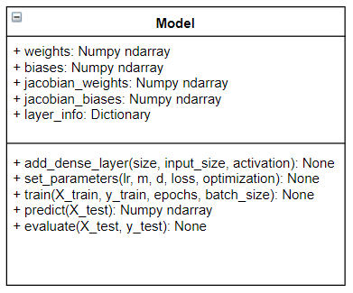

**Fig 3.1:** Class diagram for Model class

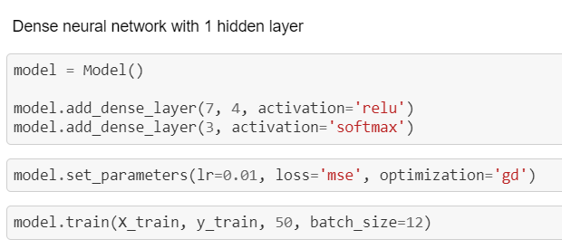

**Fig 3.2:** Code for creating a simple feed-forward neural network.

As shown in *Fig 3.2,* the parameters of ‘*set_parameters*’ method has ‘*’lr*’ as the learning rate, ‘*loss*’ as the loss function and ‘*optimization*’ as the optimization function. Additionally parameters are ‘*m*’ as momentum or beta1 and ‘*d*’ as decay factor beta2. The available loss functions are:

* MSE – ‘*mse*’
* Cross-entropy – ‘*cross_entropy*’

The available activation functions are:

* Tanh – ‘*tanh*’
* ReLU – ‘*relu*’
* Sigmoid – ‘*sigmoid*’
* Softmax – ‘*softmax*’

The available optimization functions are:

* Gradient descent – ‘*gd*’
* Stochastic gradient descent – ‘*sgd*’
* Nestrov’s Aceelerated Momentum – ‘*nam*’
* AdaGrad – ‘*adagrad*’
* RMSProp – ‘*rmsprop*’
* Adam – ‘*adam*’

# RESULTS AND ANALYSIS

## GRADIENT DESCENT AND STOCHASTIC GRADIENT DESCENT

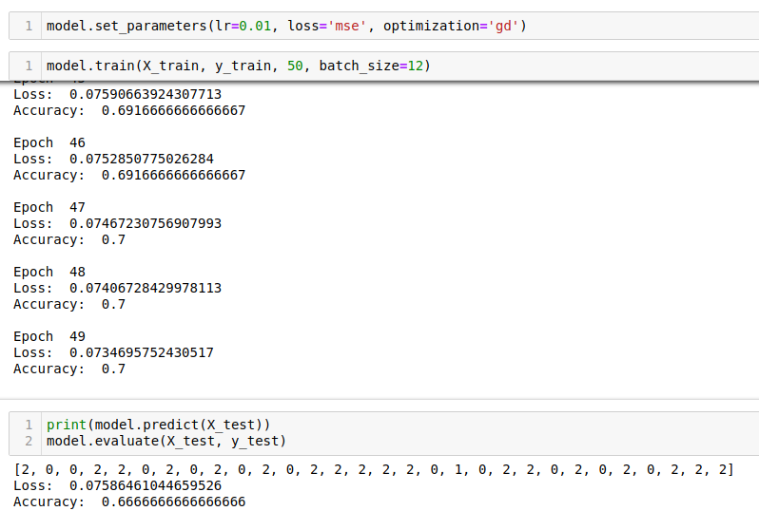

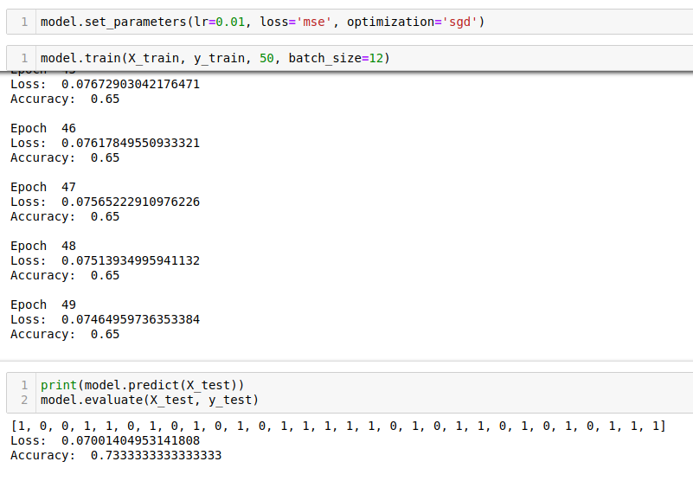

**Fig 4.1:** (top) GD and (bottom) SGD

The effect SGD is generally observed when the size of the dataset is large. Hence, using SGD over GD for ‘*Iris flower dataset’* will not change the performance. The training accuracy of 0.7 and 0.65, and testing accuracy of 0.66 and 0.73 was achieved by using GD and SGD respectively.

## NESTROV’S ACCELERATED MOMENTUM

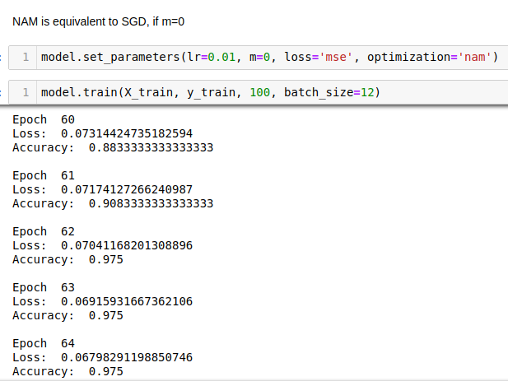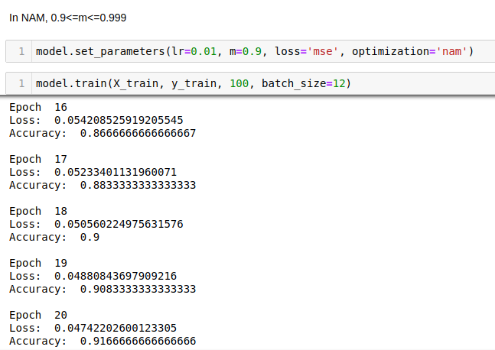

**Fig 4.2:** (top) SGD and (bottom) NAM

NAM is equivalent to SGD, if the value of ‘*m*’ is 0. Both SGD and NAM reach high accuracy after certain epochs. SGD reached 90% accuracy at 64th epoch, whereas NAM reaches it in 18th epoch. Hence, NAM converges faster.

## ADAGRAD, RMSPROP AND ADAM

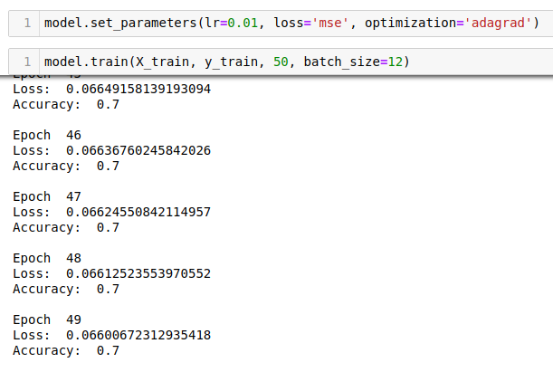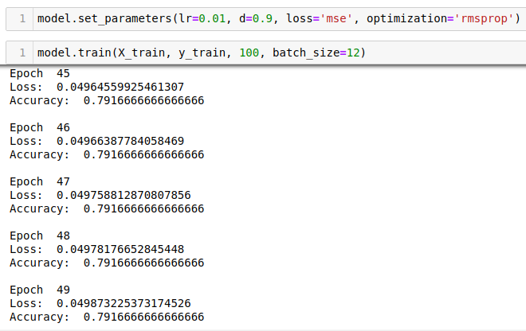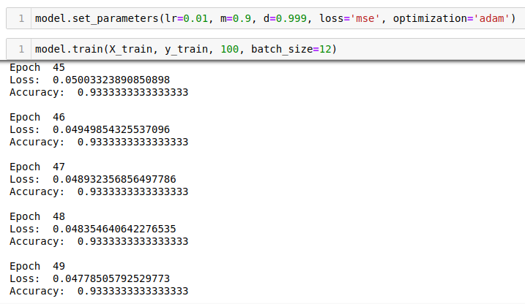

**Fig 4.3:** (top) AdaGrad, (middle) RMSProp and (bottom) Adam

Adam is an extension of RMSProp and RMSProp is an extension of AdaGrad. After 50 iterations, accuracy of 0.7, 0.79 and 0.93 is achieved by using AdaGrad, RSProp and Adam respectively. Hence, Adam converges faster than the others.

# CONCLUSION

The objectives of this project was to develop a library, similar to *Keras API*, for implementing neural networks and to compare different optimization methods. A clear understanding of the training process of the neural network was necessary to develop the library. Different update rules were used by various optimization methods to make the learning process more efficient.

It was observed that for small dataset, the performance of GD and SGD were same. Adding momentum factor during the update rule for NAM helped the neural network converge faster when compared to SGD. Adam performed better than AdaGrad and RMSProp due to the consideration of both first order moments and second order moments.

The future implementation would include newer optimization methods such as Nadam, AMSGrad and AdaMax. The concept of *Regularization* can be introduced to increase the efficiency of the neural network.

# REFERENCES

|  |  |
| --- | --- |
| [1] | "Deep learning weekly piece: the differences between AI, ML, and DL," Towards Data Science, 10 June 2017. [Online]. Available: https://towardsdatascience.com/deep-learning-weekly-piece-the-differences-between-ai-ml-and-dl-b6a203b70698. |
| [2] | J. Patterson and A. Gibson, Deep Learning: A Practitioner’s Approach, O’Reilly Media, 2017. |
| [3] | T. M. Mitchell, Machine learning, McGraw Hill, 2017. |
| [4] | "10 Gradient Descent Optimisation Algorithms," Towards Data Science, 22 November 2018. [Online]. Available: https://towardsdatascience.com/10-gradient-descent-optimisation-algorithms-86989510b5e9. |
| [5] | A. Ng, "Exponentially weighted averages - Optimization algorithms," Coursera, [Online]. Available: https://www.coursera.org/lecture/deep-neural-network/exponentially-weighted-averages-duStO. |
| [6] | CS231n, "Convolutional Neural Networks for Visual Recognition," Stanford University, [Online]. Available: http://cs231n.stanford.edu/. |
| [7] | R. Fisher, "UCI Machine Learning Repository," [Online]. Available: http://archive.ics.uci.edu/ml/datasets/Iris. |