
Topic Choosen: 1. Critically evaluate the underlying architecture of an Enterprise Resource Planning (ERP) system with which you are familiar. Compare this to recent technological developments (e.g., SAP HANA or Blockchain). Finally, using appropriate evidence, comment on which industries might be disrupted by these emerging technologies, and where traditional technologies are likely to remain prevalent.
Title: From Monoliths to Metaverse: How Blockchain and SAP HANA Are Redefining ERP Architecture in the Era of Decentralized Business
MSc BAC Jan 2025; MS834 - Business Information Systems.

BIS-Group 1
Name | Registration Number
Roshan LalitChand Thakur | 202565681
Rahul Shantha Kumar Gowda | 202570205
Huzaifa Abdul Rahman | 202578870

Table of Contents
- Introduction & Background.
- Traditional ERP Architecture & Challenges.
- Emerging ERP Technologies: SAP HANA and Blockchain.
- Comparative Evaluation.
- Industry Disruption Analysis.
- Theoretical Framework (TOE & Porter).
- Strategic Recommendations.
- Conclusion.
- References .

1. Introduction & Background
ERP systems have over the years played an important infrastructure role in organizations to bring together and coordinate major business functions including finance, supply chain, human resource, and production. ERP systems can be effective because they can centralize data into the single data-based platform, maintain the integrity of data, operational efficiency, and strategic decision-making. Historically, such systems have been dependant upon monolithic architectures e.g. built around functional modules and based on centralized databases and focused on efficiently managing internal processes.
But the typical ERP systems such as SAP ECC, Oracle e-business Suite, and Microsoft dynamics ax are no longer fit in the contemporary floating, information-based, and de-centralized business scenario. Such systems are usually based on batch processing and this delays data availability, and does not allow real-time decisions. Furthermore, they possess inflexible protocols and advanced tailoring that make them inflexible and not easy to scale, hence businesses cannot innovate or be responsive to any dynamics in the market. Both system upgrades and migrations tend to be accompanied by a lot of risk, cost, and disruption to operations.
To address these shortcomings, companies are shifting to newer technologies that provide agile, visibility and real-time insight. SAP HANA and Blockchain are two of the outstanding innovations transforming the ERP architecture.
SAP HANA refers to an in-memory database platform that combines Online Transaction Processing (OLTP) and Online Analytical Processing (OLAP) to conduct real-time analytics and operation insight. It also covers the latency and data silo problems of the traditional systems, processing massive data in real-time, helping in predictive decision-making and dynamic responsiveness.
Blockchain, in turn, proposes a ledger of its own, which is decentralized and has unparalleled levels of transparency, traceability, and data security. It is incorporated in ERP systems that enable trusted cooperation between different stakeholders without centralized control. Smart contracts streamline working processes and their observance, which is why Blockchain can be especially useful in the fields where trust, regulation and provenance are important, like the field of logistics, pharmaceutical industry and finance.
The intersection of SAP HANA with Blockchain is an indication of the decentralization trend in intelligent ERP ecosystems with the focus on flexibility, agility, and collaboration. These new generation systems strongly support the vision of digital transformation so that organizations can work more strategically in ever-growing and interdependent markets.
This report assesses how there has been a change in moving away to more sophisticated structures of non-monolithic ERP having a change to decentralized structures. It makes use of the Technology-Organization-Environment (TOE) approaches and the Porter model of Value Chain to gauge the strategic ramifications of this change, complemented fine-grained by industry-based cases studies and practitioner examples to demonstrate proximal influence and imminent predisposition.

2. Traditional ERP Architecture & Challenges (515 words)
Traditional ERP systems have served as the foundational enterprise backbone for over three decades, enabling organizations to centralize data and unify business processes. These systems are typically built on a three-tier architecture: a presentation layer, a business logic or application layer, and a centralized relational database layer. The presentation layer offers a user-friendly interface for end-users to interact with ERP functionalities. The application layer processes business logic, manages workflow, and validates transactions, while the centralized database consolidates data from various departments, ensuring consistency, accuracy, and data integrity across the enterprise.
ERP platforms such as SAP ECC, Oracle E-Business Suite, and Microsoft Dynamics AX exemplify this monolithic architecture. These systems integrate core modules—finance, procurement, production, and human resources—within a single database environment, offering standardized reporting and strong governance. This centralized model has historically enabled operational control, policy compliance, and informed decision-making.
However, traditional ERP systems face growing limitations in today’s fast-evolving digital landscape. A primary challenge is data latency caused by batch-based processing. Data updates often occur periodically—usually overnight—resulting in delayed analytics and reporting. This delay hinders real-time decision-making and restricts organizational agility in responding to market dynamics.
Scalability presents another significant limitation. Traditional ERP systems often require extensive customization tailored to specific organizational needs. While initially beneficial, these customizations complicate expansion efforts. Mergers, new market entry, or operational scaling demand costly and time-consuming system modifications, undermining flexibility and responsiveness.
Upgrades pose yet another difficulty. Legacy ERP architectures demand extensive planning, high resource commitment, and significant system downtime during updates. Even minor changes carry major risks, as seen in the failed SAP implementation at Lidl, which led to losses exceeding €500 million. Such cases highlight the hazards of modernizing rigid ERP systems without strategic foresight.
Flexibility is also constrained in traditional ERP architectures. Tightly coupled modules limit the ability to adapt to evolving business models, regulatory shifts, and technological innovations. Integration with external platforms—such as cloud services, mobile apps, or AI tools—often requires complex middleware and expensive workarounds.
In conclusion, while traditional ERP systems provided stability and data consistency, their architectural rigidity increasingly hinders innovation and adaptability. Persistent challenges such as latency, scalability, inflexible upgrades, and integration difficulties compel organizations to explore modern alternatives like SAP HANA and Blockchain. Recognizing and addressing these limitations is essential for enterprises aiming to thrive in the era of digital transformation and real-time responsiveness.
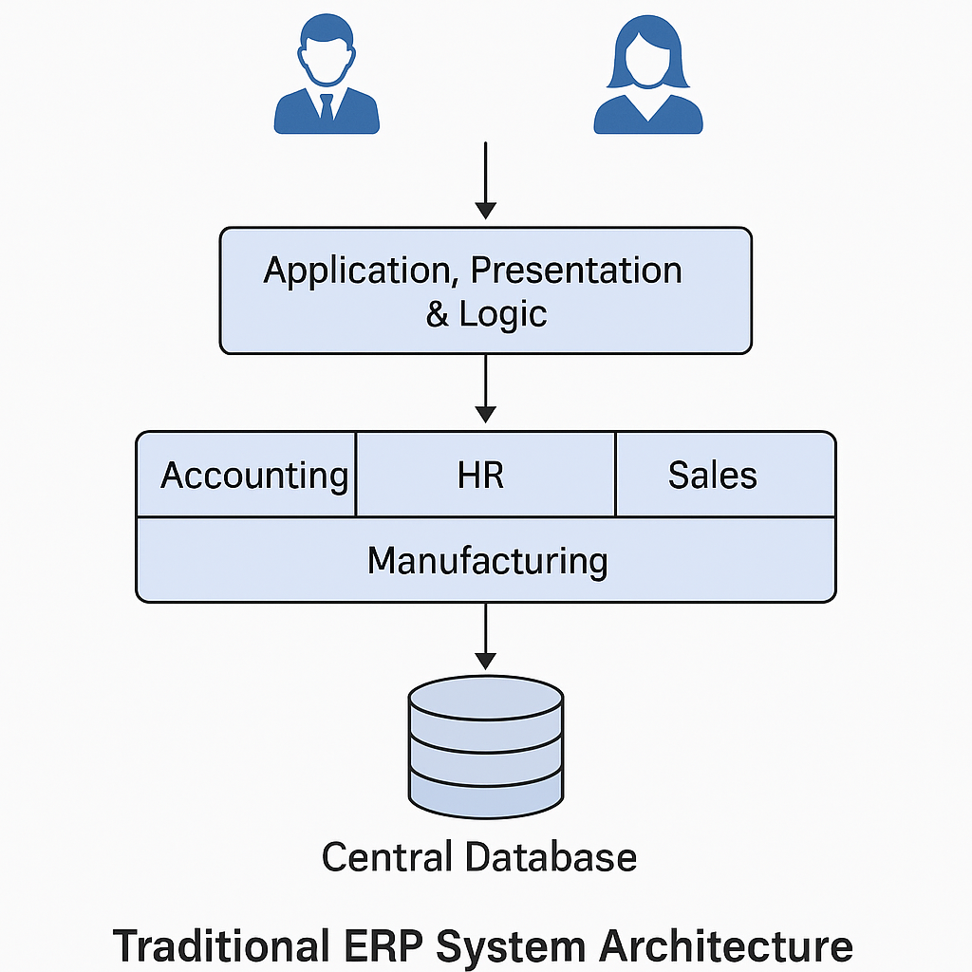

3. Emerging ERP Technologies: SAP HANA and Blockchain
Due to the mounting pressures of organizations to become more responsive and agile, the need of emerging technologies such as SAP HANA and Blockchain are redesigning the ERP architectures. These technologies enable the new generation of enterprise platforms that respond and behave intelligently to unforeseen events, because they directly respond to weaknesses of traditional ERP systems especially related to real-time data processing, scalability, transparency, and flexibility of systems.
One of the most advanced software solutions in ERP data management is the High-Performance Analytic Appliance of SAP, which revolutionises in-memory computing. In contrast to the disk-based systems, SAP HANA stores data in the Random Access Memory (RAM) that enables fast (almost immediate) access to data as well as performs real- time analytics. It integrates both Online Transaction Processing (OLTP) and Online Analytical Processing (OLAP), there is no need to have a separate data warehouse or analytics engine.
In addition to speed, SAP Hana employs columnar storage format of the data, which enhances query speed as well as data compression effects. This enables organizations to be able to perform high-end predictive modeling, and real-time reporting in a most efficient manner. SAP HANA is used by such companies as BMW to perform predictive analysis, and optimize operations, and Nestle that has integrated the platform to make its global supply chain more visible and responsive.
Blockchain on the contrary, adds trust to ERP, but it is decentralized. Being a distributed ledger technology (DLT), it makes sure that records of all the transactions are synchronized, unamendable, and auditable by all nodes engaged in it. Block chain is particularly applicable in such industry where multi party cooperation is usually necessary and where data integrity and transparency is essential.
One of the innovations by blockchain incorporated in ERP is smart contracts characterized by being auto-enforced agreements that necessitate the use of predetermined rules. The automation limits the number of manual parts reducing interventions, increasing compliance and reducing the number of transaction errors. Some logistics giants such as Maersk and FedEx also utilize blockchain to document secure shipment, and such platforms as IBM Food Trust enhance food supply in terms of transparency and safety.
But the two technologies have disadvantages in terms of implementation issues. SAP HANA has very intensive infrastructure and training requirements, and Blockchain also has a scalability problem as well as a regulatory and energy consumption issue based on the consensus system employed.
Nevertheless, both SAP HANA and Blockchain are revolutionary ERP innovations despite the existence of these hurdles. Combinedly, they empower companies to step out of monolithic systems and provide smart, observable and swift platforms. The adoption of such next-generation ERP capabilities by early adopters will result in highly competitive advantages and the creation of robust and data-driven operations.
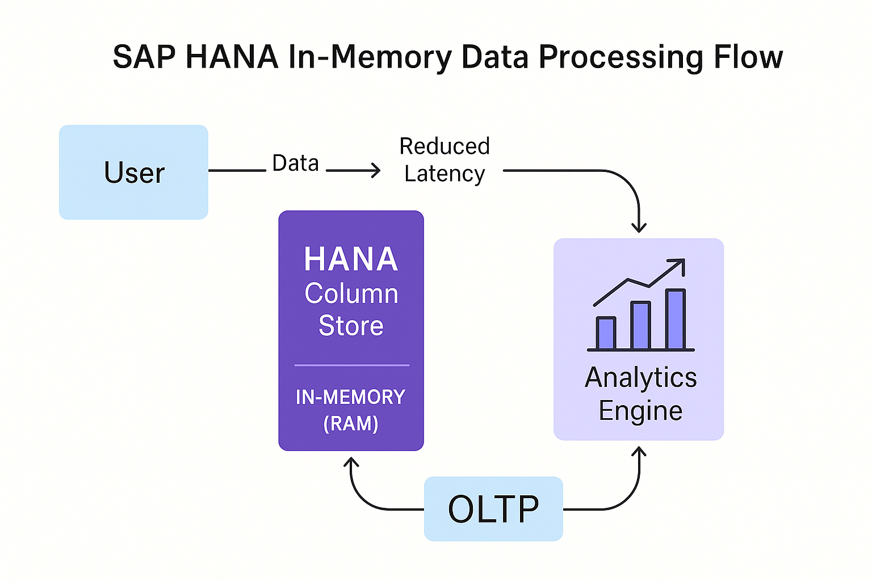

4. Comparative Evaluation
Comparative study of traditional ERP systems, SAP HANA and ERP architectures over Blockchain shows a great discrepancy in the structure, functionality and strategic implications and these are the main factors to be taken into account when an organization is in process of undergoing a digital transformation.
Conventional ERP applications like the SAP ECC, Oracle E-Business Suite and Microsoft Dynamics AX, are monolithic in that their designs are centralized. They are deployed in a three tier architecture representation presentation, application and database, so that they are consistent across the levels, well integrated and accurate in transactions. The systems are most powerful in standardization of processes in large enterprises giving them stability and governance. But they are quite rigid and this severely impedes agility. It is expensive to customize, updates can be tricky and the process of batch processing leads to late delivery of real-time information. Such constraints exclude the option of an organization scaling up or responding in a timely manner to market shifts, as in the case of high-profile migration failure associated with Lidl and SAP.
SAP HANA, in comparison, reinvents ERP by integrating transactional and analytical loads on an in-memory platform in real time. Its columnized storage and simplified data models allow this to speed query performance by supporting advanced analytics and diminishing latency. Real-time decision-making, increased scalability, and responsiveness of operations benefit organizations. Nevertheless, it involves heavy financial investment in infrastructure, talent and proper migration of existing systems.
ERP systems that use blockchain bring in a decentralized method of data integrity and trust. Blockchain does not centre the authority in one place, where all the transactions are authorised by a distributed ledger and smart contracts. As a result, transactions are not immutable; they are synchronised across multiple stakeholders. This model advances transparency, automation of hefty procedures, and is operating in a multi-party ecosystem, such as logistics and finance. However, the scalability issue, as well as integration complexity and a changing regulatory landscape, are not overcoming obstacles to adoption.
To conclude, recent development of SAP HANA and Blockchain can be described as transformative (as compared to traditional ERP systems), in regard to the paradigm of agility, transparency, and innovation. Decision on which of these architectures to use should depend on the preparedness, strategy, industry factors and digital maturity of an organization.
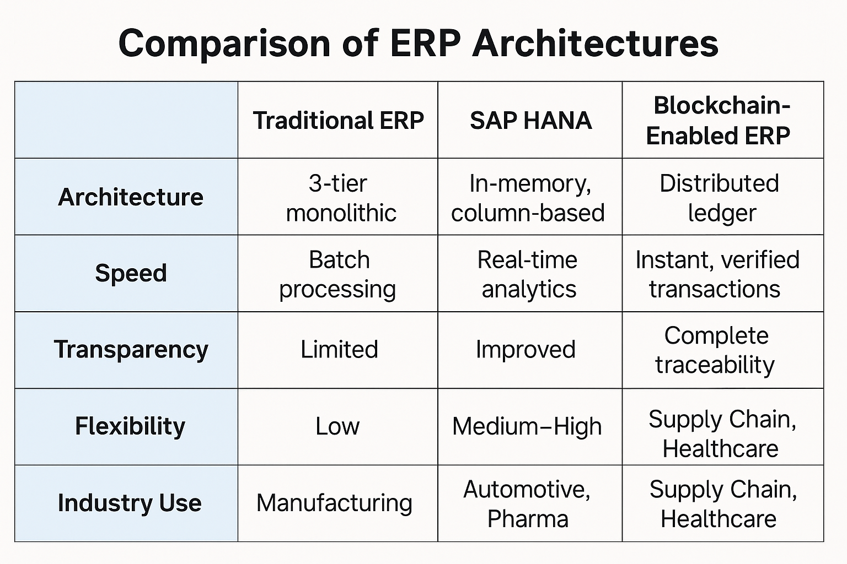

5. Industry Disruption Analysis
The SAP HANA and Blockchain technology combination with ERP technologies is making a major disruptive impact to those industries where real-time analytics, transparency, efficiency of the operations, and a collaborative multi-party ecosystem are critical. This interruption is based on the fact that these technologies have been able to address legacy concerns of traditional ERP solutions, including data latency, narrow scalability, opaqueness, and complicated inter-organizational communications.
Regulatory compliance and strict quality requirements spurring the need of highly traceable products in the world of pharmaceutical industry. With Blockchain, ERP solutions are transforming this industry by storing transparent, immutable and validatable records across the supply chain and trying to minimize the chances of counterfeit drugs because guarantees adherence to compliance standards. Such firms as Pfizer and Merck also focus more on blockchain solutions in order to ensure the authenticity of their product, to ease the procedure of regulatory reporting and to increase customer confidence.
SAP HANA is also revolutionizing the retailing industry with real- time analytical prowess. Retailers use the analysts on demand to deliver dynamic pricing, one-on-one-marketing campaign, optimization of inventory, and personal response customer experience. As an example, Walmart leverages SAP HANA to realize end-to-end inventory forecasting and replenishment processes, which provide potential to make real-time decisions on thousands of sites across the world. At the same time, the use of Blockchain allows transparency and traceability of sourcing, which help enormously to determine consumer reliability in product authenticity and compliance with ethical standards.
Logistics and transport industries are also disturbed by ERP architectures with Blockchain. FedEx, Maersk, and other organizations have started using blockchain-based smart contracts to automate documentation, payment, and regulatory compliance of the shipments, alleviating manual management, delays in processing, and expenses to a significant extent. Increased traceability will help diminish fraud and allow the global supply chains operation to have better efficiency so that it can respond quickly in case of any disruption and market changes.
Both technologies provide large disruption to financial services. The benefits of real time offered with SAP HANA allow instant risk assessment, fraud detection, and regulatory compliances reporting that are of importance to financial institutions that experience high volatility in regulatory regulations and the market environment. Blockchain also transforms finance through accessible and clear multi-party transactions, which makes the cross-border transaction of payments, settlements, and securities trading extremely easy. The efforts to build payment networks with blockchain technology like JPMorgan Quorum and the Ripple blockchain payment network are cases of such changes.
Although there are clear benefits, such areas as government and heavy manufacturing are behind in the adoption of ERP technologies. Integration of advanced ERP solutions is hindered by budgetary issues, legacy relationships, inflexible regulatory regimes and organisational complexity. However, pressures of regulation, market competition and the demands of consumers, who expect the increasing transparency, speed and efficiency in operations, will probably drive even these more traditional sectors that are slower to adopt changes.
To conclude, it is apparent that both SAP HANA and Blockchain are immensely disruptive technologies supplying flexibility, openness, and real-time responsiveness, which cannot be neglected in a modern, data-driven marketplace. Major companies that use these creative ERP technologies strategically will gain a better competitive position, operation efficiency, and resilience in the changing digital economy in which they operate.

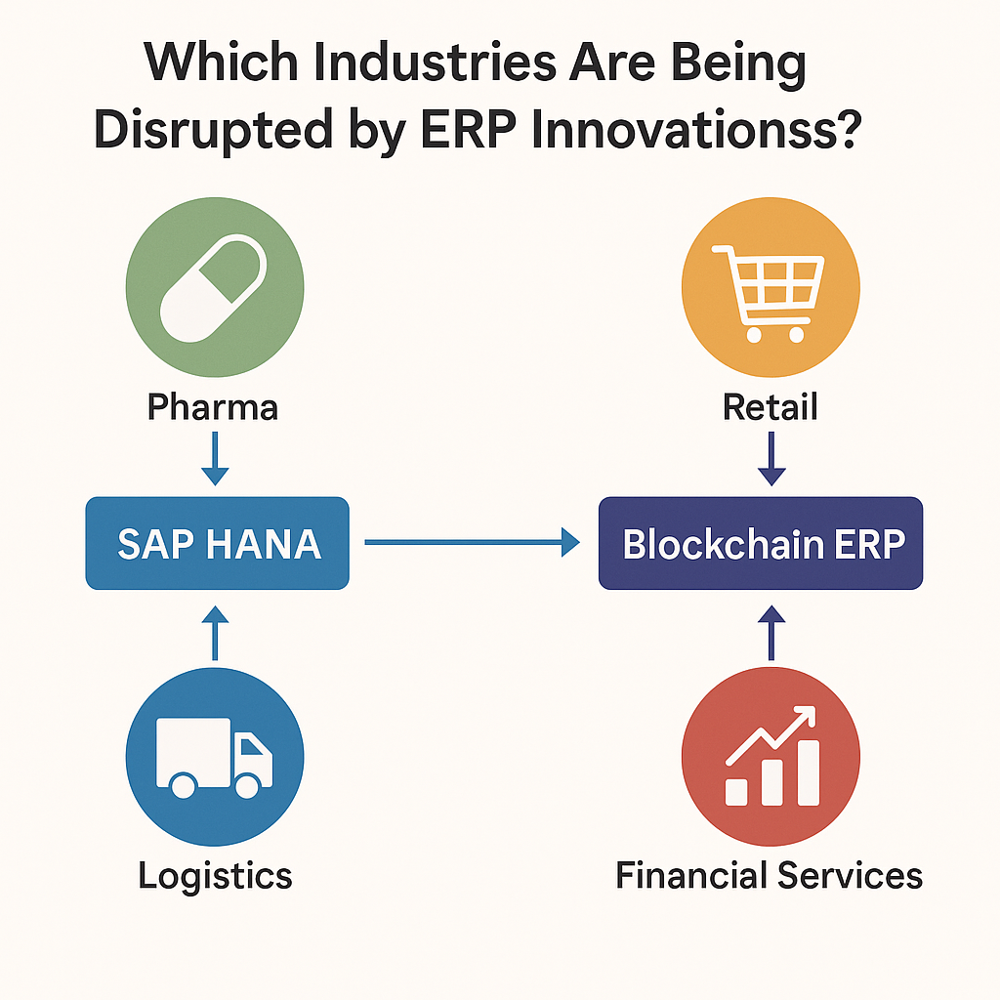

6. Theoretical Framework
Technology-Organization-Environment (TOE) framework proposed by Tornatzky and Fleischer (1990) can be of great use in understanding the dynamics of adopting and implementing the new ERP tools such as SAP HANA and Blockchain. TOE represents technology adoption affected by three main contexts, namely, technological, organizational, and environmental.
Technological context determines relative advantage, complexity and compatibility of new solutions. The real-time analytics functions of the SAP HANA Data Warehouse and the decentralized visibility of the Blockchain solution make obvious strong benefits of such technology over the traditional ERP systems, where the problems of latency and inflexibility and transparency shortfalls are addressed successfully. They however are quite complex and therefore require large investments in dedicated infrastructure, skills and thoughtful migration plans, which pose significant barriers to adoption.
Organizational context focuses on internal factors of preparedness such as commitment of the managers, availability of resources and technicalities. Firms with best financial capability, strategic leadership involvement and no lack of IT competency would have high level of adoption, they have incorporated high level of ERP technologies in operation structure.
Adoption decisions are also determined by environmental context factors like the pressure of competition, regulatory factors, and the requirements of the industry. Strict regulatory compliance and high levels of transparency requirements as well as stiff competition are becoming the distinctive features of industries (e.g., pharmaceuticals, logistics, and finance), where innovative ERP technologies are currently being adopted to ensure competitiveness.
The key takeaway about TOE assumption integration is that it includes the various dimensions that must be considered when implementing an ERP technology-related solution, in particular, the vulnerability of evaluating the impact of the technology on the environmental, organizational, and technological levels.
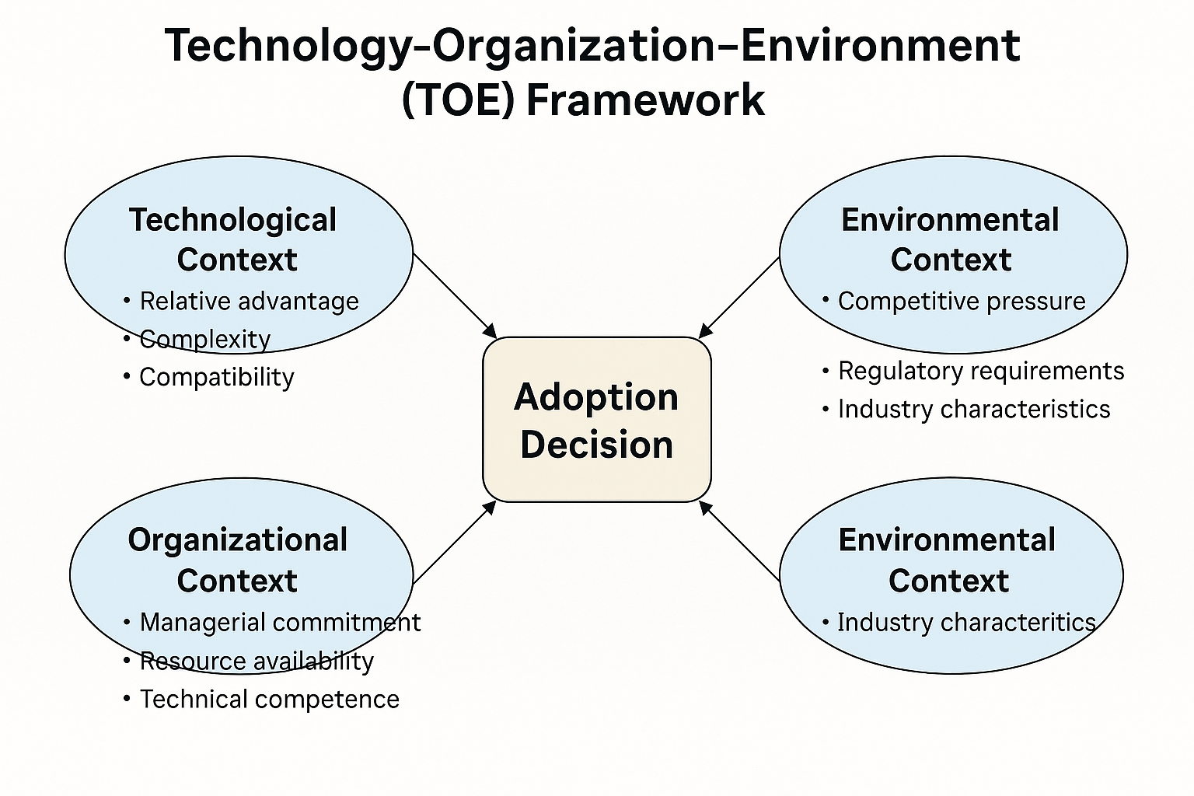

7. Strategic Recommendations
Organizations that want to successfully migrate their traditional ERP system to new kinds ERP architecture like SAP HANA and Blockchain must implement changes phased and strategically.
To begin with, practicing modular integration is the key in which organizations will gradually integrate SAP HANA real-time analytics and Blockchain decentralized trust mechanism into their current ERP frameworks. This phased approach initiates few transition risks, fast returns of investments, and ease of internal acceptance.
Second, the organizations are advised to implement high-value use cases since this will show direct value. As an example, a technology investment can be proven fast through supply chain transparency by means of Blockchain or via SAP HANA analytics predictive maintenance, which can show them what returns might appear.
Thirdly, it is necessary to invest in the capability building in the digital sphere. Companies need to maintain a continuous relationship to train staff, hire professional talent, and nurture the relationships with IT vendors offering advanced ERP packages and universities to maintain a high level of competency within sophisticated ERP software solutions.
Also, effective governance structures should be put in place that will help in inclusion of new technologies and ensure that privacy of data is maintained, interoperability and compliance with stipulated policies.
Last but not least, it is important to constantly monitor new innovations in technology and the industry in order to be agile and have organizations take advantages of changing innovations in ERP and sustain competitive edge.
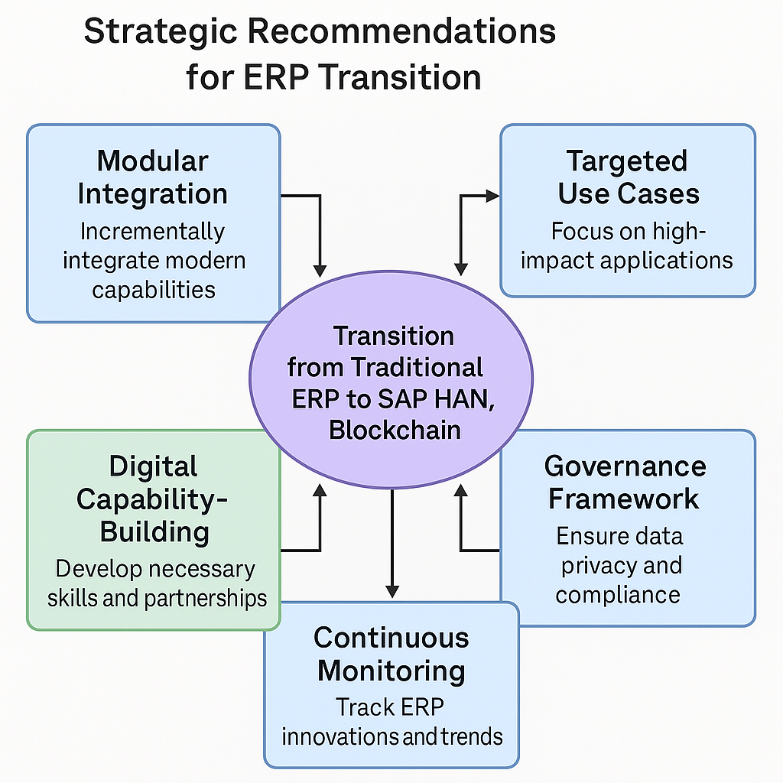

8. Conclusion
The emerging trend of migrating the ERP systems that are based on older modes of monolithic architectures to the decentralized intelligent architecture enabled with SAP HANA and Blockchain is transforming enterprise operations and strategies in significant ways. The conventional ERP systems, although historically effective in standardization of business practices and enforcement of transactional integrity, are becoming insufficient to address current demands of the business. Such restrictions including data latency, scalability and lock-in integration models are highly limiting to organizational agility, real-time responsiveness, and innovation potential.
The recent advances in ERP, technology are specifically focused to correct these deficiencies, by providing unsurpassed real-time analytics capabilities, operational clarity and collaboration trust within highly complex and adaptive organizational ecosystems. The in-memory processing power of SAP HANA eradicates conventional ERP latency concerns and helps to make real-time insights and flexible decision-making. In the meantime, Blockchain transforms ERP surroundings into secure, transparent, and decentralized data transactions via distributed ledgers and automated smart contracts.
The future incorporation of these new technologies in a strategic manner makes an organization well placed in such data driven competitive markets. Nevertheless, cautious execution, post-training proficiency, and practical governance systems are also crucial towards effective integration of technology. These complex considerations are highlighted by the Technology-Organization-Environment (TOE) framework where a combination of technological capabilities, organization preparedness, and external market demands are considered.
Finally, the upgrading of ERP architectures of higher order is the factor that companies need to consider when wishing to be competitive and innovative in the global economy of the world, mostly embracing digitalization. Incorporating strategic use of these ERP developments organizations will be able to achieve large efficiencies in their operations, improved market flexibility as well as sustainable competitive advantages due to strategic balance between technological innovations, organisational capacity building and responsiveness to the environment which are the key elements of successful utilisation of this emerging technological advancement.

References
Bourgeois, D.T., Smith, J.L., Wang, S. and Mortati, J., 2019. Information Systems for Business and Beyond. Saylor Academy. Available at: https://open.umn.edu/opentextbooks/textbooks/information-systems-for-business-and-beyond
Deloitte, 2020. Intelligent ERP: The Rise of Smart Enterprise Systems. Deloitte Insights. Available at: https://www.deloitte.com/us/en/services/consulting/articles/erp-strategy-and-implementation.html
Ernst & Young, 2021. Why Blockchain will Reshape the ERP Landscape. EY Global Blockchain Report. Available at: https://www.ey.com/en_gl/services/blockchain
Gartner, 2021. Magic Quadrant for Cloud ERP for Product-Centric Enterprises. Gartner Research. Available at: https://www.gartner.com/en/documents/4005693
Hofmann, E. and Rüsch, M., 2017. Industry 4.0 and the current status as well as future prospects on logistics. Computers in Industry, 89, pp.23-34. doi:10.1016/j.compind.2017.04.002
IBM, 2022. IBM Food Trust: Creating Transparency in the Food Supply Chain. Available at: https://www.ibm.com/blockchain/solutions/food-trust
Iansiti, M. and Lakhani, K.R., 2017. The Truth About Blockchain. Harvard Business Review, [online] Jan–Feb. Available at: https://hbr.org/2017/01/the-truth-about-blockchain
Kshetri, N., 2018. 1 Blockchain’s roles in meeting key supply chain management objectives. International Journal of Information Management, 39, pp.80-89. doi:10.1016/j.ijinfomgt.2017.12.005
Lidl ERP Failure Case Study, 2018. Lidl cancels SAP project after €500 million investment. Handelsblatt. Available at: https://www.henricodolfing.com/2020/05/case-study-lidl-sap-debacle.html
McKinsey & Company, 2022. Next-generation ERP: The Digital Core of Future Enterprises. Available at: https://www.mckinsey.com/business-functions/mckinsey-digital/our-insights
Oracle, 2023. Blockchain for ERP. Oracle White Paper. Available at: https://www.oracle.com/blockchain
Porter, M.E., 1985. Competitive Advantage: Creating and Sustaining Superior Performance. Free Press, New York.
SAP, 2022. SAP HANA Platform Overview. SAP Product Documentation. Available at: https://help.sap.com/viewer/p/SAP_HANA_PLATFORM
Siemens AG, 2021. Digital Transformation with SAP HANA: Case Study. Available at: https://assets.new.siemens.com/siemens/assets/api/uuid:6c0c4b93-7470-4ea3-9907-223fb1c82101/gbs-reference-s4hana.pdf
VeChain, 2022. Blockchain Solutions for Pharmaceutical Supply Chain Integrity. Available at: https://www.tandfonline.com/doi/full/10.1080/00207543.2022.2125595
Zhou, W., Wang, Y., Xu, L.D. and Zhang, C., 2020. Blockchain and ERP Integration: A Framework for the Future. Journal of Industrial Information Integration, 18, p.100144. doi:10.1016/j.jii.2020.100144

