<https://www.youtube.com/watch?v=a60xXhaWmlU>

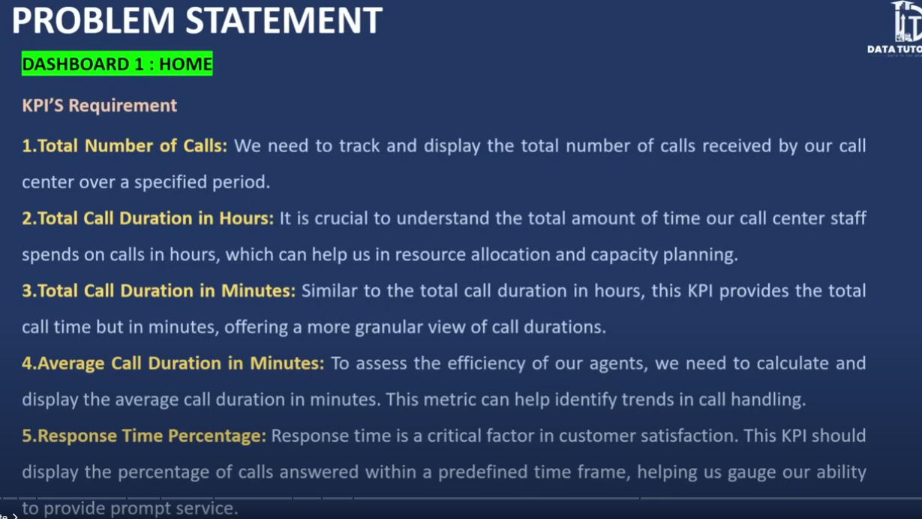



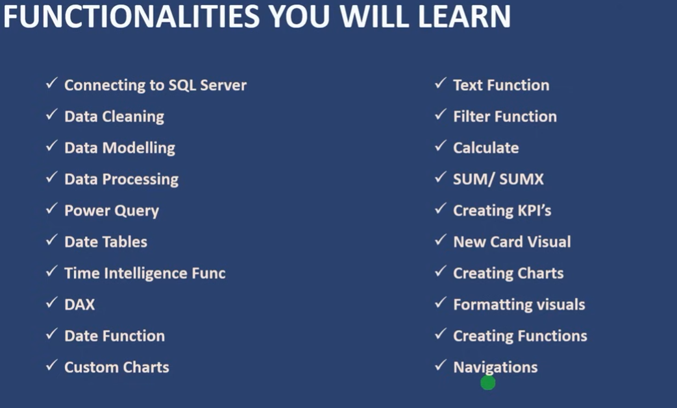



1. Load .csv to Power BI
2. Check the data quality.
3. Creted Date Table:
4. Date Table = CALENDAR(MIN('Call Center_Call Center'[Call Timestamp]), MAX('Call Center_Call Center'[Call Timestamp]))
5. Create a Day table:

Day = FORMAT('Date Table'[Date], "ddd")