|  |  |  |  |  |
| --- | --- | --- | --- | --- |
| **Roshan S. Jadhav**  **roshan.22220205@viit.ac.in**  **Electronics and**  **Telecommunications Department**  **Vishwakarma Institute of**  **Information Technology Pune, India** | **Shruti K Gangurde shruti.22110848@viit.ac.in**  **Electronics and**  **Telecommunications Department**  **Vishwakarma Institute of**  **Information Technology Pune, India** | **Rajesh Kamble rajesh.22110316@viit.ac.in**  **Electronics and**  **Telecommunications Department**  **Vishwakarma Institute of**  **Information Technology Pune, India** | **G Aman Kumar**  **gaman.22110559@viit.ac.in**  **Electronics and**  **Telecommunications Department**  **Vishwakarma Institute of**  **Information Technology Pune, India** |  |

**Power Factor Measurement Circuit using PZEM004T**

**ABSTRACT**

**The Phase Angle Measurement Circuit and Power Factor Measurement Circuit are essential components in electrical engineering for analyzing the efficiency and quality of power systems. These circuits enable precise measurement of the phase angle between voltage and current waveforms, as well as the power factor, which are critical parameters for assessing the performance of electrical loads. By accurately quantifying the phase relationship between voltage and current, these circuits provide valuable insights into the reactive power consumption and overall efficiency of electrical equipment. Their applications range from industrial power systems to renewable energy installations, where optimizing power factor and phase angle is essential for minimizing energy losses and maximizing system reliability. Through their compact design and precise measurement capabilities, these circuits play a vital role in ensuring the efficient operation of electrical networks in various sectors.**

.

# INTRODUCTION

The Phase Angle Measurement Circuit and Power Factor Measurement Circuit are fundamental components in electrical engineering, crucial for assessing the performance and efficiency of power systems. These circuits play a pivotal role in analyzing the phase relationship between voltage and current waveforms, as well as quantifying the power factor of electrical loads. By providing accurate measurements of phase angle and power factor, these circuits enable engineers to optimize energy usage, improve system stability, and reduce wastage in diverse applications. Their importance spans across industries, including manufacturing, utilities, and renewable energy, where precise control of power factor is essential for enhancing overall system efficiency and reliability. This introduction highlights the significance of Phase Angle Measurement and Power Factor Measurement Circuits in modern electrical engineering practices.

**Embedded** **Introduction:**

An embedded system is one kind of a computer system mainly designed to perform several tasks like to access, process, and store and also control the data in various electronics-based systems. Embedded systems are a combination of hardware and software where software is usually known as firmware that is embedded into the hardware. One of its most important characteristics of these systems is, it gives the o/p within the time limits. Embedded systems support to make the work more perfect and convenient. So, we frequently use embedded systems in simple and complex devices too. The applications of embedded systems mainly involve in our real life for several devices like microwave, calculators, TV remote control, home security and neighbourhood traffic control systems, etc.

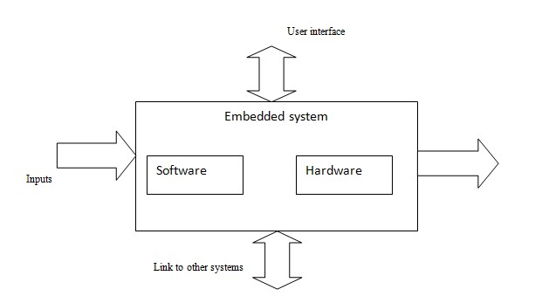

Fig: Overview of embedded system

**Embedded system:**

Embedded system includes mainly two sections, they are

1. Hardware
2. Software

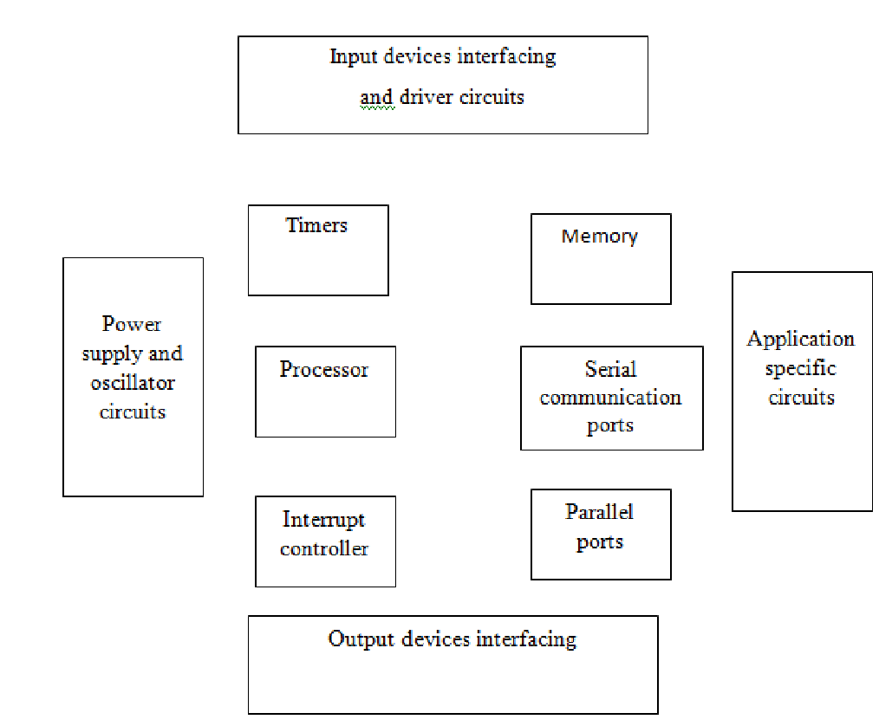

**Embedded System Hardware:**

As with any electronic system, an embedded system requires a hardware platform on which it performs the operation. Embedded system hardware is built with a microprocessor or microcontroller. The embedded system hardware has elements like input output (I/O) interfaces, user interface, memory and the display. Usually, an embedded system consists of:

* + Power Supply
  + Processor
  + Memory
  + Timers
  + Serial communication ports
  + Output/Output circuits
  + System application specific circuits

Embedded systems use different processors for its desired operation. Some of the processors used are

1. Microprocessor
2. Microcontroller
3. Digital signal processor

**Microprocessor vs. Microcontroller**

**Microprocessor**

* + **CPU** on a chip.
  + We can attach required amount of ROM, RAM and

I/O ports.

* + Expensive due to external peripherals.
  + Large in size
  + general-purpose

**Microcontroller**

* + **Computer** on a chip
  + fixed amount of on-chip ROM, RAM, I/O ports
  + Low cost.
  + Compact in size.
  + Specific –purpose

**Embedded System Software:**

The embedded system software is written to perform a specific function. It is typically written in a high level format and then compiled down to provide code that can be lodged within a nonvolatile memory within the hardware. An embedded system software is designed to keep in view of the three limits:

* + Availability of system memory
  + Availability of processor’s speed
  + When the system runs continuously, there is a need to limit power dissipation for events like stop, run and wake up.

**Bringing software and hardware together for embedded system:**

To make software to work with embedded systems we need to bring software and hardware together .for this purpose we need to burn our source code into microprocessor or microcontroller which is a hardware component and which takes care of all operations to be done by embedded system according to our code.

Generally we write source codes for embedded systems in assembly language, but the processors run only executable files.The process of converting the source code representation of your embedded software into an executable binary image involves three distinct steps:

1. Each of the source files must be compiled or assembled into an object file.
2. All of the object files that result from the first step must be linked together to produce a single object file, called the re-locatable program.
3. Physical memory addresses must be assigned to the relative offsets within the re-locatable program in a process called relocation.

The result of the final step is a file containing an executable binary image that is ready to run on the embedded system.

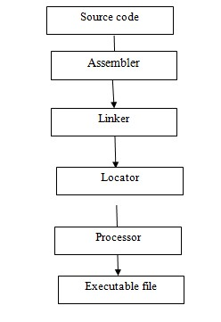

Flow of burning source code to processor **Applications:**

Embedded systems have different applications. A few selectapplications of embedded system[s a](https://www.elprocus.com/embedded-systems-real-time-applications/)re smart cards, telecommunications, satellites, missiles, digital consumer electronics, computer networking, etc.

[Embedded Systems in Automobiles](http://www.edgefx.in/importance-of-embedded-systems-in-automobiles-with-applications/)

* + Motor Control System
  + Engine or Body Safety
  + [Robotics i](http://www.edgefx.in/top-list-robotics-projects-for-engineering-beginners/)n Assembly Line
  + Mobile and E-Com Access

Embedded systems in Telecommunications

* + Mobile computing
  + Networking
  + [Wireless Communications](http://www.edgefx.in/multiple-input-and-multiple-output-mimo-wireless-communications/)

Embedded Systems in Smart Cards

* + Banking
  + Telephone
  + [Security Systems](http://www.edgefx.in/microcontroller-based-projects-on-car-security-systems-using-gsm/)

**Implementation flow:**

**Stage 1:**

Considering the problems of existing methods and giving solution to that problem by considering the basic requirements for our proposed system

**Stage 2:**

Considering the hardware requirement for the proposed system

For this we need to select the below components:

1. Microcontroller
2. Inputs for the proposed system (ex: sensors, drivers etc.,)
3. Outputs (ex: relays, loads)

**Stage 3:**

After considering hardware requirements, now we need to check out the software requirements. Based on the microcontroller we select there exists different software for coding, compiling, debugging. we need to write source code for that proposed system based on our requirements and compile, debug the code in that software.

After completing all the requirements of software and hardware we need to bring both together to work our system. For this we need to burn our source code into microcontroller, after burning our source code to microcontroller then connect all input and output modules as per our requirement.

**LITERATURE REVIEW**

* In "Phase Angle Measurement Techniques: A

Review" by Sharma et al. (2019), the authors discuss various methods and techniques used for phase angle measurement in power systems, including analog and digital approaches.

* "A Review on Phase Angle Measurement
* and Its Applications" by Gupta et al. (2020)
* provides an overview of the importance of phase angle
* measurement in power quality analysis
* and control, highlighting its applications
* in renewable energy systems and smart grids.
* Zhang et al. (2018) explore the advancements in phase angle measurement technology and its role in grid synchronization and stability analysis in their paper "Recent Advances in Phase Angle

Measurement Techniques for Power Systems".

* "Comparison of Phase Angle Measurement Techniques for Power Systems" by Li and Wang (2017) compares different phase angle measurement techniques, including voltage and current synchronization methods, phase-locked loop (PLL) techniques, and digital signal processing (DSP) algorithms.
* Singh et al. (2019) review the advancements in power factor measurement techniques and their applications in energy management systems in their paper "Recent Trends in Power Factor Measurement Techniques".
* "A Review on Power Factor Measurement

Techniques and Their Applications" by Das et al. (2020) provides insights into the various methods used for power factor measurement, including analog and digital approaches, and discusses their significance in power quality assessment.

* Kumar et al. (2018) discuss the challenges and opportunities in power factor measurement in their paper "Power Factor Measurement Techniques: Challenges and Future Trends".
* "Power Factor Measurement: A Review" by Mishra and Mishra (2016) offers a comprehensive review of power factor measurement techniques, emphasizing their importance in energy efficiency and power quality improvement initiatives.

# EXISTING METHOD

Phase Angle Measurement Circuit: Utilizes analog or digital techniques such as phase shifters, zero crossing detection, or digital signal processing to measure the phase difference between voltage and current signals. Arduino-based solutions offer cost-effective and versatile options for phase angle measurement.

Power Factor Measurement Circuit: Implements methods like the wattmeter technique, reactive power compensation, digital power analyzers, or harmonic analysis to assess power factor. These circuits enable accurate evaluation of power factor, essential for optimizing energy efficiency and system stability in electrical networks.

**Drawbacks:**

• Manual references are required

# PROPOSED METHOD

Arduino UNO is a versatile microcontroller board widely used in various electronic projects due to its ease of use, flexibility, and robust performance. Equipped with an Atmega328 microcontroller, Arduino UNO offers a wide range of input and output pins, analog and digital interfaces, and built-in communication protocols. Its simple programming environment, based on the Arduino IDE, allows users to quickly develop and deploy code for controlling sensors, actuators, and other peripherals. Arduino UNO's compatibility with a vast array of sensors, shields, and modules further enhances its versatility, making it suitable for prototyping, experimentation, and educational purposes. With its low cost and widespread availability, Arduino UNO serves as an accessible platform for electronics enthusiasts, hobbyists, students, and professionals alike, empowering them to bring their creative ideas to life and explore the world of embedded systems and IoT applications.

**BLOCK DIAGRAM**

Arduin

o

LCD

Power

supply

Pzeo004

t

Relay

Bulb

**Fig: block diagram of proposed method**

# ADVANTAGES AND APPLICATIONS

**ADVANTAGES**

* Real time monitoring
* Remote Access
* Periodical collection of data

**APPLICATIONS**

* Energy production
* Substations

**HARDWARE AND SOFTWARE REQUIREMENTS**

**HARDWARE REQUIREMENTS**

# ARDUINO

The Arduino microcontroller is an easy to use yet powerful single board computer that has gained considerable traction in the hobby and professional market. The Arduino is open-source, which means hardware is reasonably priced and development software is free. This guide is for students in ME 2011, or students anywhere who are confronting the Arduino for the first time. For advanced Arduino users, prowl the web; there are lots of resources.

This is what the Arduino board looks like.

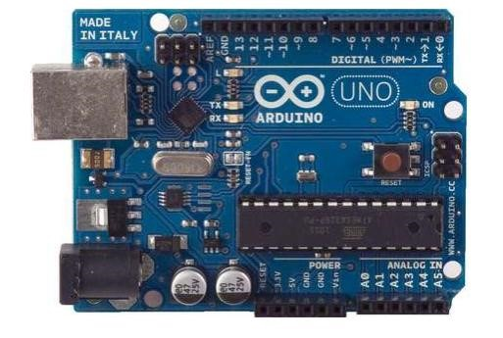

The Arduino programming language is a simplified version of C/C++. If you know C, programming the Arduino will be familiar. If you do not know C, no need to worry as only a few commands are needed to perform useful functions.

**Arduino Hardware**

The power of the Arduino is not its ability to crunch code, but rather its ability to interact with the outside world through its input-output (I/O) pins. The Arduino has 14 digital I/O pins labeled 0 to 13 that can be used to turn motors and lights on and off and read the state of switches.

Each digital pin can sink or source about 40 mA of current. This is more than adequate for interfacing to most devices, but does mean that interface circuits are needed to control devices other than simple LED's. In other words, you cannot run a motor directly using the current available from an Arduino pin, but rather must have the pin drive an interface circuit that in turn drives the motor. A later section of this document shows how to interface to a small motor.

To interact with the outside world, the program sets digital pins to a high or low value using C code instructions, which corresponds to +5 V or 0 V at the pin. The pin is connected to external interface electronics and then to the device being switched on and off.

**Power supply:**

A power supply is a component that provides at least one electrical charge with power. It typically converts one type of electrical power to another, but it can also convert a different Energy form in electrical energy, such as solar, mechanical, or chemical.

A power supply provides electrical power to components. Usually the term refers to devices built into the powered component. Computer power supplies, for example, convert AC current to DC current and are generally located along with at least one fan at the back of the computer case.

Most computer power supplies also have an input voltage switch that, depending on the geographic location, can be set to 110v/115v or 220v/240v. Due to the different power voltages supplied by power outlets in different countries, this switch position is crucial.

**Transformer:**

A transformer is a static electrical gadget that exchanges control between at least two circuits. A fluctuating current creates a changing attractive motion in one transformer curl, which thus actuates a differing electromotive power over a second loop twisted around a similar center.

|  |
| --- |
| prompted voltage in any curl because of the changing attractive **Circuit of rectifier**  flux surrounded by the coil.    **Rectifier** |

Without a metallic association between the two circuits, electrical vitality can be exchanged between the two loops. The enlistment law of Faraday found in 1831 portrayed the impact of **Circuit of transformer**

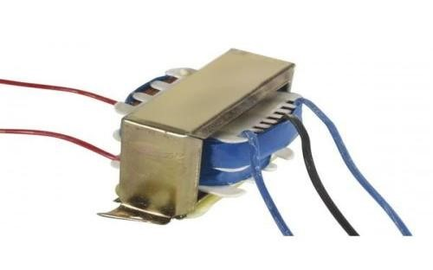

## Transformer

**Rectifier:**

A **rectifier** is an electrical device tha[t convert](https://en.wikipedia.org/wiki/Electric_power_conversion)[s alternating current (](https://en.wikipedia.org/wiki/Alternating_current)AC), which periodically reverses direction, t[o direct current (](https://en.wikipedia.org/wiki/Direct_current)DC), which flows in only one direction. The process is known as *rectification*, since it "straightens" the direction of current.

Rectifiers have many uses, but are often found to serve as components of DC power supplies and direct power transmission systems with high voltage. Rectification can be used in roles other than direct current generation for use as a power source.

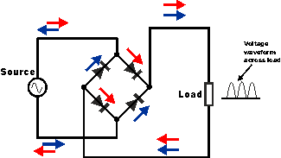

**Capacitors:**

Capacitors are used to attain from the connector the immaculate and smoothest DC voltage in which the rectifier is used to obtain throbbing DC voltage which is used as part of the light of the present identity. Capacitors are used to acquire square DC from the current AC experience of the current channels so that they can be used as a touch of parallel yield.

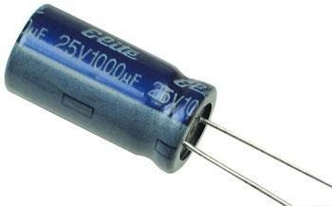

## Capacitor

**Voltage regulators:**

The 78XX voltage controller is mainly used for voltage controllers as a whole. The XX speaks to the voltage delivered to the specific gadget by the voltage controller as the yield. 7805 will supply and control 5v yield voltage and 12v yield voltage will be created by 7812.

The voltage controllers are that their yield voltage as information requires no less than 2 volts. For example, 7805 as sources of information will require no less than 7V, and 7812, no less than 14 volts. This voltage is called Dropout Voltage, which should be given to voltage controllers.

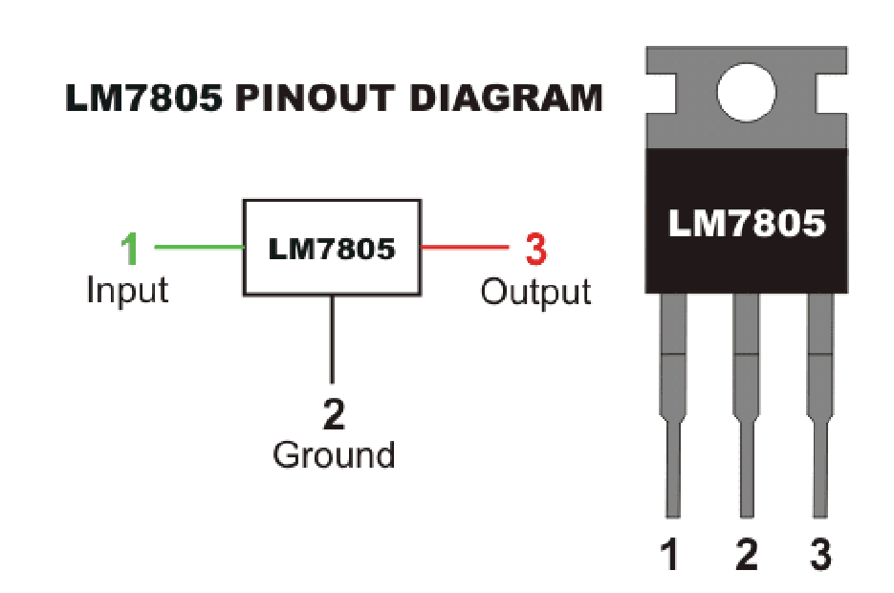

**7805 voltage regulator with pinout**

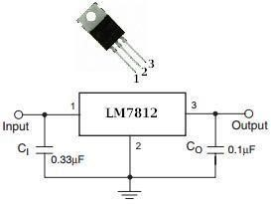

**7812 voltage regulator with pinout**

to set the bandwidth. Pin-7 is the analog output pin. Pin-8 is the power supply pin.

**Relay:**

**What is a relay?**

A relay is an electromagnetic switch that is used to turn on and turn off a circuit by a low power signal, or where several circuits must be controlled by one signal.

Most of the high end industrial application devices have relays for their effective working. Relays are simple switches which are operated both electrically and mechanically. Relays consist of an electromagnet and also a set of contacts. The switching mechanism is carried out with the help of the electromagnet. There are also other operating principles for its working. But they differ according to their applications. Most of the devices have the application of relays.

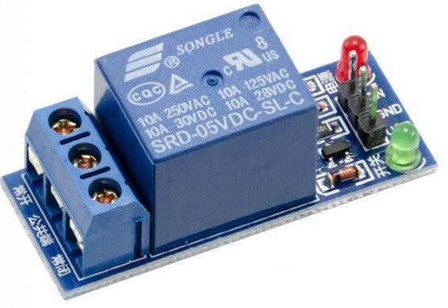

**Pin Diagram:**

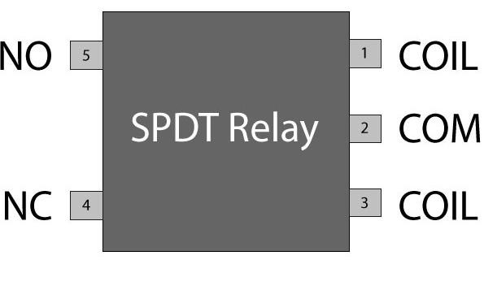

**Why is a relay used?**

The main operation of a relay comes in places where only a lowpower signal can be used to control a circuit. It is also used in places where only one signal can be used to control a lot of circuits. The application of relays started during the invention of telephones. They played an important role in switching calls in telephone exchanges. They were also used in long distance telegraphy. They were used to switch the signal coming from one source to another destination. After the invention of computers they were also used to perform Boolean and other logical operations. The high end applications of relays require high power to be driven by electric motors and so on. Such relays are called contactors.

# Relay Design

* There are only four main parts in a relay. They are
* Electromagnet
* Movable Armature
* Switch point contacts
* Spring

# Pole and Throw

Relays have the exact working of a switch. So, the same concept is also applied. A relay is said to switch one or more poles. Each pole has contacts that can be thrown in mainly three ways. They are

* **Normally Open Contact (NO):** NO contact is also called a make contact. It closes the circuit when the relay is activated. It disconnects the circuit when the relay is inactive.
* **Normally Closed Contact (NC):** NC contact is also known as break contact. This is opposite to the NO contact. When the relay is activated, the circuit disconnects. When the relay is deactivated, the circuit connects.
* **Change-over (CO) / Double-throw (DT) Contacts:** This type of contacts are used to control two types of circuits. They are used to control a NO contact and also a NC contact with a common terminal. According to their type they are called by the names **break before make** and **make before break** contacts.

Relays can be used to control several circuits by just one signal. A relay switches one or more poles, each of whose contacts can be thrown by energizing the coil.

Relays are also named with designations like

* **Single Pole Single Throw (SPST)**: The SPST relay has a total of four terminals. Out of these two terminals can be connected or disconnected. The other two terminals are needed for the coil to be connected.
* **Single Pole Double Throw (SPDT):** The SPDT relay has a total of five terminals. Out of these two are the coil terminals. A common terminal is also included which connects to either of two others.
* **Double Pole Single Throw (DPST):** The DPST relay has a total of six terminals. These terminals are further divided into two pairs. Thus they can act as two SPST which are actuated by a single coil. Out of the six terminals two of them are coil terminals.
* **Double Pole Double Throw (DPDT)**: The DPDT relay is the biggest of all. It has mainly eight relay terminals. Out of these two rows are designed to be change over terminals. They are designed to act as two SPDT relays which are actuated by a single coil.

# Relay Applications

* A relay circuit is used to realize logic functions. They play a very important role in providing safety critical logic.
* Relays are used to provide time delay functions. They are used to time the delay open and delay close of contacts.
* Relays are used to control high voltage circuits with the help of low voltage signals. Similarly they are used to control high current circuits with the help of low current signals.
* They are also used as protective relays. By this function all the faults during transmission and reception can be detected and isolated.

## *Application of Overload Relay*

Overload relay is an electro-mechanical device that is used to safeguard motors from overloads and power failures. Overload relays are installed in motors to safeguard against sudden current spikes that may damage the motor. An overload relay switch works in characteristics with current over time and is different from circuit breakers and fuses, where a sudden trip is made to turn off the motor. The most widely used overload relay is the thermal overload relay where a bimetallic strip is used to turn off the motor. This strip is set to make contact with a contactor by bending itself with rising temperatures due to excess current flow. The contact between the strip and the contactor causes the contactor to de-energize and restricts the power to the motor, and thus turns it off.

Another type of overload motor is the electronic type which continuously watches the motor current, whereas the thermal overload relay shuts off the motor depending on the rise of temperature/heat of the strip.

All overload relays available to buy comes in different specifications, the most important of them being the current ranges and response time. Most of them are designed to automatically reset to work after the motor is turned back on.

# Relay Selection

You must note some factors while selecting a particular relay.

They are

* Protection Different protections like contact protection
* and coil protection must be noted. Contact protection helps
* in reducing
* arcing in circuits using inductors. Â Coil protection helps in reducing surge voltage produced during switching.
* Look for a standard relay with all regulatory approvals.
* Switching time Ask for high speed switching relays if you want one.
* Ratings There are current as well as voltage ratings. The current ratings vary from a few amperes to about 3000 amperes. Â In

case of voltage ratings, they vary from 300 Volt AC to 600 Volt AC. There are also high voltage relays of about 15,000 Volts.

* Type of contact used whether it is a NC or NO or closed contact.
* Select Make before Break or Break before Make contacts wisely.
* Isolation between coil circuit and contacts

**LCD:**

LCD (Liquid Crystal Display) is the innovation utilized in scratch pad shows and other littler PCs. Like innovation for light-producing diode (LED) and gas-plasma, LCDs permit presentations to be a lot more slender than innovation for cathode beam tube (CRT). LCDs expend considerably less power than LED shows and gas shows since they work as opposed to emanating it on the guideline of blocking light.

A LCD is either made with a uninvolved lattice or a showcase network for dynamic framework show. Likewise alluded to as a meager film transistor (TFT) show is the dynamic framework LCD. The uninvolved LCD lattice has a matrix of conductors at every crossing point of the network with pixels. Two conductors on the lattice send a current to control the light for any pixel. A functioning framework has a transistor situated at every pixel crossing point, requiring less current to control the luminance of a pixel.

Some aloof network LCD's have double filtering, which implies they examine the matrix twice with current in the meantime as the first innovation took one sweep. Dynamic lattice, be that as it may, is as yet a higher innovation.

A 16x2 LCD show is an essential module that is generally utilized in various gadgets and circuits. These modules more than seven sections and other multi fragment LEDs are liked. The reasons being: LCDs are affordable; effectively programmable; have no restriction of showing exceptional and even custom characters (not at all like in seven fragments), movements, etc.

A 16x2 LCD implies 16 characters can be shown per line and 2 such lines exist. Each character is shown in a lattice of 5x7 pixels in this LCD. There are two registers in this LCD, in particular

Command and Data.

The directions given to the LCD are put away by the order

register. An order is a direction given to LCD to play out

a predefined assignment, for example, introducing it,

clearing its screen, setting the situation of the cursor,

controlling presentation, and so forth. The information

register will store the information that will be shown on

the LCD. The information is the character's ASCII incentive

to show on the LCD.

**Block Diagram of LCD Display:-**

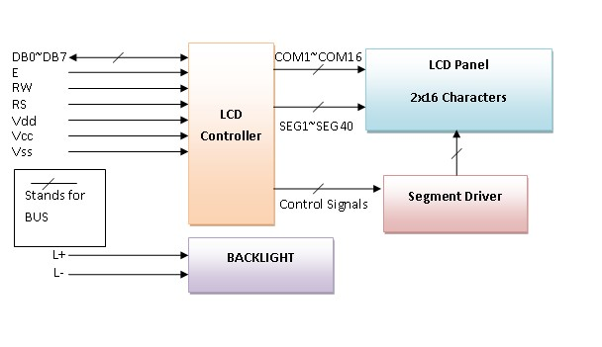

The LCD can work in two striking modes, the 4-bit mode and the 8-bit mode. We send the information snack through snack in 4 bit mode, first upper chomp, by then lower snack. For those of you who don't have the foggiest idea what a goody is: a chomp is a four-piece gathering, so a byte's lower four bits (D0-D3) are the lower snack, while a byte's upper four bits (D4-D7) are the higher snack. This enables us to send 8 bit data. This connects with us to send 8 bit data. Whereas in 8 bit mode we can send the 8-bit information truly in one stroke since we utilize all the 8 information lines. You need to get it now; yes 8-bit mode is quicker and immaculate than 4-bit mode. In any case, the fundamental shortcoming is that it needs 8 microcontrollerrelated information lines. This will result in our MCU coming up short on I/O pins, so 4-bit mode is extensively utilized. To set these modes, no control pins are used.

# BULB

The electronic bulb is the simplest electrical lamp that was invented for illumination more than a century ago. It was the small and simplest light that brightened the dark space. The electronic bulb is also known as an incandescent lamp, incandescent light globe or incandescent light bulb. Bulb comes in different sizes and light output and operates with a voltage range from 1.5 Volts to about 300 Volts. Now let us study the parts and structure of the bulb in detail.

An electronic bulb is a small and simple light source that uses a wire filament to glow on the application of electricity. The structure of incandescent light bulbs is shown in the figure below.

The light bulb consists of three key parts

* The filament
* The glass bulb
* The base of the light bulb

The filament, which is a coiled thin wire, is made of tungsten. Tungsten is chosen as filament sine it has a high melting point, which avoids the melting of the filament at high temperatures.

The filament is enclosed in a globe-shaped glass mount and is connected with copper and lead wires connected to the lamp’s base. The wires and the filament are enclosed in a glass bulb, which is filled with an inert gas like argon. Since argon is an inactive gas, it protects the filament from burning as well as increases the lifetime of the filament. Thin glass is used to manufacture the bulb, preventing the air from reaching the filament to protect it from burning.

When electric power is passed through the bulb, it reaches the filament through copper and lead wires. The base holds the bulb upright and connects to the electric circuit.

Copper and lead wires let the electricity pass from the base to the tungsten filament. It causes the filament to emit light and glow.



PZEM-004T is an electronic module that functions to measure: Voltage, Current, Power, Frequency, Energy and Power Factors.

With the completeness of these functions / features, the PZEM004T module is ideal for use as a project or experiment for measuring power on an electrical network such as a house or building.

The PZEM-004T module is produced by a company called Peacefair, there are 10 Ampere and 100 Ampere models. Please be careful because the wiring between the 10 Ampere models with 100 Amperes is different, if a short circuit or a short circuit can occur in the electrical network.

**The DifferenceBetween PZEM-004T V2.0 and PZEM-004T**

**V3.0**

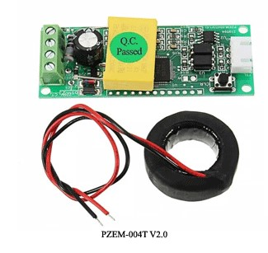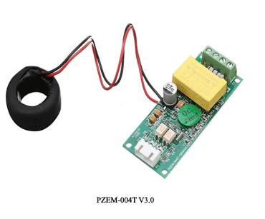

PZEM-004T V2.0 and PZEM-004T V3.0

* There is Reset Energi button on V2.0
* In V3.0 the function to Reset Energy uses software, so there is no push button for Reset Energy
* V3.0 is an upgraded version of V2.0 so that the level of accuracy is better
* The conversion / reading time on V3.0 is faster than V2.0
* The protocol used for data communication is different between the two

**PZEM-004T Current Transformer ( CT ) Split Core**

In addition there is also the PZEM-004T 100 Ampere which uses the Current Transformer split core model. Because it uses a split core, of course it has advantages in its ease of use because it can be directly installed on a power network cable that is already installed without having to remove the power cable.

Examples of PZEM-004T modules that use CT split core can be seen in the image below

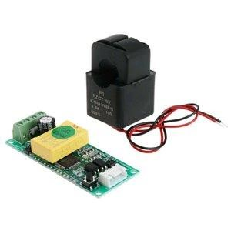

PZEM-004T CT Split Core

**Specifications / Features PZEM-004T**

Although there are some differences between PZEM-004T V2.0 and PZEM-004T V3.0, functionally or featureally, both have similarities. Following are the features or specifications of the PZEM-004T module :

1. Function
   * Measurement function (voltage, current, active power).
   * Power button clear / reset Energy (PZEM-004T V2.0)
   * Power-down data storage function (cumulative
   * power down before saving)
   * TTL Serial Communication
   * Power Measurement : 0 ~ 9999kW
   * Voltage Measurement : 80 ~ 260VAC
   * Current Measurement : 0 ~ 100A
2. Spesifications
   * Working voltage: 80 ~ 260VAC
   * Rated power: 100A / 22000W
   * Working Frequency: 45-65Hz
   * Measurement accuracy: 1.0

**PZEM-004T programming**

PZEM-004T module is very easy to use in programming using various types of microcontroller boards such as Arduino, ESP8266, STM32, WeMos, NodeMCU, Raspberry Pi etc. because it uses TTL serial communication.

It should be noted that the protocols used in PZEM-004T V2.0 and PZEM-004T V3.0 are different, so the library and programming are also different. Many people think that the

PZEM-004T module is corrupt or doesn’t work just because they don’t know and are using the wrong library.

## SOFTWARE REQUIREMENTS

**Arduino IDE:**

**Arduino IDE** where IDE stands for Integrated Development Environment – An official software introduced by Arduino.cc, that is mainly used for writing, compiling and uploading the code in the Arduino Device. Almost all Arduino modules are compatible with this software that is an open source and is readily available to install and start compiling the code on the go.

**Introduction to Arduino IDE:**

* Arduino IDE is an open source software that is mainly used for writing and compiling the code into the Arduino Module.
* It is an official Arduino software, making code compilation too easy that even a common person with no prior technical knowledge can get their feet wet with the learning process.
* It is easily available for operating systems like MAC, Windows, and Linux and runs on the Java Platform that comes with inbuilt functions and commands that play a vital role for debugging, editing and compiling the code in the environment.
* A range of Arduino modules available including Arduino Uno, Arduino Mega, Arduino Leonardo, [Arduino Micro a](https://www.theengineeringprojects.com/2018/09/introduction-to-arduino-micro.html)nd many more.
* Each of them contains a microcontroller on the board that is actually programmed and accepts the information in the form of code.
* The main code, also known as a sketch, created on the IDE platform will ultimately generate a Hex File which is then transferred and uploaded in the controller on the board.
* The IDE environment mainly contains two basic parts: Editor and Compiler where former is used for writing the required code and later is used for compiling and uploading the code into the given Arduino Module.
* This environment supports both C and C++ languages.

**How to install Arduino IDE:**

You can download the Software from [Arduino m](https://www.arduino.cc/en/Main/Software)ain website. As I said earlier, the software is available for common operating systems like Linux, Windows, and MAX, so make sure you are downloading the correct software version that is easily compatible with your operating system.

* If you aim to download Windows app version, make sure you have Windows 8.1 or Windows 10, as app version is not compatible with Windows 7 or older version of this operating system.

The IDE environment is mainly distributed into three sections

* **1. Menu Bar**
* **2. Text Editor**
* **3. Output Pane**

As you download and open the IDE software, it will appear like an image below.

The bar appearing on the top is called **Menu Bar** that comes with five different options as follow

* **File** – You can open a new window for writing the code or open an existing one. Following table shows the number of further subdivisions the file option is categorized into.

As you go to the preference section and check the compilation

section, the Output Pane will show the code compilation as

you click the upload button.

And at the end of compilation, it will show you the hex file

it has generated for the recent sketch that will send to the

Arduino Board for the specific task you aim to achieve.

* **Edit** – Used for copying and pasting the code with further modification for font
* **Sketch** – For compiling and programming
* **Tools** – Mainly used for testing projects. The Programmer section in this panel is used for burning a bootloader to the new microcontroller.
* **Help** – In case you are feeling skeptical about software, complete help is available from getting started to troubleshooting.

The **Six Buttons** appearing under the Menu tab are connected with the running program as follow.

* The check mark appearing in the circular button is used to verify the code. Click this once you have written your code.
* The arrow key will upload and transfer the required code to the Arduino board.
* The dotted paper is used for creating a new file.
* The upward arrow is reserved for opening an existing Arduino project.
* The downward arrow is used to save the current running code.
* The button appearing on the top right corner is a **Serial Monitor** – A separate pop-up window that acts as an independent terminal and plays a vital role for sending and receiving the Serial Data. You can also go to the Tools panel and select Serial Monitor, or pressing Ctrl+Shift+M all at once will open it instantly. The Serial Monitor will actually help to debug the written Sketches where you can get a hold of how your program is operating. Your Arduino Module should be connected to your computer by USB cable in order to activate the Serial Monitor.
* You need to select the baud rate of the Arduino Board you are using right now. For my Arduino Uno Baud Rate is 9600, as you write the following code and click the Serial Monitor, the output will show as the image below.

The main screen below the Menu bard is known as a simple text editor used for writing the required code.

The bottom of the main screen is described as an Output Pane that mainly highlights the compilation status of the running code: the memory used by the code, and errors occurred in the program. You need to fix those errors before you intend to upload the hex file into your Arduino Module.

More or less, Arduino C language works similar to the regular C language used for any embedded system microcontroller, however, there are some dedicated libraries used for calling and executing specific functions on the board.

**Libraries:**

Libraries are very useful for adding the extra functionality into the Arduino Module. There is a list of libraries you can add by clicking the Sketch button in the menu bar and going to Include Library.

As you click the Include Library and Add the respective library it will on the top of the sketch with a #include sign. Suppose, I

Include the EEPROM library, it will appear on the text editor as #include <EEPROM.h>.

Most of the libraries are preinstalled and come with the Arduino software. However, you can also download them from the external sources.

**Making pins Input and output:**

The digitalRead and [digitalWrite c](https://www.theengineeringprojects.com/2018/09/how-to-use-digitalwrite-arduino-command.html)ommands are used for addressing and making the Arduino pins as an input and output respectively.

These commands are text sensitive i.e. you need to write them down the exact way they are given like digitalWrite starting with small “d” and write with capital “W”. Writing it down with

Digitalwrite or digitalwrite won’t be calling or addressing any function. **How to select the board:**

In order to upload the sketch, you need to select the relevant board you are using and the ports for that operating system. As you click the Tools on the Menu, it will open like the figure below.

* Just go to the “Board” section and select the board you aim to work on. Similarly, COM1, COM2, COM4, COM5, COM7 or higher are reserved for the serial and USB board. You can look
* for the USB serial device in the ports section of the
* Windows Device Manager.

Following figure shows the COM4 that I have used for

my project, indicating the Arduino Uno with COM4 port at

the right bottom corner of the screen.

* After correct selection of both Board and Serial Port,
* click the verify and then upload button appearing in the
* upper left corner of the six button section or you can go
* to the Sketch section and press verify/compile and then
* upload.
* The sketch is written in the text editor and is then saved
* with the file extension .ino.

It is important to note that the recent Arduino

Modules will reset automatically as you compile

and press the upload

button the IDE software, however, older version

may require the physical

reset on the board.

* Once you upload the code, TX and RX LEDs
* will blink on the board, indicating the desired
* program is running
* successfully.

**Note**: The port selection criteria mentioned above is dedicated for Windows operating system only, you can check this [Guide i](https://www.arduino.cc/en/Guide/Environment)f you are using MAC or Linux.

The amazing thing about this software is that no prior

arrangement or bulk of mess is required to install this

software, you will be writing your first program within

2 minutes after the installation of the IDE environment.

**BootLoader:**

As you go to the Tools section, you will find a bootloader at the end. It is very helpful to burn the code directly into the controller, setting you free from buying the external burner to burn the required code.

When you buy the new Arduino Module, the bootloader is already installed inside the controller. However, if you intend to buy a controller and put in the Arduino module, you need to burn the bootloader again inside the controller by going to the Tools section and selecting the burn bootloader.

**TESTING RESULTS**

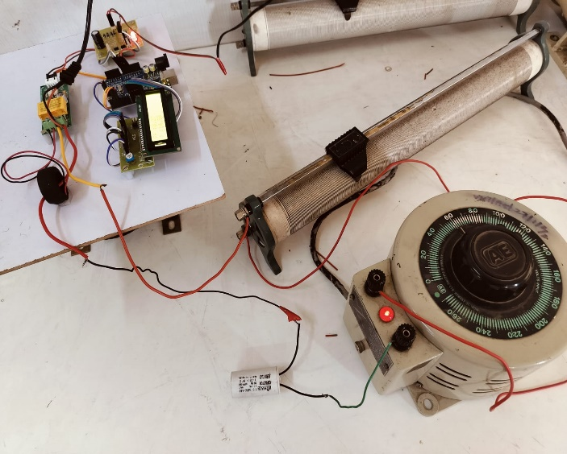

## CONCLUSION REFERENCES

In conclusion, both the Phase Angle Measurement Circuit and

Measurement Circuit play crucial roles in

• Li, C., Zhao, Y., & Li, Q. (2017). Phase Angle

assessing and optimizing the performance of electrical systems.

Measurement of Voltage and Current Signals in

The Phase Angle Measurement Circuit offers precise

Power System Based on Arduino. 2017 IEEE

determination of the phase relationship between voltage and

International Conference on Smart Grid and Clean

current waveforms, aiding in the analysis of system stability and

Energy Technologies (ICSGCE). doi:

efficiency. On the other hand, the Power Factor Measurement

10.1109/icsgce.2017.241

Circuit provides valuable insights into the utilization of

• Hu, L., Liu, W., Liu, Y., & Chen, W. (2018). Design

electrical power, helping to identify opportunities for improving of

energy efficiency and reducing wastage. By integrating these

Based on Arduino. 2018 IEEE 3rd Advanced

circuits into power monitoring and control systems, engineers

Information Technology, Electronic and Automation

can enhance the reliability, efficiency, and sustainability of

Control Conference (IAEAC). doi:

electrical networks across various industries. Together, these

10.1109/iaeac.2018.8546823

circuits contribute to the advancement of electrical engineering

* Hong, W., & Zhang, J. (2020). Research on Power

practices, enabling the development of more efficient and

Factor Measurement Circuit of Smart Meter Based

environmentally friendly power systems for the future.

on Improved Design. 2020 International Conference

on Electronics Technology (ICET). doi:

10.1109/icet48669.2020.9182821

* Rovira, S., Ordonez, R., & Rodriguez, P. (2015). A

. Novel Power Factor Measurement Circuit Using

Low-Cost Microcontrollers. IEEE Transactions on

Instrumentation and Measurement, 64(12), 3441-

3450. doi: 10.1109/tim.2015.2418604

•