AI-Assisted Digital Payment Dispute & Refund Management Platform
Business Case and Project Charter
Prepared by: Roshan Thakur
Role: Technical Business Analyst / IT Business Analyst / Business Consultant
Project Type: Portfolio Project
Industry: FinTech / Digital Payments / Refund Operations
Table of Contents
Table of Contents
Executive Summary
- Project Title
- Business Owner Story
- Business Background
- Current Business Problem
- Why This Problem Matters
- Project Objectives
- Project Scope
- Out of Scope
- Key Stakeholders
9.1 RACI Matrix
- Proposed Solution
- Expected Business Benefits
- Success KPIs
- Next Steps
- Data Analysis Findings
14.1 Dataset Overview
14.2 Key Findings from Excel Analysis
14.3 Business Interpretation
14.4 Recommended Business Actions
14.5 Excel Dashboard and Analysis Screenshots
- Consulting Diagnosis
15.1 SWOT Analysis
15.2 PESTLE Analysis
15.3 Five Whys Analysis
15.4 Fishbone Root Cause Analysis
15.5 Gap Analysis
15.6 MCDA Solution Option Analysis
15.7 Risk Register
- Process Modelling and BPMN
16.1 Purpose of Process Modelling
16.2 As-Is Process
16.3 Problems in the As-Is Process
16.4 To-Be Process
16.5 BPMN Elements Used
16.6 Process Improvement Summary
- Requirements Documentation
17.1 Purpose of Requirements Documentation
17.2 BRD – Business Requirements Document
17.2.1 Business Requirements
17.3 FRD – Functional Requirements Document
17.3.1 Functional Requirements
17.3.2 Functional Modules
17.4 PRD – Product Requirements Document
17.4.1 Product Vision
17.4.2 Product Goals
17.4.3 Target Users
17.4.4 MVP Scope
17.4.5 Future Roadmap
17.4.6 Product Success Metrics
17.5 Non-Functional Requirements
17.5.1 Non-Functional Requirements Table
17.6 Business Rules
17.6.1 Business Rules Table
17.7 Refund Eligibility Decision Table
17.8 Requirements Traceability Matrix
17.9 Confluence Documentation Structure
- Agile and Delivery Planning
18.1 Delivery Approach
18.1.1 SDLC, Waterfall, Agile and Scrum Alignment
18.2 Hybrid Agile and Waterfall Explanation
18.3 Product Backlog
18.3.1 Jira Backlog and Sprint Tracking
18.4 User Stories and Acceptance Criteria
18.5 Sprint Plan
18.6 Definition of Ready
18.7 Definition of Done
18.8 Sprint Review and Retrospective
18.9 Change Control Log
- AI Agent Automation Design
19.1 Purpose of AI Automation
19.2 AI Dispute Triage Agent
19.3 AI Agent Inputs and Outputs
19.4 AI Classification Logic
19.5 AI Refund Recommendation Logic
19.6 AI Customer Response Generation
19.7 Human Oversight and Control
- Prototype and System Design
20.1 Purpose of Prototype
20.2 Proposed Prototype Scope
20.3 System Modules
20.4 User Roles and Permissions
20.5 System Architecture Diagram
20.6 Data Flow Overview
20.7 Data Flow Design
20.8 Proposed Integration Landscape
20.9 API Requirements
20.10 Prototype Screen Design
20.11 System Design Summary
- Testing and UAT
21.1 Purpose of UAT
21.2 UAT Test Cases
21.3 Defect Log
21.3.1 Jira Defect Tracking
21.4 Test Summary
21.5 Go / No-Go Decision
- Go-Live and Benefits Realisation
22.1 Purpose of Go-Live Planning
22.2 Implementation Plan
22.3 Go-Live Checklist
22.4 Rollback Plan
22.5 Training Plan
22.6 Benefits Realisation Plan
22.7 KPI Benefits Framework
22.8 Final Business Recommendations
22.9 Tools Used and IT BA Evidence
- Project Conclusion
List of Figures
Figure 1: Dashboard summary showing overall dispute performance and key operational KPIs
Figure 2: Dispute type analysis showing the distribution of customer payment issues
Figure 3: SLA analysis showing cases resolved within and beyond the target resolution time
Figure 4: Root cause analysis showing the main operational and technical causes behind disputes
Figure 5: Refund impact analysis showing the financial effect of payment dispute cases
Figure 6: As-Is BPMN process showing the current manual, fragmented, and spreadsheet-based digital payment dispute workflow
Figure 7: To-Be BPMN process showing the future-state AI-assisted dispute and refund workflow
Figure 8: Proposed PayFix AI system architecture showing user interface, case management, business logic, AI-assisted decision support, data, reporting and governance layers
Figure 9: Data flow diagram showing how dispute, transaction, refund, SLA, risk, audit and dashboard data move through the PayFix AI platform
Figure 10: Proposed integration landscape showing how PayFix could connect with CRM, payment gateway, transaction systems, merchant settlement, fraud monitoring, refund processing, notification services, BI reporting and identity access management
Figure 11: KPI benefits framework linking business problems, PayFix features, KPI measurements and expected business benefits

Executive Summary
This portfolio project presents an end-to-end business transformation case for an AI-assisted digital payment dispute and refund management platform. The project was designed from the perspective of a business owner, Technical Business Analyst, IT Business Analyst, and business consultant, with the aim of solving a realistic fintech operations problem.
The business problem focuses on manual and fragmented payment dispute handling. Customers may raise issues such as failed payments, duplicate debits, delayed refunds, merchant non-confirmation, unauthorised transactions, wrong amount debited, and suspected fraud. In the current process, teams rely on Excel sheets, emails, transaction logs, internal messages, and manual handoffs between customer support, payment operations, merchant support, fraud review, and refund approval teams. This creates delayed resolution, SLA breaches, inconsistent refund decisions, weak visibility, poor customer communication, and increased operational pressure.
To understand the problem, a synthetic payment dispute dataset was created and analysed in Excel. The dataset was designed to simulate realistic fintech dispute cases while avoiding any real customer, bank, or merchant data. The analysis explored dispute types, payment methods, SLA breaches, refund impact, root causes, risk levels, and customer sentiment. These findings provided the evidence base for the consulting diagnosis and solution design.
The project applied several business analysis and consulting tools, including SWOT, PESTLE, Five Whys, Fishbone root cause analysis, Gap Analysis, MCDA, and a risk register. These tools helped identify the main causes of the problem and compare possible solution options. The recommended solution was an AI-assisted dispute and refund management platform because it provides stronger case visibility, structured workflow control, refund decision support, SLA tracking, management reporting, and improved customer communication.
The process modelling section compared the current As-Is process with the future To-Be process. The As-Is process showed manual case logging, fragmented investigation, unclear ownership, and limited reporting. The To-Be process introduced structured case intake, AI-assisted triage, refund eligibility logic, automated routing, SLA monitoring, dashboard visibility, and human oversight for sensitive cases.
The requirements documentation translated the business problem into clear BRD, FRD, PRD, non-functional requirements, business rules, and a refund eligibility decision table. Agile and delivery planning were also included through a hybrid Agile and Waterfall approach, product backlog, user stories, acceptance criteria, sprint plan, Definition of Ready, Definition of Done, sprint review, and retrospective.
The AI automation design proposed an AI Dispute Triage Agent that can classify disputes, identify severity, recommend evidence, suggest routing, support refund eligibility assessment, generate internal summaries, suggest customer responses, and flag SLA or risk concerns. The AI is positioned as a decision-support tool, not a final decision-maker, with human review retained for fraud-related, high-risk, high-value, and complex cases.
The final solution design included prototype scope, system modules, user roles, data flow, screen design, UAT test cases, defect log, go-live checklist, rollback plan, training plan, benefits realisation plan, and final business recommendations.
Overall, this project demonstrates how a Technical Business Analyst or IT Business Analyst can understand a real business problem, analyse data, identify root causes, redesign processes, document requirements, plan delivery, design AI-assisted automation, validate the solution, and prepare for go-live. It shows the ability to connect business strategy, fintech operations, data analysis, process improvement, system thinking, Agile delivery, and responsible AI use into one complete portfolio project.
1. Project Title
The project title is “AI-Assisted Digital Payment Dispute & Refund Management Platform.”
This project focuses on solving a real-world fintech operations problem where digital payment disputes, refund delays, failed transactions, duplicate debits, unauthorised transactions, and manual case handling create poor customer experience and operational inefficiency.
The project is designed as an end-to-end Technical Business Analyst and IT Business Analyst portfolio project. It starts from business problem discovery and data analysis, then moves into consulting diagnosis, BPMN process redesign, requirements documentation, AI automation design, testing, and go-live planning.
2. Business Owner Story
As a fintech business owner and Technical Business Analyst, I identified a recurring operational problem in digital payment dispute and refund handling. Customers were raising issues related to failed transactions, duplicate debits, delayed refunds, merchant non-confirmation, wrong amount debited, unauthorised transactions, and suspected fraud.
The existing process was highly manual. Teams were relying on Excel sheets, emails, transaction logs, internal messages, and manual follow-ups between customer support, payment operations, merchant support, fraud review, and refund teams.
This created delays, inconsistent decisions, SLA breaches, poor visibility, and customer dissatisfaction. Therefore, I decided to design an AI-assisted digital payment dispute and refund management platform that could centralise case handling, classify disputes, support refund decisions, monitor SLA performance, and improve customer communication.

3. Business Background
The business operates in the fintech and digital payment environment, where customers expect fast, transparent, and secure resolution of payment issues. Payment disputes usually require coordination between multiple teams, including customer support, payment operations, merchant support, fraud review, refund approval, and technology teams.
In a digital payment business, customer trust is directly linked to how quickly and clearly payment issues are resolved. When customers experience failed payments, delayed refunds, duplicate debits, unauthorised transactions, or unclear transaction status, they expect the business to provide fast updates and fair resolution.
However, when dispute handling is manual and fragmented, the business struggles to track cases, prioritise urgent issues, identify repeated root causes, and provide consistent customer communication. This creates both operational pressure and customer dissatisfaction.
4. Current Business Problem
The current dispute and refund process is fragmented, manual, and slow. Customer complaints are received through different channels and then investigated by separate teams using multiple systems. There is no single source of truth, no automated dispute classification, no consistent refund eligibility logic, and limited SLA visibility.
operations teams must manually check transaction status, payment gateway logs, merchant settlement status, customer evidence, fraud indicators, and refund history. This creates delays and increases the chance of inconsistent decision-making.
As a result, cases take longer to resolve, customers receive delayed updates, management has limited visibility of recurring dispute patterns, and the business faces increased operational pressure. These issues create a strong need for a structured, data-driven, and AI-assisted dispute management platform.
5. Why This Problem Matters
Payment disputes directly affect customer trust, operational efficiency, financial control, and business reputation. If customers do not receive clear updates or timely refunds, they may lose trust in the payment provider and raise further complaints.
From an operational perspective, manual dispute handling increases workload for support and payment operations teams. It also creates repeated follow-ups, duplicated investigation effort, delayed handoffs, and poor visibility of which dispute types are causing the biggest problem.
From a management perspective, the lack of data-driven reporting makes it difficult to understand patterns, identify root causes, reduce avoidable disputes, and improve the overall payment experience. Therefore, this project is important because it connects business analysis, data analysis, process improvement, system design, AI automation, and customer experience improvement.
6. Project Objectives
The main objective of this project is to design and prototype an AI-assisted digital payment dispute and refund management platform that improves dispute handling, refund decision support, SLA tracking, customer communication, and operational visibility.
The specific objectives are:
1. To understand the current dispute and refund handling process.
2. To create and analyse a realistic synthetic payment dispute dataset.
3. To identify dispute patterns, SLA breaches, refund delays, manual review cases, and root causes.
4. To redesign the current manual process using BPMN and process improvement methods.
5. To document business, functional, product, and non-functional requirements.
6. To design an AI dispute triage agent that supports classification, prioritisation, refund eligibility, and customer communication.
7. To create a prototype that demonstrates the proposed solution.
8. To prepare UAT test cases, go-live planning, and recruiter-facing portfolio evidence.
7. Project Scope
The scope of this project includes:
1. Business problem discovery and project charter creation.
2. Synthetic payment dispute dataset creation.
3. Excel-based data analysis and dashboard planning.
4. Consulting analysis using SWOT, PESTLE, Five Whys, Fishbone, Gap Analysis, MCDA, and Risk Register.
5. As-Is and To-Be process mapping using BPMN.
6. BRD, FRD, PRD, and non-functional requirements documentation.
7. User stories, acceptance criteria, product backlog, and sprint planning.
8. AI dispute triage agent design.
9. Refund eligibility and SLA tracking logic.
10. Prototype design using Python and Streamlit.
11. UAT test cases and defect log.
12. Go-live plan and benefits realisation plan.
13. GitHub, LinkedIn, CV, and interview-ready project presentation.
8. Out of Scope
The project will not connect to real banking systems, process real customer payments, store real personal customer data, or make final automated refund decisions without human review.
The dataset used in this project will be synthetic and created only for portfolio demonstration, learning, and business analysis practice.
The AI automation will be designed as a decision-support tool, not as a fully autonomous financial decision-making system. This means the AI can classify cases, suggest next actions, and support refund eligibility assessment, but final refund decisions would remain under human review in a real business environment.
9. Key Stakeholders
The project involves multiple stakeholders because payment disputes and refund decisions require coordination between customer-facing, operational, technical, risk, and management teams.
Stakeholder | Role in Project | Main Concern
Customer | Raises payment dispute or refund reques | Fast resolution, clear updates, fair outcome
Customer Support Team | Receives and logs customer issues | Easy case creation and communication
Payment Operations Team | Investigates transaction and payment status | Accurate transaction visibility and workflow control
Merchant Support Team | Checks merchant settlement and confirmation | Merchant response and evidence availability
Fraud Review Team | Reviews suspicious or unauthorised cases | Risk control and fraud prevention
Refund Approval Manager | Reviews refund recommendations and approvals | Consistent decisions and financial control
Product Owner | Owns product vision and MVP priorities | Business value and user experience
Technical Business Analyst | Converts business needs into system requirements | Clear requirements, process flow, and delivery alignment
Development Team | Builds and tests the solution | Clear functional and technical specifications

9.1 RACI Matrix
A RACI matrix was used to clarify stakeholder responsibility across the PayFix AI project. This helps show who is responsible, accountable, consulted, and informed during key project activities.
Activity | Product Owner | Technical BA | Developer | Tester | Operations Manager | Fraud Review Team | Refund Approval Manager
Business problem discovery | A | R | I | I | C | C | C
Business requirements | A | R | C | C | C | C | C
Functional requirements | C | R | C | C | C | C | C
Process modelling / BPMN | C | R | C | I | C | C | C
Product backlog creation | A | R | C | C | C | I | I
Prototype development | C | C | R | C | I | I | I
AI triage logic definition | A | R | C | C | C | C | C
UAT test case preparation | C | R | C | R | C | C | C
Defect review | C | R | R | R | C | I | I
Go-live approval | A | R | C | C | A | C | C
R = Responsible, A = Accountable, C = Consulted, I = Informed.
The RACI matrix helps ensure clear ownership across the business, product, technology, operations, fraud, refund and testing teams. This is important in a fintech/payment operations project because unclear ownership can lead to delayed decisions, duplicated work, weak accountability and poor implementation control.

10. Proposed Solution
The proposed solution is an AI-assisted digital payment dispute and refund management platform.
The platform will allow customer support agents or customers to submit dispute cases through a structured form. The system will generate a unique case ID, classify the dispute type, check refund eligibility rules, assign the case to the correct team, track SLA status, and provide dashboard visibility for managers.
The AI dispute triage agent will support the operations team by reading customer complaint text, identifying dispute type, suggesting severity, recommending required evidence, generating internal case summaries, suggesting customer response messages, and flagging cases that require fraud or manual review.
The solution is designed to improve case visibility, reduce manual workload, support consistent refund decisions, reduce SLA breaches, and improve customer communication.
11. Expected Business Benefits
The expected business benefits are:
1. Faster dispute and refund resolution.
2. Reduced manual investigation workload.
3. Improved SLA tracking and escalation.
4. Better refund decision consistency.
5. Improved customer communication.
6. Clearer visibility of dispute patterns.
7. Stronger root cause analysis.
8. Better management reporting.
9. Reduced operational pressure on support and payment operations teams.
10. Improved customer trust in the payment service.
12. Success KPIs
The success of the project will be measured using operational, financial, customer experience, and automation-related KPIs.
13. Next Steps
The next step is to create a realistic synthetic payment dispute dataset in Excel. This dataset will be used to analyse dispute patterns, SLA breaches, refund delays, root causes, payment method issues, manual review cases, and refund value.
The Excel analysis will become the evidence base for the consulting diagnosis, process redesign, BRD, FRD, PRD, AI automation design, prototype, UAT, and final go-live plan.
After the dataset is created, the project will move into Excel analysis, dashboard planning, consulting diagnosis, BPMN process mapping, requirements documentation, Agile delivery planning, AI agent design, prototype development, testing, and go-live preparation.
14. Data Analysis Findings
To understand the business problem in a more structured way, a synthetic payment dispute dataset was created and analysed in Excel. The purpose of the analysis was to identify the most common dispute types, SLA performance issues, payment method patterns, root causes, refund impact, risk levels, and customer experience concerns.
The dataset is synthetic and was created for portfolio demonstration purposes. It does not contain real customer, bank, or merchant data. However, the data structure and dispute scenarios were designed to reflect realistic fintech and digital payment operations.
14.1 Dataset Overview
The dataset contains payment dispute case records with key fields such as case ID, customer ID, transaction ID, date raised, payment method, dispute type, transaction amount, transaction status, evidence availability, risk level, refund eligibility, case status, SLA target days, actual resolution days, SLA breach status, assigned team, refund amount, root cause, and customer sentiment.
14.2 Key Findings from Excel Analysis
The Excel analysis highlighted several important business findings:
1. Payment disputes are not evenly distributed across all categories. Some dispute types create a higher operational workload and should therefore be prioritised for improvement.
2. SLA breaches indicate that the current dispute handling process is affected by delays, manual handoffs, and limited escalation visibility.
3. Payment method analysis helps identify whether specific channels, such as card payments, wallet payments, bank transfers, or open banking payments, are creating more disputes than others.
4. Root cause analysis shows that many disputes are linked to repeated operational or technical issues, such as gateway timeout, merchant delay, duplicate processing, refund processing delay, fraud suspicion, or customer error.
5. Refund analysis shows the financial impact of disputes and helps identify which dispute categories create the highest refund cost.
6. Risk analysis shows that not all cases should follow the same workflow. Low-risk cases may be suitable for faster processing, while high-risk or fraud-related cases should be routed for manual review.
7. Customer sentiment analysis shows that delayed refunds, unclear communication, and failed transactions can negatively affect customer trust.
14.3 Business Interpretation
The analysis suggests that the dispute and refund process requires a more structured and automated approach. The current manual process creates delays, inconsistent decision-making, weak SLA visibility, and limited management reporting.
From a business owner and Technical Business Analyst perspective, the data shows that the organisation needs a centralised platform that can capture dispute cases, classify dispute types, assess refund eligibility, route cases to the right team, track SLA performance, and provide dashboard-based insights.
The analysis also supports the need for an AI-assisted dispute triage agent. The AI agent can help reduce manual workload by classifying customer claims, suggesting severity, identifying required evidence, recommending refund eligibility, generating customer response messages, and flagging fraud or manual review cases.
14.4 Recommended Business Actions
Based on the Excel analysis, the recommended business actions are:
1. Centralise all dispute and refund cases into one platform.
2. Introduce automated dispute classification to reduce manual triage effort.
3. Track SLA performance for every case from the date raised.
4. Create clear refund eligibility rules for common dispute types.
5. Route high-risk and fraud-related cases to specialist review.
6. Use dashboards to monitor dispute volume, SLA breaches, refund value, root causes, and customer sentiment.
7. Improve customer communication using standardised and AI-assisted response templates.
8. Use root cause trends to reduce repeated payment issues at source.

14.5 Excel Dashboard and Analysis Screenshots
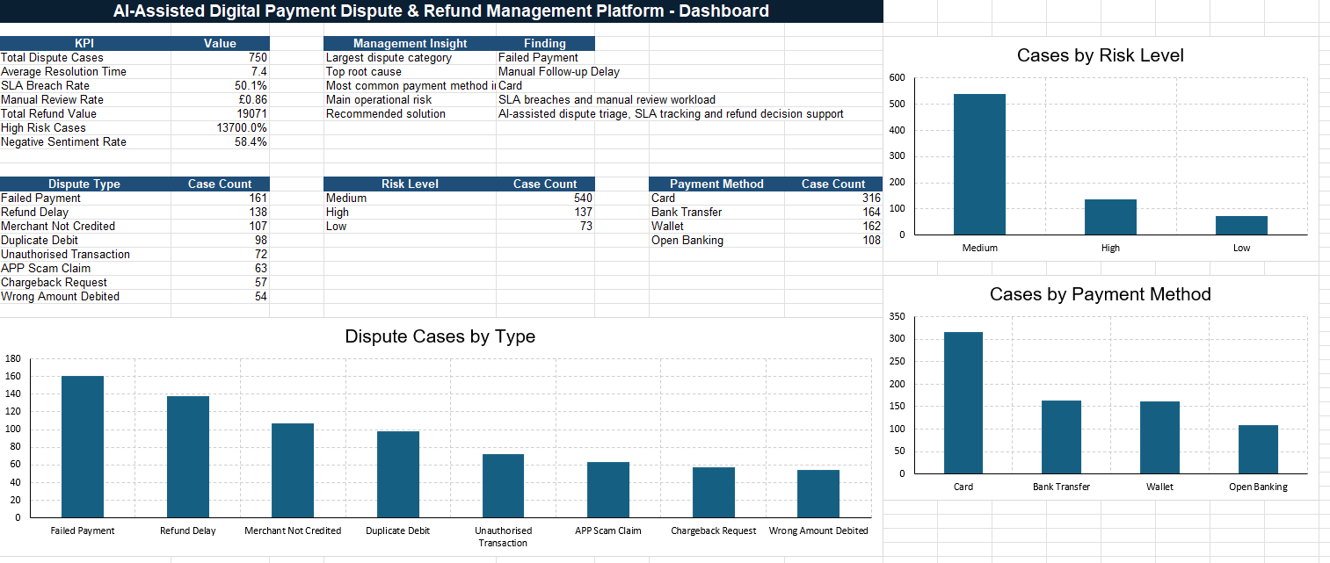
Figure 1: Dashboard summary showing overall dispute performance and key operational KPIs.

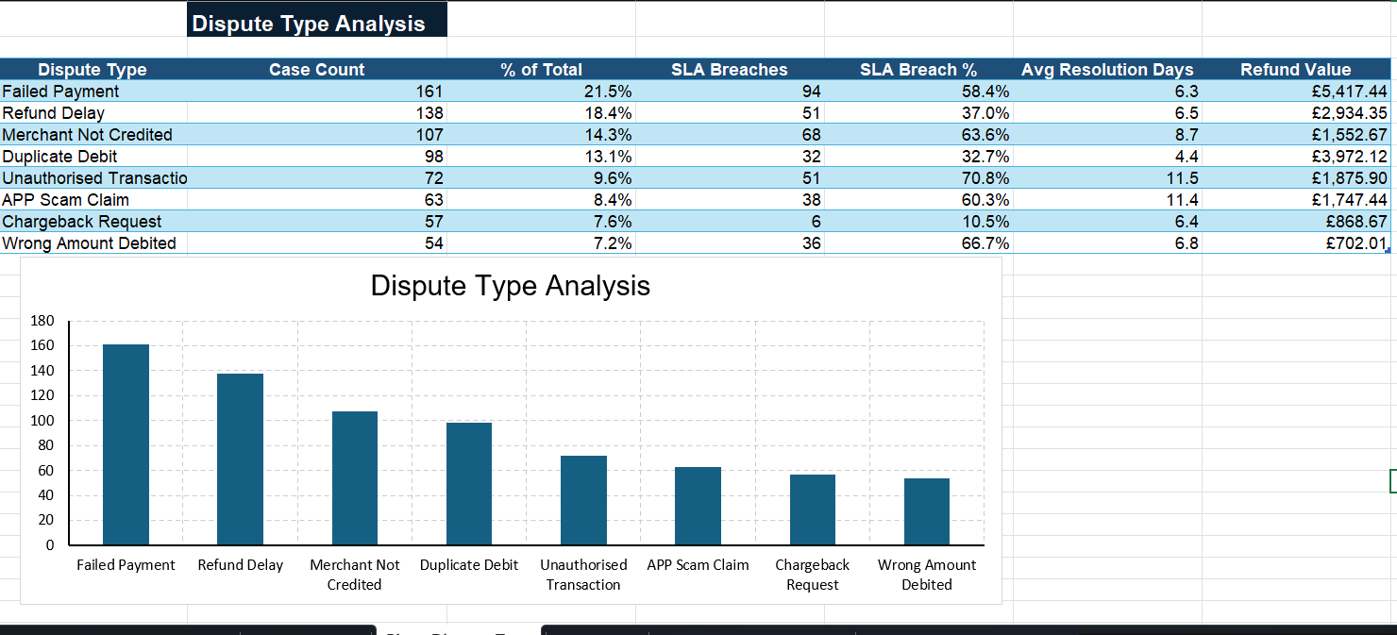
Figure 2: Dispute type analysis showing the distribution of customer payment issues.
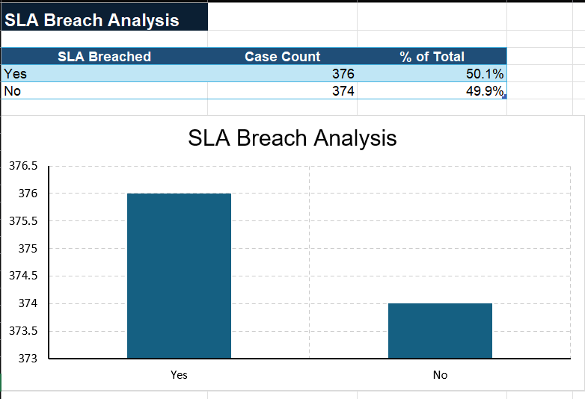
Figure 3: SLA analysis showing cases resolved within and beyond the target resolution time.

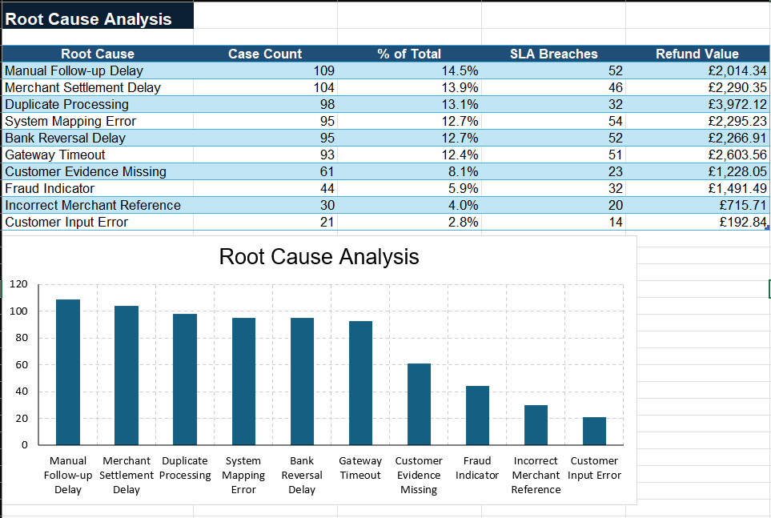
Figure 4: Root cause analysis showing the main operational and technical causes behind disputes.
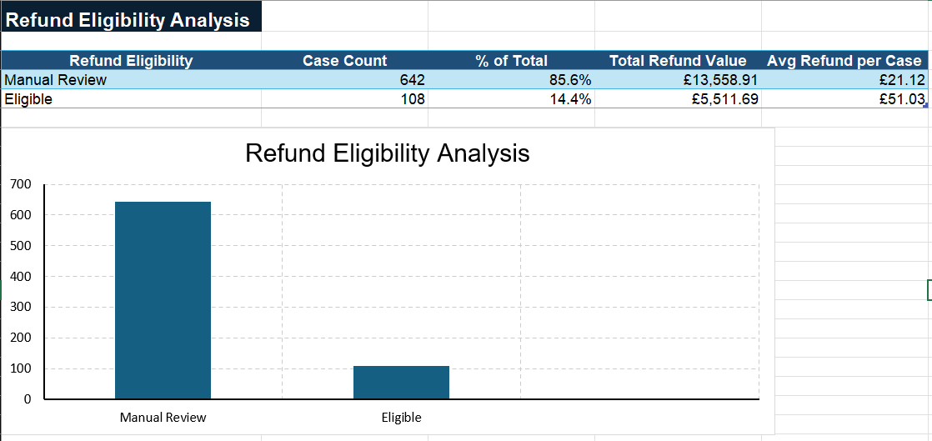
Figure 5: Refund impact analysis showing the financial effect of payment dispute cases.

15. Consulting Diagnosis
After analysing the synthetic payment dispute dataset, the next step was to diagnose the business problem using consulting and business analysis tools. The purpose of this section is to understand the internal and external factors affecting the dispute and refund process, identify root causes, compare solution options, and recommend a practical improvement approach.
The consulting diagnosis connects the data findings with business strategy, operational improvement, process redesign, technology requirements, AI automation, and delivery planning.
15.1 SWOT Analysis
The SWOT analysis was used to assess the internal strengths and weaknesses of the current dispute and refund process, as well as the external opportunities and threats affecting the fintech/payment business.
Strengths | Weaknesses | Opportunities | Threats
Existing payment and transaction data is available for analysis. | Current process is manual, fragmented, and dependent on multiple teams. | AI can support faster dispute classification and case triage. | Delayed refunds can reduce customer trust and increase complaints.
Teams already have operational knowledge of disputes, refunds, merchant issues, and fraud cases | No single source of truth for dispute case management | Dashboard reporting can improve management visibility and decision-making. | High SLA breaches can create operational, reputational, and compliance risk.
Synthetic dataset shows that dispute patterns can be measured and analysed. | Limited SLA tracking and weak escalation visibility. | Standardised refund eligibility rules can improve consistency | Fraud and unauthorised transaction cases require careful handling and human review
Business has a clear need for structured process improvement. | Refund decisions may be inconsistent due to manual checks and unclear rules. | Centralised platform can reduce duplicated investigation effort. | Poor customer communication can damage customer experience and brand reputation.
The SWOT analysis shows that the business has useful operational knowledge and dispute data, but the current process is limited by manual handling, poor visibility, inconsistent decision-making, and weak SLA control. The main opportunity is to use a centralised digital platform supported by AI-assisted triage, dashboard reporting, and clear refund rules. However, the solution must also manage risks carefully, especially around fraud-related cases, customer trust, and human oversight for refund decisions.
15.2 PESTLE Analysis
The PESTLE analysis was used to understand the wider external environment affecting a UK fintech/payment business. This helps ensure that the proposed solution is not only operationally useful, but also realistic within the business, regulatory, technology, and customer context.
Factor | Impact on the Business | Project Relevance
Political | he UK financial services environment places strong focus on consumer protection, financial trust, fraud prevention, and responsible digital payment services. | The platform must support clear case tracking, responsible refund handling, and auditability.
Economic | Refund delays, manual investigation, and repeated disputes increase operational cost and reduce efficiency | The solution should reduce manual workload, improve resolution time, and provide refund value visibility
Social | Customers expect fast, transparent, and fair resolution when payment problems occur. Poor communication can quickly reduce trust. | AI-assisted customer response templates and SLA tracking can improve communication and customer experience
Technological | Fintech businesses increasingly rely on automation, data analytics, AI, dashboards, APIs, and integrated case management systems | The project uses AI triage, Excel/SQL analysis, dashboarding, and prototype design to support digital transformation.
Legal | Payment dispute handling may involve complaint rules, fraud review, data protection, audit trails, and evidence management. | The platform should include role-based access, data masking, audit history, and human review for sensitive cases.
Environmental | Digital platforms can reduce paper-based processes and improve remote operational handling. | The project supports digital-first case management and reduces manual documentation dependency
The PESTLE analysis shows that the proposed platform is relevant in a UK fintech context because payment businesses must balance speed, customer experience, operational efficiency, fraud control, and responsible decision-making. The project should therefore focus on automation as decision support, not full replacement of human judgement. This is especially important for high-risk, fraud-related, or high-value refund cases.
This dataset was used to analyse how payment disputes move through the business, where delays occur, which dispute types create the highest workload, and where AI-assisted automation could improve the process.
Dispute Type Analysis
The dispute type analysis helps identify which payment issues are happening most frequently. This is important because the business should prioritise the dispute categories that create the highest workload and customer dissatisfaction.
SLA Analysis
The SLA analysis shows whether the current dispute process is resolving cases within the expected target time. A high SLA breach rate indicates delays, weak escalation, manual handoffs, and poor case visibility.
Payment Method Analysis
The payment method analysis helps identify whether disputes are concentrated in a specific payment channel. This supports investigation into whether certain channels have higher operational, technical, or merchant-related issues.
Root Cause Analysis
The root cause analysis helps identify why payment disputes are happening. Repeated root causes show that the problem is not random, but linked to process gaps, system issues, merchant delays, fraud checks, or refund handling delays.
Refund Impact Analysis
The refund analysis shows the financial impact of payment disputes. High refund values indicate where the business is losing money or spending significant time on refund review and approval.
Risk Analysis
The risk analysis helps identify cases that require stronger review, fraud checks, or manual approval. This is important because not every dispute should be handled in the same way.
Dashboard Summary
The dashboard provides a management-level view of dispute volume, SLA performance, refund impact, risk level, root causes, and customer sentiment. This helps decision-makers understand the operational health of the dispute and refund process.
15.3 Five Whys Analysis
The Five Whys analysis was used to identify the underlying causes behind delayed dispute resolution, refund inefficiency, SLA breaches, and poor customer communication. The analysis focuses on moving beyond surface-level symptoms and understanding why the current process is not performing effectively.
Question | Answer
Why are customers experiencing delayed dispute and refund resolution? | Because cases are handled manually across different teams and systems.
Why are cases handled manually across different teams and systems? | Because there is no centralised dispute management platform or single source of truth
Why is there no single source of truth? | Because customer support, payment operations, merchant support, fraud review, and refund teams use separate tools, spreadsheets, and manual communication
Why does this create SLA breaches and inconsistent decisions? | Because there is limited automated routing, unclear refund eligibility logic, weak escalation visibility, and no real-time dashboard monitoring
Why does the business need an AI-assisted platform? | Because AI-assisted triage can classify disputes, recommend next actions, support refund eligibility checks, generate summaries, and improve speed and consistency while keeping human review for sensitive cases
The Five Whys analysis shows that the main issue is not only the volume of disputes, but the lack of a structured and centralised process. Manual handoffs, separate systems, unclear refund rules, and limited SLA visibility create delays and inconsistent outcomes. This supports the need for a digital platform with workflow control, clear business rules, dashboard reporting, and AI-assisted triage.
15.4 Fishbone Root Cause Analysis
The Fishbone analysis was used to group the root causes of payment dispute and refund inefficiency into key categories. This helps identify whether the problem is caused by people, process, technology, data, policy, or external factors.
Category | Root Causes | Business Impact
People | Support agents and operations teams depend on manual checks and follow-ups. | Increased workload, slower resolution, and inconsistent handling.
Process | No standardised end-to-end dispute workflow from intake to refund decision. | Delays, duplicated effort, unclear ownership, and SLA breaches.
Technology | No centralised case management platform, limited automation, and separate systems. | Poor visibility, manual investigation, and weak reporting.
Data | Dispute data is fragmented across emails, spreadsheets, transaction logs, and team notes. | Difficult to identify trends, root causes, and priority issues.
Policy / Rules | Refund eligibility rules are not clearly standardised or automated. | Inconsistent refund decisions and higher manual review effort.
External / Merchant | Merchant confirmation and settlement checks can delay case resolution. | Longer resolution time and poor customer updates.
The Fishbone analysis shows that the dispute problem is caused by a combination of process gaps, technology limitations, fragmented data, unclear refund rules, and manual team dependencies. The issue cannot be solved by adding more people alone. The business needs a better operating model supported by a centralised system, defined workflows, clear rules, automation, and management reporting.
15.5 Gap Analysis
The Gap Analysis compares the current dispute and refund process with the desired future state. This helps translate the business problem into practical improvement areas and system requirements.
Area | Current State | Future State | Gap / Required Change
Case Intake | Disputes are received through multiple channels and logged manually. | All disputes captured through a structured digital form. | Create a centralised case intake process.
Case Tracking | Case progress is tracked manually using spreadsheets and team updates. | Every case has a unique ID, status, owner, SLA timer, and audit trail. | Implement digital case tracking and workflow visibility.
Dispute Classification | Agents manually identify dispute type. | AI-assisted triage classifies dispute type based on customer claim and case data. | Introduce automated classification support.
Refund Eligibility | Refund decisions depend on manual checks and inconsistent interpretation. | System applies standard refund eligibility rules and recommends outcome. | Define business rules and decision table.
SLA Monitoring | SLA breaches are identified late or manually. | SLA timer and escalation alerts are visible in dashboard. | Add automated SLA tracking and escalation logic.
Reporting | Management has limited visibility of dispute trends and root causes. | Dashboard shows dispute volume, SLA breaches, refund value, root causes, and risk. | Build management reporting dashboard.
Customer Communication | Updates are manual and inconsistent. | AI-assisted response templates support faster and clearer communication. | Standardise communication templates and AI support.
The Gap Analysis shows that the future solution must address both operational and technical gaps. The main required changes are centralised case intake, structured workflow tracking, automated dispute classification, defined refund eligibility rules, SLA monitoring, dashboard reporting, and improved customer communication. These gaps will directly inform the BRD, FRD, PRD, user stories, and prototype design.
15.6 MCDA Solution Option Analysis
A Multi-Criteria Decision Analysis (MCDA) was used to compare possible solution options for improving the digital payment dispute and refund process. The aim was to select the most suitable option based on business value, implementation effort, cost, scalability, automation potential, customer experience impact, and operational control.
The following solution options were considered:
Option 1: Continue with Excel-based manual tracking.
Option 2: Use a generic customer service ticketing tool.
Option 3: Build a centralised dispute management platform without AI.
Option 4: Build an AI-assisted digital payment dispute and refund management platform.
Criteria | Weight | Option 1: Excel Manual Tracking | Option 2: Generic Ticketing Tool | Option 3: Centralised Platform | Option 4: AI-Assisted Platform
Business Value | 25% | 1 | 2 | 4 | 5
Implementation Cost | 15% | 5 | 3 | 2 | 2
Ease of Implementation | 10% | 5 | 4 | 3 | 3
Scalability | 15% | 1 | 3 | 4 | 5
Automation Potential | 15% | 1 | 2 | 3 | 5
Customer Experience Impact | 10% | 1 | 3 | 4 | 5
Operational Control | 10% | 1 | 3 | 4 | 5
Scoring scale: 1 = Very Poor, 2 = Poor, 3 = Moderate, 4 = Good, 5 = Excellent.

The MCDA indicates that Option 4, the AI-assisted digital payment dispute and refund management platform, provides the strongest overall value. Although it requires more implementation effort than continuing with Excel or using a generic ticketing tool, it offers the highest potential for automation, scalability, operational control, customer experience improvement, and data-driven decision-making.
Recommended Option:
The recommended solution is Option 4: AI-Assisted Digital Payment Dispute and Refund Management Platform.
Reason for Recommendation:
This option best addresses the root causes identified in the analysis. It supports centralised case intake, workflow visibility, automated dispute classification, refund eligibility support, SLA monitoring, risk flagging, management dashboards, and improved customer communication. This makes it the most suitable solution for a fintech/payment business that wants to improve dispute handling while maintaining human oversight for sensitive refund and fraud-related decisions.
15.7 Risk Register
A risk register was created to identify potential business, technology, data, operational, compliance, and delivery risks associated with the proposed platform. The purpose of the risk register is to support better planning, mitigation, and stakeholder decision-making.
Risk ID | Risk Description | Impact | Likelihood | Mitigation | Owner
R1 | AI may classify some dispute cases incorrectly. | High | Medium | Keep AI as decision support only and require human review for sensitive cases. | Technical BA / Product Owner
R2 | Synthetic dataset may not fully reflect all real-world payment scenarios. | Medium | Medium | Clearly state dataset assumptions and design it around realistic fintech dispute patterns. | Technical BA
R3 | High-risk or fraud-related cases may require specialist investigation. | High | High | Route fraud and unauthorised transaction cases to manual review. | Fraud Review Team
R4 | Users may resist moving from Excel/manual process to a new platform. | Medium | Medium | Provide training, clear benefits, and phased adoption. | Change Lead / Product Owner
R5 | Refund rules may be too complex for full automation. | High | Medium | Use decision tables and keep final approval with refund manager. | Refund Approval Manager
R6 | Poor data quality may reduce dashboard and AI output accuracy. | Medium | Medium | Add mandatory fields, validation rules, and data quality checks. | Data Analyst / Technical BA
R7 | Project scope may become too broad. | Medium | Medium | Define MVP clearly and manage backlog priorities through Agile sprint planning. | Product Owner
The risk register shows that the proposed solution must be implemented carefully. The most important risks relate to AI accuracy, fraud-sensitive cases, refund decision complexity, user adoption, and data quality. To manage these risks, the platform should use AI as a decision-support tool rather than a final decision-maker. Human review should remain mandatory for high-risk, fraud-related, high-value, or complex refund cases.
16. Process Modelling and BPMN
Process modelling was used to understand how digital payment dispute and refund cases currently move through the business and how the process should be redesigned in the future. This section presents the As-Is process, identifies key process problems, and defines the To-Be process for the proposed AI-assisted dispute and refund management platform.
BPMN-style process thinking was used to show the sequence of activities, handoffs, decision points, teams involved, and improvement opportunities. This helps translate business problems into clear process and system requirements.
16.1 Purpose of Process Modelling
The purpose of process modelling is to visualise how the current dispute and refund handling process works and where delays, handoffs, duplicated effort, and control gaps occur.
For this project, process modelling supports five key objectives:
1. To understand the current manual dispute process.
2. To identify operational pain points and bottlenecks.
3. To compare the current As-Is process with the future To-Be process.
4. To define system and workflow requirements for the proposed platform.
5. To support communication between business stakeholders, operations teams, product owners, and technical teams.
This is important because a Technical Business Analyst must be able to convert business problems into clear process flows, system requirements, and delivery-ready user stories.
16.2 As-Is Process
The As-Is process represents the current manual and fragmented way in which digital payment disputes and refund cases are handled. The process involves multiple teams, manual checks, separate communication channels, and limited visibility of case progress.
As-Is Dispute and Refund Process:
1. Customer experiences a payment issue.
2. Customer contacts support through email, phone, chat, or app message.
3. Customer support manually records the complaint.
4. Support agent checks whether basic transaction details are available.
5. If information is missing, customer is asked to provide more evidence.
6. If information is available, case is forwarded to payment operations.
7. Payment operations manually checks transaction status and payment logs.
8. If merchant confirmation is required, the case is forwarded to merchant support.
9. Merchant support checks settlement status and waits for merchant response.
10. If fraud or unauthorised transaction is suspected, the case is forwarded to fraud review.
11. Refund team reviews the case and decides whether refund is eligible.
12. Customer support sends manual update to customer.
13. Case is manually closed or kept pending for further review.
14. Management receives limited reporting through spreadsheets or manual summaries.
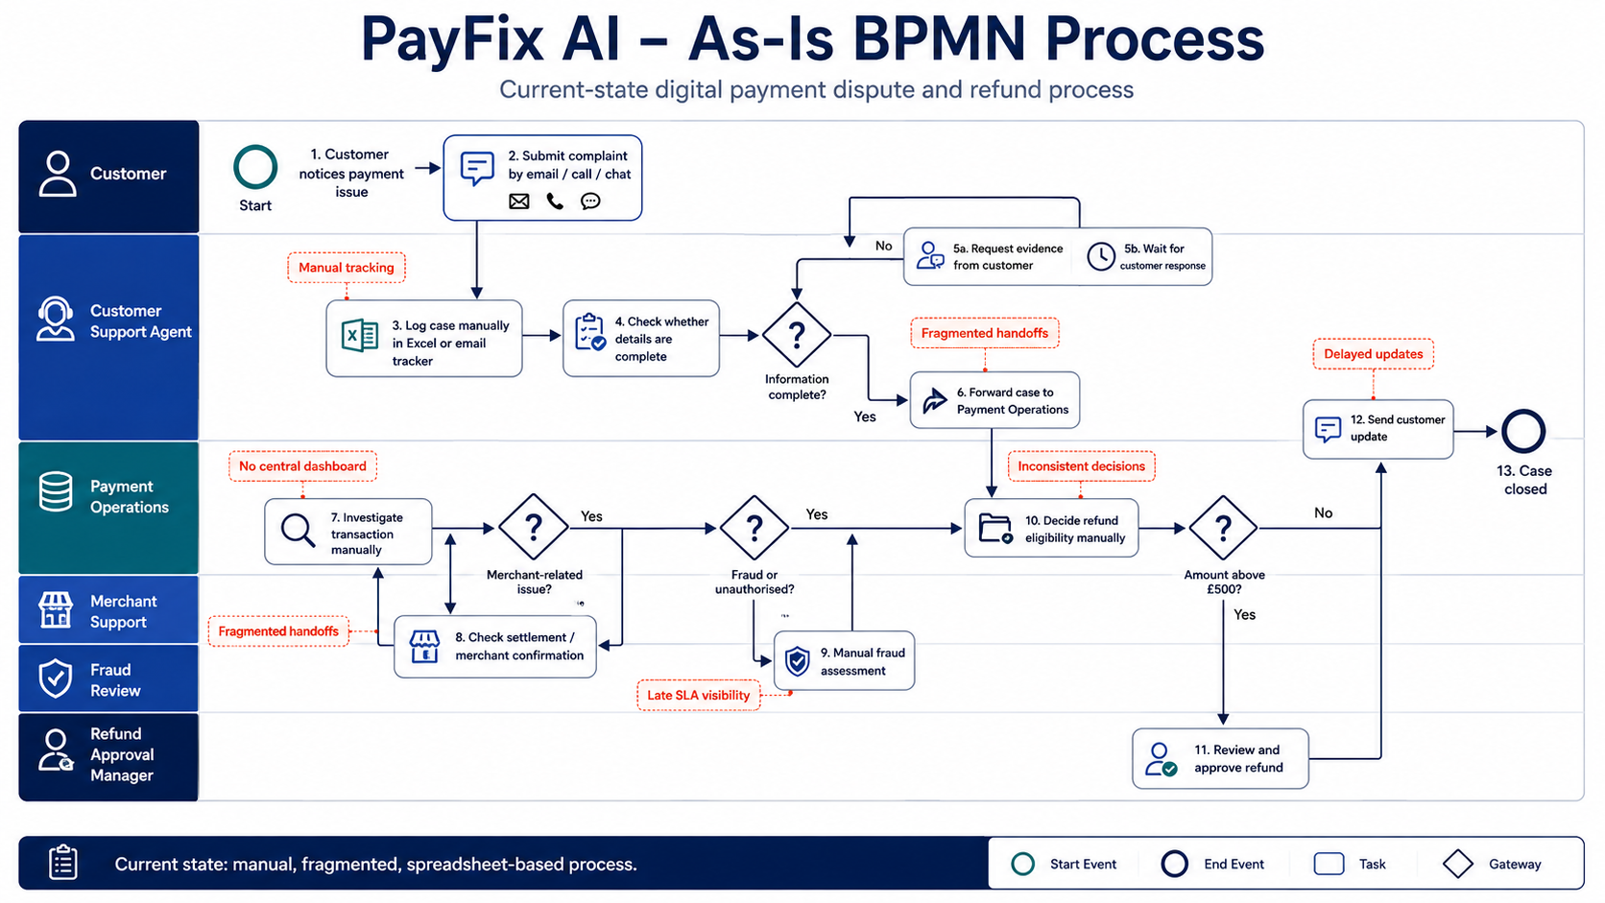
Figure 6: As-Is BPMN process showing the current manual, fragmented, and spreadsheet-based digital payment dispute workflow.
Step | Activity | Responsible Team | Issue / Limitation
1 | Customer raises dispute | Customer / Support | Multiple intake channels create inconsistent case capture
2 | Case logged manually | Customer Support | Risk of missing or incomplete information
3 | Basic details checked | Customer Support | Manual validation and repeated customer follow-up
4 | Transaction checked | Payment Operations | Requires manual checking across payment logs
5 | Merchant confirmation requested | Merchant Support | Waiting time creates delays
6 | Fraud review if needed | Fraud Review Team | High-risk cases require specialist handling
7 | Refund | Refund Team / Manager | Decision may be inconsistent without standard rules
8 | Customer updated | Customer Support | Updates may be delayed or inconsistent

16.3 Problems in the As-Is Process
The As-Is process creates several operational and customer experience problems:
1. Multiple intake channels make it difficult to capture all dispute cases consistently.
2. Manual case logging increases the risk of missing information and duplicated effort.
3. Customer support, payment operations, merchant support, fraud review, and refund teams work across separate tools and communication channels.
4. There is no single source of truth for case status, owner, SLA timer, or audit history.
5. Dispute classification depends on manual judgement, which may lead to inconsistent categorisation.
6. Refund eligibility is not supported by a standardised decision table or automated rule logic.
7. SLA breaches may only be noticed late because escalation is not automated.
8. Customer updates are manual, which can create delays and inconsistent communication.
9. Management reporting is limited, making it difficult to identify patterns, root causes, and improvement priorities.
The As-Is process shows that the main issue is not only individual payment failures, but the lack of a structured dispute operating model. The process needs centralised case intake, standardised classification, automated SLA tracking, clear refund rules, dashboard visibility, and AI-assisted triage support.
16.4 To-Be Process
The To-Be process represents the improved future-state workflow for handling digital payment disputes and refund cases through the proposed AI-assisted platform. The future process is designed to reduce manual effort, improve visibility, standardise refund decision support, track SLA performance, and improve customer communication.
To-Be AI-Assisted Dispute and Refund Process:
1. Customer or support agent submits a dispute through a structured digital form.
2. Platform generates a unique dispute case ID.
3. Mandatory fields are validated before the case is submitted.
4. AI dispute triage agent reads the customer claim and classifies the dispute type.
5. System identifies risk level and required evidence.
6. System checks refund eligibility rules using a decision table.
7. Case is automatically routed to the correct team: Payment Operations, Merchant Support, Fraud Review, or Refund Approval.
8. SLA timer starts from the case creation date.
9. AI generates an internal case summary for the operations team.
10. AI suggests a customer response message.
11. Assigned team reviews the case and updates status.
12. High-risk, fraud-related, or high-value cases go to manual review.
13. Refund manager reviews and approves eligible refund cases.
14. Customer receives a clear update.
15. Case is closed with audit history.
16. Dashboard updates management KPIs such as dispute volume, SLA breaches, refund value, root causes, and risk levels.
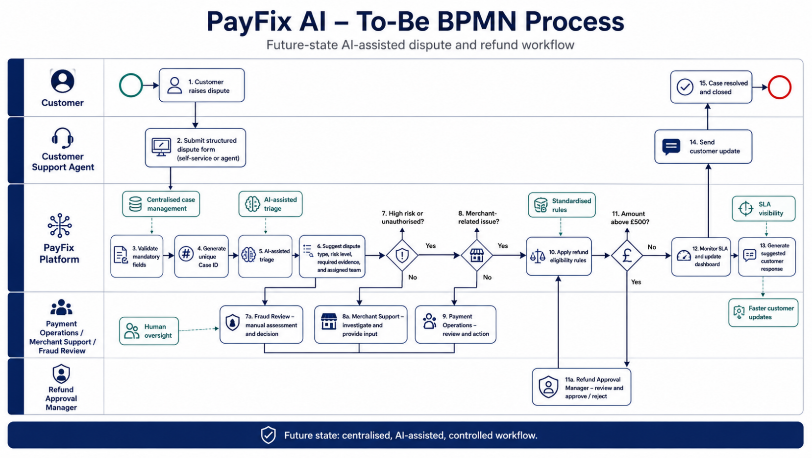
Figure 7: To-Be BPMN process showing the future-state AI-assisted dispute and refund workflow with structured intake, AI triage, refund rules, SLA visibility, routing and human oversight.
Step | Activity | Responsible/ System | Improvement
1 | Submit structured dispute form | Customer / Support Agent | Standardised case intake
2 | Generate case ID | Platform | Unique tracking and auditability
3 | Validate mandatory fields | Platform | Reduces incomplete cases
4 | Classify dispute type | AI Triage Agent | Faster and more consistent categorisation
5 | Assess risk and evidence needs | AI + Business Rules | Better prioritisation and review control
6 | Check refund eligibility | System Decision Table | More consistent refund recommendation
7 | Route case to correct team | Workflow Engine | Reduces manual handoffs
8 | Track SLA status | Platform | Real-time visibility and escalation
9 | Generate summary and response | AI Triage Agent | Improves communication and reduces manual effort
The To-Be process introduces a structured and controlled workflow. Instead of relying on manual case logging, separate spreadsheets, and informal handoffs, the proposed platform provides a single case record, automated classification support, clear team routing, SLA visibility, refund decision support, and management reporting.
This future-state process improves operational efficiency while maintaining human oversight for fraud-related, high-value, or complex refund decisions.
16.5 BPMN Elements Used
The process can be represented using BPMN-style elements to show the flow of activities, decisions, responsibilities, and system interactions. The purpose of using BPMN is to make the process understandable for both business and technical stakeholders.
BPMN Element | How It Is Used in This Project | Example
Start Event | Shows where the process begins | Customer raises payment dispute
Task | Represents an activity performed by a person or system | Support logs case, AI classifies dispute
User Task | Activity completed by a human user | Refund manager reviews case
Service Task | Automated activity completed by the system | Platform generates case ID
Gateway | Decision point in the process | Is refund eligible? Is fraud suspected?
Sequence Flow | Shows the order of activities | Case intake → AI triage → team routing
End Event | Shows where the process finishes | Case closed and customer updated
The BPMN-style process view helps convert the business problem into a clear operational workflow. It highlights where human tasks, automated system tasks, AI-assisted activities, and decision gateways are required. This supports later requirements documentation because each process step can be translated into functional requirements, user stories, acceptance criteria, and UAT test cases.
16.6 Process Improvement Summary
The process modelling exercise shows a clear shift from a manual, fragmented, and reactive dispute process to a structured, centralised, and AI-assisted operating model.
The key process improvements are:
1. Centralised dispute intake through a structured form.
2. Unique case ID generation for tracking and auditability.
3. Mandatory field validation to reduce incomplete cases.
4. AI-assisted dispute classification to reduce manual triage effort.
5. Standard refund eligibility rules to improve decision consistency.
6. Automatic team routing to reduce manual handoffs.
7. SLA tracking and escalation visibility to reduce resolution delays.
8. AI-generated internal summaries and customer response suggestions.
9. Dashboard reporting for management visibility.
10. Human review retained for high-risk, fraud-related, high-value, and complex cases.
This process improvement supports the business objective of improving dispute resolution speed, reducing manual workload, strengthening refund control, improving customer communication, and enabling better management decision-making.
17. Requirements Documentation
Requirements documentation was created to translate the business problem, data findings, consulting diagnosis, and process redesign into clear business, functional, product, and non-functional requirements.
This section shows how the proposed AI-assisted digital payment dispute and refund management platform should be defined before development. The purpose is to ensure that business stakeholders, product owners, technical teams, operations teams, and testing teams have a shared understanding of what needs to be built and why.
17.1 Purpose of Requirements Documentation
The purpose of requirements documentation is to convert business needs into structured, testable, and delivery-ready requirements. In this project, requirements documentation is important because the proposed platform involves multiple stakeholders, operational workflows, payment dispute rules, refund decisions, AI-assisted triage, SLA tracking, dashboard reporting, and user access controls.
For a Technical Business Analyst or IT Business Analyst, this stage is critical because it creates the bridge between business problems and technical delivery. The requirements must be clear enough for stakeholders to validate, developers to build, testers to test, and product owners to prioritise.
17.2 BRD - Business Requirements Document
The Business Requirements Document defines what the business needs from the proposed platform. It focuses on business objectives, stakeholder needs, expected outcomes, scope, constraints, assumptions, and success criteria.
BRD Area | Description
Business Need | Improve the manual, fragmented, and slow digital payment dispute and refund process.
Business Objective | Centralise dispute handling, reduce manual workload, improve SLA tracking, support consistent refund decisions, and improve customer communication.
Business Users | Customer support, payment operations, merchant support, fraud review, refund approval manager, product owner, and management team.
Business Outcome | Faster dispute resolution, better visibility, reduced SLA breaches, improved customer trust, and stronger management reporting.
Business Scope | Dispute intake, case tracking, AI-assisted classification, refund eligibility support, SLA monitoring, dashboard reporting, and customer response support.
Constraints | No real payment processing, no real customer data, human review required for high-risk and refund-sensitive cases.
Assumptions | Synthetic data reflects realistic fintech dispute patterns; AI is used for decision support, not final automated decision-making.
Success Criteria | Reduced resolution time, lower SLA breach rate, improved case visibility, better refund consistency, and improved customer communication.

17.2.1 Business Requirements
The following business requirements describe what the organisation needs to achieve through the proposed platform.
Requirement ID | Business Requirement | Priority | Business Value
BR-01 | The business must centralise all payment dispute and refund cases into one platform. | Must Have | Improves visibility and reduces fragmented case handling.
BR-02 | The business must capture all required dispute information at the point of case creation. | Must Have | Reduces incomplete cases and repeated customer follow-up.
BR-03 | The business must classify disputes by type, payment method, risk level, and refund eligibility. | Must Have | Supports faster triage and better case prioritisation.
BR-04 | The business must track SLA status for every dispute case. | Must Have | Helps reduce resolution delays and identify service risk.
BR-05 | The business must use standard refund eligibility rules for common dispute scenarios. | Must Have | Improves refund decision consistency and financial control.
BR-06 | The business must route cases to the correct team based on dispute type and risk. | Must Have | Reduces manual handoffs and improves ownership.
BR-07 | The business must retain human review for fraud-related, high-risk, high-value, or complex cases. | Must Have | Supports responsible decision-making and risk control
BR-08 | The business must provide management dashboards for dispute volume, SLA breaches, refund value, root causes, and risk levels. | Should Have | Improves operational reporting and decision-making
BR-09 | The business must improve customer communication using standardised and AI-assisted response templates | Should Have | Improves customer experience and reduces manual effort
BR-10 | The business must maintain an audit trail of key case actions and decisions. | Must Have | Supports traceability, compliance awareness, and accountability.
The business requirements show that the proposed solution must address both operational and management needs. The platform must not only capture cases, but also improve visibility, reduce delays, support consistent refund decisions, route cases correctly, track SLA performance, and retain human control for sensitive cases.
These business requirements will be translated into functional requirements, product requirements, user stories, acceptance criteria, and UAT test cases in later sections.
17.3 FRD - Functional Requirements Document
The Functional Requirements Document defines the system features and functions required to deliver the business requirements. While the BRD explains what the business needs, the FRD explains what the platform must do to meet those needs.
For this project, the functional requirements cover dispute case intake, case tracking, AI-assisted triage, refund eligibility support, SLA monitoring, team routing, dashboard reporting, customer communication, and audit trail management.
17.3.1 Functional Requirements
The following functional requirements describe the key features that the AI-assisted digital payment dispute and refund management platform must provide.
Requirement ID | Functional Requirement | Linked Business Requirement | Priority | Acceptance Criteria
FR-01 | The system shall allow a customer support agent to create a new dispute case. | BR-01, BR-02 | Must Have | User can enter dispute details and submit a case successfully.
FR-02 | The system shall generate a unique case ID for every dispute case. | BR-01 | Must Have | Each submitted case receives a unique case reference.
FR-03 | The system shall validate mandatory fields before case submission. | BR-02 | Must Have | Case cannot be submitted if required fields are missing.
FR-04 | The system shall allow dispute type to be captured or suggested. | BR-03 | Must Have | Case includes a dispute type such as failed payment, duplicate debit, refund delay, fraud claim, or merchant non-confirmation.
FR-05 | The system shall use AI-assisted triage to classify customer claim text. | BR-03, BR-09 | Should Have | AI suggests dispute type, risk level, evidence required, and next action.
FR-06 | The system shall assess refund eligibility using predefined business rules. | BR-05 | Must Have | System recommends Eligible, Not Eligible, or Manual Review.
FR-07 | The system shall route cases to the correct team based on dispute type and risk level. | BR-06 | Must Have | Case is assigned to Payment Operations, Merchant Support, Fraud Review, or Refund Approval.
FR-08 | The system shall start SLA tracking from the case creation date. | BR-04 | Must Have | SLA status is calculated using target days and actual resolution days.
FR-09 | The system shall flag SLA breaches. | BR-04 | Must Have | Cases exceeding target resolution time are marked as breached.
FR-10 | The system shall allow users to update case status. | BR-01 | Must Have | Users can update status such as Open, In Review, Awaiting Evidence, Resolved, or Rejected.
FR-11 | The system shall generate an internal case summary using AI assistance | BR-09 | Should Have | AI produces a short summary for operations teams
FR-12 | The system shall generate suggested customer response messages. | BR-09 | Should Have | AI suggests a professional customer update based on case type and status.
FR-13 | The system shall provide dashboard reporting. | BR-08 | Should Have | Dashboard shows dispute volume, SLA breaches, refund value, root causes, and risk levels.
FR-14 | The system shall maintain an audit trail of case actions. | BR-10 | Must Have | Key actions such as creation, update, assignment, and closure are recorded.
FR-15 | The system shall require manual review for fraud, high-risk, high-value, or complex cases. | BR-07 | Must Have | Sensitive cases are not automatically approved without human review
The functional requirements translate the business needs into system behaviour. They define what the platform must do to support dispute intake, classification, refund eligibility checks, routing, SLA monitoring, dashboard reporting, customer communication, and auditability.
These requirements also show where AI is used as decision support. The AI assists with classification, summarisation, response generation, and risk indication, but it does not replace human judgement for sensitive refund or fraud-related decisions.
17.3.2 Functional Modules
The proposed platform can be grouped into the following functional modules:
Module | Purpose | Main Users
Dispute Intake Module | Captures new dispute cases using a structured form. | Customer Support / Customer
Case Management Module | Tracks case status, owner, SLA, evidence, and resolution. | Support, Payment Operations, Managers
AI Triage Module | Suggests dispute type, risk level, evidence required, summary, and customer response. | Support, Payment Operations
Refund Eligibility Module | Applies business rules and recommends refund outcome. | Refund Team / Manager
SLA Monitoring Module | Tracks target and actual resolution time and flags breaches. | Operations Manager / Team Lead
Dashboard and Reporting Module | Provides management-level insights and KPIs. | Product Owner / Senior Management
Audit and Control Module | Records case actions and supports traceability. | Compliance, Managers, Technical BA

17.4 PRD - Product Requirements Document
The Product Requirements Document defines the product vision, target users, core features, MVP scope, success metrics, and future roadmap for the AI-assisted digital payment dispute and refund management platform.
While the BRD focuses on business needs and the FRD focuses on system functions, the PRD explains the product direction and how the proposed solution creates value for users and the business.
17.4.1 Product Vision
The product vision is to create a centralised, AI-assisted dispute and refund management platform that helps fintech/payment operations teams resolve customer payment issues faster, improve refund decision consistency, monitor SLA performance, reduce manual investigation effort, and improve customer communication.
The platform is designed to support operational teams with better visibility, structured workflows, AI-assisted triage, refund eligibility recommendations, and management dashboards.
17.4.2 Product Goals
The main product goals are:
1. Reduce manual effort in dispute classification and case triage.
2. Improve visibility of case status, ownership, and SLA performance.
3. Support consistent refund eligibility recommendations.
4. Route cases to the correct team based on dispute type and risk level.
5. Improve customer communication through standardised and AI-assisted response templates.
6. Provide management dashboards for dispute trends, refund impact, root causes, risk levels, and SLA breaches.
7. Retain human review for fraud-related, high-value, high-risk, or complex cases.
17.4.3 Target Users
User Group | Needs | Product Value
Customer Support Agent | Log cases quickly and provide clear updates | Structured intake form and AI-assisted response suggestions
Payment Operations Analyst | Investigate transaction issues efficiently | Case details, transaction status, root cause, and routing support
Merchant Support Analyst | Check merchant settlement and confirmation | Clear case ownership and merchant-related workflow
Fraud Review Analyst | Review suspicious or unauthorised cases | Risk flagging and manual review routing
Refund Approval Manager | Make consistent refund decisions | Refund eligibility recommendation and decision table
Operations Manager | Monitor workload, SLA, refund value, and root causes | Dashboard reporting and KPI visibility

17.4.4 MVP Scope
The Minimum Viable Product will focus on the most important features required to demonstrate business value and operational improvement.
MVP Feature | Description | Priority
Dispute Submission Form | Allows support agents to create structured dispute cases. | Must Have
Unique Case ID | Generates a unique reference for each case. | Must Have
Case Management View | Shows case status, assigned team, SLA, risk level, and refund eligibility. | Must Have
AI Dispute Classification | Suggests dispute type based on customer claim text. | Should Have
Refund Eligibility Recommendation | Suggests Eligible, Not Eligible, or Manual Review based on business rules. | Must Have
SLA Tracking | Calculates SLA breach status based on target and actual resolution days. | Must Have
Dashboard View | Shows dispute KPIs, trends, root causes, refund value, and risk levels. | Should Have
AI Customer Response Suggestion | Generates suggested customer communication messages. | Should Have

17.4.5 Future Roadmap
Future Feature | Description | Business Value
Live Payment Gateway Integration | Connect with real transaction systems and payment gateway logs. | Reduces manual transaction checking
Merchant API Integration | Pull merchant settlement confirmation automatically. | Speeds up merchant-related disputes
Fraud Risk Scoring Model | Use advanced analytics to score fraud risk. | Improves risk prioritisation
Customer Self-Service Portal | Allows customers to track dispute status directly. | Reduces support workload
Automated SLA Escalation Alerts | Notify managers when cases approach breach. | Improves operational control
Power BI Executive Dashboard | Provide senior management reporting. | Improves strategic decision-making

17.4.6 Product Success Metrics
Product success will be measured using the following metrics:
Metric | Target Direction | Reason
Average Resolution Time | Reduce | Shows faster dispute handling
SLA Breach Rate | Reduce | Shows better control and escalation
Manual Review Rate | Reduce for low-risk cases | Shows automation opportunity
Customer Sentiment | Improve | Shows better customer experience
Refund Decision Consistency | Improve | Shows stronger business rules
Case Visibility | Improve | Shows better operational tracking
AI Classification Accuracy | Improve over time | Shows quality of AI-assisted triage
The PRD shows that the proposed platform is not only a technical system, but a product designed to solve real operational problems. The MVP focuses on the core dispute and refund workflow, while the future roadmap allows the solution to mature into a more advanced fintech operations platform with live integrations, self-service tracking, fraud scoring, and executive reporting.
17.5 Non-Functional Requirements
Non-functional requirements define how the system should perform, behave, and operate. They focus on quality areas such as usability, performance, security, auditability, reliability, data protection, accessibility, and maintainability.
For this project, non-functional requirements are important because the proposed platform handles payment dispute information, refund decisions, case routing, SLA tracking, AI-assisted recommendations, and management reporting.
17.5.1 Non-Functional Requirements Table
Requirement ID | Category | Non-Functional Requirement | Priority | Acceptance Criteria
NFR-01 | Usability | The platform should be simple enough for non-technical support and operations users to use with minimal training. | Must Have | A user can create and update a case without technical support.
NFR-02 | Performance | Dashboard and case views should load within 3 seconds for the portfolio dataset size. | Should Have | Dashboard opens without noticeable delay during demo.
NFR-03 | Security | Access should be role-based so users only see features relevant to their role. | Must Have | Support, operations, fraud, refund manager and admin roles have different access levels.
NFR-04 | Data Protection | The demo dataset must not include real customer, bank, merchant, or transaction data. | Must Have | Dataset uses synthetic IDs and no personal data.
NFR-05 | Auditability | The system should maintain a record of important case actions and decisions. | Must Have | Case creation, assignment, status update, refund recommendation and closure are traceable.
NFR-06 | Reliability | The platform should support consistent case handling without losing submitted case data. | Must Have | Submitted case records are saved and visible in the case list.
NFR-07 | Maintainability | Business rules should be documented clearly so they can be updated later. | Should Have | Refund eligibility rules are documented in a decision table.
NFR-08 | Explainability | AI-assisted recommendations should be explainable to users. | Must Have | AI output shows reason for classification, refund recommendation or manual review.
NFR-09 | Scalability | The design should allow future expansion to larger datasets and live integrations. | Could Have | Future roadmap includes payment gateway, merchant API and Power BI integration.
NFR-10 | Human Oversight | High-risk, fraud-related, high-value and complex cases must require human review. | Must Have | AI does not make final refund decisions for sensitive cases.
The non-functional requirements show that the platform must be usable, secure, explainable, auditable, and reliable. This is especially important because the solution involves payment dispute handling, refund recommendations, risk routing, and AI-assisted decision support.
The most important non-functional principle is human oversight. AI should support the user by classifying cases, summarising information, and suggesting next actions, but final decisions for sensitive or high-risk cases should remain with trained human users.
17.6 Business Rules
Business rules define the logic that guides dispute classification, refund eligibility, routing, SLA tracking, and manual review decisions. These rules help convert business policy and operational judgement into structured system behaviour.
17.6.1 Business Rules Table
Rule ID | Business Rule | Outcome | Priority
RULE-01 | If transaction status is Failed and amount was debited, refund eligibility should be marked as Eligible. | Refund recommended | Must Have
RULE-02 | If dispute type is Duplicate Debit and evidence is available, refund eligibility should be marked as Eligible. | Refund recommended | Must Have
RULE-03 | If dispute type is Refund Delay and merchant confirmation is pending, case should be routed to Merchant Support. | Merchant review required | Must Have
RULE-04 | If dispute type is Merchant Not Credited, case should be routed to Payment Operations and Merchant Support. | Joint investigation required | Must Have
RULE-05 | If dispute type is Unauthorised Transaction, case should be routed to Fraud Review | Manual fraud review | Must Have
RULE-06 | If risk level is High, case should require manual review before any refund decision. | Manual review required | Must Have
RULE-07 | If transaction amount is above £500, case should require manager approval | Manager approval required | Must Have
RULE-08 | If evidence is not available, case status should be Awaiting Evidence. | Customer follow-up required | Must Have
RULE-09 | If actual resolution days are greater than SLA target days, SLA breach should be Yes. | SLA breach flag | Must Have
RULE-10 | If customer sentiment is Negative and SLA is breached, case should be prioritised for urgent communication. | Priority communication | Should Have
RULE-11 | If case is low-risk and refund eligibility is clear, case can be fast-tracked for review. | Faster resolution | Should Have
RULE-12 | AI-generated recommendations must be treated as decision support, not final approval. | Human oversight | Must Have

The business rules help standardise dispute handling and reduce inconsistent decision-making. They also provide the logic needed for refund eligibility, team routing, SLA breach identification, risk escalation, and AI-assisted triage.
These rules are important for system design because they can later be translated into prototype logic, user stories, acceptance criteria, and UAT test cases.
17.7 Refund Eligibility Decision Table
The refund eligibility decision table explains how different dispute scenarios should be assessed. It supports consistent decision-making by linking dispute type, transaction status, evidence availability, risk level, and transaction amount to a recommended outcome.
Scenario | Transaction Status | Evidence Available | Risk Level | Transaction Amount | Recommended Outcome
Failed payment with debit confirmed | Failed | Yes | Low / Medium | Any | Eligible
Duplicate debit confirmed | Success | Yes | Low / Medium | Any | Eligible
Refund delay with merchant pending | Success | Partial / No | Medium | Any | Manual Review
Merchant not credited | Success / Pending | Yes | Medium | Any | Manual Review
Unauthorised transaction claim | Success | Yes / No | High | Any | Fraud Review
High-value dispute | Any | Yes / No | Medium / High | Above £500 | Manager Approval
Missing evidence | Any | No | Any | Any | Awaiting Evidence
Customer error confirmed | Success | Yes | Low | Any | Not Eligible
Complex or unclear case | Any | Partial | Medium / High | Any | Manual Review

The decision table supports transparent refund recommendations and reduces dependency on individual judgement. It does not remove human decision-making, but it provides a consistent structure for assessing common dispute scenarios.
In the proposed platform, this decision table would support the refund eligibility module and AI dispute triage agent. The system could recommend Eligible, Not Eligible, Awaiting Evidence, Manual Review, Fraud Review, or Manager Approval depending on the case conditions.
17.8 Requirements Traceability Matrix
A Requirements Traceability Matrix was created to show how business requirements connect to functional requirements, Jira user stories, UAT test cases and final delivery status.
This is important because a Technical Business Analyst must ensure that every important business need is translated into system functionality and tested before go-live.
Business Requirement | Functional Requirement | Jira Story | UAT Test Case | Status
BR-01 Centralise dispute cases into one platform | FR-01 Create new dispute case | PAYFIX-02 Create structured dispute submission form | UAT-01 Create dispute case | Passed
BR-02 Capture all required dispute information | FR-03 Validate mandatory fields | PAYFIX-04 Validate mandatory fields | UAT-02 Mandatory field validation | Passed
BR-03 Classify disputes by type, payment method, risk and refund eligibility | FR-05 AI-assisted triage | PAYFIX-08 Add AI-style dispute classification | UAT-03 AI triage output | Passed
BR-04 Track SLA status for every case | FR-08 Start SLA tracking and FR-09 Flag SLA breaches | PAYFIX-05 Calculate SLA breach status | UAT-04 SLA breach checker | Passed
BR-05 Use standard refund eligibility rules | FR-06 Refund eligibility assessment | PAYFIX-06 Build refund eligibility checker | UAT-05 Refund eligibility outcome | Passed
BR-06 Route cases to the correct team | FR-07 Team routing | PAYFIX-07 Route case to assigned team | UAT-06 Team routing logic | Passed
BR-07 Retain human review for sensitive cases | FR-15 Manual review for fraud, high-risk and high-value cases | PAYFIX-11 Add human oversight warning | UAT-07 Human review warning | Passed
BR-08 Provide management dashboards | FR-13 Dashboard reporting | PAYFIX-10 Build executive dashboard | UAT-08 Dashboard KPI visibility | Passed
BR-09 Improve customer communication | FR-12 Customer response suggestion | PAYFIX-09 Generate customer response suggestion | UAT-09 Customer response generator | Passed
BR-10 Maintain audit trail | FR-14 Audit trail of case actions | PAYFIX-12 Prepare UAT evidence and audit concept | UAT-10 Audit and evidence check | Passed
The traceability matrix confirms that the solution is not only documented, but also linked from business need to functional requirement, Jira delivery item and UAT validation.
17.9 Confluence Documentation Structure
In a real project environment, Confluence would be used as the central documentation hub for the PayFix AI project. The Word report represents the portfolio version, while Confluence would organise the same content into structured project pages for business, product, technical and testing stakeholders.
Confluence Page | Purpose
PayFix AI Project Home | Provides project overview, objectives, links and current status
Business Case and Project Charter | Stores business problem, scope, objectives and expected benefits
BRD – Business Requirements | Documents business requirements and stakeholder needs
FRD – Functional Requirements | Documents system features, behaviours and acceptance expectations
PRD – Product Requirements | Defines product vision, users, MVP scope and roadmap
NFR and Business Rules | Stores non-functional requirements, business rules and decision table
BPMN Process Design | Stores As-Is and To-Be process diagrams
API and Integration Requirements | Documents proposed APIs, data flow and integrations
UAT Test Summary | Stores test cases, test status, defects and sign-off evidence
Go-Live Readiness | Stores implementation plan, checklist, rollback plan and training plan
Decision Log | Records important project decisions and reasons
Change Log | Tracks approved scope or requirement changes
Meeting Notes | Stores workshop notes, sprint review notes and stakeholder feedback
Confluence would help maintain version control, stakeholder visibility, decision history and a single source of truth for project documentation.

18. Agile and Delivery Planning
Agile and delivery planning was used to show how the proposed AI-assisted digital payment dispute and refund management platform could move from requirements into implementation. This section explains the delivery approach, backlog structure, user stories, sprint planning, acceptance criteria, and delivery governance.
The purpose of this section is to demonstrate how a Technical Business Analyst supports delivery by translating business and functional requirements into prioritised work items that can be understood by product owners, developers, testers, and business stakeholders.
18.1 Delivery Approach
The project uses a hybrid delivery approach that combines Waterfall-style governance with Agile/Scrum delivery.
Waterfall is used for structured project stages such as business case creation, requirements documentation, stakeholder sign-off, risk review, UAT planning, and go-live approval. This is useful because payment dispute and refund processes involve operational risk, financial impact, customer communication, and human oversight.
Agile/Scrum is used for designing and building the prototype in iterative sprints. This allows the project to deliver working features gradually, gather feedback, refine requirements, and demonstrate progress through sprint outputs.
This hybrid approach is realistic for fintech and payment-related projects because business stakeholders often require clear documentation and control, while technical teams benefit from iterative delivery and backlog-based development.
18.1.1 SDLC, Waterfall, Agile and Scrum Alignment
This project follows an SDLC-style delivery journey from business problem discovery to go-live planning. The early stages of the project follow a Waterfall-style approach because the business case, scope, stakeholder analysis, requirements documentation, risk register, business rules, UAT plan and go-live checklist are prepared in a structured sequence.
Agile and Scrum are used for iterative prototype delivery. The product backlog, user stories, acceptance criteria, sprint plan, Definition of Ready, Definition of Done, sprint review and retrospective show how the solution could be built, tested and improved across sprints.
This hybrid approach is suitable for a fintech/payment operations project because it provides the documentation and governance needed for risk-sensitive work, while still allowing the prototype and product features to be developed iteratively.
18.2 Hybrid Agile and Waterfall Explanation
The hybrid approach separates governance-heavy activities from iterative solution delivery. This allows the project to maintain structure and control while still supporting flexibility during prototype development.
Project Area | Waterfall Use | Agile/Scrum Use | Reason
Business Case | Created upfront before delivery begins | Reviewed during sprint planning | Ensures the project has clear business justification
Requirements | BRD, FRD, PRD and NFR documented before build | Refined into user stories and backlog items | Converts business needs into delivery-ready tasks
Process Design | As-Is and To-Be processes documented before prototype | Updated if sprint feedback identifies changes | Keeps process improvement aligned with delivery
Risk and Controls | Risk register, business rules and decision table documented early | Risks reviewed during sprint planning and reviews | Supports responsible delivery and human oversight
Prototype Build | High-level solution scope agreed upfront | Built iteratively across sprints | Allows working features to be delivered step by step
Testing | UAT approach and acceptance criteria defined early | Testing completed during each sprint and final UAT | Ensures the solution meets business expectations
Go-Live | Go-live checklist and sign-off prepared at the end | Sprint outputs support release readiness | Reduces implementation risk

The hybrid delivery approach shows that the project is not treated as a simple coding exercise. It is managed as a business transformation project where documentation, stakeholder alignment, risk control, iterative development, testing, and go-live planning all work together.
This is important for a Technical Business Analyst because the role often sits between business stakeholders and technical delivery teams. The BA must ensure that business needs are properly understood, translated into requirements, prioritised into backlog items, tested through acceptance criteria, and delivered in a controlled way.
18.3 Product Backlog
The product backlog contains the prioritised features, tasks, and improvements required to deliver the AI-assisted digital payment dispute and refund management platform. The backlog converts business requirements and functional requirements into delivery-ready items that can be planned across Agile sprints.
Backlog ID | Backlog Item | Description | Priority | Linked Requirement | Sprint
PB-01 | Dispute submission form | Create a structured form to capture payment dispute details. | Must Have | FR-01, FR-03 | Sprint 1
PB-02 | Unique case ID generation | Generate a unique reference for every dispute case. | Must Have | FR-02 | Sprint 1
PB-03 | Case management table | Display case ID, status, assigned team, SLA status, risk level, and refund eligibility | Must Have | FR-10 | Sprint 2
PB-04 | AI dispute classification | Suggest dispute type based on customer claim text. | Should Have | FR-05 | Sprint 3
PB-05 | Refund eligibility logic | Recommend Eligible, Not Eligible, Manual Review, Fraud Review, or Manager Approval. | Must Have | FR-06 | Sprint 3
PB-06 | Team routing logic | Assign cases to Payment Operations, Merchant Support, Fraud Review, or Refund Approval. | Must Have | FR-07 | Sprint 3
PB-07 | SLA tracking | Calculate SLA breach status using target and actual resolution days. | Must Have | FR-08, FR-09 | Sprint 2
PB-08 | Dashboard reporting | Show dispute volume, SLA breaches, refund value, root causes, risk levels, and payment method issues. | Should Have | FR-13 | Sprint 4
PB-09 | AI internal case summary | Generate a short internal summary for operations teams. | Should Have | FR-11 | Sprint 4
PB-10 | AI customer response suggestion | Suggest customer response messages based on case type and status. | Should Have | FR-12 | Sprint 4
PB-11 | Audit trail concept | Document how case actions and decisions should be tracked. | Must Have | FR-14 | Sprint 5
PB-12 | UAT test cases | Create business test scenarios for key platform functions. | Must Have | FR-01 to FR-15 | Sprint 5
The product backlog shows how the solution can be delivered in manageable increments. The early sprints focus on core workflow features such as dispute submission, case tracking, and SLA visibility. Later sprints introduce AI-assisted triage, refund eligibility logic, dashboard reporting, customer communication support, audit trail design, and UAT preparation.
18.3.1 Jira Backlog and Sprint Tracking
Jira would be used as the Agile delivery and tracking tool for the PayFix AI project. The purpose of using Jira is to manage epics, user stories, tasks, sub-tasks, bugs, sprint planning, acceptance criteria, task ownership and sprint progress.
The business requirements and functional requirements are translated into Jira backlog items. Each Jira item includes a summary, description, priority, linked requirement, acceptance criteria, sprint allocation, owner and delivery status.

Proposed Jira Issue Types
Jira Item Type | How It Is Used in PayFix AI | Example
Epic | Large delivery area or feature group | Dispute Case Management
Story | User-focused requirement | As a support agent, I want to create a dispute case so that customer issues are captured consistently
Task | Technical or BA activity needed to deliver a story | Create mandatory field validation logic
Sub-task | Smaller activity under a story or task | Add validation for transaction ID field
Bug / Defect | Issue found during testing or UAT | SLA breach flag not updating correctly
Sprint | Time-boxed delivery cycle | Sprint 1: Case Intake Foundation
Acceptance Criteria | Conditions required for story acceptance | Case cannot be submitted if mandatory fields are missing
Status | Progress tracking | To Do, In Progress, In Review, Ready for UAT, Done
Proposed Jira Workflow
Workflow Stage | Meaning
Backlog | Item is captured but not yet selected for delivery
Selected for Sprint | Item has been prioritised for the upcoming sprint
In Progress | Work has started
In Review | Output is being reviewed by BA/Product Owner/Tester
Ready for UAT | Item is ready for business testing
Done | Item meets acceptance criteria and is accepted
Proposed Jira Defect Workflow
Defect Status | Meaning
Open | Defect has been raised
In Progress | Developer or owner is working on the defect
Fixed | Fix has been completed
Retest | Tester is validating the fix
Closed | Defect has passed retest and is closed
Example Jira Backlog Items
Jira ID | Issue Type | Summary | Priority | Sprint | Status
PAYFIX-01 | Epic | Dispute Case Management | Must Have | Sprint 1–2 | Planned
PAYFIX-02 | Story | Create structured dispute submission form | Must Have | Sprint 1 | Done
PAYFIX-03 | Story | Generate unique case ID | Must Have | Sprint 1 | Done
PAYFIX-04 | Story | Validate mandatory fields | Must Have | Sprint 1 | Done
PAYFIX-05 | Story | Calculate SLA breach status | Must Have | Sprint 2 | Done
PAYFIX-06 | Story | Build refund eligibility checker | Must Have | Sprint 3 | Done
PAYFIX-07 | Story | Route case to assigned team | Must Have | Sprint 3 | Done
PAYFIX-08 | Story | Add AI-style dispute classification | Should Have | Sprint 4 | Done
PAYFIX-09 | Story | Generate customer response suggestion | Should Have | Sprint 4 | Done
PAYFIX-10 | Story | Build executive dashboard | Should Have | Sprint 4 | Done
PAYFIX-11 | Story | Add human oversight warning | Must Have | Sprint 5 | Done
PAYFIX-12 | Task | Prepare UAT test evidence and screenshots | Must Have | Sprint 5 | Done
PAYFIX-13 | Bug | SLA breach flag not updating correctly | Medium | Sprint 5 | Closed
PAYFIX-14 | Bug | Customer response formatting issue | Low | Sprint 5 | Closed
Jira would support backlog refinement, sprint planning, sprint review, retrospective, defect tracking and UAT readiness. This makes the delivery process more transparent for the Product Owner, Technical Business Analyst, developers, testers and business stakeholders.
18.4 User Stories and Acceptance Criteria
User stories were created to describe platform features from the perspective of users. Acceptance criteria were added to define when each user story can be considered complete and testable.
Story ID | User Story | Priority | Acceptance Criteria | Linked Backlog Item
US-01 | As a customer support agent, I want to create a structured dispute case so that customer issues are captured consistently. | Must Have | Required fields must be completed before submission; case is saved successfully. | PB-01
US-02 | As a support agent, I want the system to generate a unique case ID so that every dispute can be tracked | Must Have | A unique case ID is generated after case submission. | PB-02
US-03 | As a payment operations analyst, I want to view all open and in-review cases so that I can manage investigation workload. | Must Have | Case list displays case ID, dispute type, status, assigned team, risk level, and SLA status. | PB-03
US-04 | As a support agent, I want AI to suggest the dispute type so that I can reduce manual classification effort. | Should Have | AI suggests a dispute type based on customer claim text. | PB-04
US-05 | As a refund approval manager, I want the system to recommend refund eligibility so that decisions are more consistent. | Must Have | System shows Eligible, Not Eligible, Manual Review, Fraud Review, or Manager Approval. | PB-05
US-06 | As an operations manager, I want cases routed to the correct team so that ownership is clear. | Must Have | Case is assigned based on dispute type and risk level. | PB-06
US-07 | As an operations manager, I want SLA breaches to be visible so that delayed cases can be escalated. | Must Have | Cases exceeding SLA target are marked as breached. | PB-07
US-08 | As a senior manager, I want a dashboard of dispute KPIs so that I can monitor business performance. | Should Have | Dashboard shows total cases, SLA breach rate, refund value, dispute type, root cause, and risk level. | PB-08
US-09 | As a payment operations analyst, I want AI to generate an internal case summary so that I can understand the case quickly. | Should Have | AI summary includes dispute type, issue, risk level, evidence needed, and next action | PB-09
US-10 | As a customer support agent, I want AI to suggest customer response messages so that communication is faster and clearer. | Should Have | AI generates a professional response based on case type and status. | PB-10
The user stories connect the business and functional requirements with real user needs. They also provide a clear basis for sprint planning, prototype development, testing, and UAT. Each story is written in a way that helps developers understand the expected feature and helps testers confirm whether the feature meets the business need.
18.5 Sprint Plan
The sprint plan shows how the product backlog can be delivered in structured Agile iterations. Each sprint focuses on a specific set of outputs that gradually move the project from requirements into prototype, AI automation, testing, and go-live preparation.
Sprint | Focus Area | Key Activities | Main Outputs | Linked Backlog Items
Sprint 1 | Case Intake Foundation | Build structured dispute submission form and case ID logic. | Dispute form, mandatory fields, unique case ID. | PB-01, PB-02
Sprint 2 | Case Management and SLA | Build case management table and SLA tracking logic. | Case list, case status, SLA breach indicator. | PB-03, PB-07
Sprint 3 | Refund and Routing Logic | Build refund eligibility logic and team routing rules. | Refund recommendation, assigned team logic. | PB-05, PB-06
Sprint 4 | AI and Dashboard Features | Add AI dispute classification, internal summary, customer response, and dashboard view | AI triage output, response suggestion, KPI dashboard | PB-04, PB-08, PB-09, PB-10
Sprint 5 | Audit, Testing and Go-Live Prep | Document audit trail concept, UAT test cases, defect log, and go-live readiness. | UAT pack, test summary, go-live checklist. | PB-11, PB-12
The sprint plan demonstrates how the project can be delivered in manageable increments. The first two sprints focus on core case handling and SLA visibility. The next sprints introduce refund rules, team routing, AI-assisted features, dashboard reporting, auditability, testing, and go-live readiness.
This structure allows business stakeholders to review progress at the end of each sprint and provide feedback before the solution is finalised.
18.6 Definition of Ready
The Definition of Ready explains the conditions that a backlog item must meet before it can be taken into a sprint. This helps ensure that the development team has enough information to start work without major ambiguity.
Ready Criteria | Description
Clear Business Value | The backlog item explains why it matters to the business or user.
User Story Written | The item is written as a user story or clear delivery task.
Acceptance Criteria Defined | The expected outcome is clear and testable.
Dependencies Identified | Any dependency on data, rules, design, or another feature is known
Priority Confirmed | The product owner has confirmed the priority.
Scope Understood | The team understands what is included and excluded.
Testability Confirmed | The item can be validated through testing or UAT.

18.7 Definition of Done
The Definition of Done explains the conditions that must be met before a backlog item or sprint output can be considered complete.
Done Criteria | Description
Requirement Met | The output meets the linked business or functional requirement.
Acceptance Criteria Passed | All acceptance criteria have been tested successfully.
Data Validation Completed | Inputs, outputs, and calculations are checked for accuracy.
Error Handling Considered | Common user or data errors are handled appropriately.
Documentation Updated | Relevant BRD, FRD, PRD, process, or testing documentation is updated.
UAT Evidence Captured | Screenshot, test note, or result is recorded where relevant.
Stakeholder Feedback Reviewed | Business or user feedback has been considered.
Ready for Demo or Release | The output can be shown in sprint review or included in go-live preparation.

18.8 Sprint Review and Retrospective
Sprint review and retrospective notes were included to show how Agile feedback and continuous improvement would be managed during delivery.
Sprint Review Approach:
At the end of each sprint, the completed outputs would be demonstrated to stakeholders such as the product owner, operations manager, support team, and technical team. The review would focus on whether the sprint outputs meet the agreed user stories, acceptance criteria, and business objectives.
Example sprint review questions:
1. Does the feature solve the intended business problem?
2. Is the workflow clear for users?
3. Are the outputs easy to understand?
4. Does the feature support the target KPIs?
5. What feedback should be added to the backlog?
Sprint Retrospective Approach:
After each sprint, the delivery team would review what went well, what did not go well, and what should be improved in the next sprint.
Example retrospective questions:
1. What worked well during this sprint?
2. What caused delay or confusion?
3. Were requirements clear enough?
4. Did the acceptance criteria support testing?
5. What should be improved in the next sprint?
The Agile delivery planning section shows how the project can move from documentation into practical delivery. It demonstrates how a Technical Business Analyst supports backlog preparation, user story writing, sprint planning, acceptance criteria, stakeholder feedback, testing alignment, and delivery governance.
This also shows that the project has been structured like a real business transformation initiative rather than a standalone technical prototype.
18.9 Change Control Log
A change control log was used to show how requirement and scope changes would be reviewed, assessed and approved during delivery.
This is important because fintech/payment operations projects involve business risk, customer communication, refund decisions, fraud review and operational controls. Changes should therefore be managed carefully rather than added informally.
Change ID | Change Request | Reason | Impact | Decision | Owner
CR-01 | Add human review for high-value refunds above £500 | Reduce refund risk and improve financial control | Medium | Approved | Product Owner / Refund Manager
CR-02 | Add customer response generator | Improve communication speed and consistency | Low | Approved | Product Owner / Technical BA
CR-03 | Add SLA breach checker | Improve service visibility and escalation | Medium | Approved | Operations Manager
CR-04 | Add AI-style dispute classification | Reduce manual triage effort | Medium | Approved | Product Owner / Technical BA
CR-05 | Add integration landscape diagram | Strengthen IT BA solution design | Low | Approved | Technical BA
CR-06 | Keep AI as decision-support only | Reduce risk in refund and fraud-sensitive decisions | High | Approved | Product Owner / Fraud Review Team
The change control log shows that changes were assessed based on business value, risk, implementation impact and stakeholder approval. This supports controlled delivery and prevents uncontrolled scope expansion.
19. AI Agent Automation Design
AI automation was included in this project to support faster dispute triage, improved case summarisation, better refund decision support, and clearer customer communication.

The AI component is designed as a decision-support tool for payment operations teams. It does not replace human judgement, especially for high-risk, fraud-related, high-value, or complex refund cases.
19.1 Purpose of AI Automation
The purpose of AI automation in this project is to reduce manual effort, improve case prioritisation, support consistent decision-making, and improve communication quality in the digital payment dispute and refund process.
In the current As-Is process, support and operations teams manually read customer claims, identify dispute types, check evidence, decide which team should handle the case, assess refund eligibility, and write customer updates. This creates delays, inconsistency, and operational workload.
In the proposed To-Be process, AI assists by reading the customer claim and generating structured outputs such as dispute type, risk level, evidence required, recommended team, refund recommendation, internal case summary, and suggested customer response.
The AI is not used to make final financial decisions. Instead, it supports human users by preparing information faster and more consistently.
19.2 AI Dispute Triage Agent
The AI Dispute Triage Agent is designed to support the first stage of dispute handling. When a new payment dispute is submitted, the agent reads the customer claim and case details, then produces a structured triage output for the support or payment operations team.
AI Agent Function | Description | Business Value
Dispute Classification | Identifies whether the case relates to failed payment, duplicate debit, refund delay, merchant not credited, unauthorised transaction, or other issue. | Reduces manual triage effort and improves consistency.
Risk Identification | Suggests whether the case is low, medium, or high risk. | Helps prioritise urgent or sensitive cases.
Evidence Recommendation | Identifies what evidence may be needed to progress the case. | Reduces repeated customer follow-up.
Team Routing Suggestion | Recommends whether the case should go to Payment Operations, Merchant Support, Fraud Review, or Refund Approval. | Improves ownership and reduces handoff delays.
Refund Recommendation Support | Suggests Eligible, Not Eligible, Awaiting Evidence, Manual Review, Fraud Review, or Manager Approval. | Supports consistent refund decision-making.
Internal Case Summary | Summarises the customer issue and key case details for operations teams. | Saves time and improves case understanding.
Customer Response Suggestion | Generates a professional customer update based on case status and issue type. | Improves communication speed and quality.
SLA Risk Flag | Identifies cases that may need urgent attention based on risk, sentiment, or delay. | Supports escalation and service control.

19.3 AI Agent Inputs and Outputs
The AI agent uses structured case information and customer complaint text as input. It then returns a structured output that can be used by support agents, payment operations analysts, refund managers, and fraud review teams.
Input Data | Example | How AI Uses It
Customer Claim | “Money was debited but merchant says payment was not received.” | Understands the issue and classifies dispute type.
Payment Method | Card / Wallet / Bank Transfer / Open Banking | Supports channel-based triage and risk context.
Transaction Status | Success / Failed / Pending | Supports refund eligibility recommendation.
Transaction Amount | £85.00 | Helps identify high-value cases needing approval.
Evidence Available | Yes / No / Partial | Determines if case can progress or needs more evidence.
Risk Level | Low / Medium / High | Supports manual review and prioritisation.
Dispute Type | Refund Delay / Duplicate Debit / Failed Payment | Supports routing and response generation
SLA Status | Within SLA / Breached | Supports escalation and customer communication.
Customer Sentiment | Negative / Neutral / Positive | Helps decide communication urgency and tone.
The expected AI output is structured so that it can be reviewed by a human user before any action is taken.

AI Output | Example Output | User Benefit
Dispute Type | Merchant Not Credited | Faster classification
Severity | High | Better prioritisation
Required Evidence | Bank debit confirmation and merchant settlement status | Clear next steps
Recommended Team | Payment Operations + Merchant Support | Better routing
Refund Recommendation | Manual Review | More consistent decision support
Internal Summary | Customer paid £85 but merchant has not confirmed receipt. | Faster case understanding
Customer Response | We are reviewing your payment and will update you shortly. | Faster communication
SLA Risk | High | Escalation awareness
The input and output structure helps make the AI agent explainable and useful for business users. Instead of giving a vague answer, the AI returns structured fields that can be checked, edited, accepted, or rejected by a human user.
This supports responsible AI use because the AI provides assistance, but operational teams remain accountable for final decisions.
19.4 AI Classification Logic
The AI classification logic explains how the AI Dispute Triage Agent can classify customer claims into the correct dispute category. The aim is to reduce manual triage effort and improve consistency when cases are first received.
The classification logic uses customer complaint text, payment method, transaction status, evidence availability, risk level, and transaction amount to suggest a dispute type and severity level.
Customer Claim Pattern | Suggested Dispute Type | Suggested Severity | Routing Suggestion
Money debited but payment failed | Failed Payment | Medium / High | Payment Operations
Charged twice for same transaction | Duplicate Debit | Medium | Payment Operations / Refund Approval
Refund promised but not received | Refund Delay | Medium | Merchant Support / Refund Approval
Merchant says payment not received | Merchant Not Credited | High | Payment Operations + Merchant Support
Customer denies making the payment | Unauthorised Transaction | High | Fraud Review
Wrong amount was deducted | Wrong Amount Debited | Medium | Payment Operations
Customer reports scam or suspicious transfer | Fraud / Scam Claim | High | Fraud Review
Evidence missing or unclear issue | Incomplete Case | Medium | Awaiting Evidence / Support Follow-up
The classification logic provides a structured way for the AI agent to support first-level triage. The AI does not make final decisions, but it helps the support or operations team understand the likely dispute category, urgency, and correct routing path.
19.5 AI Refund Recommendation Logic
The AI refund recommendation logic uses business rules and the refund eligibility decision table to suggest whether a case is likely to be eligible for refund, not eligible, awaiting evidence, requiring manual review, requiring fraud review, or requiring manager approval.
Condition | Evidence Status | Risk Level | Transaction Amount | AI Recommendation
Failed transaction and debit confirmed | Yes | Low / Medium | Any | Eligible
Duplicate debit confirmed | Yes | Low / Medium | Any | Eligible
Refund delay but merchant confirmation pending | Partial / No | Medium | Any | Manual Review
Merchant not credited | Yes / Partial | Medium | Any | Manual Review
Unauthorised transaction claim | Any | High | Any | Fraud Review
High-value dispute | Any | Medium / High | Above £500 | Manager Approval
Missing evidence | No | Any | Any | Awaiting Evidence
Customer error confirmed | Yes | Low | Any | Not Eligible
The refund recommendation logic improves consistency by applying the same decision structure across similar cases. However, the AI recommendation remains advisory. Final refund approval should be completed by the refund manager, fraud team, or authorised operations user depending on case type and risk.
19.6 AI Customer Response Generation
The AI customer response generation feature is designed to help support agents communicate with customers more quickly and consistently. The AI uses the dispute type, case status, evidence requirement, SLA status, and refund recommendation to suggest a professional response message.
Scenario | Case Status | AI Response Purpose | Example Response
Failed payment raised | Open | Acknowledge issue and confirm investigation | Thank you for contacting us. We are reviewing your payment issue and will update you once the transaction status has been checked.
Duplicate debit | In Review | Reassure customer that duplicate charge is being checked | We understand your concern about being charged twice. Our team is reviewing the transaction details and will provide an update shortly.
Refund delay | Awaiting Merchant Confirmation | Explain delay clearly | We are checking the refund status with the merchant and will update you as soon as confirmation is received.
Missing evidence | Awaiting Evidence | Request required information | To continue reviewing your case, please provide supporting evidence such as payment confirmation or bank statement screenshot.
Fraud claim | Fraud Review | Confirm specialist review | Your case has been routed to our fraud review team for specialist investigation. We will keep you updated throughout the review.
SLA breached | Escalated | Apologise and confirm escalation | We apologise for the delay. Your case has been escalated and our team is prioritising the investigation.
Case resolved | Resolved | Confirm outcome | Your case has now been reviewed and resolved. Please check the final update for the outcome and next steps.
AI-generated customer responses help reduce manual writing effort and improve communication consistency. Support agents should review and edit the suggested response before sending it to the customer, especially for sensitive or high-risk cases.
19.7 Human Oversight and Control
Human oversight is a key control in the proposed AI-assisted dispute and refund management platform. The AI agent is designed to support users with classification, summarisation, refund recommendation, routing suggestions, and customer communication, but it should not make final financial, fraud, or high-risk decisions independently.
The following controls should be applied:
Control Area | Control Requirement | Reason
Refund Approval | Final refund decisions must be approved by authorised human users. | Prevents inappropriate automated financial decisions.
Fraud Cases | Fraud, scam, and unauthorised transaction cases must be routed to specialist review. | Protects business and customer from financial and compliance risk.
High-Value Cases | Cases above £500 must require manager approval. | Provides stronger financial control.
AI Explainability | AI output should include a short reason for its recommendation. | Helps users understand and validate the suggestion.
User Override | Users should be able to accept, edit, or reject AI recommendations. | Keeps human accountability in the process.
Audit Trail | AI suggestions and user decisions should be recorded. | Supports traceability and review.
Data Protection | Demo data must remain synthetic and exclude real personal data. | Protects privacy and keeps portfolio project safe.
The human oversight controls ensure that AI is used responsibly. The platform benefits from automation, speed, and consistency, while still maintaining human judgement for sensitive decisions. This balance is important in fintech and payment operations because dispute and refund decisions can affect customers, business cost, fraud risk, and regulatory confidence.
20. Prototype and System Design
The prototype and system design section explains how the proposed AI-assisted digital payment dispute and refund management platform can be converted from business requirements into a working solution concept.
The prototype is designed to demonstrate the key features of the platform, including dispute case intake, case tracking, SLA visibility, refund eligibility recommendation, AI-assisted triage, customer response support, and dashboard reporting.
This section is important because it shows how a Technical Business Analyst connects business problems, process flows, requirements, data, AI logic, and system functionality into a practical solution design.
20.1 Purpose of Prototype
The purpose of the prototype is to demonstrate how the proposed platform could work in practice before full-scale implementation.
The prototype will help stakeholders understand the future-state process, validate core requirements, review user experience, test business rules, and assess how AI-assisted triage can support dispute and refund handling.
For this portfolio project, the prototype is not intended to connect to real banking systems or process real financial transactions. Instead, it will use the synthetic payment dispute dataset created in Excel to demonstrate realistic case management, refund recommendation, SLA tracking, AI-assisted classification, and dashboard reporting.
The prototype will be useful for showing recruiters that the project goes beyond documentation and includes practical solution thinking.
20.2 Proposed Prototype Scope
The prototype will focus on the core features needed to demonstrate the business value of the AI-assisted dispute and refund management platform. The scope is intentionally limited to an MVP so that the solution remains realistic, focused, and deliverable.
Prototype Feature | Description | Included in MVP? | Reason
Dispute Submission Form | Allows a user to enter dispute details such as payment method, dispute type, amount, claim text, and evidence status. | Yes | Demonstrates structured case intake.
Case ID Generation | Creates a unique reference for each dispute case. | Yes | Supports case tracking and auditability.
Case Management View | Displays case status, assigned team, SLA status, risk level, and refund eligibility. | Yes | Demonstrates operational visibility.
SLA Tracker | Calculates whether a case is within SLA or breached. | Yes | Shows service control and escalation need.
Refund Eligibility Logic | Recommends Eligible, Not Eligible, Awaiting Evidence, Manual Review, Fraud Review, or Manager Approval. | Yes | Demonstrates business rules and decision table usage.
AI Triage Output | Suggests dispute type, severity, evidence required, team routing, and internal summary. | Yes | Demonstrates AI-assisted decision support.
Dashboard Reporting | Shows key KPIs such as total cases, SLA breaches, refund value, dispute types, risk levels, and root causes. | Yes | Demonstrates management insight.
Real Banking Integration | Connects to live payment gateway, bank, or merchant systems. | No | Out of scope for portfolio prototype.
The prototype scope focuses on proving the core business idea rather than building a full production system. The MVP demonstrates the most important workflows: creating a dispute case, classifying the issue, checking refund eligibility, tracking SLA status, routing cases, and viewing management insights.

This approach supports realistic delivery because it allows the business to validate the concept before investing in full integration with payment gateways, merchant systems, fraud tools, or customer self-service portals.
20.3 System Modules
The proposed platform is divided into functional modules. Each module represents a group of related features that support a specific business or user need.
Module | Purpose | Key Features | Main Users
Dispute Intake Module | Capture new payment dispute cases in a structured way. | Form fields, mandatory validation, case ID creation. | Customer Support Agent
Case Management Module | Track and manage dispute cases through their lifecycle. | Case list, status update, assigned team, SLA status. | Support, Payment Operations, Managers
AI Triage Module | Support case classification and triage using AI-assisted logic. | Dispute classification, severity, evidence needs, summary, response suggestion. | Support, Payment Operations
Refund Eligibility Module | Recommend refund outcome using business rules and decision table. | Eligible, Not Eligible, Awaiting Evidence, Manual Review, Fraud Review, Manager Approval. | Refund Team, Refund Manager
SLA Monitoring Module | Track case resolution time and identify SLA breaches. | SLA target, actual resolution days, breach flag, escalation visibility. | Operations Manager
Dashboard and Reporting Module | Provide management-level insight into dispute performance. | KPIs, charts, dispute type analysis, refund value, root causes, risk levels. | Product Owner, Senior Management
Audit and Control Module | Support traceability and responsible decision-making. | Action history, AI recommendation record, user decision record. | Managers, Compliance, Technical BA
The system modules show how the platform can be structured logically. Each module is linked to the business requirements, functional requirements, user stories, and sprint plan created earlier in the project.
This modular design also supports future development because features can be built, tested, and improved incrementally.
20.4 User Roles and Permissions
User roles and permissions define who can access different parts of the platform and what actions they are allowed to perform. This is important because dispute and refund handling involves customer information, payment issues, refund recommendations, fraud review, and management reporting.
The prototype will demonstrate role-based thinking at a design level, even though the portfolio version will not use real customer or banking data.
User Role | Access Level | Allowed Actions | Restrictions
Customer Support Agent | Standard user | Create dispute case, view assigned cases, update case notes, send customer response | Cannot approve refunds or close fraud cases
Payment Operations Analyst | Operations user | Review transaction-related cases, update investigation status, add root cause | Cannot approve high-value refunds
Merchant Support Analyst | Operations user | Review merchant-related cases, update merchant confirmation status | Cannot approve fraud-related claims
Fraud Review Analyst | Specialist user | Review unauthorised, scam, and high-risk cases | Cannot auto-approve refunds without manager process
Refund Approval Manager | Approval user | Review refund recommendations, approve or reject refund outcome | Must follow audit and approval rules
Operations Manager | Management user | View dashboard, monitor SLA, review workload, identify bottlenecks | Cannot edit technical system rules directly
System Admin | Admin user | Manage user access, configuration, and system settings | Should not change business decisions without approval
The role and permission structure supports operational control and accountability. It ensures that users can complete tasks relevant to their role while preventing unauthorised refund approvals, inappropriate access, or uncontrolled changes to business rules.

20.5 System Architecture Diagram

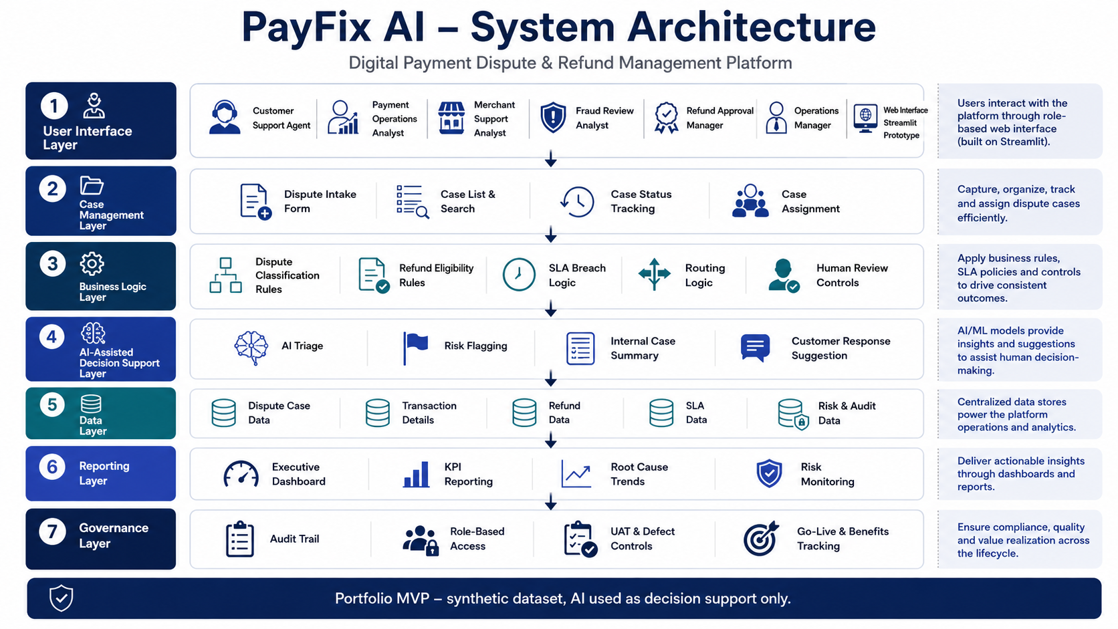
Figure 8: Proposed PayFix AI system architecture showing user interface, case management, business logic, AI-assisted decision support, data, reporting and governance layers.

20.6 Data Flow Overview
The data flow overview explains how dispute information moves through the proposed platform from case creation to resolution and reporting. This helps show how user inputs, AI-assisted logic, business rules, and dashboard outputs are connected.
Proposed Data Flow:
1. User submits dispute details through the dispute intake form.
2. Platform validates mandatory fields.
3. Platform generates a unique case ID.
4. Case data is saved into the case management dataset or database.
5. AI triage logic reads the customer claim and key case fields.
6. AI suggests dispute type, severity, required evidence, assigned team, internal summary, and customer response.
7. Refund eligibility logic checks case conditions against business rules and decision table.
8. SLA logic calculates whether the case is within target or breached.
9. User reviews AI and system recommendations.
10. Case owner updates status and next action.
11. Dashboard updates KPIs, charts, and management insights.
12. Final case outcome is stored with audit trail.
Data Stage | Input | Processing | Output
Case Intake | Customer claim, payment method, amount, evidence status | Mandatory field validation | New case record
Case Creation | Submitted dispute details | Unique case ID generation | Trackable dispute case
AI Triage | Customer claim and case fields | Classification and summary logic | Dispute type, severity, evidence required, response suggestion
Refund Logic | Transaction status, evidence, risk, amount | Business rules and decision table | Refund recommendation
SLA Logic | Date raised, SLA target, resolution days | SLA calculation | SLA breached: Yes / No
Reporting | Case records and outcomes | KPI aggregation and charts | Dashboard and management insights
The data flow shows that the platform is driven by structured case data. Each stage transforms raw dispute information into useful operational outputs, such as routing suggestions, refund recommendations, SLA status, and dashboard insights.
20.7 Data Flow & Design
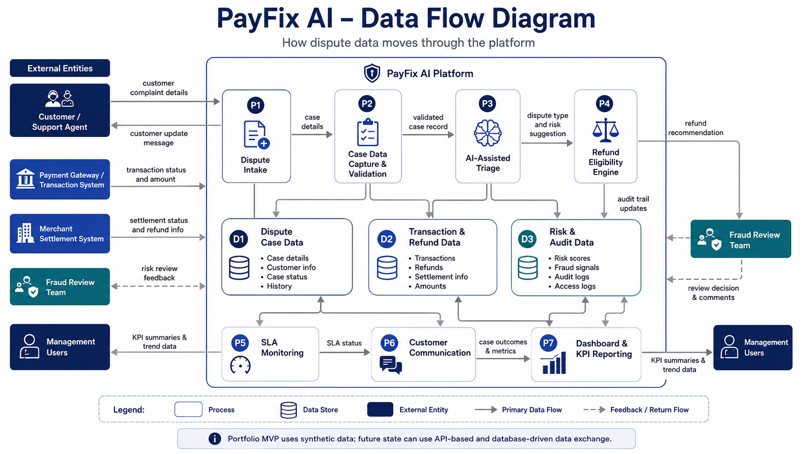
Figure 9: Data flow diagram showing how dispute, transaction, refund, SLA, risk, audit and dashboard data move through the PayFix AI platform.
20.8 Proposed Integration Landscape
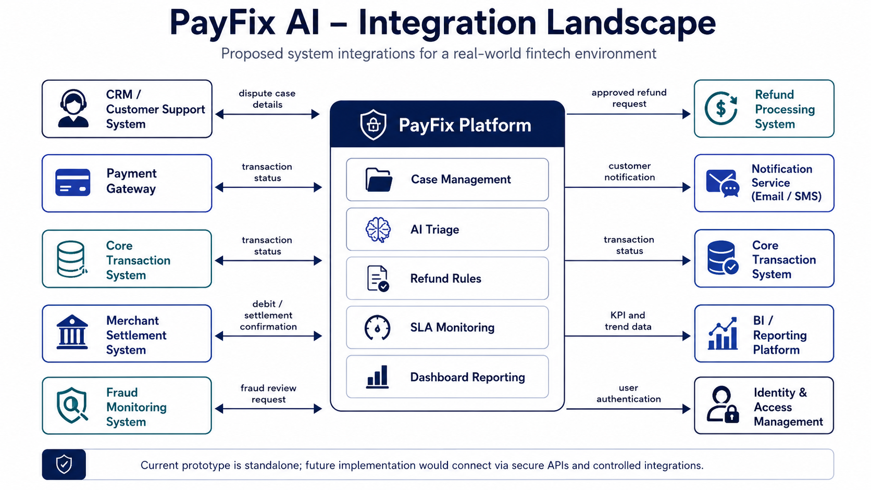
Figure 10: Proposed integration landscape showing how PayFix could connect with CRM, payment gateway, transaction systems, merchant settlement, fraud monitoring, refund processing, notification services, BI reporting and identity access management.
20.8 API Requirements
Although the current portfolio prototype uses a synthetic CSV dataset, a real implementation of PayFix AI would require APIs to exchange data between dispute management, payment gateway, transaction systems, merchant settlement, fraud review, refund processing, notification services and dashboard reporting.
The purpose of this section is to show how the proposed platform could work in a real IT environment.
API ID | API Name | Purpose | Input | Output
API-01 | Create Dispute Case API | Create a new dispute case | Customer ID, transaction ID, dispute type, message, amount, evidence status | Case ID, case status, created timestamp
API-02 | Get Dispute Case API | Retrieve dispute case details | Case ID | Full case details
API-03 | Update Case Status API | Update case status, owner or comments | Case ID, new status, assigned team, comments | Updated case status
API-04 | Get Transaction Details API | Retrieve payment transaction information | Transaction ID | Transaction status, amount, payment method, merchant ID
API-05 | Refund Recommendation API | Apply refund business rules | Dispute type, transaction status, evidence, risk level, amount | Refund recommendation and reason
API-06 | Refund Processing API | Submit approved refund request | Case ID, transaction ID, refund amount, approval ID | Refund request ID and refund status
API-07 | SLA Status API | Calculate SLA status | Case ID, SLA target, actual resolution days | SLA breach Yes / No
API-08 | Fraud Review API | Send high-risk or unauthorised cases to fraud review | Case ID, customer ID, transaction ID, risk level | Fraud review reference and status
API-09 | Customer Notification API | Send customer update | Customer ID, case ID, message, channel | Notification status
API-10 | Dashboard KPI API | Provide KPI data for dashboard reporting | Date range, team, dispute type | Total cases, SLA breach rate, refund value, risk breakdown
API Control Requirements
Control Area | Requirement
Authentication | APIs should require authenticated users or service tokens
Authorisation | Role-based access should control who can create, update, approve or view cases
Validation | Mandatory fields should be validated before processing
Audit Logs | Important API actions should be logged for traceability
Data Protection | Sensitive customer and payment data should be protected
Error Handling | API errors should be clear and should not expose sensitive system details
Human Approval | Refund processing should require authorised approval before execution
The API requirements show how a Technical Business Analyst can translate business and functional requirements into system-to-system interaction needs. This is important because real IT projects often require BAs to work with product owners, developers, testers, architects, data teams and external vendors.
20.10 Prototype Screen Design
The prototype will include a small number of focused screens that demonstrate the core business workflow. The aim is not to create a full production system, but to show how the main user journeys and system features would work.
Screen | Purpose | Key Fields / Components | User Value
Home / Project Overview | Explains the business problem and solution purpose | Project summary, KPIs, navigation menu | Helps users understand the platform objective
Submit Dispute | Allows user to create a new dispute case | Payment method, dispute type, amount, claim text, evidence status | Standardises case intake
Case Management | Shows dispute cases in a table format | Case ID, status, team, risk, SLA, refund eligibility | Improves visibility and ownership
AI Triage Output | Shows AI-assisted recommendation | Dispute type, severity, evidence needed, summary, response | Reduces manual triage effort
Refund Eligibility Checker | Shows refund recommendation based on rules | Transaction status, evidence, risk, amount, recommendation | Supports consistent decisions
SLA Tracker | Shows SLA performance | Target days, actual days, SLA breached flag | Supports escalation and control
Dashboard | Shows management KPIs and charts | Total cases, SLA breach rate, refund value, root causes, risk levels | Supports business decision-making
The prototype screen design is aligned with the To-Be process, functional requirements, user stories, and product backlog. Each screen demonstrates a specific part of the dispute and refund workflow, making the solution easier for stakeholders and recruiters to understand.

20.11 System Design Summary
The system design shows how the proposed platform can convert a manual and fragmented dispute process into a structured, data-driven, and AI-assisted workflow.
The prototype will use synthetic data to demonstrate case creation, dispute classification, refund eligibility logic, SLA tracking, team routing, customer communication support, and dashboard reporting. The design also includes role-based access thinking, auditability, human oversight, and future scalability.
From a Technical Business Analyst perspective, this section shows how business requirements can be translated into system modules, data flows, user permissions, screen designs, and prototype scope. It also provides a clear bridge between documentation and practical solution delivery.
21. Testing and UAT
Testing and User Acceptance Testing were included to validate whether the proposed AI-assisted digital payment dispute and refund management platform meets the agreed business requirements, functional requirements, user stories, acceptance criteria, and process improvement objectives.
This section demonstrates how the solution would be tested from a business user perspective before go-live. It focuses on core workflows such as dispute case creation, case ID generation, AI triage, refund eligibility recommendation, SLA tracking, team routing, dashboard reporting, and human oversight.
21.1 Purpose of UAT
The purpose of User Acceptance Testing is to confirm that the proposed platform supports the real business process and meets user expectations before implementation.
For this project, UAT is important because the platform affects payment dispute handling, refund recommendation, SLA monitoring, customer communication, fraud review routing, and management reporting.
The UAT approach focuses on answering the following questions:
1. Can users create a dispute case correctly?
2. Does the system generate a unique case ID?
3. Does the AI triage output support dispute classification?
4. Does refund eligibility logic follow the decision table?
5. Are high-risk and fraud-related cases routed for manual review?
6. Does SLA tracking correctly identify breached cases?
7. Does the dashboard provide useful management insight?
8. Are AI recommendations explainable and subject to human review?
21.2 UAT Test Cases
The following UAT test cases were created to validate the core business scenarios of the proposed platform. Each test case is linked to a business process, user story, or functional requirement.
Test ID | Test Scenario | Test Steps | Expected Result | Linked Requirement | Status
UAT-01 | Create new dispute case | Enter all mandatory dispute details and submit the form. | Case is created successfully and saved in the case list. | FR-01, FR-03 | Pass
UAT-02 | Generate unique case ID | Submit a new dispute case. | System generates a unique case ID for the case | FR-02 | Pass
UAT-03 | Mandatory field validation | Try submitting a dispute case with missing required fields. | System prevents submission and highlights missing fields. | FR-03 | Pass
UAT-04 | AI classifies failed payment claim | Enter customer claim: “Money was debited but payment failed.” | AI suggests dispute type as Failed Payment and routes to Payment Operations. | FR-05 | Pass
UAT-05 | Duplicate debit refund recommendation | Enter duplicate debit case with evidence available. | System recommends refund eligibility as Eligible. | FR-06, RULE-02 | Pass
UAT-06 | Unauthorised transaction routing | Enter case where customer denies making the payment. | Case is routed to Fraud Review and marked for manual review. | FR-07, RULE-05 | Pass
UAT-07 | High-value case approval | Enter transaction amount above £500. | System recommends Manager Approval. | RULE-07 | Pass
UAT-08 | Missing evidence case | Create case without evidence. | Case status is set to Awaiting Evidence. | RULE-08 | Pass
UAT-09 | SLA breach calculation | Enter actual resolution days greater than SLA target days. | SLA breach status is marked as Yes. | FR-08, FR-09 | Pass
UAT-10 | Dashboard KPI visibility | Open dashboard view. | Dashboard shows total cases, SLA breach rate, refund value, dispute types, root causes, and risk levels. | FR-13 | Pass
UAT-11 | AI customer response suggestion | Generate response for refund delay case. | AI suggests a clear and professional customer update. | FR-12 | Pass
UAT-12 | Human oversight for high-risk case | Submit high-risk fraud-related case. | AI recommendation is shown, but final decision requires human review. | NFR-10, RULE-12 | Pass
The UAT test cases demonstrate that the proposed platform can be validated against real business scenarios. The tests cover case creation, mandatory field validation, AI triage, refund eligibility, routing, SLA tracking, dashboard reporting, customer response generation, and human oversight.
This testing approach ensures that the solution is not only technically functional but also aligned with the business process and user expectations.
21.3 Defect Log
A defect log was created to record issues identified during testing. In a real project, defects would be reviewed, prioritised, assigned, fixed, retested, and closed before go-live.
Defect ID | Description | Severity | Priority | Owner | Status | Resolution
DEF-01 | AI classification may misclassify unclear customer claim text. | Medium | High | AI / Technical BA | Open | Add clearer prompts and fallback manual review.
DEF-02 | Missing evidence cases may need clearer customer instruction. | Low | Medium | Support / Product Owner | Open | Improve evidence request message template.
DEF-03 | Dashboard may become cluttered if too many KPIs are shown. | Low | Medium | Product Owner | Open | Prioritise most important KPIs for MVP.
DEF-04 | Refund eligibility logic may not cover all edge cases. | Medium | High | Refund Manager / Technical BA | Open | Add more scenarios to decision table.
DEF-05 |  | Medium | High | Development Team | Open | Add high-risk label and escalation indicator.
DEF-06 |  | Medium | Medium | Development Team | Open | Add role-based access as future enhancement.
The defect log shows that the main testing concerns relate to AI accuracy, missing evidence communication, dashboard usability, refund decision edge cases, risk visibility, and role-based access control. These are realistic issues for an AI-assisted fintech operations platform.
For the portfolio prototype, these defects are treated as improvement items and future enhancements. In a real production project, high-priority defects would need to be resolved or accepted by stakeholders before go-live.

21.3.1 Jira Defect Tracking
Jira would be used to record, prioritise, assign, retest and close UAT defects. Each defect would include severity, priority, owner, steps to reproduce, expected result, actual result, screenshots and current status.
Jira Defect ID | Defect Summary | Severity | Priority | Owner | Status
PAYFIX-BUG-01 | SLA breach flag not updating correctly | Medium | High | Developer | Closed
PAYFIX-BUG-02 | Customer response message formatting issue | Low | Medium | Developer | Closed
PAYFIX-BUG-03 | Refund eligibility result unclear for missing evidence | Medium | Medium | Technical BA / Developer | Retested and Closed
PAYFIX-BUG-04 | Dashboard filter not refreshing after case selection | Low | Low | Developer | Closed
The Jira defect tracking approach supports clear ownership, transparent defect status, retesting, and evidence-based UAT sign-off. This helps ensure that the prototype is not only built, but also tested and validated against business expectations.
21.4 Test Summary
The UAT testing confirmed that the proposed platform design supports the core dispute and refund management workflow. The tested areas included dispute case creation, mandatory field validation, case ID generation, AI-assisted classification, refund eligibility recommendation, routing logic, SLA breach calculation, dashboard visibility, customer response generation, and human oversight controls.
Test Area | Result | Comment
Dispute Case Creation | Passed | Structured case intake supports consistent data capture.
Case ID Generation | Passed | Unique case reference supports tracking and auditability.
AI Triage | Passed with improvement items | Works as decision support but needs human review for unclear claims.
Refund Eligibility Logic | Passed with improvement items | Covers common scenarios but edge cases should be expanded
SLA Tracking | Passed | SLA breach logic supports escalation visibility.
Dashboard Reporting | Passed | Provides useful management visibility, but KPI selection should remain focused.
Overall, the testing results show that the proposed platform is suitable for MVP demonstration. The solution meets the core business objectives, but future improvements should focus on AI accuracy, role-based access, additional refund scenarios, and stronger risk indicators.
21.5 Go / No-Go Decision
Based on the UAT test results, the portfolio prototype is suitable for demonstration as an MVP. The core business workflow is clear, the main requirements are covered, and the solution demonstrates how the dispute and refund process can be improved through structured case management, AI-assisted triage, refund eligibility logic, SLA tracking, and dashboard reporting.
Decision Area | Outcome
Business Workflow | Acceptable for MVP demonstration
Core Requirements | Covered
AI Decision Support | Acceptable with human oversight
Refund Logic | Acceptable for common scenarios
Overall Decision | Go for portfolio MVP demonstration
The decision is Go for portfolio MVP demonstration, with the condition that the project clearly states the dataset is synthetic, the AI is decision-support only, and final refund or fraud decisions require human review.
In a real business implementation, the next step would be to resolve high-priority defects, conduct stakeholder sign-off, complete security and compliance review, and prepare controlled go-live.
22. Go-Live and Benefits Realisation
Go-live and benefits realisation planning was included to show how the proposed AI-assisted digital payment dispute and refund management platform could move from prototype validation into controlled business implementation.
This section explains the implementation approach, go-live checklist, rollback considerations, training needs, expected benefits, and final business recommendations. It demonstrates that the project is not only focused on analysis and design, but also on practical delivery, adoption, and measurable business value.

22.1 Purpose of Go-Live Planning
The purpose of go-live planning is to ensure that the proposed platform can be introduced into the business in a controlled, safe, and practical way.
For this project, go-live planning is important because the solution affects dispute handling, refund recommendations, fraud review routing, SLA monitoring, customer communication, and management reporting.
A structured go-live approach helps reduce implementation risk, prepare users, confirm readiness, manage defects, define fallback options, and ensure that the business can measure whether the solution delivers the expected benefits.
22.2 Implementation Plan
The implementation plan explains how the proposed solution could be introduced gradually. A phased implementation approach is recommended to reduce risk and allow users to adapt to the new process.
Phase | Activity | Description | Owner | Output
Phase 1 | Stakeholder Sign-Off | Review business case, requirements, process design, UAT results, and go-live readiness. | Product Owner / Business Sponsor | Approval to proceed
Phase 2 | Data Preparation | Prepare synthetic/demo data for prototype or clean business data for real implementation. | Technical BA / Data Analyst | Validated dataset
Phase 3 | User Training | Train support, payment operations, refund, fraud, and management users. | Training Lead / Technical BA | Training completion
Phase 4 | Pilot Launch | Launch platform to a small group of users or limited dispute categories. | Product Owner / Operations Manager | Pilot feedback
Phase 5 | Monitor and Support | Track issues, user feedback, SLA impact, AI output quality, and dashboard usage. | Support Team / Technical BA | Issue and feedback log
Phase 6 | Full Rollout | Expand platform to wider dispute handling team after pilot success. | Product Owner / Operations Manager | Wider adoption
Phase 7 | Benefits Review | Compare pre- and post-implementation KPIs. | Business Analyst / Management | Benefits realisation report

The implementation plan uses a phased rollout rather than an immediate full launch. This is suitable for a fintech/payment operations environment because dispute handling and refund decisions involve customer trust, financial impact, operational risk, and fraud-sensitive cases.
The phased approach allows the business to validate the platform with controlled users, monitor AI-assisted outputs, collect feedback, fix issues, and expand only when the process is stable.
22.3 Go-Live Checklist
The go-live checklist confirms whether the business, users, data, process, system, testing, and support arrangements are ready before the platform is launched.
Checklist Item | Description | Owner | Status
Business case approved | Confirm that the business problem, objectives, and expected benefits are agreed. | Business Sponsor | Complete
Requirements signed off | Confirm BRD, FRD, PRD, NFRs, business rules, and decision table are reviewed. | Product Owner / Technical BA | Complete
Process design approved | Confirm As-Is and To-Be process flows are understood by stakeholders. | Technical BA | Complete
Dataset validated | Confirm synthetic/demo dataset is clean and suitable for portfolio demonstration. | Data Analyst / Technical BA | Complete
UAT completed | Confirm core UAT test cases have passed or open issues are accepted. | UAT Lead / Business Users | Complete
High-priority defects reviewed | Confirm critical defects are fixed or accepted with mitigation. | Product Owner | Complete
AI oversight confirmed | Confirm AI is used as decision support and not final decision-maker. | Product Owner / Risk Team | Complete
User roles defined | Confirm user access and responsibility levels are documented. | Operations Manager | Complete
Training material prepared | Confirm users have guidance on how to use the platform. | Training Lead / Technical BA | In Progress
Support process defined | Confirm users know how to report issues after launch. | Support Team | In Progress
Go-live approval received | Confirm final approval to launch MVP demonstration. | Business Sponsor / Product Owner | Pending

The go-live checklist shows that the MVP should only be demonstrated or launched once core business, process, requirements, testing, AI control, and support readiness items are confirmed. This reduces the risk of launching a solution that is not understood, not tested, or not supported by users.
22.4 Rollback Plan
A rollback plan defines what the business should do if the new platform does not work as expected after launch. Even though this is a portfolio MVP, including a rollback plan shows implementation awareness and responsible delivery thinking.
Rollback Scenario | Trigger | Rollback Action | Owner
Platform unavailable | Users cannot access the system during launch. | Return temporarily to Excel-based dispute tracking. | Support Team / Product Owner
Incorrect refund recommendation | System gives repeated incorrect recommendations. | Disable refund recommendation feature and use manual decision table. | Refund Manager / Technical BA
AI misclassification issue | AI repeatedly classifies cases incorrectly. | Disable AI triage and route cases manually until prompts/rules are improved. | Product Owner / AI Lead
Dashboard data mismatch | Dashboard KPIs do not match source data. | Use raw Excel reports until calculations are corrected. | Data Analyst
User adoption issue | Users are unable to complete core tasks. | Pause rollout and provide additional training. | Training Lead
High-risk case handling issue | Fraud or high-value cases are not routed correctly. | Switch sensitive cases to manual review workflow immediately. | Fraud Review Team / Operations Manager
Major defect after launch | Critical workflow issue affects case handling. | Stop wider rollout and return to pilot group only. | Product Owner

The rollback plan protects the business if the MVP does not perform as expected. It also confirms that manual processes and human review remain available as fallback options, especially for refund-sensitive, fraud-related, and high-risk cases.
22.5 Training Plan
The training plan explains how users would be prepared to use the proposed platform. Training is important because the project changes how dispute cases are captured, routed, reviewed, tracked, and communicated.
User Group | Training Topic | Training Method | Duration | Expected Outcome
Customer Support Agents | Creating dispute cases and sending customer updates | Demo session + user guide | 1 hour | Agents can create and update cases confidently
Payment Operations Team | Reviewing transaction-related cases and SLA status | Walkthrough + practice cases | 1 hour | Analysts can investigate and update assigned cases
Merchant Support Team | Handling merchant confirmation cases | Scenario-based training | 45 minutes | Users understand merchant-related workflow
Fraud Review Team | Reviewing high-risk and unauthorised cases | Specialist workflow walkthrough | 45 minutes | Fraud cases are handled through manual review
Refund Approval Manager | Reviewing refund recommendations and decision table | Decision table training | 1 hour | Refund decisions are reviewed consistently
Operations Managers | Using dashboard and SLA reporting | Dashboard demo | 45 minutes | Managers can monitor KPIs and identify bottlenecks
System Admin / Support | Managing user access and support issues | Admin guide + support process | 1 hour | Admin users can support basic platform issues

The training plan supports user adoption and reduces resistance to change. It ensures that each user group receives relevant guidance based on their role in the dispute and refund process. This is important because the success of the platform depends not only on system design, but also on whether users understand and trust the new workflow.
22.6 Benefits Realisation Plan
The benefits realisation plan explains how the business will measure whether the proposed AI-assisted digital payment dispute and refund management platform has delivered the expected value after implementation.
The purpose is to connect the project objectives with measurable outcomes such as faster resolution, reduced SLA breaches, improved refund consistency, reduced manual workload, stronger reporting, and better customer communication.
Benefit | Baseline Problem | Target Improvement | Measurement Method | Owner
Faster dispute resolution | Manual handoffs delay case closure | Reduce average resolution time | Compare average resolution days before and after implementation | Operations Manager
Lower SLA breach rate | SLA breaches are identified late | Reduce percentage of breached cases | Monitor SLA breach rate on dashboard | Operations Manager
Reduced manual triage effort | Agents manually classify every case | Reduce manual classification workload for common cases | Track AI-assisted classification usage | Product Owner / Technical BA
Improved refund consistency | Refund decisions vary due to manual interpretation | Improve consistency using business rules and decision table | Review refund outcomes by dispute type | Refund Approval Manager
Better customer communication | Customer updates are manual and inconsistent | Improve response speed and clarity | Review response templates and customer feedback | Customer Support Lead
Stronger management visibility | Management relies on manual spreadsheet summaries | Provide dashboard-based reporting | Monitor dashboard usage and KPI reports | Senior Management
Improved risk control | High-risk cases may not be flagged early | Route fraud and high-risk cases to manual review | Track high-risk routing and review outcomes | Fraud Review Team
Better root cause analysis | Repeated issues are difficult to identify | Identify top dispute causes and improvement priorities | Review root cause trends monthly | Technical BA / Operations Manager

The benefits realisation plan shows how the business can measure whether the platform has created value. The main expected benefits are operational efficiency, improved SLA performance, better refund decision consistency, stronger risk control, improved communication, and better management reporting.
This is important because a successful business transformation project should not only deliver a system, but also demonstrate measurable business improvement.
22.7 KPI Benefits Framework
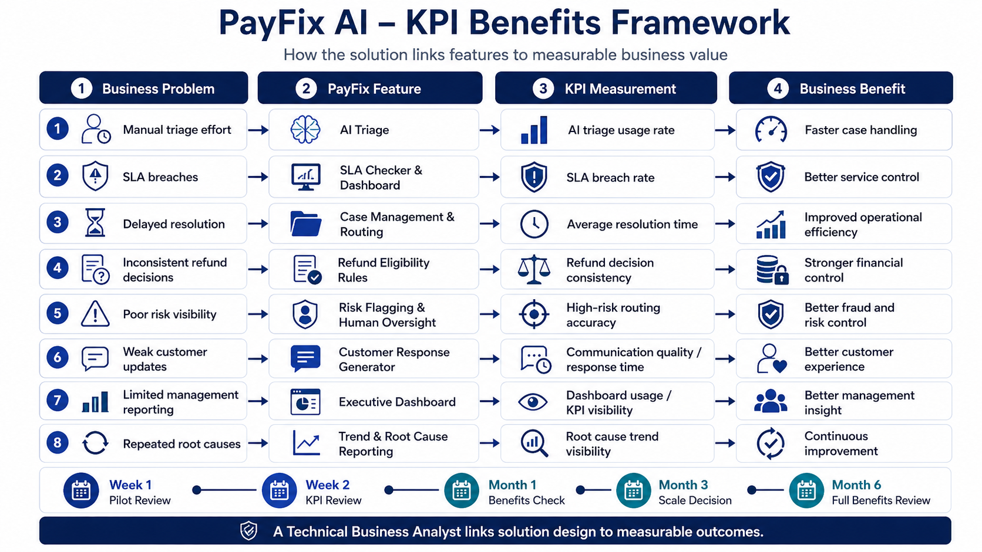
Figure 11: KPI benefits framework linking business problems, PayFix features, KPI measurements and expected business benefits.
22.8 Final Business Recommendations
Based on the business case, Excel analysis, consulting diagnosis, process modelling, requirements documentation, AI automation design, UAT results, and go-live planning, the following final business recommendations are proposed.
1. Implement a centralised dispute and refund case management platform to replace fragmented Excel, email, and manual tracking.
2. Use structured dispute intake forms to ensure required case information is captured at the beginning of the process.
3. Introduce AI-assisted dispute triage to support classification, evidence identification, routing, internal summaries, and customer response suggestions.
4. Use a refund eligibility decision table to improve consistency and reduce dependency on individual judgement.
5. Retain human review for fraud-related, high-risk, high-value, and complex refund cases.
6. Implement SLA tracking and escalation visibility to reduce delayed resolution and improve operational control.
7. Use dashboard reporting to monitor dispute volume, SLA breaches, refund value, root causes, risk levels, and customer sentiment.
8. Train users by role so that customer support, payment operations, merchant support, fraud review, refund approval, and management teams understand the new workflow.
9. Launch the solution as a controlled MVP first, then expand after user feedback, defect review, and benefits measurement.
10. Treat AI as a decision-support capability, not a final decision-maker, especially in payment, refund, fraud, and customer-sensitive scenarios.
The recommended solution provides a practical, data-driven, and AI-assisted operating model for improving digital payment dispute and refund management. It addresses the key issues identified in the project: manual case handling, weak SLA visibility, inconsistent refund decisions, limited reporting, repeated root causes, and poor customer communication.
From a Technical Business Analyst and IT Business Analyst perspective, this project demonstrates the ability to understand a real business problem, analyse data, diagnose root causes, redesign processes, document requirements, plan Agile delivery, design AI-assisted automation, validate through UAT, and prepare for controlled go-live.
22.9 Tools Used and IT BA Evidence
The following tools and methods were used or proposed as part of the PayFix AI portfolio project. This section summarises how the project demonstrates practical Technical Business Analyst and IT Business Analyst capability.
Area | Tool / Method | Evidence in Project
Business documentation | Microsoft Word / Confluence-style structure | Business case, BRD, FRD, PRD, NFR, UAT and go-live documentation
Agile delivery | Jira-style backlog and sprint tracking | Epics, user stories, sprint plan, acceptance criteria, defects and delivery status
Data analysis | Microsoft Excel | Synthetic dataset, pivot analysis, KPI dashboard and screenshots
Process modelling | BPMN-style process mapping | As-Is and To-Be BPMN diagrams
Requirements management | BRD, FRD, PRD, NFR, RTM | Requirements traceability from business need to UAT
Technical design | System architecture, data flow, APIs and integrations | Architecture diagram, data flow diagram, integration landscape and API requirements
Prototype development | Python, Streamlit and Pandas | Working MVP prototype for dispute and refund management
Testing | UAT and Jira-style defect tracking | UAT test cases, defect log, retest and Go / No-Go decision
Implementation planning | Go-live and benefits realisation | Go-live checklist, rollback plan, training plan and KPI benefits framework
Version control / Portfolio | GitHub | Public project repository with documentation, prototype and visuals
This tooling evidence shows that the project was not treated as only an academic report. It was structured like a realistic IT Business Analyst delivery case, moving from business problem discovery to requirements, backlog, process design, prototype, testing, go-live planning and portfolio presentation.
23. Project Conclusion
This project demonstrates an end-to-end business transformation approach for solving digital payment dispute and refund management challenges in a fintech/payment operations environment.
The project started by identifying a realistic business problem: manual dispute handling, delayed refunds, fragmented case tracking, SLA breaches, inconsistent refund decisions, and poor customer communication. A synthetic payment dispute dataset was then created and analysed in Excel to understand dispute patterns, SLA performance, refund impact, risk levels, root causes, and customer sentiment.
The data analysis provided the foundation for consulting diagnosis using SWOT, PESTLE, Five Whys, Fishbone, Gap Analysis, MCDA, and Risk Register. These tools helped identify the need for a centralised, structured, and AI-assisted dispute management platform.
The project then translated the business problem into As-Is and To-Be process models, BRD, FRD, PRD, non-functional requirements, business rules, refund eligibility decision table, product backlog, user stories, acceptance criteria, sprint plan, AI automation design, prototype scope, system modules, UAT test cases, go-live plan, training plan, and benefits realisation plan.
The proposed solution uses AI as a decision-support tool to classify disputes, suggest refund eligibility, recommend routing, generate internal summaries, support customer communication, and flag high-risk cases. However, the project maintains human oversight for fraud-related, high-risk, high-value, and complex refund decisions.
Overall, this project shows how a Technical Business Analyst or IT Business Analyst can connect business strategy, data analysis, consulting diagnosis, process improvement, requirements documentation, Agile delivery, AI automation, testing, and go-live planning into one complete business solution.
The project also demonstrates my ability to think like a business owner, understand operational problems, use data to identify patterns, design practical digital solutions, and communicate clearly with both business and technical stakeholders.

