*Designer babies – An application of Genetic Engineering*

Rohan N Kalpavruksha Roshan N Kalpavruksha Shivalingesh.S.Dhaded Deeksha H Kulal

*ECE ECE ECE ECE*

*PES University PES University PES University PES University*

[rohankalpavruksha@yahoo.com](mailto:rohankalpavruksha@yahoo.com) [rkalpavruksha@yahoo.com](mailto:rkalpavruksha@yahoo.com) [slingesh2000@gmail.com](mailto:slingesh2000@gmail.com) [deekulal2017@gmail.com](mailto:deekulal2017@gmail.com)

***Abstract -*** ***Preimplantation genetic screening is one of the interesting biomedical advances that the world has seen in recent years and has undoubtedly been of the greatest social repercussion. However, escalating advancement of technology before and after the turn of the twenty first century makes designer babies not only science fiction but a real possibility.*** ***With recent development in world of genetics, the possibilities for reproductive uses are surging. Prenatal testing and screening have become regular action part of pregnancy for most women. Couples undergoing in vitro fertilization (IVF) may now have their embryos tested for genetic defects by preimplantation genetic diagnosis. The notion of the phenomenon designer babies are of the distant future, which is the alarming naivety that is going to permit this technology’s transformative powers. Gene therapy is slowly the possibility of treating genetic and other diseases and may one day allow us to enhance or eliminate completely desirable and undesirable traits, respectively.*** ***CRISPR technology, the one which was discovered only by chance in microbes is no getting applied on mammalian genes and is drastically speeding up the pace of genetic experimentation and could possibly eliminate many hereditary diseases from bloodlines***

***Keywords- DNA (Deoxyribonucleic acid), CRISPR (Clustered Regularly Interspaced Short Palindromic Repeats), designer babies, genetic modifications, hereditary diseases***

1. INTRODUCTION

Genetic engineering, a branch which has a lot of secrets hidden in it and one the which is making great reforms in the world has already been squeezed to its better utilization for the genome alteration of numerous organisms. Vandana Shiva once stated that Genetic Engineering is not about saving the world, but it’s about controlling the world. A baby in which a genetic makeup has been selected in a way that a particular defect is eradicated or a particular gene is ensured to be present is usually referred to as “Designer Baby”, a figment of genetic researchers’ imaginations. It is proved as a technique which is used to prevent the child being born with x-linked diseases or any such genetic disorders using preimplantation genetic diagnosis. By selecting sperms, eggs or embryo donors with particular characteristics it is used to enhance few features in the baby like attractiveness, sporting ability or intelligence. Imagining a world of this where a technology like CRISPR which is a gene-editing technology that utilizes the Cas9 protein to alter gene so that it could remove diseases and get desired characters in the child is fascinating.

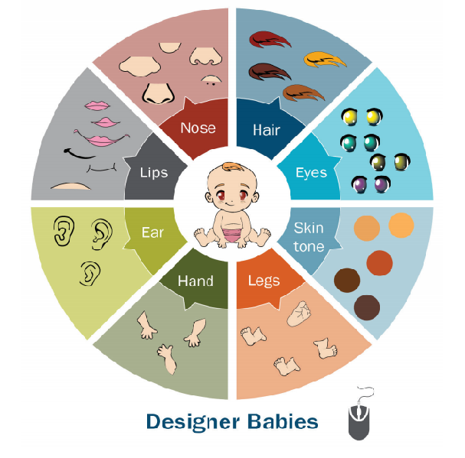

Fig.1. Designer Babies (Ref. Paper Designer babies, Justo Aznar)

1. HISTORY OF GENETIC ENGINEERING

Humans have been engineering since many years. Genetic engineering caused the humans to develop the traits required by them in plants and animals by selective breeding. The principle of how this works was known only when we discovered the Deoxyribonucleic acid (DNA) called the code of life. This is responsible for the growth, development, reproduction, etc. of everything alive. In order to see the importance of the role of genes, scientists caused mutation in different plants by exposing to radiations to check if the variance caused will be useful. In the mid-20th century scientists inserted DNA to different plants, animals and bacteria to study and modify them for research, agriculture, medicine and also for fun. Mice was the first genetically tested organism born in 1974 and studies have continued to use mice as a tool to experiment on. In 80’s, the first patent was given to a microbe engineer to absorb oil. Today this technique is widely used for many purposes like for producing insulin used to inject to diabetic patient. The first food that was genetically modified is the flavr savr tomato which had a better shelf life compared to an ordinary tomato. Fluorescent Zebra fish is also a wonder in this field.

1. MECHANISM OF CRISPR

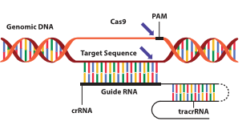

Fig.2. CRISPR Cas 9 structure (Ref.)

In order to do this most efficiently, copies of the foreign sequences are produced as RNA molecules for their viral search. The organism’s CRISPR loci present the RNA “encoded” with the viral DNA sequence. The RNA is also responsible for bringing CRISPR-associated (Cas) enzymes to the foreign DNA, travelling around the cell as a unit in pursuit of viral matches. If reinfection with a ‘logged’ virus occurs and a match is found, the encoded RNA will complementarily bind to the invader’s genome. Once the RNA has completed its task, the Cas enzyme performs its duty, cutting the invading DNA to prevent any further replication of the virus. The success of this mechanism in single-celled organisms sparked the quest for potential human applications. It soon was discovered that the multi-cellular CRISPR/Cas system only required two components: a specialized RNA known as guide RNA (gRNA), and a Cas enzyme.

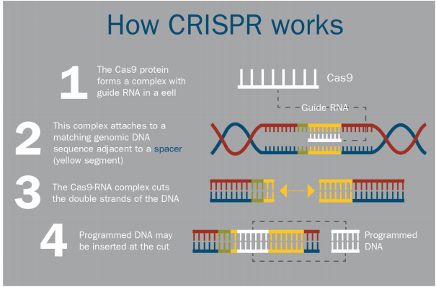

Fig.3. How CRISPR works (Ref. Genetically Modified Babies, Samuel Brown)

gRNA functions in much the same way as bacterial and archaeal cells CRISPR RNA, despite being shorter in length. After binding to the complementary sequence on the target genome, gRNA works together with the Cas enzyme to find the correct site for DNA cleavage. These striking similarities encouraged scientists to speculate about the new realm of possibilities. This potential became increasingly realistic with the 2012 discovery that the “edit-search-replace” mechanism of the CRISPR-Cas9 system, a pairing of a specifically programmed RNA molecule and the Cas9 enzyme, was not limited to viral DNA. With each additional speculation regarding the generalizability of this technique, the scope seemed to grow exponentially. The potential application of the CRISPR-Cas system to any gene sequence, and the consequent newfound ability to cleave DNA in a specified location, naturally gave rise to the promise of genomic editing particular genes. However, breaking the DNA is only half of the process. There are two primary methods for repair, both reliant on a cell’s naturally occurring repair mechanism. Thus, issues begin to arise in that the products of these repair mechanisms are not nearly as predictable as the CRISPR-Cas systems. The naturally-occurring method is characterized by the introduction of mutations, resulting in the inactivation of the gene. The artificial method, however, includes the insertion of a plasmid containing the new gene for modification. Regardless of the method performed, a great deal of the post-breakage DNA annealing is dictated by chance.

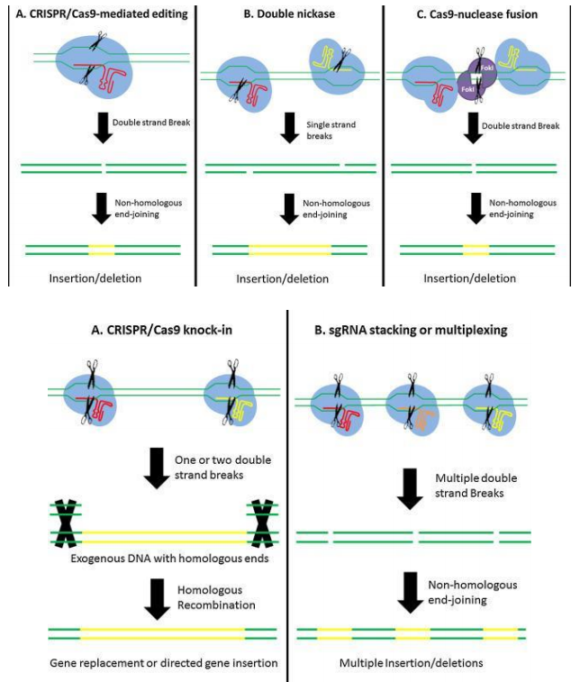

Fig.4. Mechanism of CRISPR

(Ref. Genetically Modified Babies, Samuel Brown)

Selecting Against or For Traits

While the specific terminology, selecting against and selecting for, have been used several times throughout this composition. The two phrases result in trait selection that ‘betters’ the genome -- one by removal of bad, one by addition of good -- the mechanism of decision-making has potential to be two different ethical scenarios. The former, against diseases, uses the elimination of traits to perfect what is desired, and the latter, for benign traits, choice selection. Ultimately, the ethical implications of genome editing technology are dictated by the use of one of these phrases and the morality of the actions that ensue. The concept of selecting against particular traits undeniably has similar undertones to the eugenics movement of the 20th century. The goal of eugenics was to eliminate the members of society, through selective breeding, who reduced the quality of the gene pool of society; namely, criminals, those with mental illness, and the poor.

IV. LEGALITIES IN INDIA

India as such does not have any law in specific which is going to exhibit prohibition on genetic editing of germ lines. However, ICMR (“Indian Council of Medical Research”) has also published the National Ethical Guidelines for Biomedical and Health Research on Human Participants which has put forward prohibition on the genetic engineering for modifying/selecting genetic characteristics and creating the designer babies. In addition to these Guidelines, the National Guidelines for Stem Cell Research in the year 2017, which was published by DBT (“Department of Biotechnology, Ministry of Science & Technology”), states all the necessary guidance’s for cellular research which include gene editing and also reproductive cloning. It also prohibits research such as human germ line gene therapy looking into the current state of scientific knowledge and its understanding. The permission is given to genome modification which is done by in vitro studies (i.e. outside the human body) and a thorough review from Institutional Committee for Stem Cell is been taken. In-vitro studies can also be conducted only on spare embryos, gametes or germ-line cells. The human embryos which have its genome modified should not be cultured more than 14 days of fertilization so that there is no possibility of being inserted into the womb early. Hence, we can say any research that leads to creating designer babies by non-mandatory guidelines is strictly prohibited in India.

1. ETHICAL ISSUES

Ethical and social concerns are the most roadblocks for the field of science.

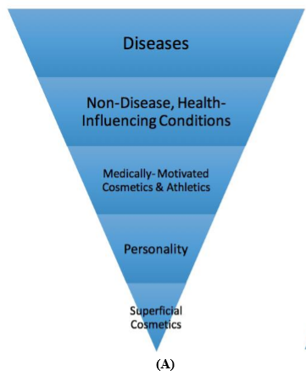

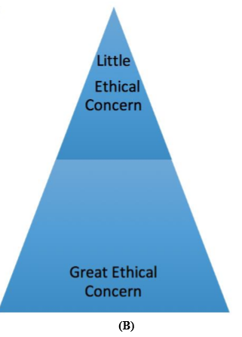

Fig.5. Degree of ethical concern (Ref. Analysis of Ethical Implications DePauw University)

The degree of ethical concern associated with the modification of various traits and characteristics, where traits/characteristics are ranked according to the perspective that, the greater the disagreement for its modification, the greater the ethical concern.

* Gene editing permits the creation of offspring having some preferred traits. Genetic modification will lead to parents requesting for traits in their children such as a specific hair or eye colour, height, memory, intelligence, in order to get the desired baby. This leads to huge number of problems in the society. In terms of health and beauty the genetically modified children prove to be better. This will increase the gap between the intellect of people as well as the rich and poor.
* Treating a person that already exists versus genetically modifying an embryo is always to be considered different. Modifying the genetic make-up of an already existing person is more likely to be seen as treatment that is highly dangerous in cases especially where such individual is unlikely to reproduce. Any genetic changes in the individual will come to a risk with the death of such individual.
* Genetic information is something so crucial and is said to be a basis for all the characteristics and we even see these characteristics passing on to the future generations. Hence there is chance of causing unpredictable effects on them, especially if such research is exploited for non-therapeutic modifications. Unexpected genetic mutations that can be passed from one generation to another are often introduced in the genome when the CRISPR-Cas9 technique is applied. Concerns about adverse irreversible changes in the human gene pool are valid.
* Presently parents have a limited control over the features of the baby. Allowing parents to pick up traits will hinder the personality as is not just impacted by the by home environment but is also based on experiences. Since every minute detail of the personality can be monitored and changed, it causes the child not having control of any of these later on. For example, if we manipulate all the children to be intelligent or beautiful it is of no use, the society doesn’t work that way and it is not good for a healthy society. In 2014, a court in England held that the mother of a child born with foetal alcohol spectrum syndrome due the mother’s heavy drinking during pregnancy is not guilty of causing harm to the child. If designer babies become a reality, we may see many more lawsuits with children suing their parents for the decisions made when the child was in the womb.

VI. LIMITATIONS OF DESIGNER BABIES

As every good side has a bad side, though this idea of designer babies seems to be very useful discovery in the recent times it has its own drawback too. The time required to make a designer babies takes up to 12 to 18 months, if indeed it is achieved. That time may be excessive to treat active tumour processes, especially acute leukaemia. The mother who is responsible for donating eggs for this process has to produce a lot of eggs in her ovary by ovarian simulation process hence she is subjected to medications. This can cause ovarian hyper stimulation syndrome which in some cases may lead to death. Preimplantation genetic diagnosis may cause errors in 1% to 5% of occasions. This also causes the mother to have lower chances of pregnancy after the age of 40.

VII.RECENT MEDICAL AND TECHNOLOGICAL ADVANCES IN INDIA

There have been no recent trials based on human germ line editing which has caused a major setback when we compare ourselves to other countries which are leading a way forward in this field. But still there are Indians who are working on this field in abroad. The article named “Indian-origin doctor helps gene editing of human embryos” in Times of India on 6th August 2017 stated, genetically modified human embryos were modified with Sanjeev Kaul in US playing the lead role. Scientists now have found out an effective way to use a gene-editing tool for correcting disease causing gene mutation. Here the problem of heart attack caused by a faulty gene which thickens the walls of the heart has been corrected. For certain days, the selected embryos were allowed to grow but it wasn’t implanted into humans. This in turn reduces the heritable diseases being carried on to next generation.

Recent advances in Assisted Reproductive Technologies (ART) provide parents with an accurate method of selecting the sex of their children prior to conception. Promoters of this technology argue that families are simply seeking a balance. However, rejecting a boy or girl when there is no medical need seems morally disgraceful. Abandoning an embryo simply based on its sex is an entirely new form of sex discrimination. There is also a concern that this type of genetic selection is all too similar to forms of selective abortion, which are still being practiced in societies of India. These countries have long practiced infanticide, where infants are suffocated shortly after birth, or have used selective abortions to terminate female foetuses. In an attempt to avoid such scenarios, many countries have implemented types of regulation saying after you have “x” number of children that are one gender you can use Preimplantation genetic diagnosis(PGD) to make sure you have a child of the other gender.

VIII. FUTURE SCOPE IN INDIA

Today here in country India, this idea has not gained a lot of popularity. Guidelines of ICMR can be questioned, the position of the Indian Government on Designer Babies cannot be. The guidelines of ICMR make the fact that India does not support creation of Designer Babies very clear. As the time passes, people might understand that this concept is very useful in creating a healthier life and also might accept this concept. It is also necessary to understand that this concept isn’t introduced for misusing science. This reality of this concept is that it is used only to change humanity for better. Therefore, India should start working towards the legislation that regulates research and its application for creation of Designer Babies.

Does ‘designer baby ‘affect the future of reproduction?

Many pregnancies end when the medical reports tell the abnormality in the gene pool of the baby. Preselecting features before birth leads to a thought that all the non-perfect humans on earth will be eliminated. This practice exists in a way in the present scenario too. Designer babies are in the path of development. But this can modify the entire species as it is passed to their children and pass with generations. First genetic baby might have only a few changes where in a genetic disease is corrected but with the advancement in this, people tend to get many other desired characteristics to the life of their children. So as soon the first genetically modified kid is born a door is opened that can’t be closed anymore. As it becomes more accepted and we learn more info our temptations will grow. Modified humans become the new standard. This causes a lot of problems in the society and also ethically. The challenges faced by this are enormous and maybe unachievable.

IX. GROWTH OF DESIGNER BABIES

Genetically engineered babies are created by using the mitochondrial DNA from two mothers. See, mitochondrial DNA is only passed on through the mother, and is most responsible for genetic diseases, so two mothers allows for the chance for the perfect child. And with technology it is becoming possible to isolate specific DNA to pick specific traits (Gates). It won’t be long before it is possible for parents to choose both physical and mental traits of their child. But these possibilities have caused controversy from many scientists, doctors, parents, and religious groups. Those that approve of argue the major and main point which is that this technology can prevent several genetic diseases such as Down syndrome, and Alzheime. But in reality it only puts more lives at risk. The main campaign for volunteer women in genetic testing is women who are unable to conceive. But many scientists have failed to make it known that there are very few women that are even eligible candidates to be considered. Women have other options that are safer, and morally just. Women can adopt children who need good homes, or use in vitro fertilization which protects the fetus from genetic interference. Technology makes it seem that it’s the only way but these options are another way

X. CONCLUSION

The world’s medicine field strongly beliefs that the science of germ line for gene editing is going to be the key to unlock a glorious future for the race of humans. To conclude, although the thought of gene editing of the embryos is one of the exciting prospect in the world, our present experiments on using gene editing for treating the adults who have severe disease or the beneficial modification of genome for animal populations is been limited. Large number of experiment undertaken by the medicine field was troubling. Even with the discovery of CRISPR-Cas9, the suboptimal control of molecular tools for gene editing and after reviewing the history of gene editing we can clearly notify that there is a need to a lot more of caution and there is a need of more collaboration before undertaking additional attempts to modify germ line cells to create babies. Anyways the world is all set and is looking forward for great miracles with the technology of Genetic Engineering.

ACKNOWLEDGMENT

Our sincere and a warm gratitude to the authors of the papers, articles and books that we have referred to during the course of studying on this particular topic. Our respectful thanks are also extended to the ECE department of PES University, for guiding and correcting us through the process.

REFERENCES

1. <https://ghr.nlm.nih.gov/primer/basics/gene>
2. <http://news.bbc.co.uk/1/hi/health/1836827.stm>
3. <https://www.dnaindia.com/india/report-aiims-doctors-seek-laws-against-designer-babies-2708798>
4. <https://timesofindia.indiatimes.com/nri/us-canada-news/indian-origin-doctor-helps-gene-editing-of-human-embryos/articleshow/59939768.cms>
5. <https://www.livemint.com/Science/pqID8sFJCoKFza0LEc5zjI/Designer-babies-Indian-scientists-question-implications-of.html>
6. [https://www.researchgate.net/publication](https://www.researchgate.net/publication/)
7. [https://ghr.nlm.nih.gov/primer/testing/genepatent](https://ghr.nlm.nih.gov/primer/testing/genepatents)
8. Genetically Modified Babies and a First Application of Clustered Regularly Interspaced Short Palindromic Repeats (CRISPR-Cas9), Bruce I. Rose, MD, PhD, and Samuel Brown, MD
9. Analysis of law, policy and ethics surrounding germ line genetic engineering Strategic, Legal, Tax and Ethical issues, Nishith Desai Associates 2019
10. Designer Babies: A Paired Analysis of the Technological Advances and Ethical Implications of Genetic Selection Alexandra DePauw University
11. Designer babies. A question of ethics ,Justo Aznar, Catholic University of Valencia
12. The ethics of enhancement of human beings and Genetic interventions, Savulescu, J. (n.d.).
13. Necessity or Vanity: Designer Babies, CRISPR and the Future of Genetic Modifications Fawzaan M. Hashmi Mankato West High School, Mankato, Minnesota, USA
14. National Academies of Sciences, Medicine and Engineering. Human genome editing: ethics, science and governance. The National Academies Press; 2017, Washington, DC.
15. “Scientists Seek Ban on Method of Editing the Human Genome.” Wade, Nicholas, The New York Times, Mar. 2015.
16. Can genes be patented, Genetics Home Reference, Jan. 23, 2019
17. HFEA (Human Fertilisation and Embryology Authority). ACGT- Pre-implantation genetic diagnosis, London.
18. https://www.youtube.com/watch?v=jAhjPd4uNF
19. https://blogs.brown.edu/anth-1242-s01-fall-2016/2016/10/14/designer-babies-the-future-of-reproduction/