Name-Roshan Phakami Punmagar
Student Id- 12201590
Unit- Website Development

Introduction
-The goal of this project was to develop a fully functional bakery website using ASP.NET. The website allows users to browse through a product catalogue, filter items by category, view detailed information on products, and navigate through various sections like Home, About Us, and Contact. The project demonstrates a combination of front-end and back-end development, integrating database functionality and user interface design.

2. Project Overview
The project was built using ASP.NET MVC with a focus on:
- Product Catalogue: Displays bakery items, allowing users to filter by categories like cakes, pastries, and bread.
- Product Details Page: Shows detailed information for selected products, including name, description, price, and image. Users can select a quantity and add items to the cart.
- Shopping Cart: A service that manages added products, displaying the name, price, quantity, and total cost for each item. It also provides the option to remove items and dynamically updates the total price.
- Navigation: Clear and intuitive navigation for different sections of the website.
- Database Integration: Use of Entity Framework for database operations, including adding, viewing, and filtering products.
- Responsive Design: Use of Bootstrap for a responsive and mobile-friendly interface.

3. Methodology
- Technologies Used: ASP.NET MVC, C#, Entity Framework, Bootstrap 5.
- Development Tools: Visual Studio, SQL and Git for version control.
- Development Approach: Iterative development with a focus on adding features incrementally and testing as development progressed.

4. Implementation
Key features implemented:
- Product Catalogue: Users can browse bakery products with images, descriptions, and prices.
- Category Filtering: Products are filtered based on categories like Cake, Pastry, Bread, and Biscuit.
- Database Design: A database was designed to store product information, including product name, category, image URL, and price.
- Product Details Page: The Product Details Page shows detailed information about a selected product, including its name, description, price, and image. Using ASP.NET MVC, an action in the Catalogue Controller handles this display. Users can select a quantity and add items to the cart through the Add to Cart button, which updates the shopping cart service accordingly.

- Shopping Cart: The Shopping Cart is a service that manages products added by users. It lists each product's name, price, quantity, and total cost. The total price of all items is displayed at the bottom, and a Delete button allows users to remove items, updating the total price dynamically.
- Navigation and Layout: A responsive layout was implemented using Bootstrap, providing easy navigation through the navbar.

5. Results
The website was successfully developed and met the project’s initial objectives. The key functionalities were fully implemented, and the website offers a seamless user experience across different devices. Testing showed that the filtering system and navigation worked effectively.

6. Challenges
- Image Loading Issues: Encountered issues with loading images on the webpage. This was resolved by verifying correct file paths and ensuring all images were properly referenced in the database.
- Database Migrations: Initial difficulties with migration commands were resolved by following proper migration steps in the Entity Framework.

7. Conclusion
This project demonstrated the ability to create a fully functional bakery website using ASP.NET MVC, integrating both front-end and back-end development techniques. Future improvements could include enhancing the checkout process and adding user authentication.

8. Testing Diagrams:
The Pasticceria Papa homepage warmly welcomes visitors and showcases a variety of delicious bakery items, like cakes, pastries, and bread. At the top, a clear navigation bar helps users easily explore the website, offering links to the home page, about section, contact details, product catalogue, and shopping cart.
The centre of the page features a welcome message introducing the bakery's tradition of high-quality, handcrafted goods. Below, a vibrant image carousel displays popular products like brioche and croissant scrolls, with captions describing each item.
With a blue background and contrasting white text, the design is clean and inviting. The responsive layout, powered by Bootstrap 5.3, ensures it looks great on any device, and the locally hosted files make it fast and reliable.

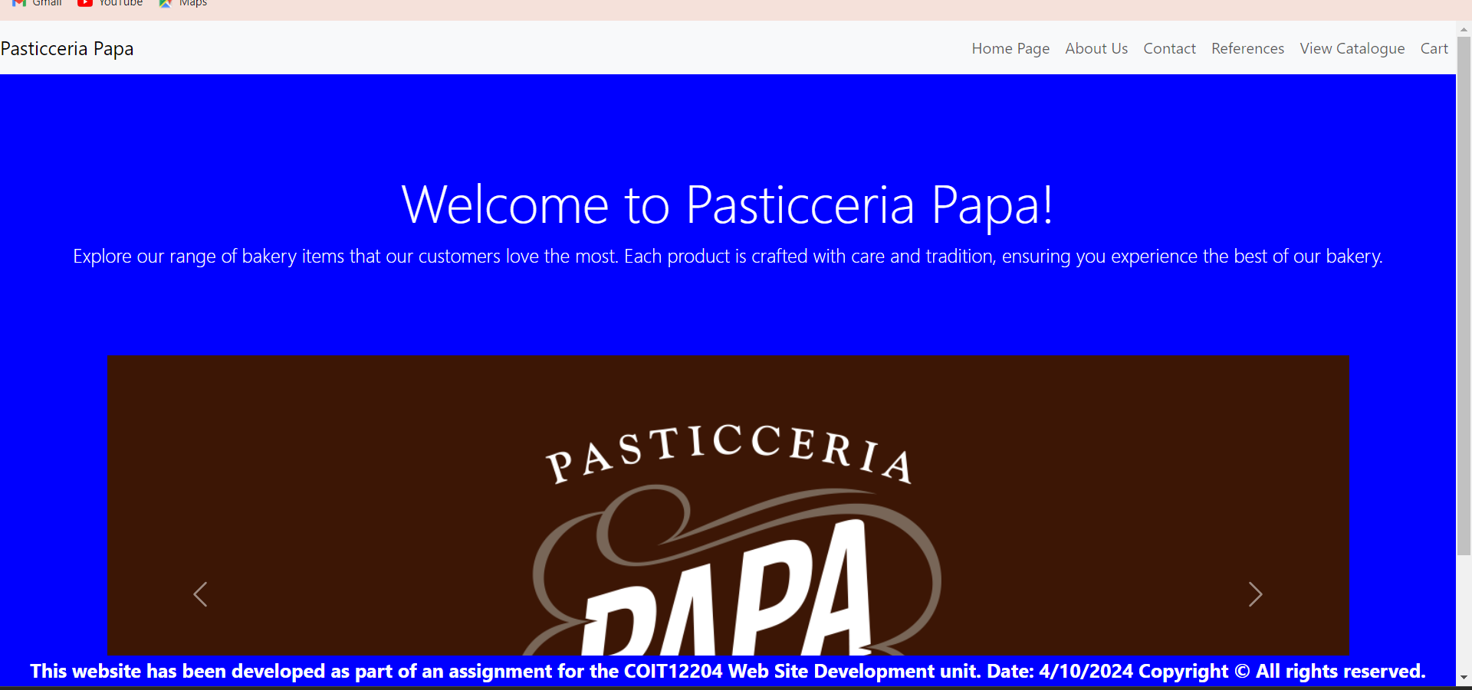

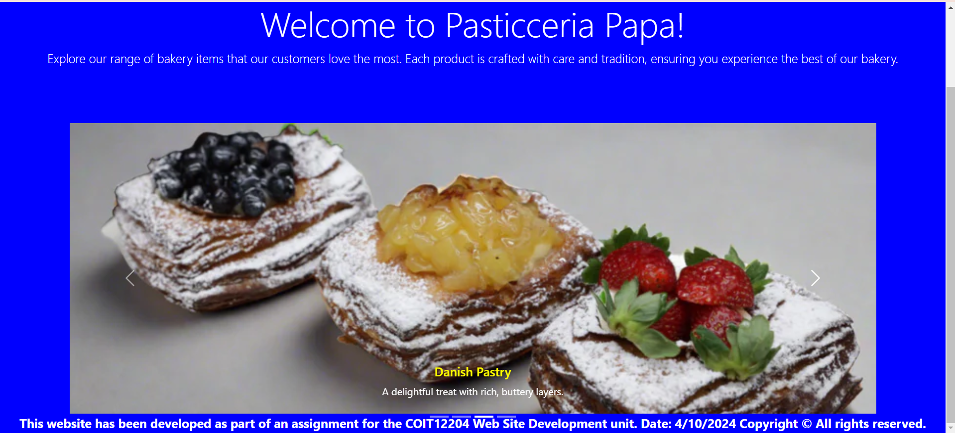

The About Us page for Pasticceria Papa introduces the bakery's history, values, and passion for baking. The page is designed with a sky-blue background and a clean, modern look. At the top, the navigation bar provides easy access to other sections of the website, including the home page, product catalogue, and contact page.
The content highlights the bakery’s journey, starting in 1985 as a family-owned business. It emphasizes the bakery’s commitment to quality, traditional Italian recipes, and its role in the community.
Users can learn about Pasticceria Papa’s mission to bring joy through delicious, lovingly made products. The page concludes with a simple footer, reinforcing that the bakery has been proudly serving its customers since its founding.

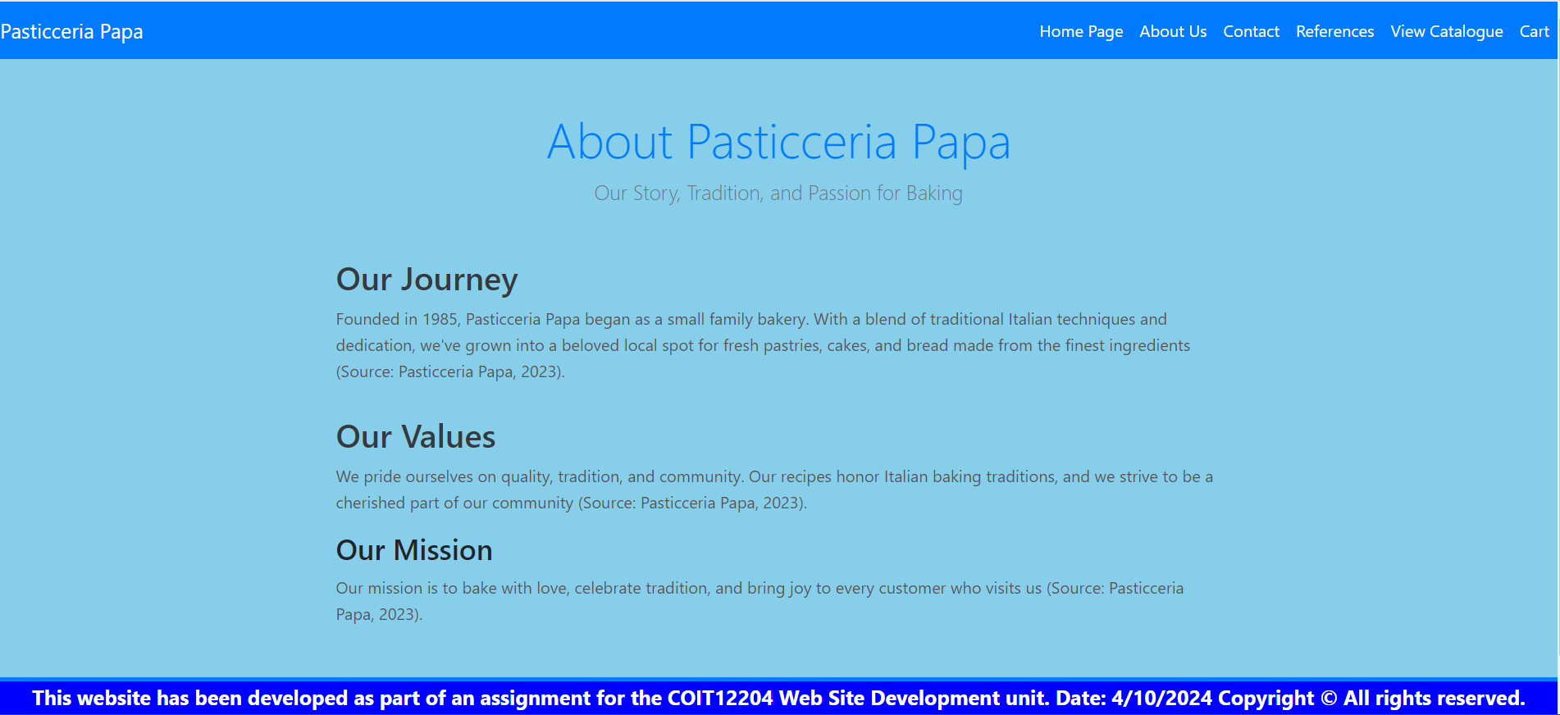

The Contact Us page for Pasticceria Papa provides a friendly and easy way for customers to get in touch. The page features a warm orange background with a clean, professional look. At the top, the navigation bar allows users to navigate to other sections like the home page, about us, catalogue, and shopping cart.
The page has two main sections: a contact form and location details. In the form, users can submit their name, email, and message directly to the bakery. On the right, there’s information about Pasticceria Papa’s location, phone number, and email address.
The design is user-friendly, with a blue and white colour scheme that makes the content easy to read, and the contact form simple to fill out.
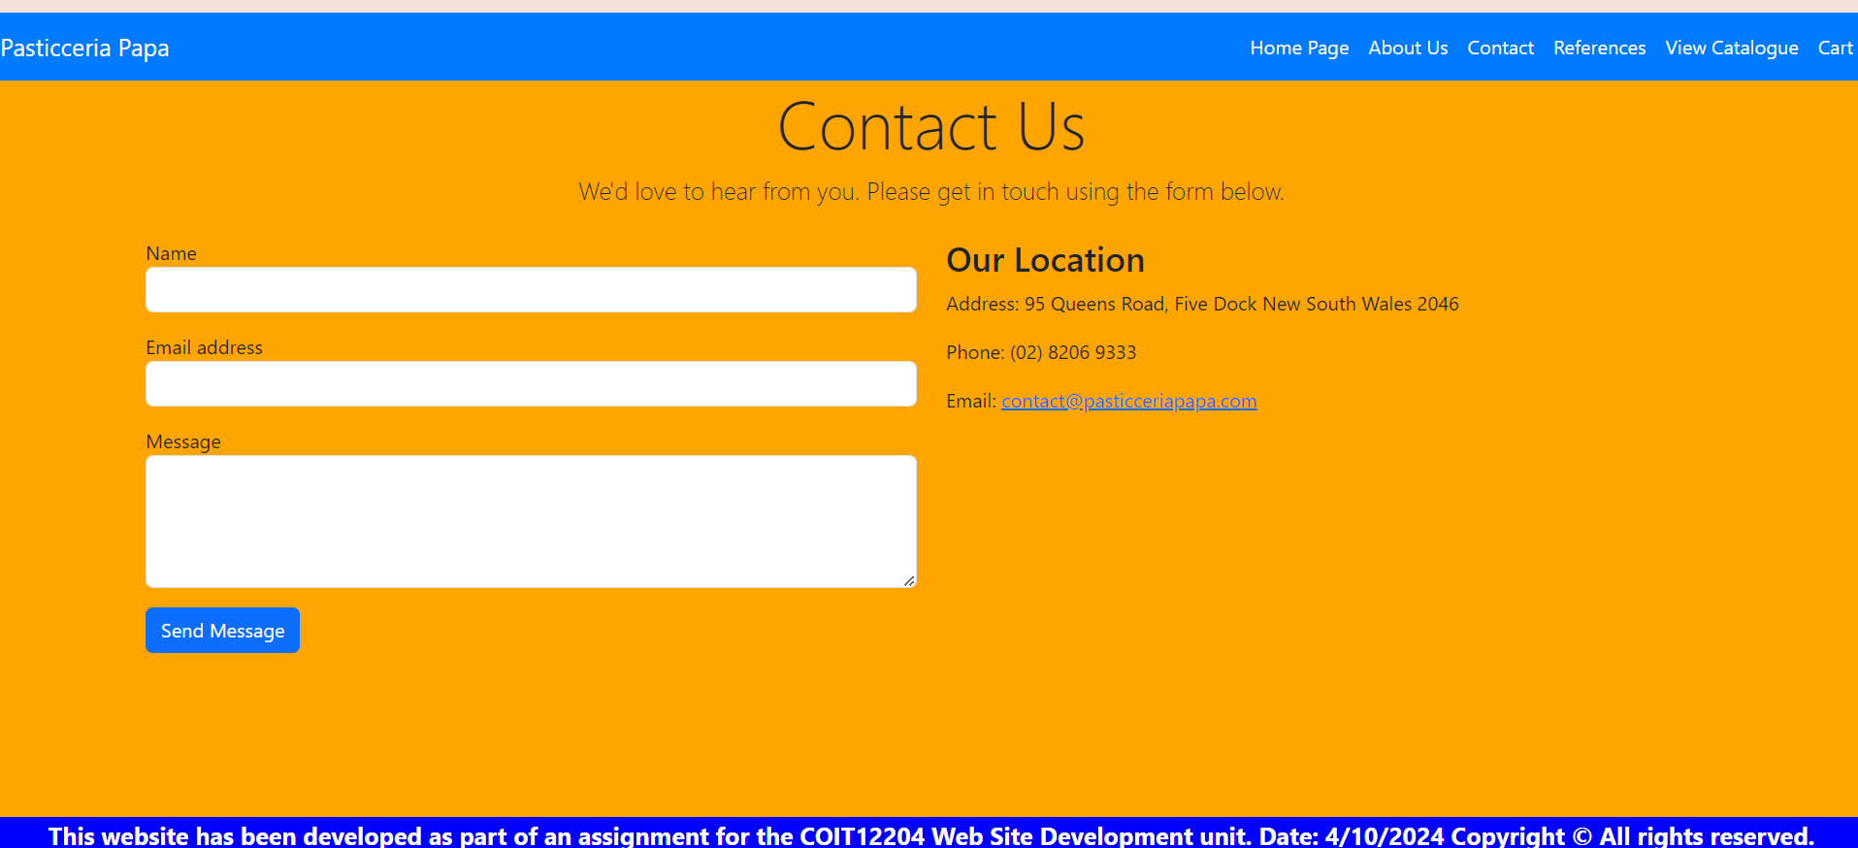

Welcome to the Product References page of Pasticceria Papa! Here, you’ll find a curated list of links showcasing our delicious offerings, complete with images to tantalize your taste buds. Each item is accompanied by a direct link to its image, allowing you to explore our treats visually and virtually.
Whether it’s our flaky Plain Croissant, indulgent Nutella Bombe Donut, or rich Cheesecake, you can easily access more details about each product. All references are up to date and can be accessed with just a click. We hope this page enhances your shopping experience and helps you discover all the delightful pastries we have to offer. Enjoy your browsing!

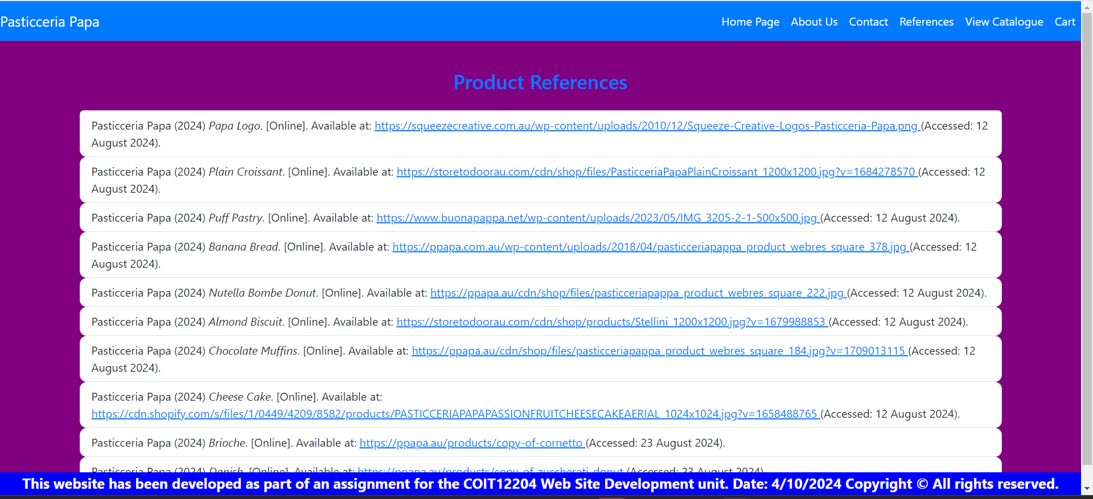

Welcome to the Pastry Items (Catalogue) page of Pasticceria Papa, where delightful treats await you! Here, you can explore our mouthwatering selection of pastries, each beautifully displayed in a grid format. Every product card showcases a tempting image, along with its name, description, price, and category.
Navigating through our offerings is a breeze, thanks to our user-friendly layout. You can easily filter your search by categories like Cake, Pastry, Bread, and Biscuit. When you find something that catches your eye, simply click on the “See Details of the Product” button for more information. Immerse yourself in our delightful pastry selection and discover your new favorite treat today at Pasticceria Papa!
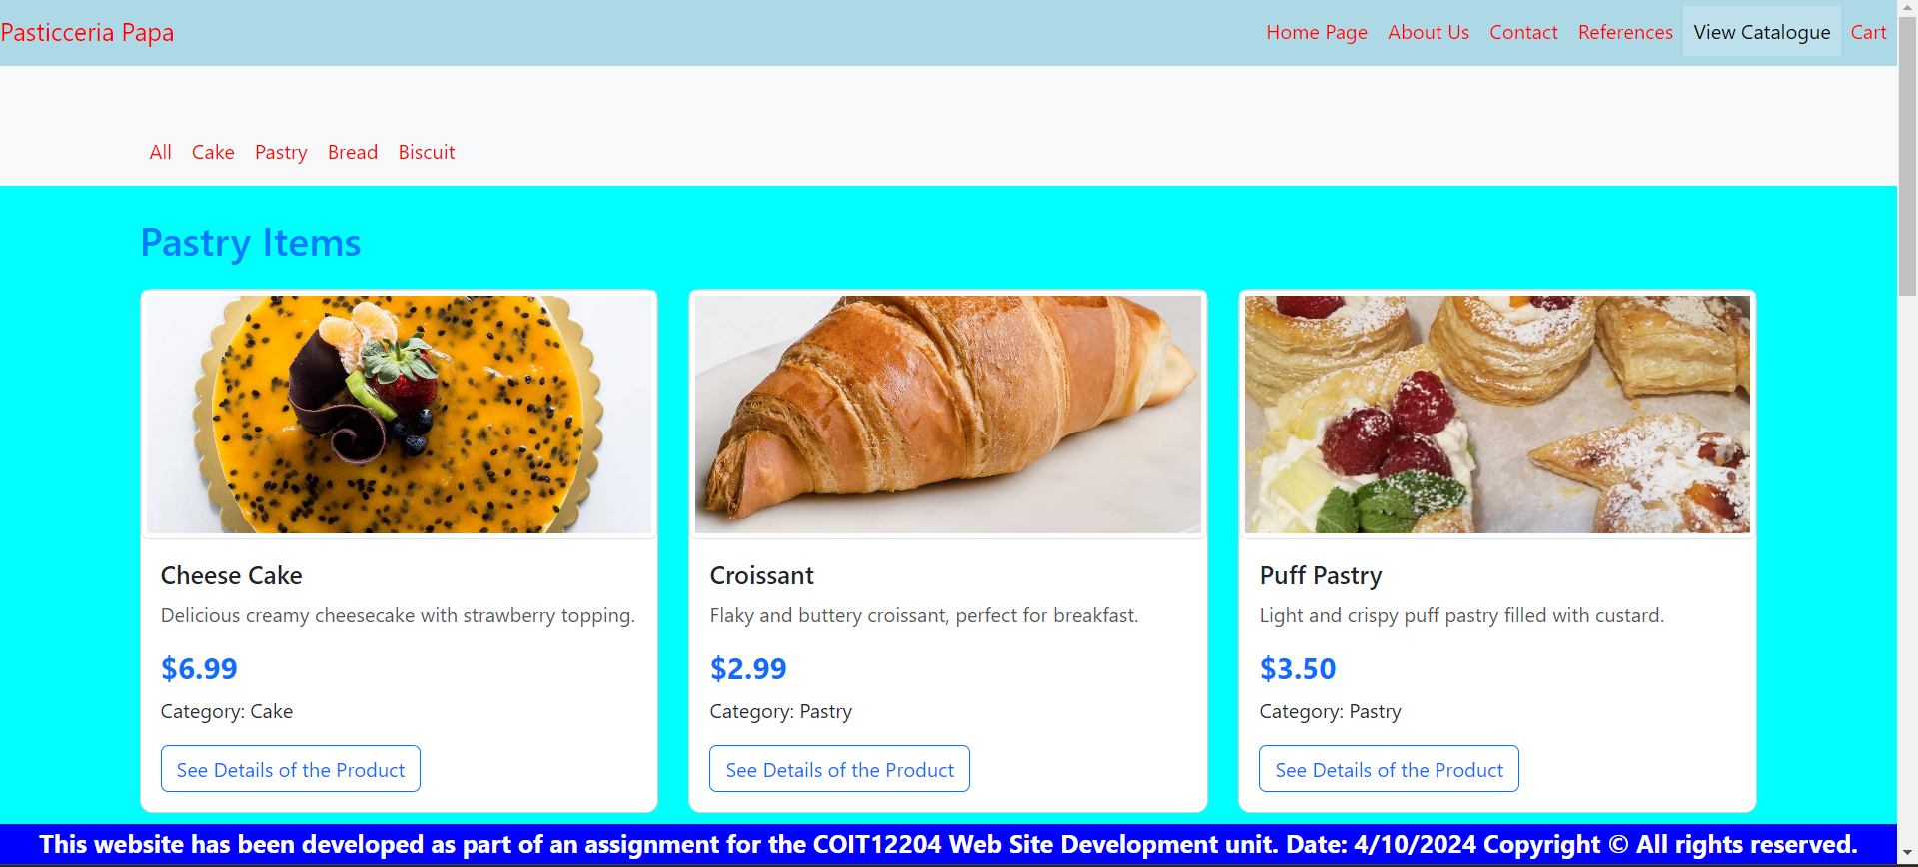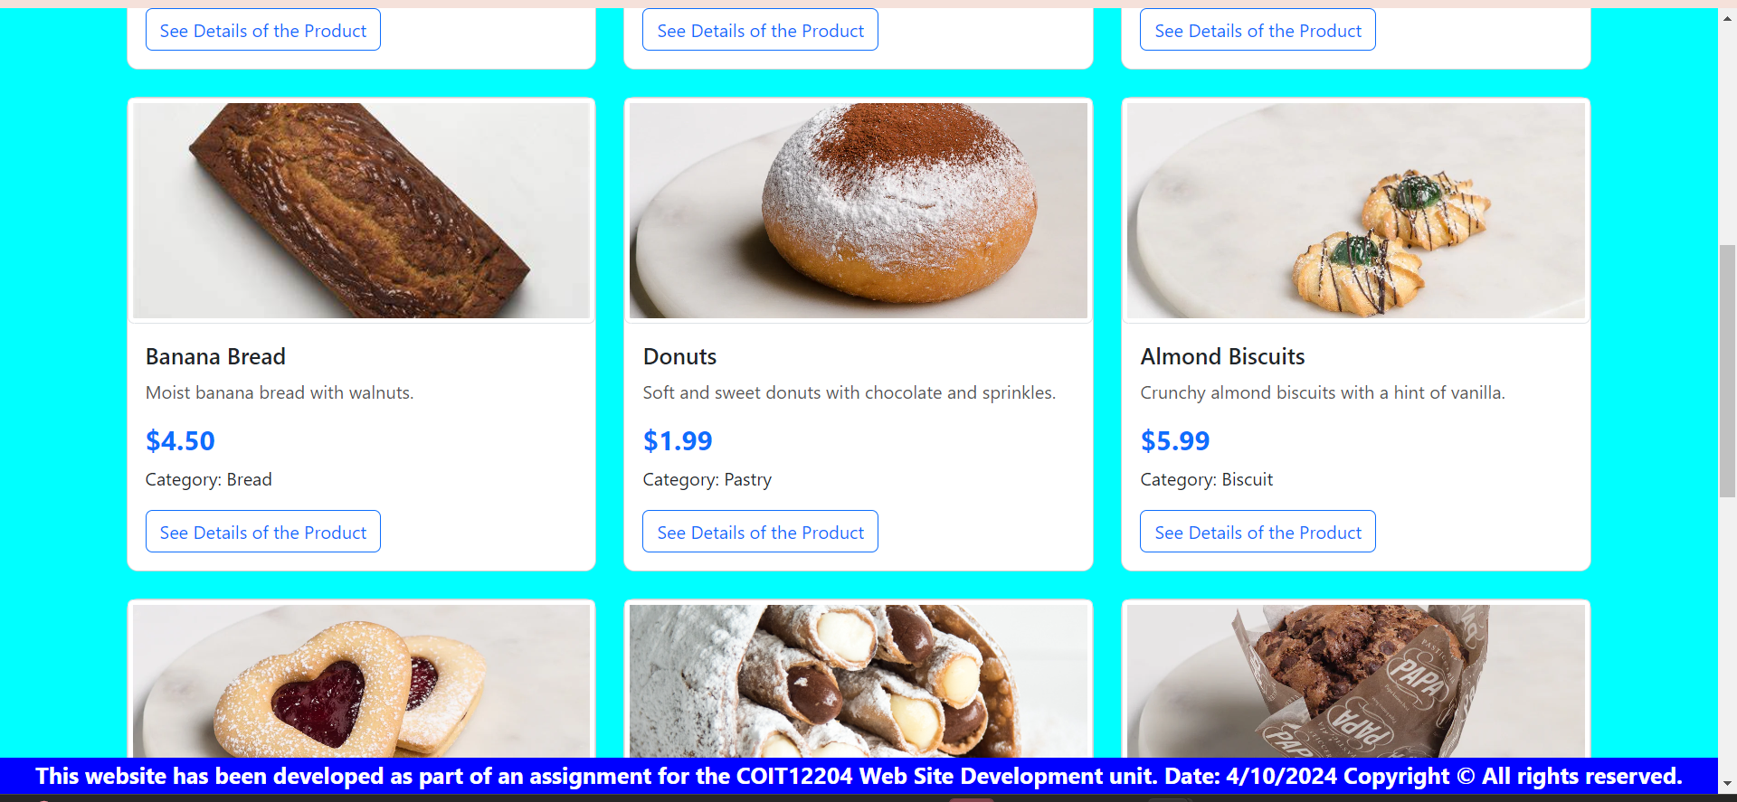

Welcome to the Product Details page for Pasticceria Papa, where we celebrate our delicious creations! Here, you can discover all the mouthwatering details about your favorite products, from scrumptious cakes to delightful pastries. Each product features a vibrant image and a detailed description, allowing you to appreciate its unique qualities.

You'll find the price and category information clearly presented, making it easy to choose what you want. If you're ready to indulge, simply select the quantity and click the "Add to Cart" button. The user-friendly design and inviting atmosphere make your shopping experience enjoyable. Dive in and treat yourself to a little taste of heaven with our delightful offerings from Pasticceria Papa!

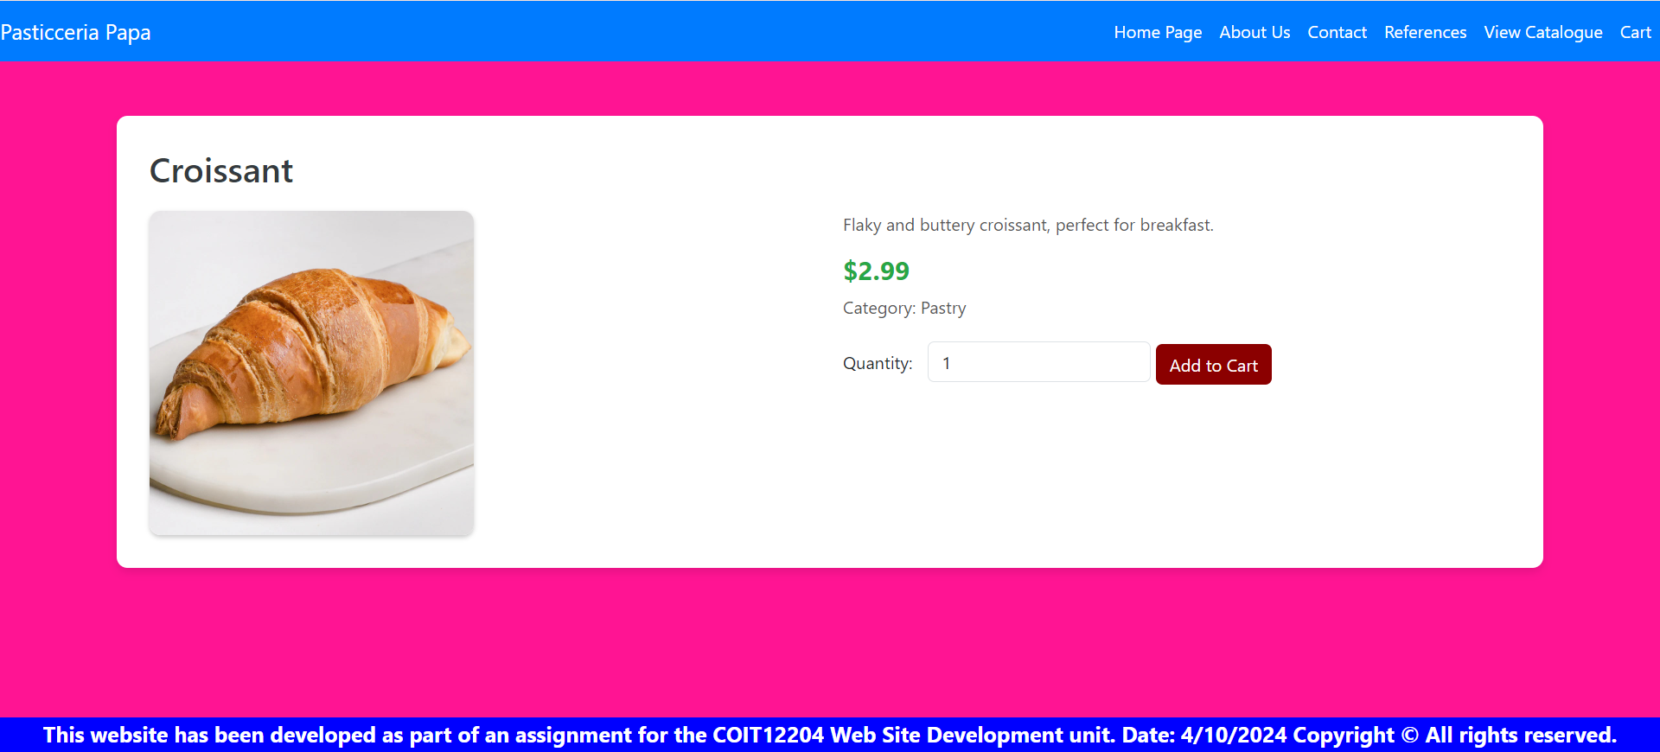

Welcome to the Shopping Cart page of Pasticceria Papa! Here, you can review all the delicious treats you’ve selected. If your cart is empty, no worries; it’s a great opportunity to explore our delightful catalogue.
Once you’ve added items, you can see the product image, price, quantity, and subtotal for each treat. If you change your mind about a pastry, simply click the “Remove” button next to it.
At the bottom, you'll find your total amount, along with options to continue shopping, clear your cart, or proceed to checkout. We aim to make your shopping experience enjoyable and straightforward. Thank you for choosing us, and happy indulging!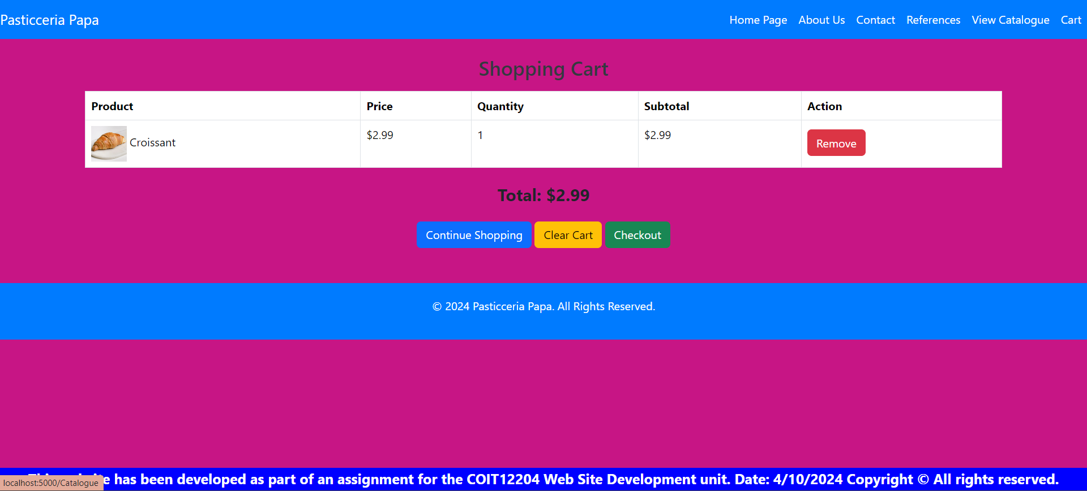

Welcome to the Checkout page at Pasticceria Papa! Here, you can finalize your delicious order and enjoy a seamless shopping experience. We’ve designed this page to be user-friendly, guiding you through providing your full name, address, and preferred payment method.
If you choose to pay by credit card, you’ll be prompted to enter your card details securely. Additionally, you’ll see a clear order summary, detailing each product, quantity, and the total amount, ensuring you know exactly what you’re purchasing.
Once everything is set, simply hit the “Place Order” button, and you’ll be one step closer to indulging in our delightful pastries. Thank you for choosing us, and happy shopping!

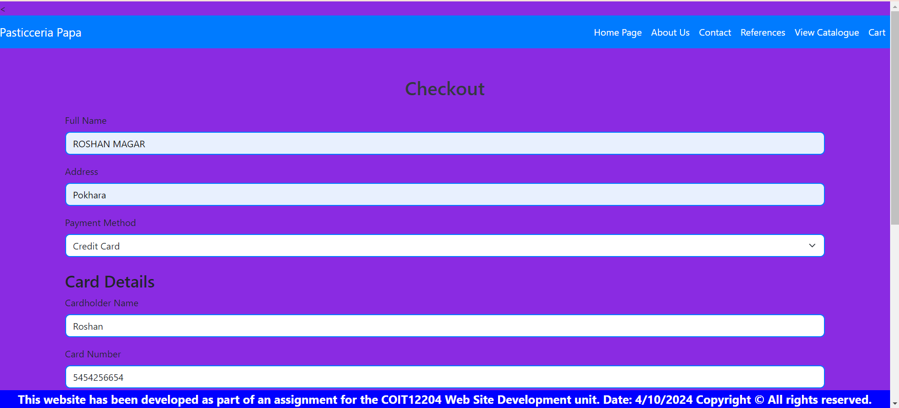
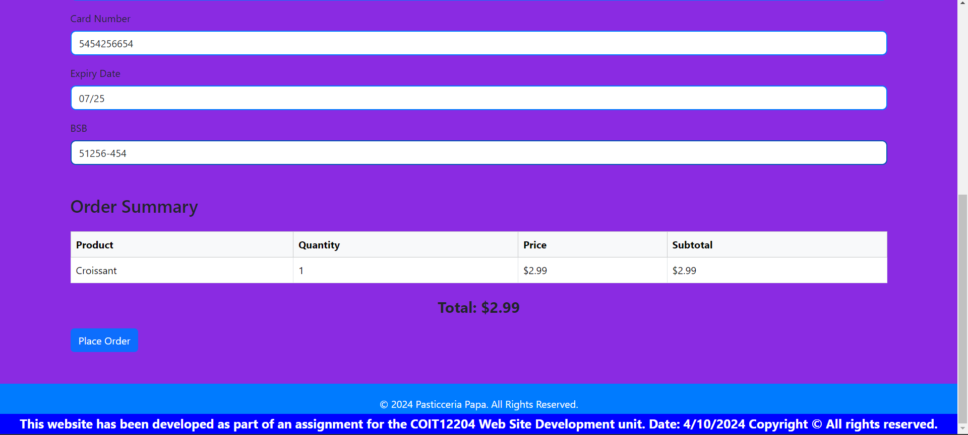

Welcome to the Order Confirmation page of Pasticceria Papa! We’re thrilled to inform you that your order has been successfully placed. Thank you for choosing us to satisfy your sweet cravings!
Here, you’ll find a warm message thanking you for your purchase, along with assurance that a confirmation email will be sent shortly. This page is designed to make you feel appreciated and informed about your order status.
If you’re ready to continue your culinary journey, simply click the “Continue Shopping” button to explore more delicious treats from our catalogue. We hope you enjoy your delightful selections, and we look forward to serving you again soon at Pasticceria Papa!
