R programming exploration - class activity

Name: Roshan Prabakar Raj

ASUID: 1209565263

### Solutions (1 point)

1. Calculate the correlation of each pair of variables in the data set of Assignment 1, put them in a table.

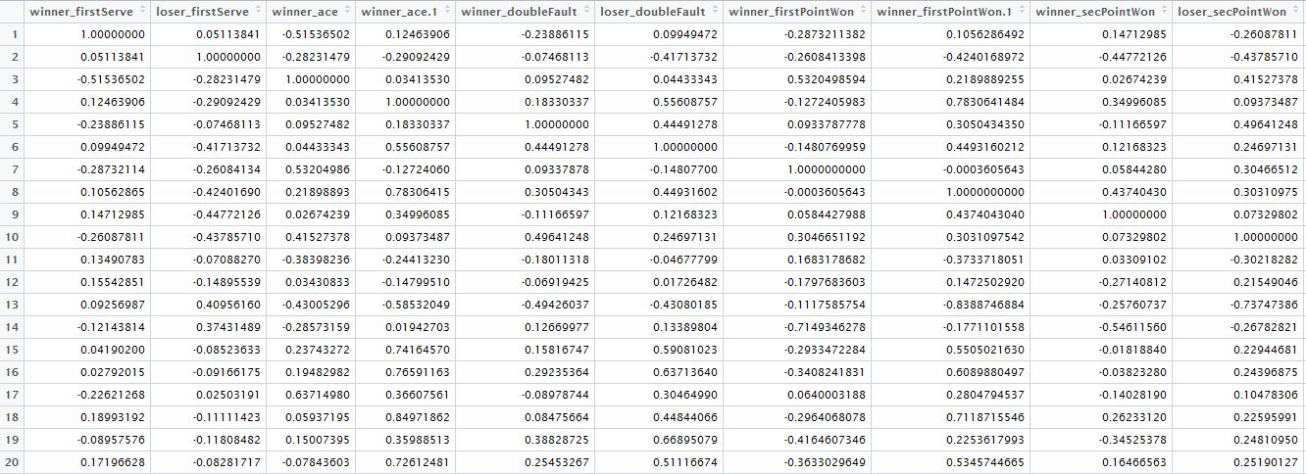

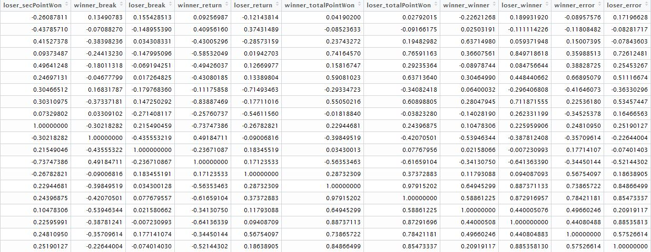

### Problems encountered (1 point)

* Establishing the correlation between all the values from the dataset was difficult.
* The correlation had to be found out neglecting the unnecessary values.

### PiSA usage (2 point)

|  |  |  |
| --- | --- | --- |
| Query | screenshot of search result pages | List of viewed SO pages |
| E.g.  Calculating correlation |  | http://ec2-54-69-239-219.us-west-2.compute.amazonaws.com/pisa_proj/search.php?search=calculate+correlation+of+each+pair+of+variables&page=1&sort=relevance |
| Finding Correlation |  | http://ec2-54-69-239-219.us-west-2.compute.amazonaws.com/pisa_proj/search.php?search=finding+correlation+in+a+dataset+in+R&page=1&sort=relevance |
| Handling NA values |  | http://ec2-54-69-239-219.us-west-2.compute.amazonaws.com/pisa_proj/search.php?search=handling+NA+values+in+R&page=1&sort=relevance |

### Suggestions or shortage of PiSA (1 point)

PiSA was very helpful in particular for this activity. Since it returned results only from Stack Overflow there was no need for using google. It returned all the results exactly as I needed.

SUGGESTIONS:

* Using a domain for PiSA will be more useful. Now we have to go to bookmarks to find out the tool.
* The User Interface could be improved. Certain modifications and then this tool will become a great success.