Landing Page for a Product

**Project Report**

Name: Roshan Richi - 2462354

A.Nihil - 2462301

Prajin.S - 2462348

Course: 3-BTCSDS

Semester: III

Date: 26-09-25

# Abstract

This project report presents the design and implementation of a landing page for a product using HTML, CSS, Bootstrap, JavaScript, and jQuery. The landing page is designed to showcase a product with modern web technologies, providing a responsive layout and smooth user experience. The project demonstrates web development skills and emphasizes the importance of well-structured and visually appealing landing pages in product promotion.

# Introduction

The objective of this project is to design a functional and visually engaging landing page that highlights the features and pricing of a product. Landing pages are crucial in digital marketing as they serve as the first point of interaction between users and a product or service. A well-designed landing page can improve customer engagement and drive conversions.

# Technologies Used

* HTML – for structuring the webpage.
* CSS – for styling and layout customization.
* Bootstrap – for responsive design and prebuilt UI components.
* JavaScript – for interactivity and dynamic features.
* jQuery – for smooth animations and DOM manipulations.

# System Design

The landing page consists of the following sections:  
1. Navigation Bar – fixed at the top for easy access.  
2. Hero Section – highlights the product with a call-to-action button.  
3. Features Section – describes the main advantages of the product.  
4. Pricing Section – displays different subscription options.  
5. Contact Section – allows users to send inquiries.  
6. Footer – provides copyright information.

# Implementation

The landing page was implemented using a combination of HTML, CSS, Bootstrap, JavaScript, and jQuery. Bootstrap was used for responsive layout and grid system, while CSS provided custom styles. JavaScript and jQuery were used to add interactivity such as smooth scrolling between sections.

# Output Screenshots

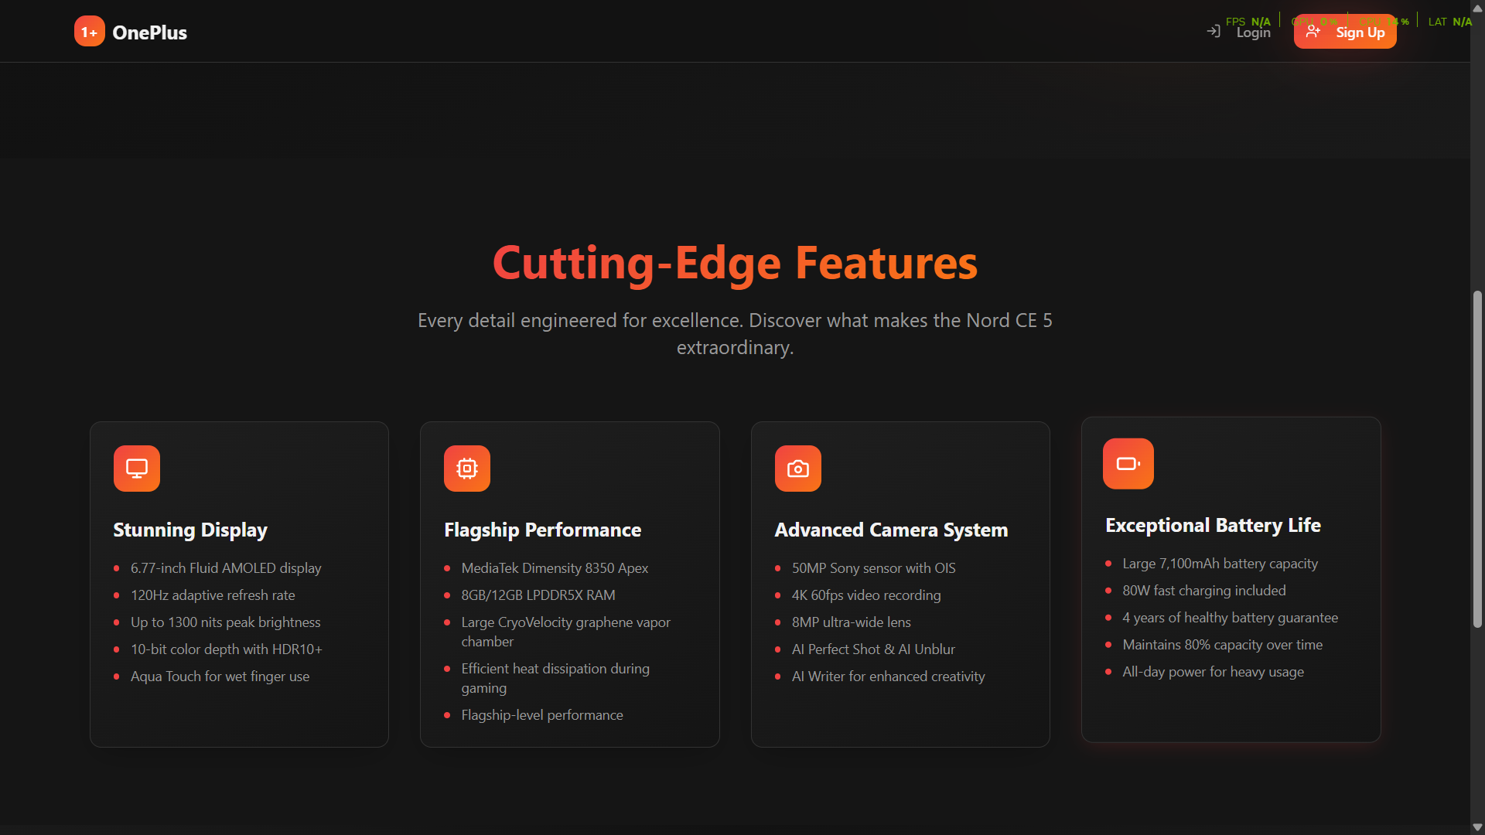

# Conclusion

This project successfully demonstrated the process of creating a responsive and modern landing page. It enhanced understanding of front-end technologies and design principles. Future improvements may include integrating backend functionality, user authentication, or analytics tracking.

# References

1. Bootstrap Documentation – https://getbootstrap.com/  
2. jQuery Documentation – https://api.jquery.com/  
3. MDN Web Docs – https://developer.mozilla.org/