AI STUDYBUDDY
AI-Powered Learning Assistance Platform
PROJECT DOCUMENTATION

Introduction
Project Title: AI StudyBuddy – AI Assistant for Smarter Learning and Study Support
Team members:
Roshan Sabeeha : Demo video
Pooja Sri : Project Implementation
Roshini : Project Implementation
Deepika : Documentation
Rajalakshmi : Documentation

Project Overview
AI StudyBuddy is an AI-powered learning assistance platform developed to simplify the study process by using modern web technologies and Generative AI. The system provides a centralized platform where authenticated students can upload or enter study materials and generate useful learning resources such as concise summaries, flashcards, multiple-choice quizzes, and personalized study plans.
The backend is developed using Node.js and Express.js and follows a RESTful API architecture. MongoDB is used as the primary NoSQL database, with Mongoose providing data modeling and schema validation. JWT-based authentication and Role-Based Access Control (RBAC) protect user information and restricted resources. Passwords are secured using bcryptjs.
A major feature of AI StudyBuddy is its integration with the Google Gemini AI API. The backend sends study content to the Gemini model through a dedicated AI service layer and dynamically generates educational content instead of depending only on predefined templates.

Objectives
- Develop an AI-powered learning assistance platform for students.
- Reduce the manual effort required to prepare notes and revision materials.
- Generate summaries, flashcards, quizzes, and study plans from study content.
- Provide secure user authentication and role-based access.
- Store study materials and generated learning resources for future use.
- Provide a scalable REST API backend using Node.js, Express.js, and MongoDB.

Scenario-Based Case Study
Rahul is a second-year engineering student preparing for semester examinations while learning technical skills for internships and placements. His study materials are spread across lecture notes, PDFs, textbooks, online articles, and handwritten notes. The large volume of material makes revision difficult and time-consuming.
AI StudyBuddy addresses this problem by centralizing study material and automating common learning tasks such as summarization, question generation, flashcard creation, and study planning.

1. Problem Statement and Proposed Solution

Problem
Students often spend considerable time organizing study material and preparing revision resources manually. This creates several difficulties during examination preparation.
- Difficulty understanding lengthy study materials within limited time.
- Manual preparation of notes consumes valuable study time.
- Creating flashcards and revision questions is repetitive.
- Lack of personalized study plans based on available time and examination dates.
- No centralized platform for storing generated learning resources.
- Difficulty assessing knowledge through self-generated quizzes.
- Switching between separate applications for notes, quizzes, and scheduling reduces productivity.

Solution
The AI StudyBuddy backend provides a centralized AI-powered learning platform. Authenticated users can upload study materials or provide textual content and select the required AI operation. The backend processes the request through secure REST APIs and communicates with Google Gemini to generate educational resources.
- Authenticate the user using JWT-based security.
- Store user information and study resources in MongoDB.
- Accept uploaded or entered study material.
- Send relevant study content to the Gemini AI service.
- Generate concise summaries, flashcards, quizzes, or study plans.
- Store generated resources for future retrieval.
- Return structured responses to the React frontend.

Usage
Student Usage: Students register and log in before accessing protected learning features. After authentication, they can upload study material and request summaries, flashcards, quizzes, or personalized study plans. Generated resources can be reviewed and saved for future reference.
Administrator Usage: Administrators manage registered users, monitor application activity, oversee system usage, review system logs, and maintain platform integrity. Administrative operations are protected through role-based authorization.

2. Technology Stack and System Architecture

Technology Stack
- Node.js – Runtime environment used to execute backend JavaScript.
- Express.js – Backend framework used to build RESTful API routes and middleware.
- MongoDB – NoSQL database used to store users, study materials, and generated resources.
- Mongoose – ODM used for schemas, validation, and database interactions.
- JWT (JSON Web Token) – Used for authentication and protected API access.
- bcryptjs – Used to securely hash user passwords before database storage.
- Google Gemini AI API – Used to generate summaries, flashcards, quizzes, and study plans.
- Multer – Used as file-upload middleware for study material uploads.
- dotenv – Used to load environment variables securely.
- CORS – Used to support controlled communication between frontend and backend.
- Postman / Thunder Client – Used to test REST API endpoints.
- React.js – Frontend client that communicates with the backend APIs
- Thunder Client – used to send HTTP request and test APIs without living VScode .

System Architecture
The AI StudyBuddy backend follows a modular RESTful architecture. Client requests are received by the Express server and passed through appropriate middleware and route handlers. Protected requests are verified using JWT authentication. Controllers implement business logic and interact with Mongoose models. AI-related requests are passed to the Gemini service, while persistent information is stored in MongoDB.
Architecture Flow:
Client Application (React.js) → Express Server → Authentication Middleware → Routes → Controllers → AI Service / Database Layer

Architecture Components
- Client Application: Provides the user interface for registration, login, material upload, and AI learning features.
- Express Server: Receives HTTP requests, handles routing, middleware, and responses.
- Authentication Middleware: Verifies JWT tokens and protects private resources.
- Route Handlers: Define endpoints for authentication, materials, AI features, and administration.
- Controller Layer: Performs request validation, business logic, authorization, and service calls.
- AI Service Layer: Communicates with Google Gemini to generate educational content.
- Database Layer: MongoDB and Mongoose store and retrieve application data.

3. Entity-Relationship Design and MVC Architecture

ER Diagram Description
The AI StudyBuddy backend manages related MongoDB collections for users, study materials, and AI-generated learning resources. The logical relationships allow generated resources to be associated with both the user and the source study material.

Entities
1. User Entity
- _id – Primary key (ObjectId)
- name – Required string
- email – Required and unique string
- password – Hashed password
- role – Student or Admin
- createdAt – Account creation time
2. Study Material Entity
- _id – Primary key
- userId – Reference to User
- title
- subject
- content
- createdAt
3. Summary Entity
- _id – Primary key
- userId – Reference to User
- materialId – Reference to Study Material
- summary
- createdAt
4. Flashcard Entity
- _id – Primary key
- userId – Reference to User
- materialId – Reference to Study Material
- question
- answer
- createdAt
5. Quiz Entity
- _id – Primary key
- userId – Reference to User
- materialId – Reference to Study Material
- questions
- createdAt
6. Study Plan Entity
- _id – Primary key
- userId – Reference to User
- studyPlan
- examDate
- createdAt

Key Relationships
- User → Study Material: One-to-Many; one user can upload multiple study materials.
- Study Material → Summary: One-to-One as described in the project design.
- Study Material → Flashcards: One-to-Many; one material can generate multiple flashcards.
- Study Material → Quiz: One-to-One as described in the project design.
- User → Study Plan: One-to-Many; a user can generate multiple study plans.
- User → AI Resources: One-to-Many; generated resources are associated with the generating user.

MVC Architecture
Model Layer: Defines MongoDB collections using Mongoose schemas and handles data validation and database interactions.
View / API Response Layer: Since this is a REST backend, the system returns structured JSON responses to the React frontend instead of using a traditional server-rendered view.
Controller Layer: Processes requests, validates input, applies authentication and authorization, communicates with models, invokes the Gemini service, and returns responses.

4. Project Setup and Backend Structure

Project Initialization
The project can be initialized by creating an AI StudyBuddy folder, opening it in Visual Studio Code, and initializing a Node.js project.
Command: npm init -y
Required dependencies:
npm install express mongoose bcryptjs jsonwebtoken cors dotenv multer @google/genai
Development dependency:
npm install --save-dev nodemon

Environment Configuration
The project uses environment variables for configuration and sensitive credentials.
PORT=5000
MONGO_URI=your_mongodb_connection_string
JWT_SECRET=your_jwt_secret
GEMINI_API_KEY=your_gemini_api_key

Suggested Backend Folder Structure
AI-StudyBuddy/
├── index.js
├── .env
├── package.json
├── .gitignore
└── src/
├── controllers/
├── routes/
├── models/
├── middleware/
└── utils/

Core Modules
- index.js – Main application entry point, Express setup, environment loading, route registration, database connection, and server startup.
- src/utils/db.js – Establishes the MongoDB connection using Mongoose.
- src/middleware/auth.js – Verifies JWT access tokens and applies role-based authorization.
- src/utils/gemini.js – Integrates the backend with Google Gemini 2.5 Flash and returns generated responses.
- src/middleware/upload.js – Handles study material file uploads and validates incoming files.
- Models – Define user, material, summary, flashcard, quiz, and study-plan data structures.
- Controllers – Contain business logic for authentication, materials, AI features, and administration.
- Routes – Define REST API endpoints and connect requests to controllers.

5. Key Features and Security Implementation

Key Features
- Secure User Authentication – Registration and login using JWT-based authentication.
- Password Protection – Passwords are hashed using bcryptjs before being stored.
- Study Material Management – Users can upload and manage learning materials.
- AI Summary Generation – Produces concise summaries for faster revision.
- AI Flashcard Generation – Creates question-and-answer flashcards for active recall.
- AI Quiz Generation – Produces multiple-choice questions for self-assessment.
- AI Study Plan Generation – Creates personalized study schedules according to learning goals, available study time, and examination timelines.
- Role-Based Access Control – Separates Student and Administrator permissions.
- Persistent Storage – Stores user information, study materials, and generated resources in MongoDB.
- Modular Architecture – Separates routes, controllers, middleware, models, database operations, and AI services.

Security Implementation
Security is an important part of AI StudyBuddy because the system handles user accounts, passwords, study materials, and protected AI services.
- JWT Authentication: After successful login, the backend generates a JWT access token. Protected routes verify the token before allowing access.
- Password Hashing: bcryptjs is used to hash passwords before they are stored in MongoDB.
- Role-Based Authorization: Student and Administrator roles are used to restrict system-level operations.
- Environment Variables: Database credentials, JWT secrets, and the Gemini API key are stored through environment variables rather than being directly embedded in application code.
- Protected Resources: Authentication middleware ensures that only authorized users can access private study resources and AI services.

User Flow
Register / Login → JWT Authentication → Dashboard → Upload or Enter Study Material → Select AI Feature → Gemini AI Processing → Generated Resource → Display and Store for Future Reference

6. API Interface and Project Execution

API Route Interface
The backend exposes RESTful APIs for authentication, study material management, AI content generation, and administrative operations.

Authentication APIs
- POST /api/auth/register – Registers a new user.
- POST /api/auth/login – Authenticates a user and generates a JWT access token.

Study Material APIs
- POST /api/material/upload – Uploads study material for authenticated users.
- Study material retrieval, update, and management operations are handled through protected material routes.

AI Feature APIs
- POST /api/materials/:id/summarize – Generates a concise AI summary.
- POST /api/ai/flashcards – Generates flashcards from study material.
- POST /api/ai/quiz – Generates multiple-choice quiz questions.
- POST /api/ai/study-plan – Generates a personalized study plan.

Administrative APIs
Administrative endpoints provide administrator-only operations for managing users and monitoring system activities. Access is restricted using the role-based authorization layer.

Project Execution
Before running the backend, the required Node.js dependencies must be installed, MongoDB must be available, and the environment variables must be configured.
Install dependencies: npm install
Start the development server: npm start
After successful execution, the server connects to MongoDB and listens for incoming API requests.

API Testing
Postman or Thunder Client can be used to verify the API endpoints. Testing should cover user registration, login, protected access, study-material upload, summary generation, flashcard generation, quiz generation, and study-plan generation.

Expected Testing Flow
- Register a new student account.
- Log in and obtain the JWT token.
- Use the token to access a protected endpoint.
- Upload study material.
- Generate an AI summary.
- Generate flashcards and a quiz.
- Generate a personalized study plan.
- Verify that generated resources are stored and can be retrieved.

Register

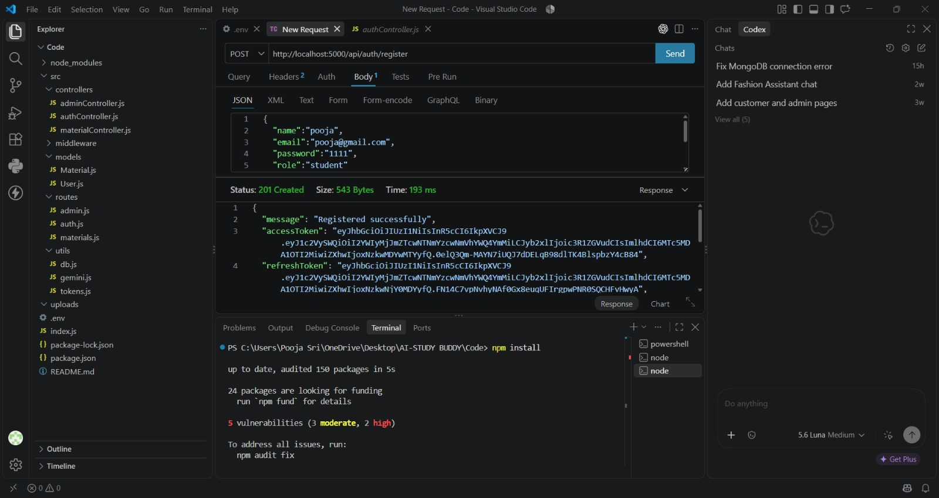
Login page

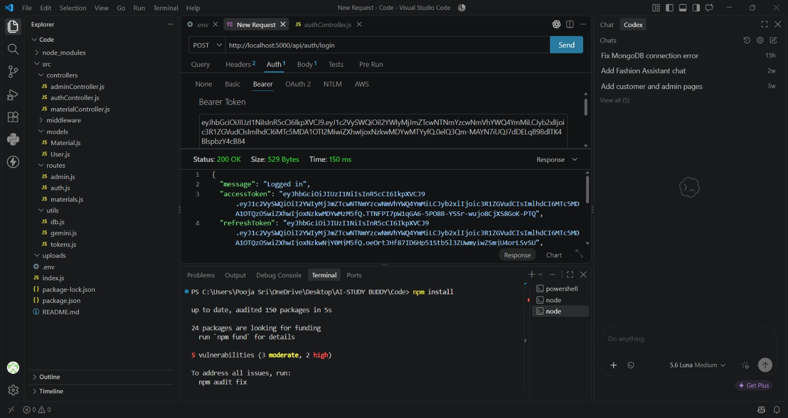

Logout
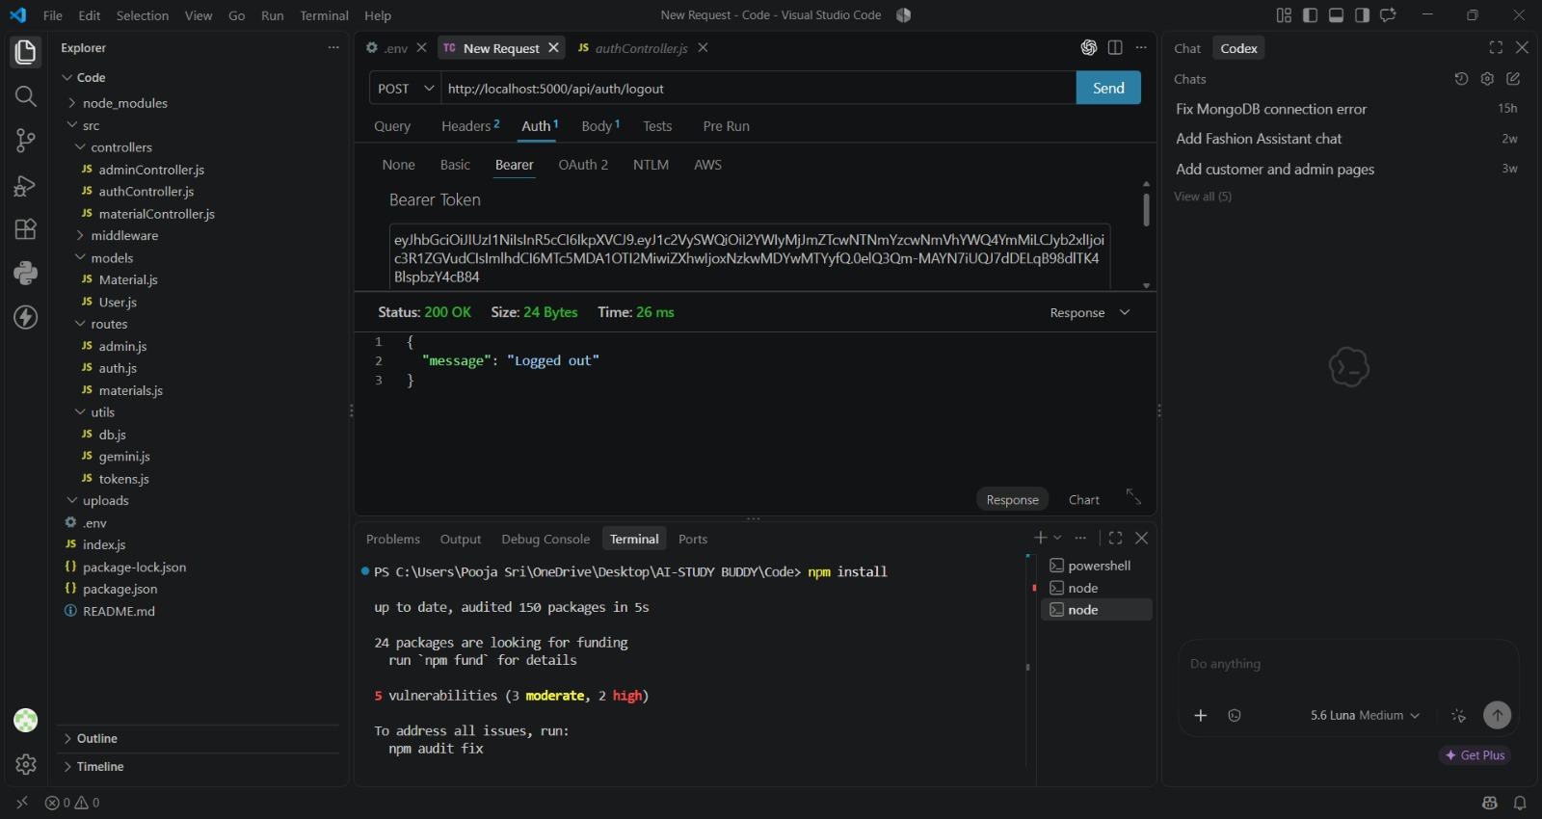

7. Outcome, Conclusion and Future Enhancements

Outcome
AI StudyBuddy combines artificial intelligence with a secure backend architecture to reduce the manual effort involved in preparing learning resources. Students can transform study materials into summaries, flashcards, quizzes, and study plans through REST APIs connected to the Google Gemini AI service.
JWT authentication, bcryptjs password hashing, MongoDB storage, Mongoose data modeling, and role-based access control provide the security and data-management foundation of the application. The modular architecture separates authentication, business logic, database operations, file uploads, and AI processing, supporting maintainability and future extension.

Advantages
- Reduces time spent manually preparing revision resources.
- Provides multiple learning formats from the same study material.
- Supports active recall through AI-generated flashcards.
- Allows students to assess understanding using generated quizzes.
- Provides personalized study planning.
- Centralizes study materials and generated resources.
- Uses secure authentication and authorization.
- Supports future expansion through a modular backend architecture.

Future Enhancements
- Add more AI-powered learning features such as difficulty-based question generation.
- Support additional study-material formats and improved document processing.
- Add progress tracking and learning analytics.
- Add reminders and notifications for study plans.
- Provide richer administrator monitoring and usage dashboards.
- Improve personalization using learning history and performance data.
- Deploy the backend and database to cloud infrastructure for wider access.

Conclusion:
The AI StudyBuddy project demonstrates the development of a modern AI-powered educational backend using Node.js, Express.js, MongoDB, Mongoose, JWT authentication, bcryptjs, and the Google Gemini AI API. By automating common study-support activities and providing secure RESTful services, the system creates a centralized platform for efficient revision and personalized learning. Its modular design also provides a foundation for adding further educational and AI capabilities.
Demo video link:
https://drive.google.com/file/d/1k6DlvcbbCNjG3DJuit4-I6c-u3jbJ5eo/view?usp=sharing
Code Drive Link:
https://drive.google.com/file/d/15M-3A0Ff966uD9TvJ_yvyJr0SWwDaaKv/view?usp=sharing
API Drive Link :
https://drive.google.com/file/d/1Xvmp70W46LFbQlFhO8b-NCaedhoYKDZr/view?usp=sharing

