1. **Write a function in python to count the number of lines from a text file "story.txt" which is not starting with an alphabet "T".**

**Example:**

**If the file "story.txt" contains the following lines:**

**A boy is playing there.**

**There is a playground.**

**An aeroplane is in the sky.**

**The sky is pink.**

**Alphabets and numbers are allowed in the password.**

**The function should display the output as 3.**

def count_line():

count=0

my_file=open('story.txt',"r")

for line in my_file:

if line[0] not in 'T':

count+= 1

my_file.close()

print("Number of lines without starting with T=",count)

count_line()

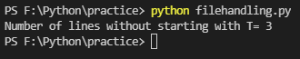

1. **Write a function display_words() in python to read lines from a text file "story.txt", and display those words, which are less than 4 characters.**

def display_words():

my_file=open('story.txt','r')

count=0

line=my_file.read()

word=line.split()

list=[]

for w in word:

if len(w)<4:

list.append(w)

print(list)

my_file.close()

display_words()

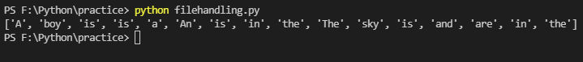

1. **Write a function in Python to copy the content of story.txt into story2.txt file.**

def copyf():

my_file=open('story.txt','r')

line=my_file.read()

my_file=open('story2.txt','w')

my_file.write(line)

copyf()