1. **Write a program to perform sum of two numbers.**

n1=float(input('Enter 1st Number='))

n2=float(input('Enter 2nd Number='))

sum=n1+n2

print('Sum=',sum)

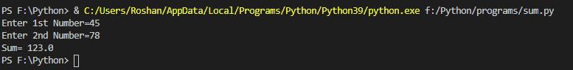

1. **Write a program to print your name.**

name=input('Enter Your Name=')

print('Hi,',name)

