1) A student will not be allowed to sit in exam if his/her attendence is less than 75%.

Take following input from user

 -Number of classes held

 -Number of classes attended.

 -And print percentage of class attended

 -Is student is allowed to sit in exam or not.

n1=int(input('Please Enter total number of held classes='))

n2=int(input('Please Enter number of attended classes= '))

per=n2/n1*100

print('Your attendance is',per,'.')

if(per>75):

    print('Congratulation,You are allowed to sit in exam! :)')

else:

    print('Sorry,You are not allowed to sit in exam! :(')

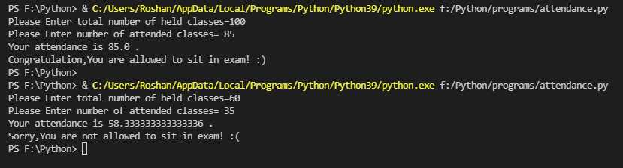

2) A company decided to give bonus of 5% to employee if his/her year of service is more than 5 years.

   Ask user for their salary and year of service and print the net bonus amount.

sal=int(input('Please Enter Your Salary='))

year=int(input('Please Enter your year of service='))

if(year>5):

    bonus=sal*0.05

    print('Congrats!You have ',bonus,'rupees bonus.')

else:

    print('Sorry!You do not have bonus.')

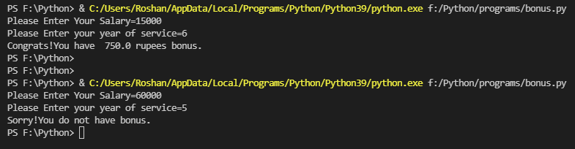

3) Use conditional statement to check is a number is even or odd.

num=int(input('Enter a Number='))

if num%2==0:

    print(num,' is Even Number.')

else:

    print(num,' is Odd Number.')

print('Program execution is completed.')

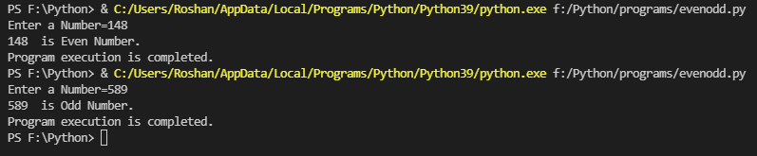

4)  Input - students percentage

Output - grade

      Conditions -  percentage >= 60  -  B grade

                            percentage >= 70   - A grade

                            percentage >= 80 - A+ grade

                            else - C  grade

per=int(input('Please Enter Your Percentage:-'))

if(per>=60 and per<=70):

    print('Congrats!You got \'B\' Grade.')

elif(per>=70 and per<=80):

    print('Congrats!You got \'A\' Grade.')

elif(per>=80):

    print('Congrats!You got \'A+\' Grade.')

else:

    print('Sorry!You got \'C\' Grade.')

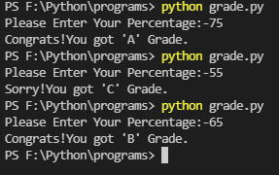

5) Use conditional statement to check if a year is a leap year or not.

year=int(input('Enter year to check it is leap or not='))

if(year%4==0):

    if(year%100==0):

        if(year%400==0):

            print(year,' is a leap year.')

        else:

            print(year,' is not leap year.')

    else:

        print(year,' is not leap year.')

else:

    print(year,' is not leap year.')

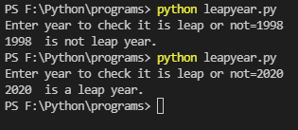

6) What is operator and how many types of operators in python

Operators are used to perform operations on variables and values There are few operators in python

And as follows:

1. **Assignment Operators**

* This operators are used to assign value to the variable.
* The assignment operator takes value or expression from right and assign to a variable on the left.
* There are some assignment operators like =, +=, -=, *=,/=,%=,//=,**= etc.

1. **Arithmetic Operators**

-This operators are used to perform mathematical operation on variables. Following are some of the arithmetic operators.

* + Addition operator(+)
    - It returns addition of 2 or more variables.
  + Subtraction operator(-)
    - It returns subtraction of 2 or more variables.
  + Multiplication operator(*)
    - It returns multiplication of 2 or more variables.
  + Division operator(/)
    - It returns the quotient in the float type.
  + Floor division(//)
    - It returns the quotient in the int type.
  + Modulus operator (%)
    - It returns the remainder after division.
  + Exponent operator(**)
    - It is used to calculate and return power of number.

1. **Conditional Operators**

These operators are used to create a condition on python program.

All the operator returns value in bool type i.e true or False.

**1. == equal to**

returns True if left and right values are equal.

**2. != not equal**

returns True if left and rigth values are not equal.

**3. > greater than**

returns true if left value is greater than right side value otherwise false.

**4. < less than**

returns true if left value is less than right side value otherwise false.

5. **>= greater than or equal to**

returns true if left side value is greater or equal to right side value.

6. **<=less than or equal to**

returns true if left side value is less than or equal to right side value.

1. **Logical Operators**

Logical operator used to write 2 or more condition in one single if statements.

1. **AND operator**

returns true if and only if al the condition is true.

1. **OR operator**

returns true if one of the condition is true, if all condition are

false then it will be false.

1. **Not Operator**

It will reverse the result.

if result is true false become true and vice versa.

1. **Membership Operators**

These operator used with sequencial object(iterable object) like list ,tuple,set,dictionary.

1. **in Operator:-**

check if value is exist in given sequence

1. **Not in**

check if the value is not exist in given sequence.

1. **Identity Operators**
2. **is:-**

returns true if memory address of 2 variable is same or not.

1. **is not:-**

returns true if memory address of 2 variable is different or not.

1. **Bitwise Operators**

7) Calculate the bike rent for given usage of vehicle.

for Bike the rent is 100 rs per Hr for 0-3Hrs.  and for 3-5 Hrs the rent is 200 Rs per hour.

for scooty, the rent is 75 Rs per hr for 0-3 hrs. from 3-5 hrs the rent is 150 Rs per hr.

vehicle=input('Which vehicle do you want Bike or Scooty?\n')

if(vehicle=='Bike' or vehicle=='bike'):

    hrs=int(input('How many hours do you want the vehicle?\n'))

    if(0<hrs<=3):

        rent=hrs*100

        print('rent=',rent,'Rupees')

    elif(3<hrs<=5):

        rent=hrs*200

        print('rent=',rent,'Rupees')

    else:

        print('We do not have service for more than 5 hours.')

elif(vehicle=='Scooty' or vehicle=='scooty'):

    hrs=int(input('How many hours do you want the vehicle?\n'))

    if(0<hrs<=3):

        rent=hrs*75

        print('rent=',rent,'Rupees')

    elif(3<hrs<=5):

        rent=hrs*150

        print('rent=',rent,'Rupees')

    else:

        print('We do not have service for more than 5 hours.')

else:

    print('Please Enter proper vehicle')

