1. **W.A.P to print number between 1 to 50 in ascending and descending order.?**

print('\nAscending Order')

for i in range(1,51):

    print(i,end=',')

print('\nDescending Order')

for i in range(50,0,-1):

    print(i,end=',')

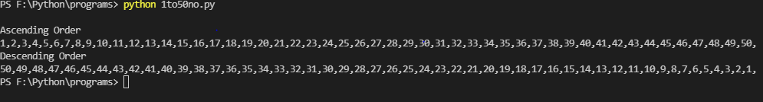

1. **W. A.P. to print odd numbers between 1 to 50.?**

print('\nOdd Numbers Between 1 to 50')

for num in range(1,51):

    if(num%2==1):

        print(num,end=',')

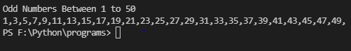

1. **W.A.P to count the Vowel, Consonant, Capital letters ,small letters,digits and symbol character in string entered by user.?**

s1=input('Enter a string=')

vowelcnt,consocnt=0,0

capscnt,smallcnt=0,0

numcnt,spcnt,totalcnt=0,0,0

for ch in s1:

    if(ch>='A' and ch<='Z') or (ch>='a' and ch<='z'):

        if ch in 'aeiouAEIOU':

            vowelcnt+=1

        elif(ch>='A' and ch<='Z') or (ch>='a' and ch<='z'):

            consocnt+=1

        if(ch>='A' and ch<='Z'):

            capscnt+=1

        elif(ch>='a' and ch<='z'):

            smallcnt+=1

    elif(ch>='0' and ch<='9'):

            numcnt+=1

    else:

        spcnt+=1

print('Vowel=',vowelcnt)

print('Consonant=',consocnt)

print('Digits=',numcnt)

print('Special Character=',spcnt)

print('Capital Letters=',capscnt)

print('Small Letters=',smallcnt)

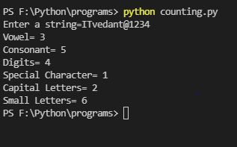

1. **W.A.P to calculate and print the Factorial of number entered by user?**

n=int(input('Enter a number='))

fact=1

for i in range(1,n+1):

    fact=fact*i

print('Factorial of ',n,'=',fact)

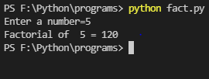

1. **W.A.P to Calculate and print sum of number between 1 to n?**

n=int(input('Enter a number='))

sum=0

for num in range(1,n+1):

    sum=num+sum

print('Addition of 1 to',n,'numbers=',sum)

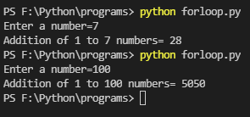

**6) W.A.P to print number between 1 to 100 divide by 3 and 7**

print('\nNumber between 1 to 100 divide by 3 & 7')

for num in range(1,101):

     if(num%3==0 and num%7==0):

         print(num,end=',')

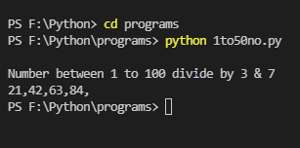

**7) W.A.P to print cube series between 1 to 20**

print('Cube Series between 1 to 20')

for num in range(1,21):

    cube=num**3

    print(num,'x',num,'x',num,'=',cube)

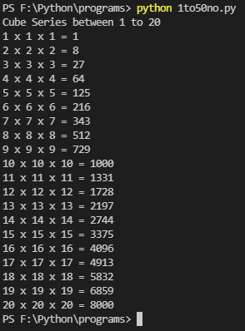

**8)W.A.P to print Fibonacci using for loop (0,1 1,2,3,5,8,11,19....)**

num=int(input('Enter limit for fibonnaci Series='))

n1=0

n2=1

nterm=0

if(num<0):

    print('The fibonacci series for 0 is',n1)

elif num<0:

    print('Please enter a positive number.')

else:

    print(num,'terms of fibonacci series are')

    print(n1,n2,end=',')

    for i in range(2,num):

        nterm=n1+n2

        print(nterm,end=',')

        n1=n2

        n2=nterm

