1. **Write a function to display sum of digits of given number.**

def sumofdigit(num):

sum=0

while num>0:

digit=num%10

sum=sum+digit

num=num//10

return sum

n=int(input('Enter a number:'))

print('Sum of digits of number=',sumofdigit(n))

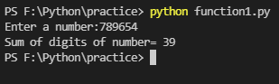

**2. Write a functions in python to perform following operation 2 numbers**

**I. Addition  
    II. Subtraction,    
    III. Multiplication,    
    IV. Division**

**V.nth Power of Number**

**e.g**

**print (cal_power(5,3) );**

def cal_add(n1,n2):

sum=n1+n2

print('Addition:',sum)

def cal_sub(n1,n2):

sub=n1-n2

print('Subtraction:',sub)

def cal_multi(n1,n2):

multi=n1*n2

print('Multiplication:',multi)

def cal_div(n1,n2):

div=n1/n2

print('Division:',div)

def cal_power(n1,n2):

power=n1**n2

print('Power:',power)

cal_add(45,65)

cal_sub(100,54)

cal_multi(45,5)

cal_div(100,5)

cal_power(12,2)

