1. **Create a function showEmployee() in such a way that it should accept employee name, and its salary and display both. If the salary is missing in the function call assign default value 9000 to salary.**

def showEmployee(name,sal=9000):

print('\t\t"Employee Info"')

print('\tEmployee Name:-',name)

print('\tSalary:-',sal)

showEmployee('Roshan',12000)

showEmployee('Suraj')

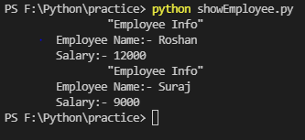

1. **Write a recursive function to calculate the factorial of given Number.**

def fact(num):

if num>1:

return num * fact(num-1)

elif num==1:

return 1

else:

return 0

n=int(input('Enter a Number='))

print('Factorial of',n,':',fact(n))

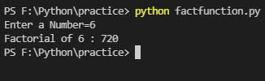

1. **Create a function using Variable Number of Argument which return the highest arguments value of it.**

def highest(*n):

ans=n[0]

for i in n:

if i>ans:

ans=i

return ans

print('Highest Value:',highest(5,42,12,32,1))

