`


Tribhuvan University

Bachelors in Computer Science and Information Technology Local Connect: Smart Local Business Directory System
A PROJECT REPORT

Submitted to
Institute of Science and Technology National Infotech College Pvt. Ltd.

In partial fulfillment of the requirements for the Bachelor’s in Computer Science and Information Technology

Submitted by Roshan Sharma
Bsc.CSIT (5th Semester)

Under the Supervision of

Anish Ansari



Tribhuvan University
Bachelor’s in Computer Science and Information Technology National Infotech College Pvt. Ltd.

Supervisor’s Recommendation

I hereby recommend that this project prepared under my supervision by Roshan Sharma entitled “LocalConnect: Smart Local Business Directory System” in partial fulfillment of the requirements for the degree of Bachelor’s in Science and Information technology is recommended for final evaluation.

SIGNATURE
Er. Anish Ansari

SUPERVISOR

National Infotech College Bsc.CSIT
Shiromani Tole, Birgunj (Nepal)



Tribhuvan University

Bachelors in Computer Science and Information Technology National Infotech College Pvt. Ltd.

LETTER OF APPROVAL

This is to certify that this project prepared by Roshan Sharma titled “LocalConnect: Smart Local Business Directory System” in partial fulfillment of their requirements for the degree of Bachelor’s of Computer Science and Information Technology has been evaluated. In our opinion it is satisfactory in the scope and quality as a project for there quired degree.

SIGNATURE of Supervisor SIGNATURE of HOD/Coordinator
Er. Anish Ansari Mr. Bijay Kushwaha
Project Supervisor Bsc.CSIT Department
National Infotech College National Infotech College Shiromani Tole, Birgunj (Nepal) Shiromani Tole ,Birgunj (Nepal)

SIGNATURE of Internal Examiner SIGNATURE of External Examiner Internal Examiner External Examiner

Acknowledgement

I would like to say thanks to Tribhuvan University, Institute of Science and Technology for the chance to accomplish this project. With the B.Sc. CSIT program, I am well equipped to perform this project as I had learnt many theoretical aspects along with practical experiences which assisted me to do this project effectively.

I am extremely thankful to Er. Anish Ansari, my project supervisor for his great support and timely suggestions. He is always ready to help whenever I had problem. He kept motivated me by suggesting, and never stopping providing support until this project was accomplished.

I would like to give special thanks to Mr. Bijay Kushwaha, Head of Department of B.Sc. CSIT at National Infotech College for his support and encouragement. He always inspired students to complete good project work, he has provided me support whenever I needed the same for my work.

Finally, I would like to thank all teachers and staff of National Infotech College for their support and cooperation.

Sincerely,
Roshan Sharma

Abstract

LocalConnect is an online website that makes it Easier for customers to search for nearby businesses from their homes or even by their phones. Instead of having to travel from one place to another in search of shops like furniture stores or coffee places, customers can view it in a single site. Information for each business and experience can be found and recorded by the customer in this site.
There are two main sides for this project. The user and the administrator side. The user can: register, look for the stores, search through its names and categories, find its information and location and also give a rating and review of the shop after its visit. While the administrator can:add new information on business shops, modify or delete information, arrange the list of shops in specific categories such as food, retail stores and others and also manage the users and the shops.
With the use of LocalConnect both customers and business owners can save time and energy. Customers save time from traveling in finding a good business in town and asking others. Business owners gain more customers from the website.
For this project, I used the programming languages HTML, CSS and JavaScript to design the parts that users can see through the browsers. For the processes that are done behind the system (data stored, users logs in and out, and search results), I used PHP and MySQL database.
The goal of LocalConnect is to provide a simple yet efficient application that allows the user to easily look for their local shops.
.

Table of Content

CERTIFICATE PAGE I
Supervisor’s Recommendation i
HEAD/PROGRAM COORDINATOR, SUPERVISOR, INTERNAL AND EXTERNAL EXAMINER’S Approval Letter ii
ACKNOWLEDGEMENT iii
ABSTRACT iv
LIST OF ABBREVIATIONS vii
LIST OF FIGURES viii
LIST OF TABLES ix
Chapter1: Introduction 1
  - Introduction 1
  - Problem Statement 1
  - Objectives 2
  - Scope and Limitation 2
    - Scope 2
    - Limitations 3
  - Development Methodology 3
  - Report Organization 4
Chapter 2: Background Study and Literature Review 6
  - Background Study 6
  - Literature Review 6
Chapter 3: System Analysis and Design 8
  - System Analysis 8
    - Requirement Analysis 8
    - Feasibility Analysis 10
    - Object Modeling 12
    - Dynamic Modeling using State and Sequence Diagrams 14
    - Process Modeling - Activity Diagram 17
Major Activities Modeled 17
  - System Design 19
    - Refinement of Class, Object, State, Sequence and Activity diagrams 19
    - Component Diagram 20
    - Deployment Diagram 21
Chapter 4: Implementation and Testing 22
  - Implementation 22
    - Tool Used 22
    - Implementation Details of Modules 23
  - Testing 23
    - Test Cases for Unit Testing 24
    - Test Cases for System Testing 24
  - Result Analysis 25
Chapter 5: Conclusion and Future Recommendations 26
  - Conclusion 26
  - Future Recommendations 26
Appendices 28
References 35

List of Abbreviations

Abbreviation | Full Form
PHP | Hypertext Preprocessor
IDE | Integrated Development Environment
HTML | Hyper Text Markup Language
CSS | Cascading Style Sheets
JS | JavaScript
SQL | Structured Query Language
GPS | Global Positioning System
PWA | Progressive Web App
CRUD | Create, Read, Update, Delete
DBMS | Database Management System
UI | User Interface
UX | User Experience
HTTP | Hyper Text Transfer Protocol
API | Application Programming Interface

List of Figures
Figure 1: Use case diagram 20
Figure 2: Class Diagram for Object Modelling 26
Figure 3: Object Diagram for Object Modeling 27
Figure 4: State Diagram 28
Figure 5: Sequence Diagram 29
Figure 6: Activity Diagram for Business Search Process 31
Figure 7: Component diagram for Local Connect 34
Figure 8: Deployment Diagram for Local Connect 35
Figure 9: Business Registration Section 47
Figure 10: User Dashboard 48
Figure 11: Add Business Section 49
Figure 12: Register Form 49
Figure 13: Login Form 50
Figure 14: Furniture Support Page 51
Figure 15: Admin Dashboard 52
Figure 16: Admin Account Section 32
Figure 17: All Business Page 32

List of Tables
Table 1: Functional Requirements 9
Table 2: Use case diagram description 9
Table 3: Non-Functional Requirements 9
Table 4: Class Diagram 9
Table 5: Dynamic Modeling 9
Table 6: Tools for implementation of code 9
Table 7: Methods/Functions of user Authentication Module 9
Table 8: Classes of Business Management Module 9
Table 9: Methods/Functions of Business Management Module 9
Table 10: Methods/Functions of Search and Filter Module 9
Table 11: Methods/Functions of Rating and Review Module 9
Table 12: Classes of Support Marketplace Module 9
Table 13: Methods/Functions of Support Marketplace Module 9
Table 14: Methods/Functions of Real-time Chat Module 9

Chapter1: Introduction

Introduction
Nowadays many users search the web to find local businesses, unlike in the old days, they can no longer afford to ask friends for the nearest available stores or look through printed directories, which are outdated and often out of date. Nevertheless, since many users still do not consider web services for the same matter, much time is being wasted for not being able to find useful services quickly. Thus, my first college project was LocalConnect: a straightforward web application designed for users who need to search, comment and contact their nearest stores from any browser.
This project aim is to be a reliable and fast web app, where each user can search any local business and have their comments, as well as to establish a contact with any owner from their own devices, regardless the time or location. Furthermore, the local businesses will be provided with their own login section, where they will be able to manage their profile information. Among the system functionalities are:
- User login and signup;

- Personal dashboard for businesses;

- System for adding and managing business listing;

- A system to review businesses and add comments;

- A micro-marketplace for support;

- Real-time chat for users to contact businesses;

- integration with Google Maps in order to show the business location;

- Offline capability for locations with poor internet connection.

I have decided to build this app using PHP, MySQL, HTML, CSS, JavaScript, Bootstrap, Google Maps API; due to their usability, reliability, and scalability. With this project I was able to acquire and improve a vast range of skills related to the full lifecycle of a web application development.

.

Problem Statement
The process of finding local businesses in Nepal currently relies on an disorganized and tedious approach to business searches. No single smart, central application currently connects the consumers with the local shops and services available in their surroundings. Such an issue affects different categories of people:

Customers & General users:
Still the majority of the Nepalese rely on the traditional approach to search local shops; they have to ask friends, neighbors, or manually walk around to find the best furniture shop, a coffee house, or repair service. Searches in the internet result in either mixed/false results or, if they go through social networks; most of the time the posts become outdated/missed. All these lead to a time consuming and non-efficient search with not very positive outcomes in services found.

Users with low digital literacy:
Rural areas or small villages contain a lot of potential users who do not feel comfortable navigating complicated applications or websites. In general existing directories assume users has an adequate knowledge on technology and internet. The potential users who only require an application which can easily fulfill their requirement remain excluded.

Users with poor internet connectivity:
There are parts in Nepal where the internet is too slow or cannot be accessed constantly. Existing web directory services require the presence of live internet connection in order to access the business details. If the connection is lost, these services fail.

Small local shop owners:
Local shops and small local service providers in Nepal cannot afford many of the existing paid directory websites. They also require too much of technical knowledge to create and update listings in many existing web directories, causing them to be unseen by potential customers while bigger competitors appear on search.

Missing useful features:
Even with existence of many directories some useful features is missing. For instance; offline access for the list, a good, simple rating and review system, chat with businesses directly and the Google Maps integration.

Objectives
The main goal of the project is to develop a user-friendly and simple web directory called LocalConnect which will assist people in finding nearby businesses. The primary objectives are as follows:

Primary Objectives:

- To develop a working web application utilizing PHP, MySQL, JavaScript and Bootstrap.
- To implement user sign-up and login module to store user details securely and grant them various levels of access like Admin, Business Owner, and User.
- To enable business owners to add, update and remove their business details via a specific business owner’s dashboard.
- To ensure that the database is hosted online such that the users have accessibility over different devices and at any point of time.
- To allow users to add ratings and reviews so that other users can refer to them while selecting a business.
- To create a marketplace where users can pose for assistance or service, while businesses offer their respective services in return.
- To embed the Google maps on a particular business's page for a better visualization of their location and direction assistance.
- To ensure that the entire application is mostly offline as the internet connectivity in villages is a bit unstable and therefore users would be able to view the details even without the internet
- To implement the various levels of development and acquire a skill of full-stack development from beginning to end.
- To ensure that new modules can be added in future, such as AI based recommendation, payment gateway etc. Without having to rework over the structure.

Secondary Objectives:

- To develop a neat and a clean MySQL database connecting all required tables such as users, businesses, reviews, support requests.

- To incorporate security features like input validation on the server-side, usage of prepared SQL statement to avoid hacking and managing user sessions securely.
- To create a web application which will function seamlessly on any kind of device without requiring additional software.
- To document the entire system with comprehensive details including database design, code structure, implementation, testing and result on accordance with college project requirements.

Scope and Limitation

Scope

I will design and implement a functional web application called LocalConnect. This system intends to empower local businesses to reach their targeted local customers. Users are able to locate and find business locally in a centralized place. Business owners will be able to manage their online presence. The features are designed as:
      - A user side to sign up/log in, find businesses, view business details, post reviews, and seek for help.
      - A business owner side to list/update their business information, respond to user reviews and customer support requests.
      - An admin side to manage all users, businesses, categories, reviews and system parameters.
      - A support marketplace to allow users to submit a request for any help and businesses to respond and offer their services.
      - Google maps to locate businesses and provide directions.
      - A live chat system to enable users and business owners to have real-time interaction.
      - An offline support mode to enable people living in areas with slow internet connection to get the information about the businesses.
      - A clean modular structure is implemented in PHP and MySQL so that it would be extensible in future.

Limitations
Being a college project completed under limited time and resources, the system has certain limitations which can be addressed in a future 2.0 version:
      - No AI suggestions, no auto-reply system for businesses.
      - No payment system like UPI or online money transfer. All payments would be manually accounted for at this stage.
      - No video calling function.
      - No mobile application development, although the site would be responsive on mobile browsers.
      - No use of WhatsApp Business API.
      - Only English language support.

Development Methodology
I developed LocalConnect incrementally. This means I did not build everything in one hit. I built a piece, tested it, fixed the bugs that I encountered then I built the next piece. This method is called Agile. It was appropriate for my college project because I could change things when I became frustrated or I had new ideas about how a certain part should work. I broke the system into 7 logical sections: User Login and Sign-up Business Management System (Add/Manage Listings) Search/Filter businesses Rating/Review system Support Marketplace Google Maps Admin panel I developed Part 1 first. Then Part 2 etc. Although I didn't have daily meetings or use formal sprints (as I was developing alone). I used the fundamental principles of Agile as seen: small iterations, test each increment, fix bugs then move on.

My work in 4 phases
- Phase 1 – Planning and DB (2 weeks)
I wrote down all features. I designed the MySQL tables on paper first.

Phase 2 – Frontend (3 weeks)
I made all pages with HTML, CSS, and Bootstrap. I added small JS for search and form checks.

Phase 3 – Backend (3 weeks)
I wrote PHP code to connect to DB. I made login work. I added basic security like prepared statements.

Phase 4 – Testing and report (2 weeks)
I tested every part. I found bugs and fixed them. Then I wrote this report.

I finished in 10 weeks. I got a working prototype at the end.

Report Organization
The report is divided into chapters and each of them deals with the particular aspect of my work.

Chapter 1: Introduction

It briefly introduces the problem I have undertaken. This chapter presents the overall project, objective, scope, constraint, the whole architecture and the report structure.

Chapter 2: Background Study and Literature Review

This chapter deals with study of the already existing systems or the same kind of projects done before. This chapter explains why LocalConnect was decided.

Chapter 3: System Analysis and Design

This chapter discusses the functionalities the system needs to have. It comprises use case diagram, data flow diagram and the system design.

Chapter 4: Implementation

This chapter discusses the technologies I have employed and how the work was carried out. The explanation of logic of code, database design, screen design and module wise implementation.

Chapter 5: Conclusion and Future Enhancements:

This chapter summarizes the achievement made throughout the project. It discusses various enhancements that could be made to the project later like recommending based on AI, payment transactions, mobile applications etc.

References:

This section deals with all the books, web pages, articles etc used in this project.

Appendices:

This section contains other supplementary information like database tables, code etc, user manual and diagrams if any.

Chapter 2: Background Study and Literature Review

Background Study
At present, people searching for local business are looking on-line. They search recommendations, posts from social network or outdated directories such as Yellow Pages. However, all this methods either are inaccurate, incomplete or complicated. Customers require a system which is easy to use and smart and it comprises of a list of local business with genuine information.

Smart Local Business Directory enables users to locate the local business in simple and convenient way by displaying the details of business, ratings and review by the customer, current location and allow the users to request for services.

As a student project LocalConnect teaches me variety of useful skills such as front-end development, backend programming, database design, system design, security and access control to the user, location service, and other tools such as PHP and MySQL. LocalConnect allows me to learn latest web development technique. As a student, at the same time it creates a system which benefit the customer by giving useful information, local business by increasing their customers online.

Literature Review
This section looks at existing systems, technologies, and frameworks related to smart local business directories. It also finds gaps in current systems and explains why a new one called LocalConnect is needed.

Existing Local Business Directory Platforms

There are many business directory platforms already. Examples include Google Business Profile, Justdial, Sulekha, Yelp, and Yellow Pages. These systems are big and work well at large scale. But they are made for general use. They do not fit the specific needs of local communities, especially in villages. These platforms lack local language support, offline access, an integrated support marketplace, and are closed-source. You cannot easily change or customize them for academic or project needs.

Academic Projects and Open-source alternatives

In many of the student projects and prototypes basic functionality is evident. These projects are mainly developed using PHP, Django or Node.js. They present modular approach to user login, data management, and content management. Nevertheless, most of the projects are far from professional architecture, design, and scalability as well as full functionality that makes up a robust business directory with a support marketplace.

The Role of PHP and MySQL

PHP is the language used to develop websites. It's what I've used in the backend for LocalConnect. The login, form data and calling the database all run through this. MySQL is the database. It stores user data, business profiles, reviews and support tickets. I didn't use Laravel, but plain PHP. This allowed me to actually learn how things are being done, without an abstraction on top. For the frontend I've used HTML, CSS, JavaScript and Bootstrap. PHP with MySQL is a common set up in college work and there are loads of useful websites online to use if I'm stuck.

The Role of Google Maps API

With the Google Maps API I have displayed maps on my website. Displaying a map will pinpoint the business location. With the displayed map the user is able to identify the shop, find driving directions, or walking directions. I also used this API to "near me" results, this will display the nearest coffee shop if the user searches for it. Without this API, a user will have to guess where the business will be located.

Identified Gaps and Justification for LocalConnect

I checked out some of the business directories already out there. While things like Google Business Profile, they aren't suited to the small, rural villages of Nepal. They rely on reliable internet connections and don't provide native language support, and they're often too expensive for small business owners. I also explored some of the other projects done by students: they mostly end up being unfinished pieces that demonstrate simple logins and searches but no other features. They're not really built with proper structures or handling a large user base in mind. I built LocalConnect with offline functionality when possible, an incredibly simplified interface that even a novice computer user at a shop will find intuitive, and a support marketplace which most other business directories lack. I plan to eventually implement support for Nepali language as well. This is something I can submit for my college, and something that might even become a real, functioning service in the future.

Chapter 3: System Analysis and Design

System Analysis
System analysis entails the study of business needs and technical specifications of the software system so that the users' requirements are satisfied. For LocalConnect: Smart Local Business Directory System, it concentrates on the identification of main functionality and user expectations and system performance needs.
  - Requirement Analysis

Functional Requirements:
Functional requirements describe the essential services and features that the system will have. The required functionalities for LocalConnect are:

Table 1:Functional Requirements

User Registration & Login | Users can register, login, and edit profile with security and roles based (Admin, Business Owner, User).
Business Listing Management | Business Owner will add, edit, update and delete Business listing with all the required information such as Business Name, Description, category, Address, Contact, Business  hours, Images.
Business Search & Discovery | Users can search businesses with Name, Category, Location and Keywords with advance search filters.
Review & Ratings | User will rate the business and write a review and the Business owner will be able to response to the review.
Category Management | Businesses will be grouped into categories and sub-categories so that the users could navigate easily.
Google Map Integration | Display the businesses on an interactive map with markers and providing directions as well as "Near me" functionality.
Support Marketplace | Users can request support service from other businesses for specific work and Businesses can provide offers to these

 | requests.
Real time chat | User and business owner can communicate using real time chat functionality.
Favorite/Save | users can add businesses to favorite list and saved it into profile for faster navigation.
User dashboard | Users can access their profiles, favorite business, support request and review.
Business Owner dashboard | Business owners will manage business listing, views statistic, and respond to review and manage their support  requests.
Admin panel | Admin will manage users, business, category, reviews, setting and other business related task.

Use Case Diagram:

It is also called the behavioral UML diagram. The user's roles within the system are immediately visible from it, showing the various user requirements how they are involved with the system.

Below is the "USE CASE DIAGRAM" of our new proposed system:

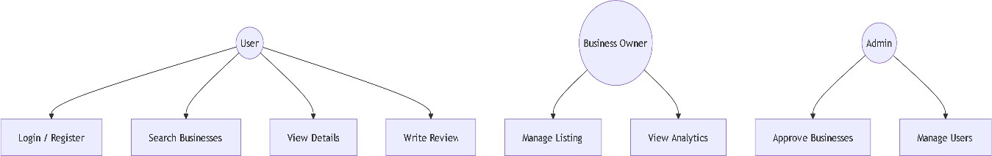

Figure 1: Use case diagram
Figure 3.1: Use case diagram.

Use case description:
Table 2: Use case diagram description

Use Case ID | Use Case Name | Actor(s) | Description
UC1 | Register | User, Business Owner | Allows a new user to create a secure account by providing necessary  details.

UC2 | Login/Logout | User, Business Owner, Admin | Enables a user to securely log in and out of the LocalConnect platform.
UC3 | Search Businesses | User | Allows users to search for businesses by name, category, or location.
UC4 | Filter Businesses | User | Enables users to filter businesses by price, rating, distance, and amenities.
UC5 | View Business Details | User | Allows users to view complete business information including  location on map.
UC6 | Write Review | User | Enables users to rate (1-5 stars) and review businesses they have visited.
UC7 | Add to Favorites | User | Allows users to save businesses to their favorites list for quick access.
UC8 | Post Support Request | User | Enables users to post requests for support services with description and budget.
UC9 | Manage Business Listing | Business Owner | Allows business owners to add, edit, and delete their business listings.
UC10 | Upload Business Images | Business Owner | Enables business owners to upload logo and multiple business photos.

Non-functional requirements:

Non-functional requirements are related to "how" the system should work, as opposed to what the system should do. For LocalConnect the important non-functional requirements are:

Table 3: Non-Functional requirements

Usability | UI should be easy to navigate, clean and intuitive enough for users, business owners and administrators regardless of the device used.
Performance | Responses such as searching, chatting, loading should be quick, response time of searches between 2-3 seconds, chat instant, Maps fast load.

Scalability | It should be able to expand future functionalities, such as AI recommendations, payment system integration and number of users using the platform should be increased without performance degradation.
Security | Storage of user accounts and businesses' information. It should be secure, using proper authentication mechanisms (password hashing with bcrypt), protect data, prevent SQL injection etc.
Maintainability | Code must be easily maintainable by developers; documentation and modularity of code will be considered. Easy addability of features in the system.
Availability | since it will be a cloud system, availability and minimal downtimes are essential.
Responsiveness | UI should be adaptive enough to different device screens, hence provide uniform experience on desktops, tablets, phones etc.
Offline Availability | a subset of the application features must be available for offline access especially in remote areas and when internet is unavailable and synchronization with online data as soon as internet is available.

Feasibility Analysis:
A feasibility study aims at exploring whether a project is feasible and worthy of undertaking. A feasibility study explores whether the proposed system can be done from a technical, operational, and economic point of view. These subsections below detail the feasibility of the LocalConnect: Smart Local Business Directory System.
      - Technical feasibility

The project is technically feasible. Technologies used (PHP, MySQL, JavaScript, HTML, CSS, and Bootstrap) are widely supported and documented. These technologies are open-source and efficient when it comes to scalable web applications. A relational database

(MySQL) is widely accepted for such content management systems, while the integration of Google Maps API is also very accessible with the documentation available and usage wide. The development tools used are available, and the developer has all the necessary know-how and resources required to create the system.
      - Operational feasibility

The proposed system satisfies the basic needs of its end users: customers searching for local businesses, business owners seeking to have an online presence, and an admin managing the platform. It provides a user-friendly and uncluttered interface for customers and business owners to search and find information about local businesses, to manage their listings, and receive their supporting services. The cloud-based feature helps overcome the problems associated with using the application on a single device and ensuring availability everywhere. This makes the system extremely easy to use since there are fewer things to manage as the system has been designed from a user point of view with low maintenance involved. Further developments like integration of payment systems will also be easily handled using the available technologies.
      - Economic feasibility

This system will be very economical to develop, mainly due to the use of free and open source technologies/frameworks. There is no expenditure for any external services or proprietary licenses. The use of Google Maps API will involve usage of its free tier service, sufficient enough for an academic project. The only cost involved is the human effort of development, the value of which is recognized for educational purposes, knowledge acquired, and future expansion capability. Thus, the project is economical enough to be developed on an academic level.
      - Schedule feasibility

The system is achievable within the constraints of an academic schedule. A project can be broken down into specific modules (user authentication, business listing, search and filters, ratings, support marketplace) based on an Agile development approach that should allow development in phases. All required core functionalities have been conceptualized and can be completed in the available time. Time will be also left for testing the system, documenting the code, and making appropriate changes/updates based on feedback and identified errors. Therefore, the project is time feasible.

Object Modeling

Object modeling: This modeling technique, used during the system design phase, involves visualizing classes, attributes, methods and the relationships among objects. In order to comprehend the object structure and the behavior of the system, object modeling technique is used. Object modeling of LocalConnect: Smart Local Business Directory System is illustrated below through the class diagram.

Class Diagram:
This diagram represents a static structure of the system. It visualizes the system classes and their relationships. The major classes used in the system are:

Table 4: Class Diagram

0 | Description
User | Contains information of the user. It contains Name, Email, Password, phone, Role, address and Profile Image of the user.
Business | Represents the business listing of the system. It contains Name, description, category, address, coordinate (x,y), phone number, working days/hours, image and status of the business.
Category | Used for organizing business categories. Contains Name, slug, Icon and description of the category.
Review | Stores the comments of customer reviews. It stores rating, comment, image and votes helpful.
Favorite | Stores business favorite by user. It connects the User and Business object.
SupportRequest | Stores support request submitted by users. Contains title, description, category, urgency, budget, location and status.

SupportOffer | Stores business offers on the support request. It stores price, estimated delivery and status.
ChatMessage | Stores chat message sent between users. Contains message, sender and receiver and status of read.

Relationships like one-to-many (User has many Reviews, Business has many Reviews, User has many Favorite Businesses, Business has many Support Offers) have been represented and these form the basis of the database and back end.

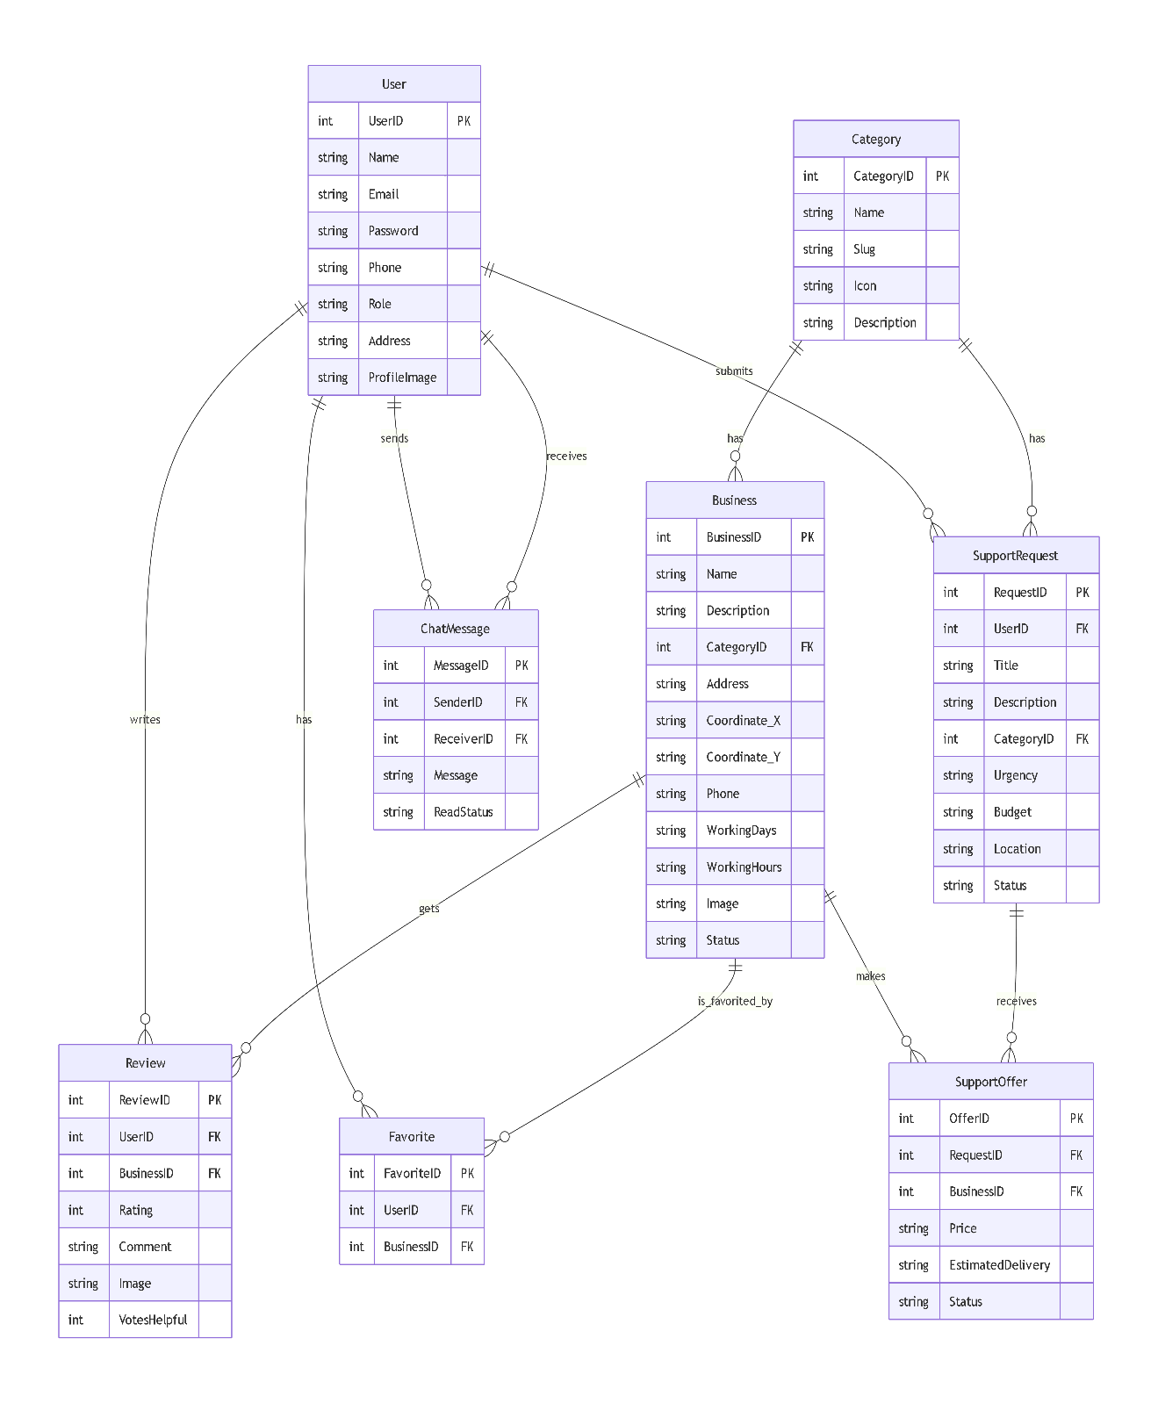

Figure 2: Class Diagram for Object Modelling.
.

Object Diagram:

The object diagram shows a snapshot of the system at a particular moment, illustrating instances of classes and their relationships.
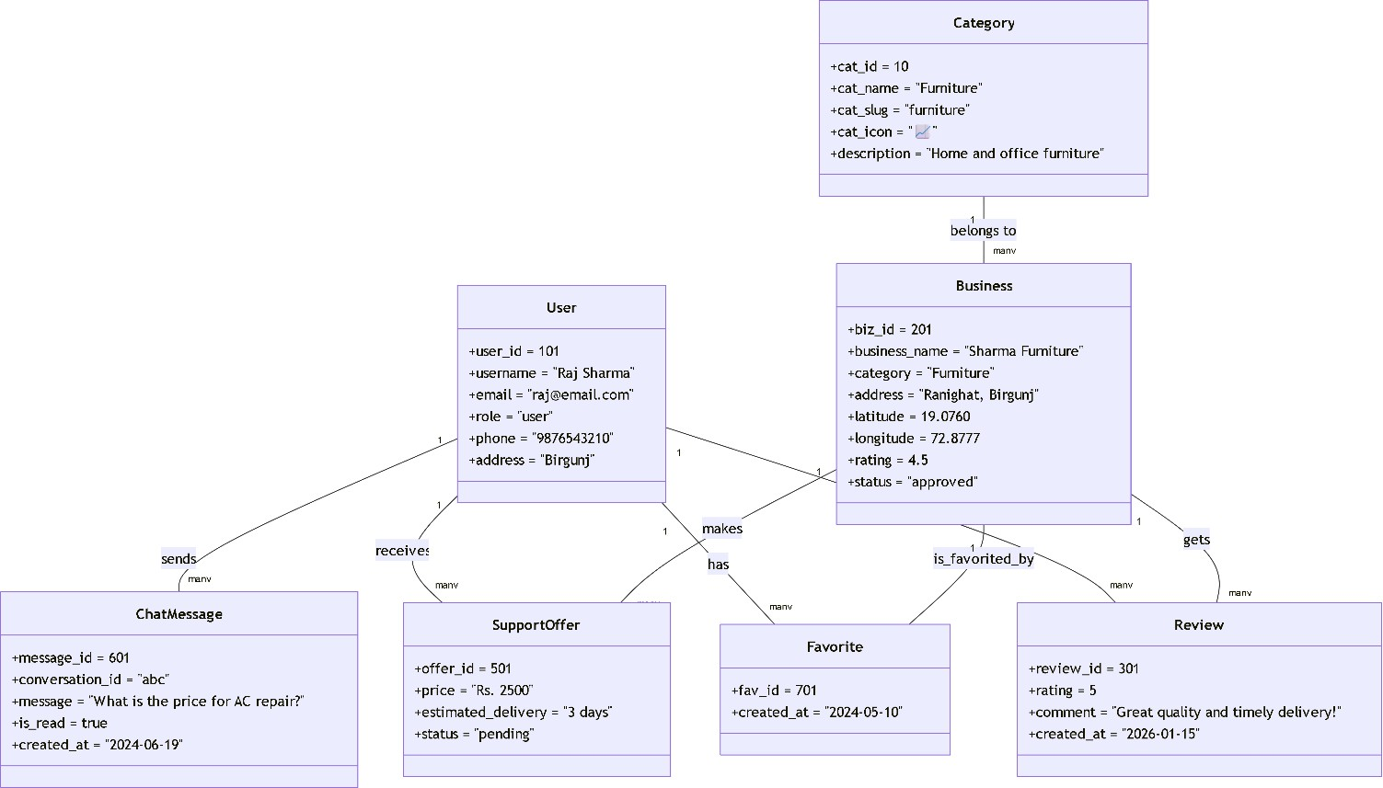

Figure 3: Object Diagram for Object Modeling

    - Dynamic Modeling using State and Sequence Diagrams:
Dynamic modeling is used to depict the runtime behavior of the system. It demonstrates how the objects and components interact and undergo state changes for different operations.
The dynamic modeling will be depicted in this project using:

Table 5: Dynamic Modeling

State diagram | depicting the lifetime of a Business Listing on the system
Sequence diagram | showing the interaction of objects during Business Search

State Diagram

The states that a Business Listing on the system may have is as follows:

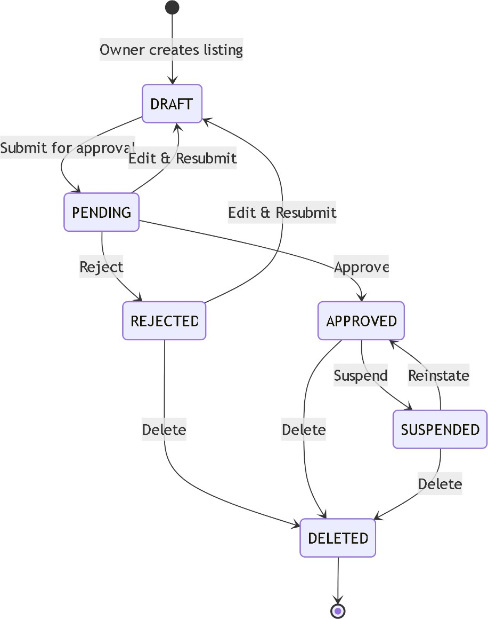

Figure 4: State Diagram
Figure 3.4 State Diagram

      - Sequence Diagram
The sequence diagram depicts object interactions in the time dimension, emphasizing message flow and method calls. This diagram will be used in this project to show the workflow for a user finding business information and viewing the information of a business.

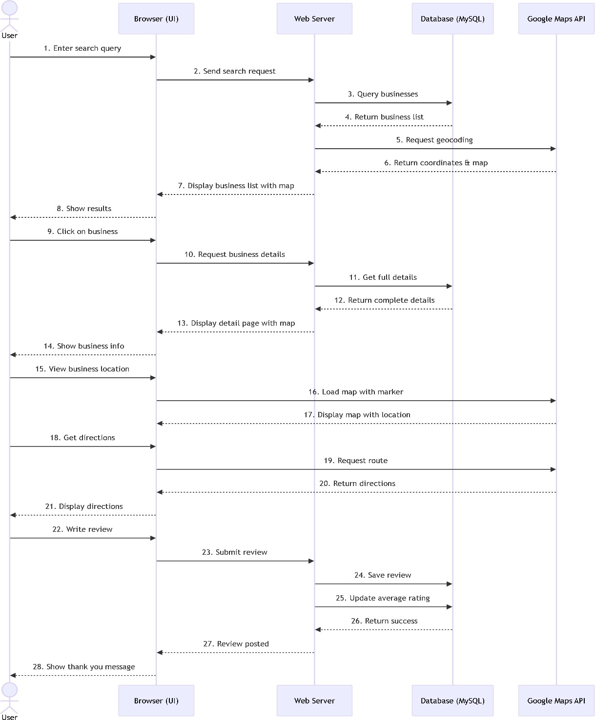

Figure 5: Sequence Diagram

    - Process Modeling - Activity Diagram
Activity Diagram is a behaviorial UML diagram. It shows workflow of the system, or business process of the system. It represents the series of activities and decision making logic when a certain functionality is processed. In this project, an activity diagram was used to show the flow process of the user searching businesses and requesting support. The context of the workflow is the LocalConnect: Smart Local Business Directory System.
Main activities in the diagram:
- User logs in / registers into the system
- User access the search / browsing page
- User search the business based on the keywords / categories / locations.
- The system filters the businesses based on the search and shows up the matched businesses.
- User reviews the business details in the map and listing view.
- User may add the business to the favorite / write the review / request support.
- User sends out a support request with the details of description and budget.
- The corresponding businesses can then send out offers.
- The user may accept one offer and then get the support.
- The user can then rate the support experience.
- User logs out of the system

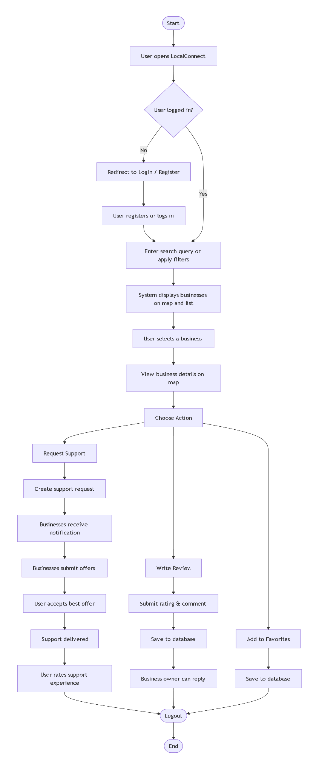

Figure 6: Activity Diagram for Business Search Process

System Design

Refinement of Class, Object, State, Sequence and Activity diagrams
Refinement in System modeling refers to revising and improving the UML diagrams after their creation to better represent the structure and behavior of the system. System modeling is an iterative process, where the system is initially modeled during analysis and design phases and later refined to better fit the system as it takes shape during implementation. This process helps in maintaining consistency, completeness, and clarity of the design during the development phase. Below are the refinements done to the various UML diagrams for LocalConnect Project:

Class Diagram Refinement:

        - The initial diagram represented only fundamental entities like User and Business.
        - Further development, the diagram was updated to include new entities like SupportRequest, SupportOffer, ChatMessage, and Favorite reflecting the actual system.
        - Associations between a User and his Favorites, Reviews, and SupportRequests and between a Business and its SupportOffers was properly defined.
        - This ensured the diagram was consistent with the actual PHP defined data-model and logic.

State Diagram Refinement:

        - State diagram for Business Listing were refined to accurately define its life-cycle transitions: Draft pending Approved suspended deleted.
        - State diagram for Support Requests were also included with relevant state transitions: open assigned in-progress completed canceled.
        - This refined the diagram such that all possible life-cycle changes of business objects are covered.

Sequence Diagram Refinement:

        - The Business Search sequence diagram were refined to include interactions like searchBusinesses(), getCoordinates() and displayOnMap().
        - This sequence diagram was also modified to include the interaction flow matching the controller-service-database flow in the actual PHP system.
        - This gave a clear, practical understanding of how different components interacted.

Activity Diagram Refinement:
        - The activity diagram was refined to depict the user activities of searching businesses and requesting support including logical decision points like is User LoggedIn, do User apply Filters, has User selected Offer to proceed or decline.
        - The life-cycle of support request was also added in the activity diagram which comprises of: Post request receive offer accept deliver rate.
        - This process made it more user oriented by covering different possibilities for different actions.
Through these refinements in the UML diagrams, we ensure that our models closely represent the system's final structure and behavior and can be used for proper evaluation as a part of this academic assignment or for further development of the system in the future.

Component Diagram

The component diagram describes the overall high level architecture of LocalConnect: Smart Local Business Directory System showing the modular nature of the application. This shows the User Interface (UI), the Application Logic Layer and the Data Access Layer together with the Database they communicate with. The components are divided to make the system maintainable, testable and scalable.

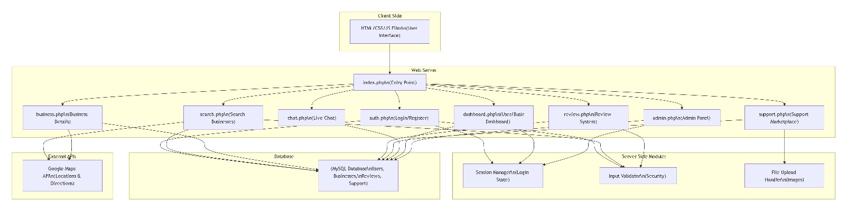

Figure 7: Component diagram for Local Connect

Deployment Diagram
This deployment diagram depicts the physical installation of the various components of the system. A web browser (Client) makes requests to a Web Server (e.g. Apache or Nginx), on which a PHP Application is running. The PHP application then interfaces with the MySQL Database to manage any processes involving data, thus allowing the web browser to interact with the database through various application layers.

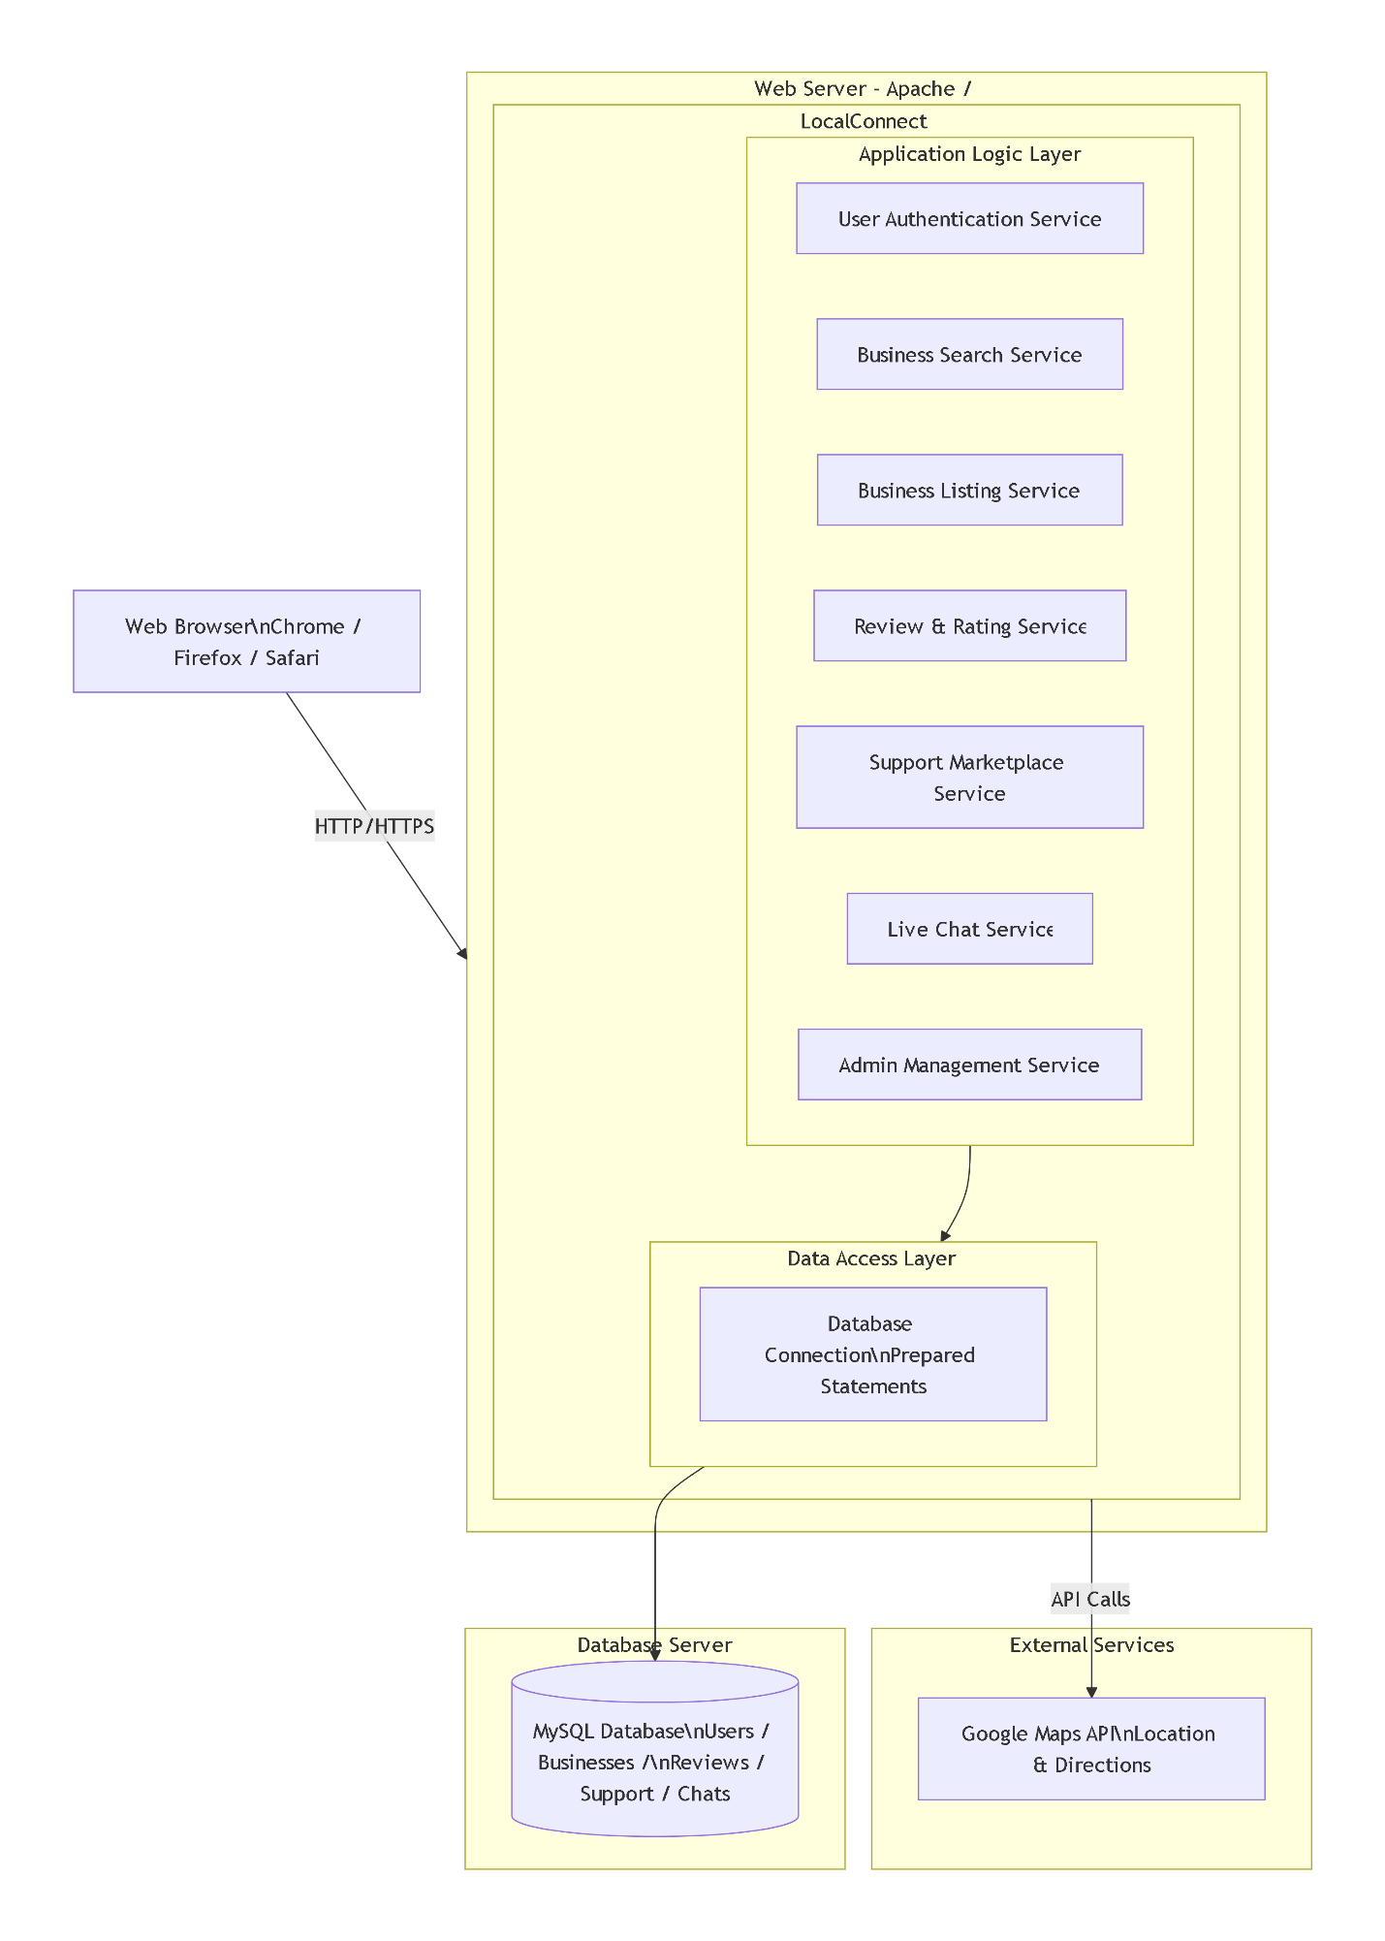

Figure 8: Deployment Diagram for LocalConnect

Chapter 4: Implementation and Testing

Implementation
The system is implemented by producing and bringing the actual system into the real products. LocalConnect: Smart Local Business Directory System also uses the design specification and system model to carry out the implementation, thus every single business requirement in this system will be covered. This phase included backend development using PHP and integrating with MySQL for database; frontend development using HTML, CSS, JavaScript and Bootstrap and also integrating with Google maps.
The modules developed during the implementation phase are: user authentication, business listing, search and filtering, review and rating, support marketplace, real time chat and google map integration. These modules are developed one by one and tested whether they conflict to the whole system before integrating all together.

Tool Used

Table 5: Tools for implementation of code

Programming language | PHP: Project mainly use PHP for developing server side scripting language used to build web  dynamic applications.
Frameworks | The web application made using core PHP with MVC like structure this use for maintain application scalability and to maintain proper  concerns like model View and Controller.
Database platform | MySQL Project uses MySQL RDBMS to save information of all users, Businesses, Category,  Reviews, Supports andChat messages.
Front end technologies | - HTML5/CSS3 Use for defining the structural markup and visual design for web pages.  - Bootstrap Use for providing styling using utility classes and responsive web design  - JavaScript Use for client-side scripting for  dynamic interaction and for

Implementation Details of Modules
The LocalConnect application consists of the following main modules working together to provide an easy and useful interface for both business owners and their customers:

User Authentication Module
        - Classes: This class handles user registration, login, profile management, and role-based access.

Methods/Functions:

Table 7: Methods/Functions of user Authentication Module

register() | Registers a new user with hashed password.
login() | Validates user credentials and creates an authentication session.
logout() | Ends the user's session.
updateProfile() | Updates user profile information.
changePassword() | Allows users to change their password.

Business Management Module

        - Classes:

Business | Represents a business listing with attributes like name, description, category, address, coordinates, phone, working hours, and image.
Category | Represents business categories like furniture, coffee shop, etc.

Methods/Functions

addBusiness() | Creates a new business listing with geocoding.
editBusiness() | Updates existing business details.
deleteBusiness() | Removes a business listing.
uploadImages() | Handles logo and gallery image uploads.
setBusinessHours() | Manages business operating hours.

approveBusiness() | Admin function to approve pending listings.

Search and Filter Module
        - Classes: Search, Filter
Methods/Functions o Search and Filter Module :

searchBusinesses() | Searches businesses by keyword, category, location.
filterByCategory() | Filters businesses by selected category.
filterByLocation() | Filters businesses by city or distance.
filterByPrice() | Filters by price range.
filterByRating() | Filters by minimum rating.
getNearbyBusinesses() | Uses GPS coordinates to find nearby businesses.

Rating and Review Module
        - Classes:
          - Review: Represents a customer review with attributes like rating, comment, image, and helpful votes.
        - Methods/Functions:

addReview() | Submits a new review with rating.
editReview() | Updates existing review.
deleteReview() | Removes a review.
replyToReview() | Business owner can reply to reviews.
markHelpful() | Users can mark reviews as helpful.
calculateAverageRating() | Updates business average rating.

Support Marketplace Module
          - Classes:

SupportRequest | Represents a support request posted by a user with title, description, category, urgency, budget, location, and status.
SupportOffer | Represents an offer made by a business with price, estimated delivery, and status.

Methods/Functions of Support Marketplace Module:

createRequest() | User posts a new support request.
browseRequests() | Businesses view nearby support requests.
submitOffer() | Business submits price and time offer.
acceptOffer() | User accepts an offer.
updateRequestStatus() | Updates status (open/assigned/completed).
rateSupport() | User rates support after completion.

Real-time Chat Module

        - Classes:
          - Chat : Represents a message sent between user and business with attributes like message, sender, receiver, and read status.

Methods/Functions of Real-time Chat Module:

sendMessage() | Sends a new chat message.
getConversations() | Retrieves user's chat conversations.
getMessages() | Retrieves messages for a conversation.
markAsRead() | Marks messages as read.
deleteMessage() | Deletes a message.

Testing
Testing is an integral part of development, to ensure the application is working and that no errors or bugs exist. This section illustrates the unit and system test cases that were used for LocalConnect..

Test Cases for Unit Testing
Unit testing focuses on individual methods or components. Here are some key unit test cases:

Test Case 1: User Registration
  - Functionality: Registration
  - Test Case Description: Register with a new user account.
  - Test Logic: Send a POST request to the /register endpoint with a new user and

their details.

  - Expected Result: New user created.

Test Case 2: User Login
  - Functionality: Login
  - Test Case Description: Login with a registered user account.
  - Test Logic: Send a POST request to the /login endpoint with the correct user details.
  - Expected Result: User logged in successfully with valid details.

Test Case 3: Add Business Listing
  - Functionality: Business Listing
  - Test Case Description: Register and add business details for a new business.
  - Test Logic: Send a POST request to the /businesses endpoint after registering a new user, and with all the necessary business details.
  - Expected Result: Business listing is created with a status of 'pending'.

Test Case 4: Search Businesses
  - Functionality: Business Listing
  - Test Case Description: Search the businesses with a particular keyword.
  - Test Logic: Send a GET request to the /businesses endpoint with a keyword to search businesses, and the business owner searched the list of businesses and found their own.
  - Expected Result: Business listings containing the keyword returned, including the added business listing.

Test Case 5: Add Review

- Functionality: Business Listing
- Test Case Description: Add a review for a business.
- Test Logic: Send a POST request to the /businesses/:businessId/reviews endpoint, to add a review to an existing business, with user details.
- Expected Result: Business average rating updated and new review is displayed for the business listing.

Test Case 6: Post Support Request
  - Functionality: User Interface
  - Test Case Description: Post a support request.
  - Test Logic: Send a POST request to the /requests endpoint to add a support request with user details.
  - Expected Result: Support request is created with 'open' status.

Test Cases for System Testing

The system testing is to test the complete functionality and performance of the integrated system.

- Test Case 1:

Complete User Workflow Purpose: To ensure complete user workflow is working from registration till requesting for support.

Steps:

- Register new user.

- Login with registered credentials.

- Search businesses based on categories.

- View business on map.

- Add to favorites.

- Add a review with rating.

- Post a support request.

- Logout Expected result:

User completes whole workflow successfully.

- Test Case 2:

Business owner Workflow Purpose: To test functionality of a business owner of managing their listings and responding to user requests.

Steps:

- Register as business owner.

- Login with created credentials.

- Add a new business listing and complete required information.

- Upload images & logo.

- View the dashboard and see analytic information.

- View all support requests around area.

- Apply on request.

- Chat with user.

Expected result: All actions by business owner are performed successfully.

- Test Case 3:

Admin Workflow Purpose: To test if the admin can manage the whole platform.

Steps:

- Login with admin credentials.

- View pending business approval and approve one of them.

- Add/Edit/Delete categories.

- Moderate reported reviews.

- Change the system settings.

- View system statistics and analytics.

Expected result: Admin performs all actions successfully.

- Test Case 4:

Google Maps integration Purpose: To test if Google Maps functionality works correctly.

Steps:

  - Search businesses for specific location.

  - Check if businesses are displayed on the map.

  - Check info window of a business marker.

  - Check if the "Near Me" feature works and returns nearby businesses.

  - Get the directions to the selected business.

Expected result: Map loaded, businesses markers visible and direction functionality works correctly.

- Test Case 5:

Real-time chat Purpose: To test if real time chat works between user and business.

Steps:

  - User sends a message to business.

  - User should be notified on receiving a reply in real time.

  - Business should receive notification that user has sent a message.

  - Business replies to user and user receives the message instantly.

Expected result: Messages transmitted between users in real-time without delay, notifications received as expected.

Result Analysis
LocalConnect system functionality, performance and security were tested

    - Functionality: All the main features of the LocalConnect such as; User Authentication, Manage Business Listings, Search & Filters, Rating and Reviews, support market, real-time chat and Google Maps were tested and proved to be fully operational.
    - Performance: The system was proved to perform well on a normal load with search taking approximately 2-3 seconds for results to appear and real-time chat performing well.
    - Security: User login credentials were kept secure using bcrypt and there were no apparent security holes in authentication, while prepared statements were used to prevent SQL injection.
    - Scalability: The system was adequate under medium traffic, however with new

improvements it can be optimized with the increasing user load.

    - Maps Integration: The Google Maps API integration was successfully implemented and functioning with efficient geocoding, search by location and navigation.

Chapter 5: Conclusion and Future Recommendations

Conclusion
The LocalConnect: Smart Local Business Directory System has effectively illustrated the usage of latest web development tools such as PHP, MySQL, JavaScript, Bootstrap CSS and Google Maps API to create an end-to-end user-friendly local business discovery system. The system is designed to allow users to explore local business and also write their reviews, obtain support services as well as allow businesses to manage their online representation. The testing of the system was thoroughly done and proved to be functional and safe. It ensures that the system authenticates users properly, stores and retrieves their data appropriately. Session management and data persistence are done securely and it has also been tested with the core features to be fully operational, providing users with the right kind of system.
As the system is intended to grow in terms of its users and content as time progresses, performance optimization in the system would need to be undertaken. For example, optimizations such as optimizing the database queries for faster retrieves, implementation of cache to manage the amount of information presented to the user at once and reducing data transfers. Other such performance enhancements would be beneficial for users and also the business owners who will be managing the system.
LocalConnect, the system, is resilient, maintainable and can also be built further with features like AI support services, integrated payment systems, mobile applications and more. This project not only represents a successful full-stack local business directory system that could work in a real-world scenario, but also the base to future expansions and new ideas.

Future Recommendations
LocalConnect offers a robust core set of features but there are some key areas that need to be focused upon to enhance user experience and further develop the platform. The most prominent recommendations are as follows:

Integrate AI-Powered Recommendations

      - Recommendation: Implement AI algorithms to help users receive personalized business recommendations based on their search history, preferences and behavior. This would enhance the value of the platform tremendously for the user.

Add Payment Integration

      - Recommendation: Add a payment feature where the platform enablesUPI, Bank Transfer and Mobile Wallets as payment methods for services provided by the users to other users.

Develop a Native Mobile Application

      - Recommendation: Design a native mobile application for both iOS and Android devices with the help of React Native or Flutter. While the current web application is mobile-responsive, native mobile apps provide enhanced user experience and offline features.

Implement Video Calling

      - Recommendation: Implement video call features which would allow users to conduct virtual consultations and support services over video using the help of third-party solutions such as Jitsi Meet.

Add WhatsApp Business Integration

      - Recommendation: Integrate WhatsApp Business API to support automated notifications and direct messaging with users/customers.

Enhance Offline Capabilities

      - Recommendation: Design the platform as a PWA (Progressive Web Application) with offline capabilities such as full offline access to cached business details and maps, allowing for smoother user experience.

Multi-language Support

      - Recommendation: Add support for different regional languages of the country to cater to a wider audience and especially to reach the rural population (Hindi, Nepali, etc.)

Advanced Analytics Dashboard

      - Recommendation: The platform should provide a more advanced and detailed analytical dashboard to businesses to help them identify customer demographics, popular product/service categories, peak working hours, and also to enable competitive benchmarking with other businesses.

Appendices

Appendix A: Screenshot
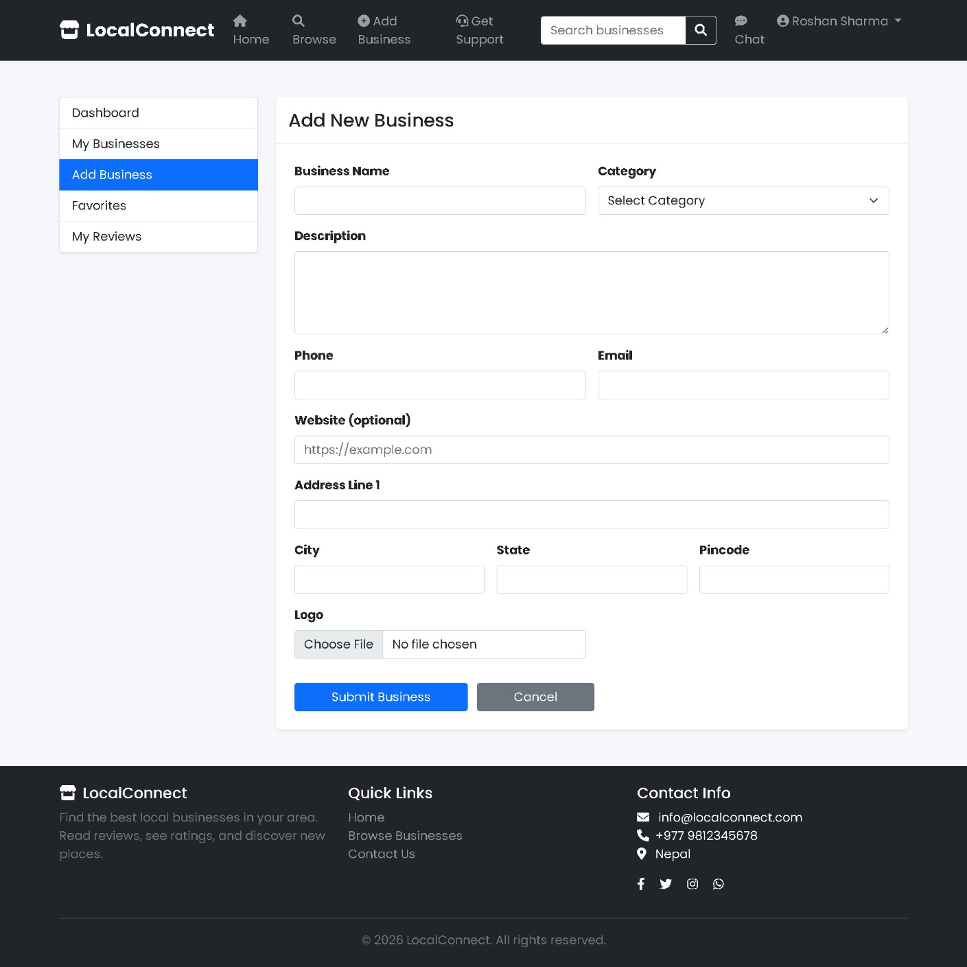

Figure 9: Business Registration Section

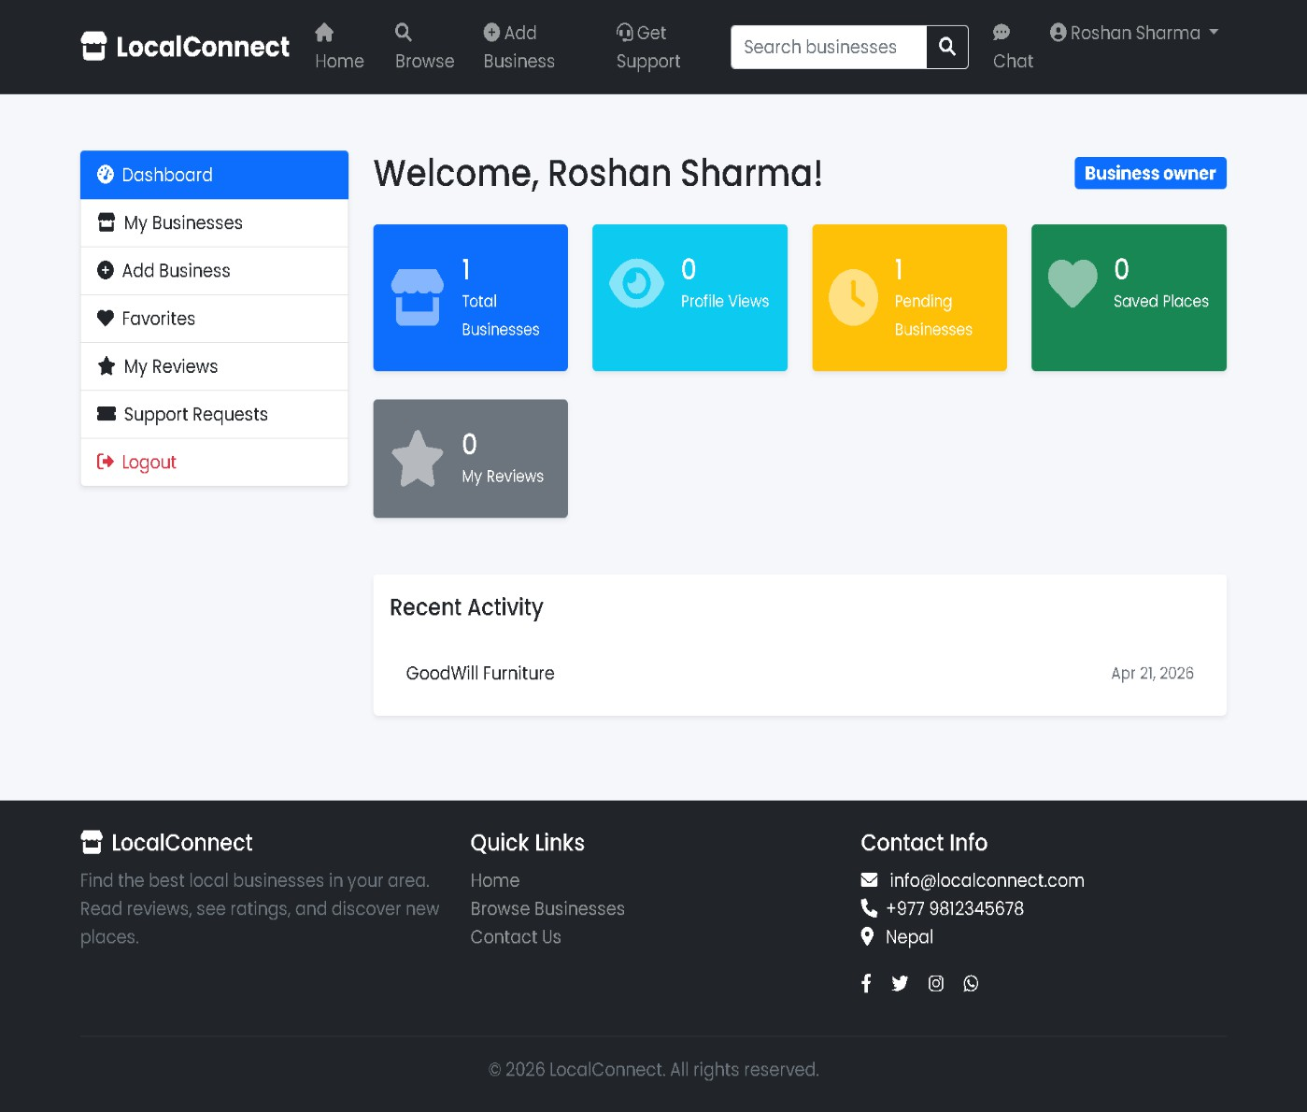

Figure 10: User Dashboard

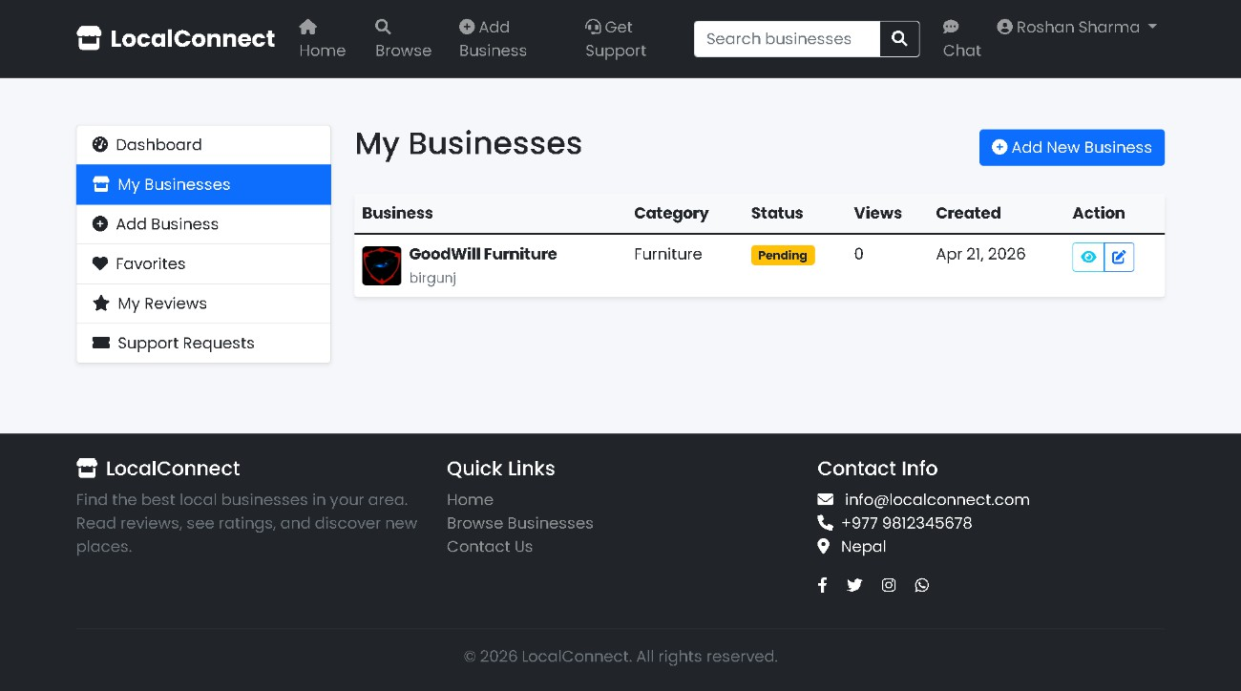

Figure 11: My Business Section

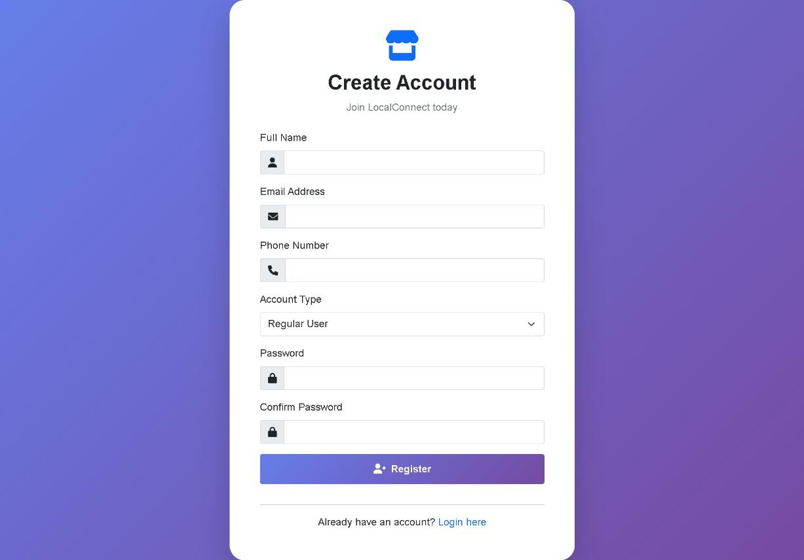

Figure 12: Register Form

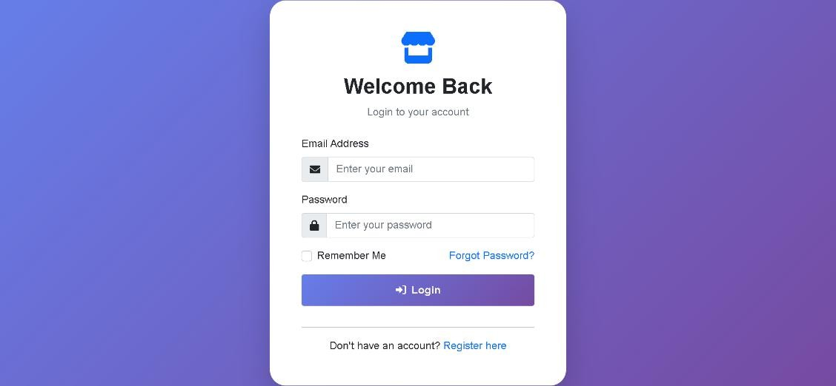

Figure 13: Login Form

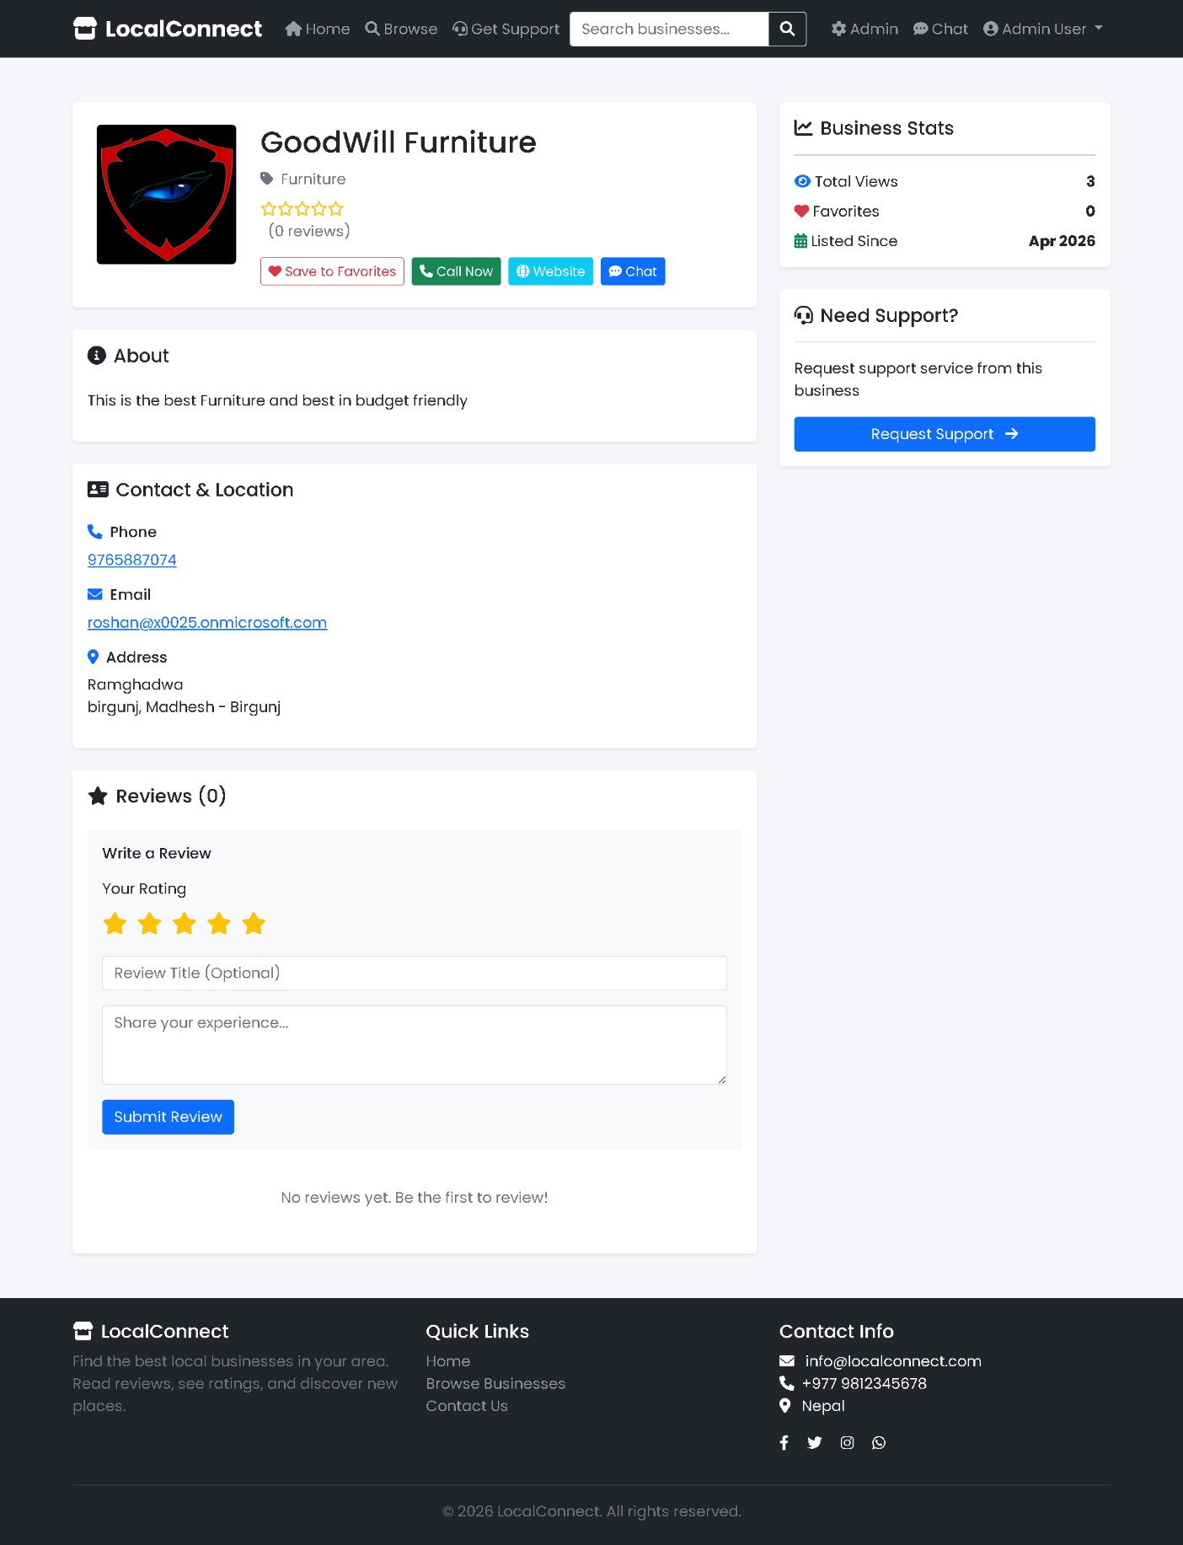

Figure 14: Furniture Support Page

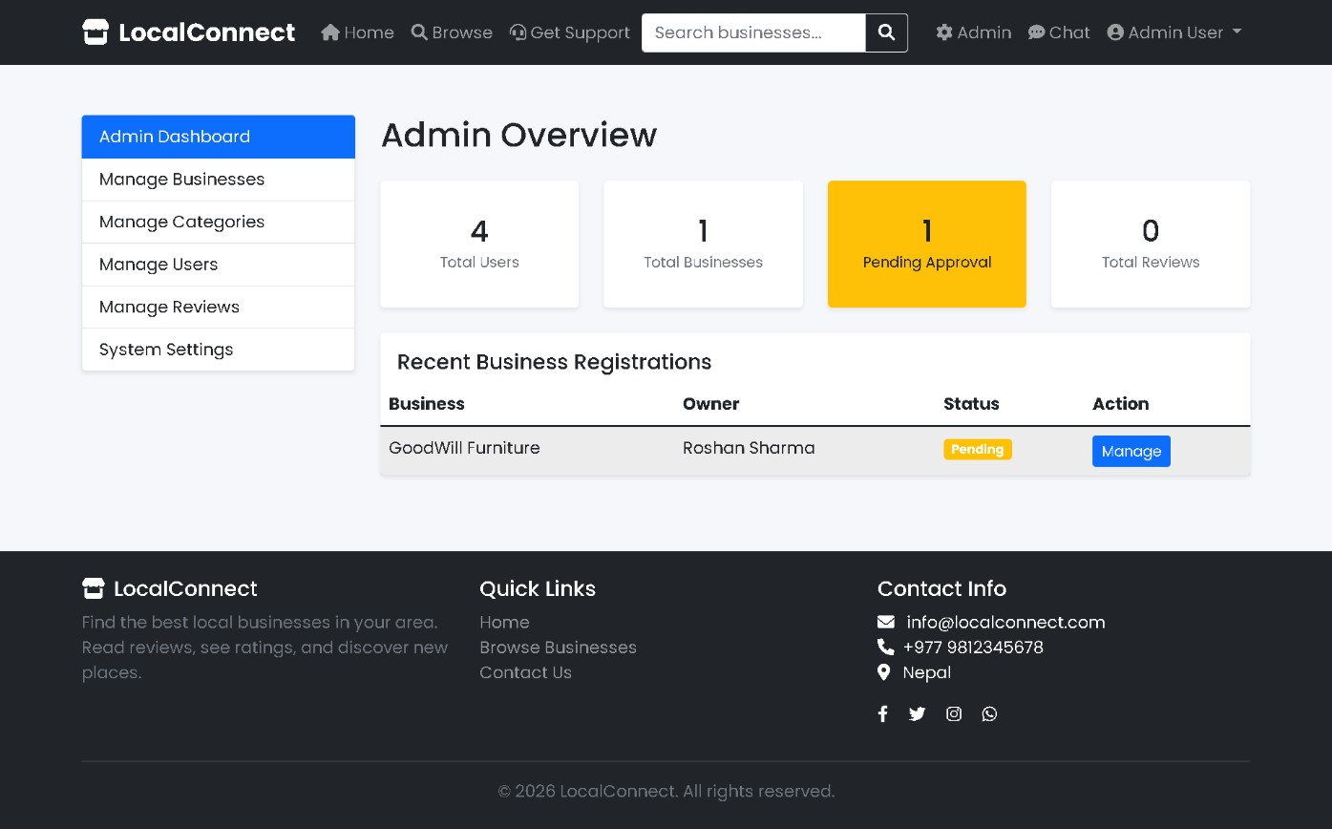

Figure 15: Admin Dashboard

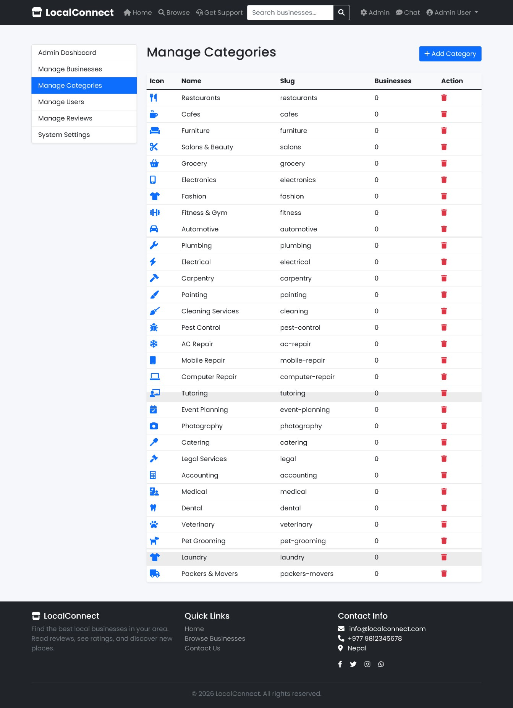

Figure 16: Admin Account Section

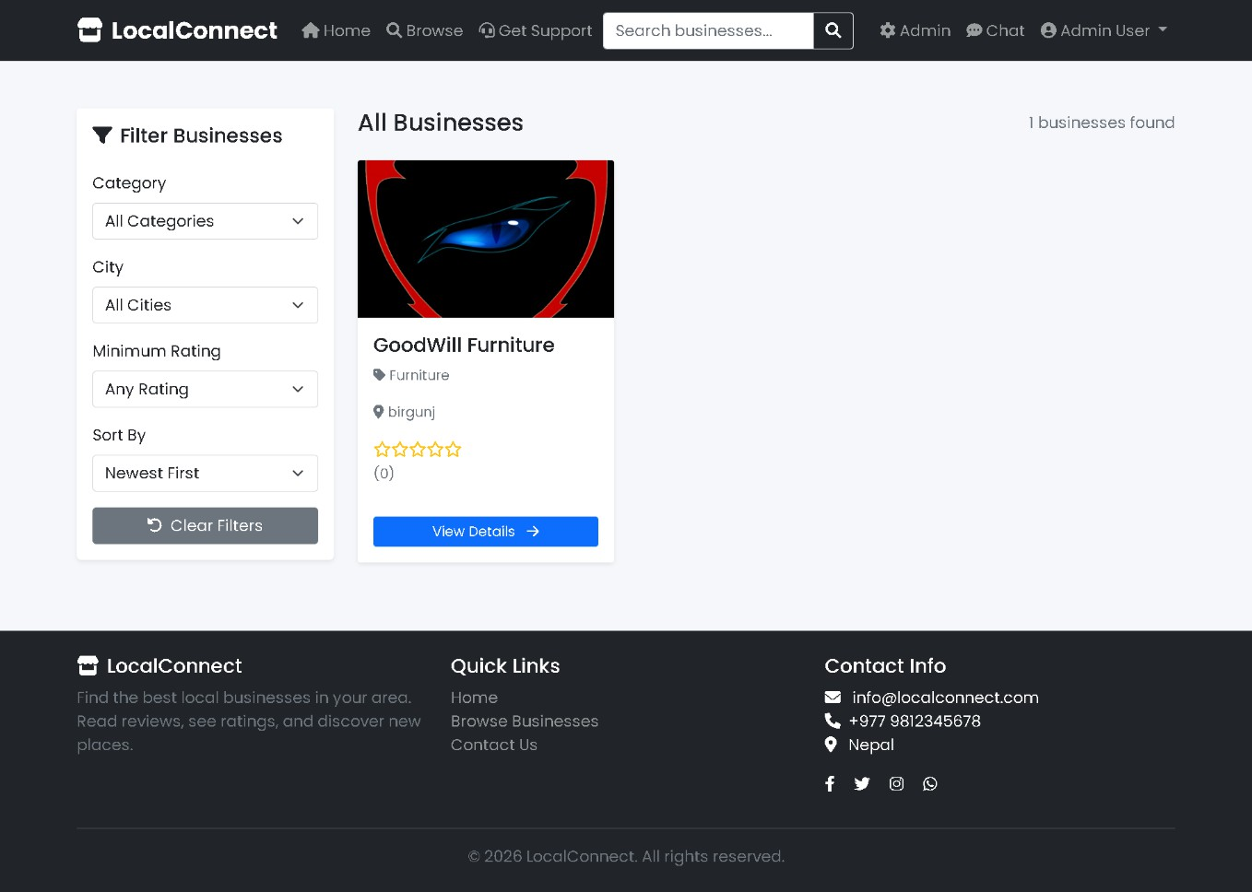

Figure 17: All Business Page

Appendix B: Code Snippet
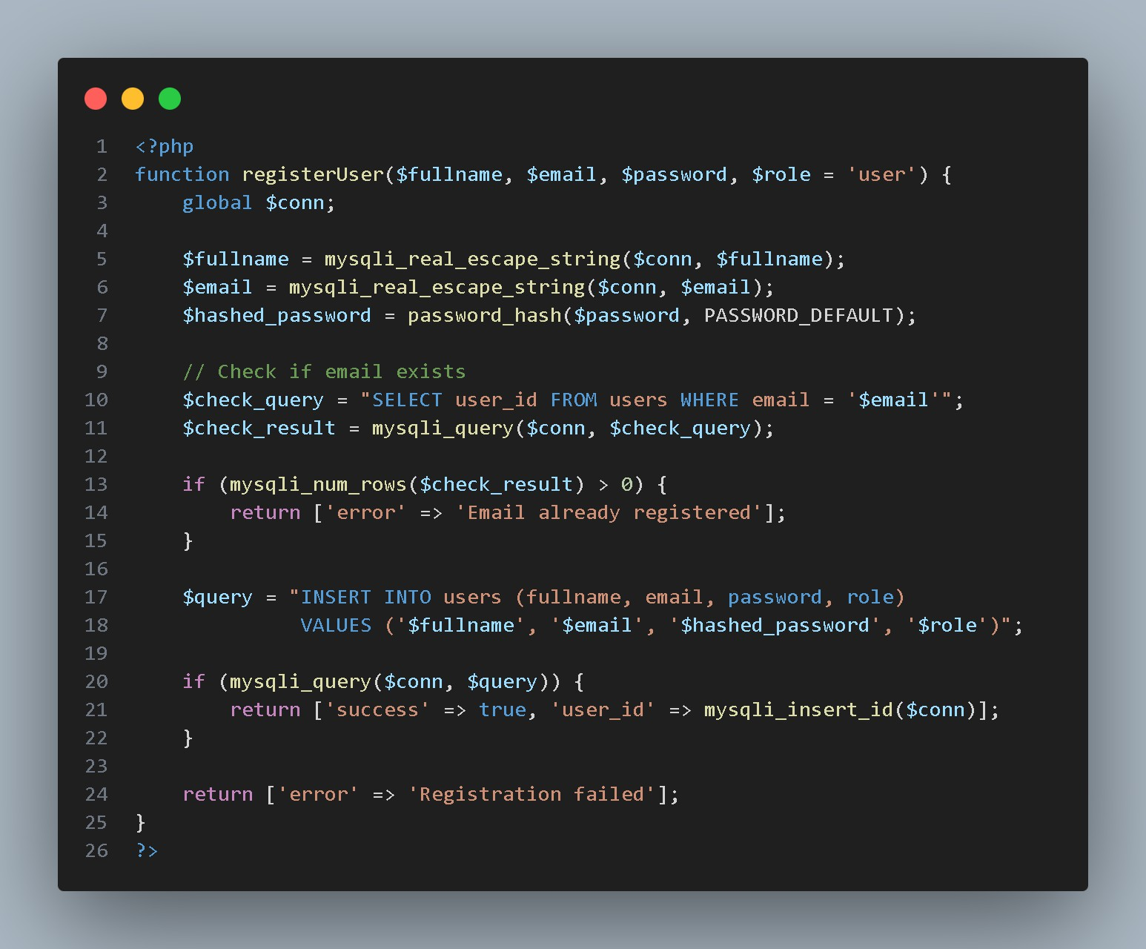

Code: Register Function

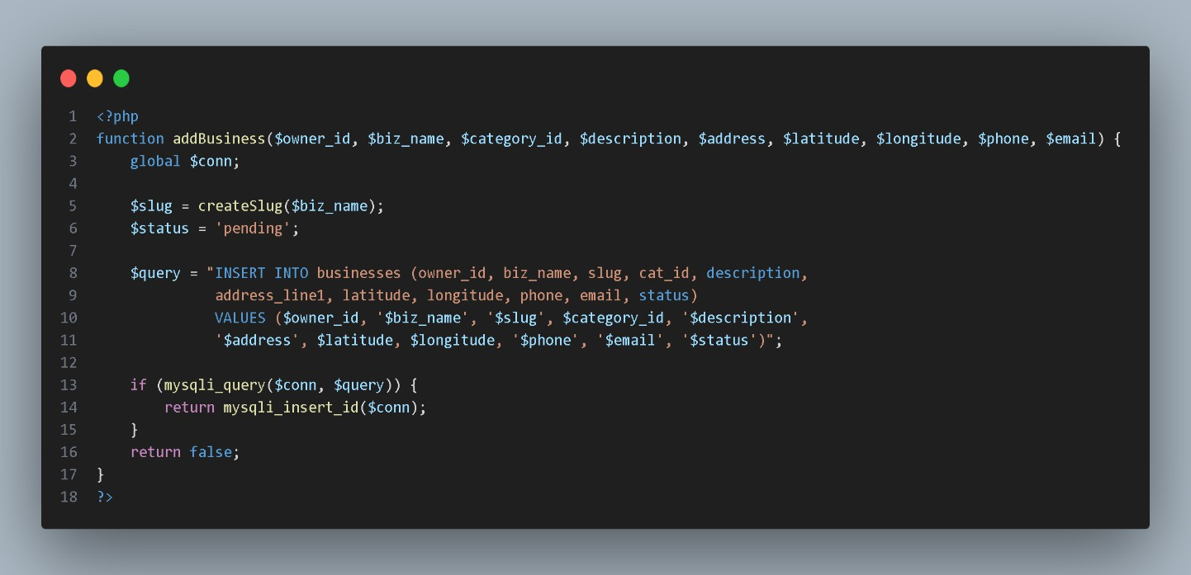

Code: Add Business Function

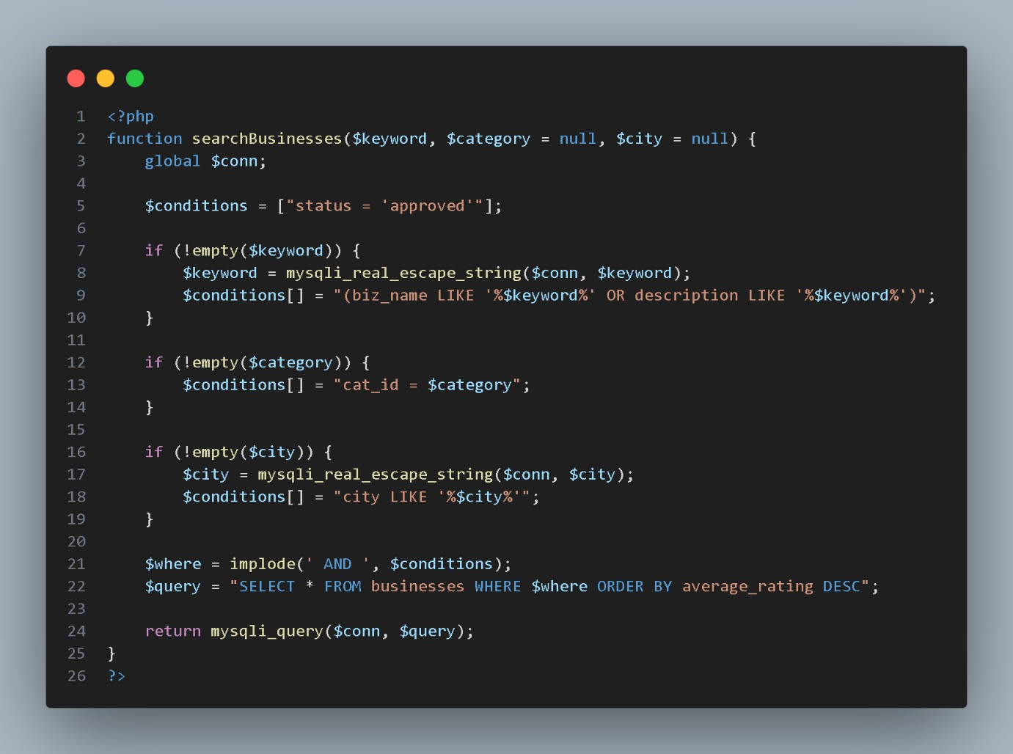

Code: Search Businesses Function

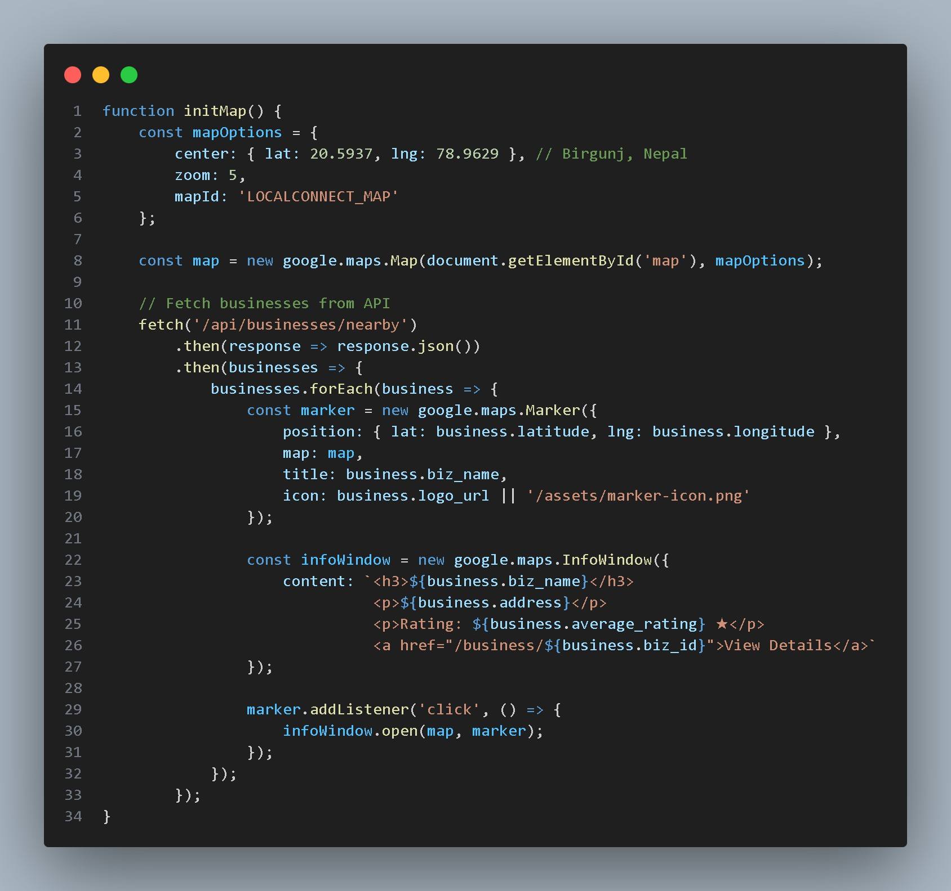

Code: Google Maps Initialization

Appendix C: Supervisor Log
This appendix contains the record of supervisor visits and technical feedback sessions held during project development.
Table: Supervisor Log

Date | Agenda / Topic | Feedback Received
Week 1 | Project scope and requirements discussion | Confirm technology stack; begin ER diagram
Week 2 | Database schema review | Normalize business, user, review tables; add status flags for business approval
Week 4 | Front-end design review | Improve form validation feedback; enhance mobile responsiveness
Week 6 | Back-end PHP integration review | Switch to prepared statements throughout; add session regeneration on login
Week 8 | Security testing session | Test SQL injection on all input fields; verify session management
Week 9 | Documentation review | Expand literature review; clarify limitations section
Week 10 | Final report review | Minor corrections to references; format checking

References
- The PHP Group, PHP Manual. Available: https://www.php.net/manual/en/. [Accessed: Sept. 5, 2025].
- MySQL, MySQL 8.0 Reference Manual. Available: https://dev.mysql.com/doc/refman/8.0/en/. [Accessed: June 25, 2025].
- Google Maps Platform, Maps JavaScript API Documentation. Available: https://developers.google.com/maps/documentation/javascript. [Accessed: July 15, 2025].
- Bootstrap, Bootstrap Documentation. Available: https://getbootstrap.com/docs/. [Accessed: Aug. 10, 2025].
- M. Fowler, Patterns of Enterprise Application Architecture. Addison-Wesley, 2002.
- G. Booch, J. Rumbaugh, and I. Jacobson, The Unified Modeling Language User Guide, 2nd ed. Addison-Wesley, 2005.
- K. Beck, Test Driven Development: By Example. Addison-Wesley, 2003.

- I. Sommerville, Software Engineering, 10th ed. Pearson, 2015.

- L. Williams, "Agile Software Development Practices," IEEE Software, vol. 28, no. 4, pp. 12-18, 2011.
- World Wide Web Consortium (W3C), HTML5 Specification. Available: https://www.w3.org/TR/html5/. [Accessed: Oct. 5, 2025].
- Laudon, K. C., & Laudon, J. P. (2019). Management Information Systems: Managing the Digital Firm (16th ed.). Pearson.
- Pressman, R. S., & Maxim, B. R. (2014). Software Engineering: A Practitioner's Approach (8th ed.). McGraw-Hill Education.

