# **AI_PHASE : 4 “AI – BASED DIABETES PREDICTION SYSTEM”**

In this work, we design a prediction model, that predicts whether a patient has diabetes, based on certain diagnostic measurements included in the dataset,  
and explore various techniques to boost performance and accuracy.

**ABOUT THIS PROJECT :**

* The objective of this project is to classify whether someone has diabetes or not.
* Dataset consists of several Medical Variables(Independent) and one Outcome Variable(Dependent)
* The independent variables in this data set are :-'Pregnancies', 'Glucose', 'BloodPressure', 'SkinThickness', 'Insulin','BMI', 'DiabetesPedigreeFunction', 'Age'
* The outcome variable value is either 1 or 0 indicating whether a person has diabetes(1) or not(0).

In [1]:

**CODE:**

import os

for dirname, _, filenames **in** os.walk('/kaggle/input'):

for filename **in** filenames:

print(os.path.join(dirname, filename))

/kaggle/input/diabetes-data-set/diabetes.csv

In [2]:

import warnings

warnings.filterwarnings("ignore")

In [3]:

*# Importing required libraries*

import numpy as np

import pandas as pd

import matplotlib.pyplot as plt

import seaborn as sns

%matplotlib inline

In [4]:

from sklearn.metrics import confusion_matrix

from sklearn.metrics import accuracy_score, recall_score, f1_score

from sklearn.metrics import roc_auc_score, classification_report

In [5]:

*# reading dataset*

df = pd.read_csv("/kaggle/input/diabetes-data-set/diabetes.csv")

df.sample(5)

Out[5]:

|  | Pregnancies | Glucose | BloodPressure | SkinThickness | Insulin | BMI | DiabetesPedigreeFunction | Age | Outcome |
| --- | --- | --- | --- | --- | --- | --- | --- | --- | --- |
| 646 | 1 | 167 | 74 | 17 | 144 | 23.4 | 0.447 | 33 | 1 |
| 649 | 0 | 107 | 60 | 25 | 0 | 26.4 | 0.133 | 23 | 0 |
| 445 | 0 | 180 | 78 | 63 | 14 | 59.4 | 2.420 | 25 | 1 |
| 566 | 1 | 99 | 72 | 30 | 18 | 38.6 | 0.412 | 21 | 0 |
| 538 | 0 | 127 | 80 | 37 | 210 | 36.3 | 0.804 | 23 | 0 |

The datasets consist of several medical predictor (independent) variables and one target (dependent) variable, Outcome. Independent variables include the number of pregnancies the patient has had, their BMI, insulin level, age, and so on.

# **DATA PREPROCESSING:**

EDA is the process of investingating the dataset to discover hidden patterns, anomalies(outliers), relationship and form hypotheses based on our understanding of the dataset.

## **1. UNDERSTANDING THE DATASET:**

* Head of the dataset
* Shape of the data set
* Types of columns
* Information about data set
* Summary of the data set

## **2. DATA CLEANING:**

* Dropping duplicate values
* Checking NULL values
* Checking for 0 value and replacing it :- It isn't medically possible for some data record to have 0 value such as Blood Pressure or Glucose levels. Hence we replace them with the mean value of that particular column.

In [6]:

*# find the shape of datset*

df.shape

Out[6]:

(768, 9)

In [7]:

*# getting information about dataset*

df.info()

<class 'pandas.core.frame.DataFrame'>

RangeIndex: 768 entries, 0 to 767

Data columns (total 9 columns):

# Column Non-Null Count Dtype

--- ------ -------------- -----

0 Pregnancies 768 non-null int64

1 Glucose 768 non-null int64

2 BloodPressure 768 non-null int64

3 SkinThickness 768 non-null int64

4 Insulin 768 non-null int64

5 BMI 768 non-null float64

6 DiabetesPedigreeFunction 768 non-null float64

7 Age 768 non-null int64

8 Outcome 768 non-null int64

dtypes: float64(2), int64(7)

memory usage: 54.1 KB

In [8]:

*# getting statical information about our dataset*

df.describe().T

Out[8]:

|  | count | mean | std | min | 25% | 50% | 75% | max |
| --- | --- | --- | --- | --- | --- | --- | --- | --- |
| Pregnancies | 768.0 | 3.845052 | 3.369578 | 0.000 | 1.00000 | 3.0000 | 6.00000 | 17.00 |
| Glucose | 768.0 | 120.894531 | 31.972618 | 0.000 | 99.00000 | 117.0000 | 140.25000 | 199.00 |
| BloodPressure | 768.0 | 69.105469 | 19.355807 | 0.000 | 62.00000 | 72.0000 | 80.00000 | 122.00 |
| SkinThickness | 768.0 | 20.536458 | 15.952218 | 0.000 | 0.00000 | 23.0000 | 32.00000 | 99.00 |
| Insulin | 768.0 | 79.799479 | 115.244002 | 0.000 | 0.00000 | 30.5000 | 127.25000 | 846.00 |
| BMI | 768.0 | 31.992578 | 7.884160 | 0.000 | 27.30000 | 32.0000 | 36.60000 | 67.10 |
| DiabetesPedigreeFunction | 768.0 | 0.471876 | 0.331329 | 0.078 | 0.24375 | 0.3725 | 0.62625 | 2.42 |
| Age | 768.0 | 33.240885 | 11.760232 | 21.000 | 24.00000 | 29.0000 | 41.00000 | 81.00 |
| Outcome | 768.0 | 0.348958 | 0.476951 | 0.000 | 0.00000 | 0.0000 | 1.00000 | 1.00 |

### **MISSING VALUES :**

In [9]:

*# checking for missing values*

df.isnull().sum()

Out[9]:

Pregnancies 0

Glucose 0

BloodPressure 0

SkinThickness 0

Insulin 0

BMI 0

DiabetesPedigreeFunction 0

Age 0

Outcome 0

dtype: int64

In [10]:

*# checking duplicate rows in dataset*

df.duplicated().sum()

Out[10]:

0

### **DATA TYPES:**

Checking for datatypes of our all features

In [11]:

*# getting numerical and categorical features form our dataset*

numerical_features = [feature for feature **in** df.columns if df[feature].dtypes **not** **in** ['O', 'o', 'object']]

categorical_fatures = [feature for feature **in** df.columns if df[feature].dtypes **in** ['O', 'o', 'object']]

In [12]:

Numerical_features

Out[12]:

['Pregnancies',

'Glucose',

'BloodPressure',

'SkinThickness',

'Insulin',

'BMI',

'DiabetesPedigreeFunction',

'Age',

'Outcome']

In [13]:

categorical_fatures

Out[13]:

[]

## **DATA VISUALIZATION:**

Here we are going to plot :-

* **Count Plot** :- to see if the dataset is balanced or not
* **Histograms** :- to see if data is normally distributed or skewed
* **Box Plot** :- to analyse the distribution and see the outliers
* **Scatter plots** :- to understand relationship between any two variables
* **Pair plot** :- to create scatter plot between all the variables

# **UNIVERIANT ANALYSIS:**

Analysing each variables seperatly

In [14]:

*# First of all analysing target feature i.e Outcome*

*# find the unique values count in our target feature*

df["Outcome"].value_counts()

Out[14]:

0 500

1 268

Name: Outcome, dtype: int64

In [15]:

*# plot a counter plot to better understand our target feature*

plt.figure(figsize=(8,4))

sns.countplot(x = 'Outcome',data = df)

plt.show()

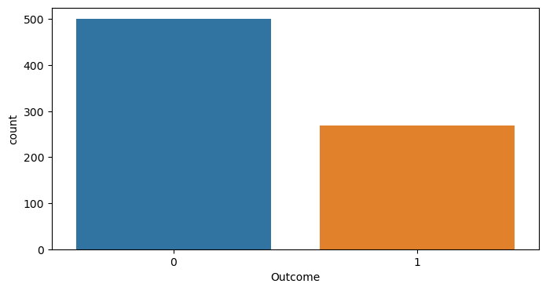

**Inference:**

* Our target varaible have only two class. 0 and 1. Here 0 and 1 represend not having diabetes and having diabetes respectilvey.
* We can see that we have inblacne dataset.
* We have to keep same ratio while we spliting our dataset into training and testing set.

In [16]:

*# Pregnancies*

plt.figure(figsize=(20,6))

plt.subplot(1,3,1)

plt.title("Counter Plot")

sns.countplot(x = 'Pregnancies',data = df)

plt.subplot(1,3,2)

plt.title('Distribution Plot')

sns.distplot(df["Pregnancies"])

plt.subplot(1,3,3)

plt.title('Box Plot')

sns.boxplot(y=df["Pregnancies"])

plt.show()

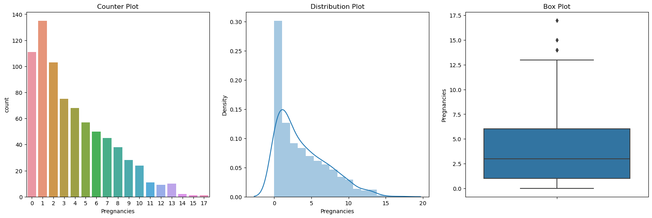

In [17]:

*# Glucose*

plt.figure(figsize=(20,6))

plt.subplot(1,3,1)

plt.title("Counter Plot")

sns.countplot(x = 'Glucose',data = df)

plt.subplot(1,3,2)

plt.title('Distribution Plot')

sns.distplot(df["Glucose"])

plt.subplot(1,3,3)

plt.title('Box Plot')

sns.boxplot(y=df["Glucose"])

plt.show()

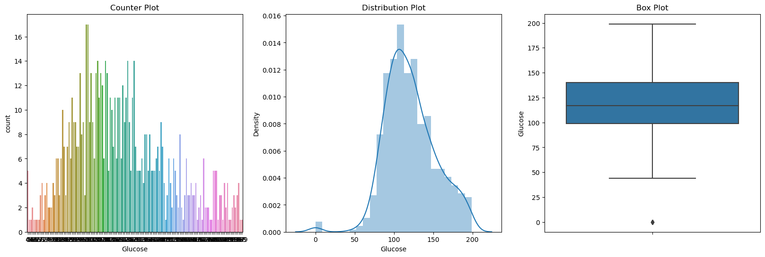

In [18]:

*# BloodPressure*

plt.figure(figsize=(20,6))

plt.subplot(1,3,1)

plt.title("Counter Plot")

sns.countplot(x = 'BloodPressure',data = df)

plt.subplot(1,3,2)

plt.title('Distribution Plot')

sns.distplot(df["BloodPressure"])

plt.subplot(1,3,3)

plt.title('Box Plot')

sns.boxplot(y=df["BloodPressure"])

plt.show()

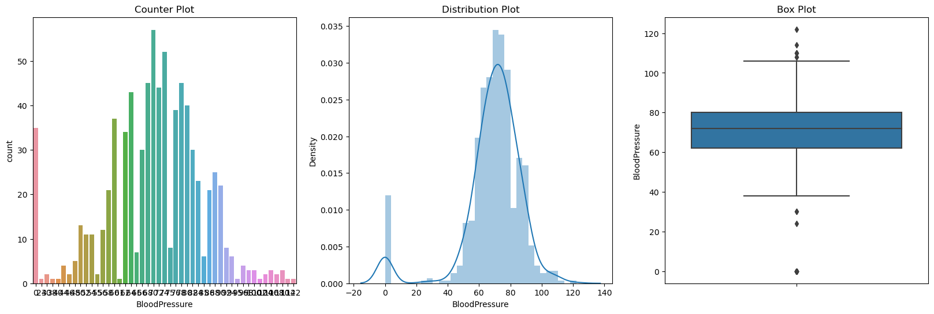

In [19]:

*# BloodPressure*

plt.figure(figsize=(20,6))

plt.subplot(1,3,1)

plt.title("Counter Plot")

sns.countplot(x = 'BloodPressure',data = df)

plt.subplot(1,3,2)

plt.title('Distribution Plot')

sns.distplot(df["BloodPressure"])

plt.subplot(1,3,3)

plt.title('Box Plot')

sns.boxplot(y=df["BloodPressure"])

plt.show()



In [20]:

*# SkinThickness*

plt.figure(figsize=(20,6))

plt.subplot(1,3,1)

plt.title("Counter Plot")

sns.countplot(x = 'SkinThickness',data = df)

plt.subplot(1,3,2)

plt.title('Distribution Plot')

sns.distplot(df["SkinThickness"])

plt.subplot(1,3,3)

plt.title('Box Plot')

sns.boxplot(y=df["SkinThickness"])

plt.show()

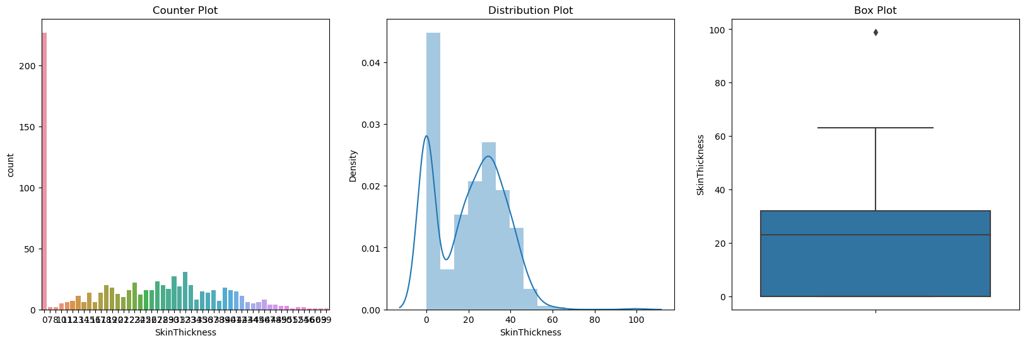

**Insulin** : 2-Hour serum insulin (mu U/ml)

In [21]:

*# Insulin*

plt.figure(figsize=(20,6))

plt.subplot(1,3,1)

plt.title("Counter Plot")

sns.countplot(x = 'Insulin',data = df)

plt.subplot(1,3,2)

plt.title('Distribution Plot')

sns.distplot(df["Insulin"])

plt.subplot(1,3,3)

plt.title('Box Plot')

sns.boxplot(y=df["Insulin"])

plt.show()

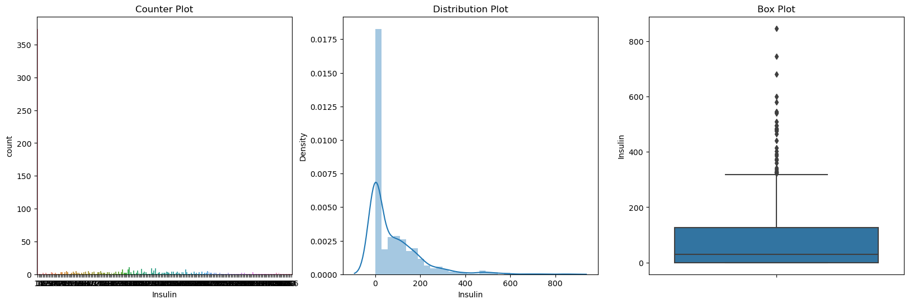

In [22]:

*# BMI*

plt.figure(figsize=(20,6))

plt.subplot(1,3,1)

plt.title("Counter Plot")

sns.countplot(x = 'BMI',data = df)

plt.subplot(1,3,2)

plt.title('Distribution Plot')

sns.distplot(df["BMI"])

plt.subplot(1,3,3)

plt.title('Box Plot')

sns.boxplot(y=df["BMI"])

plt.show()

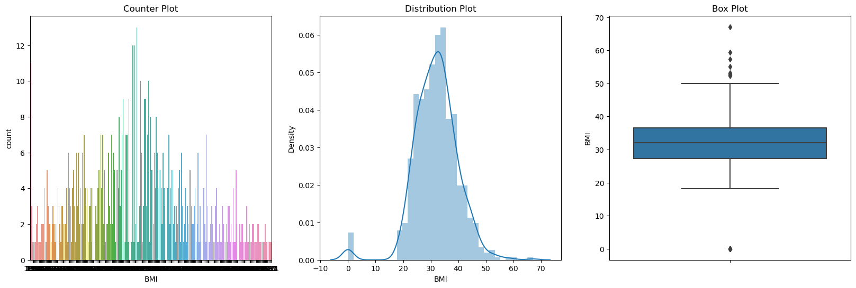

# **BIVERIANT ANALYSIS:**

Now let's find the relationship between independent and dependent numerical features

In [23]:

*# Plotting the Relationship between target and features variables using scatter plot*

for feature **in** numerical_features:

plt.figure(figsize=(6,3))

plt.scatter(y=df["Outcome"], x=df[feature])

plt.ylabel("Outcome")

plt.xlabel(feature)

plt.show()

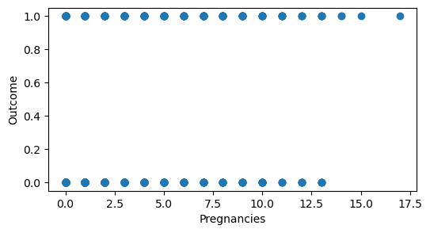

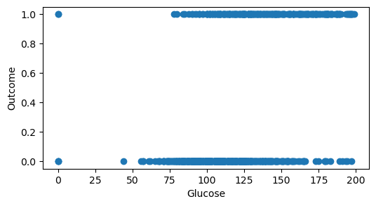

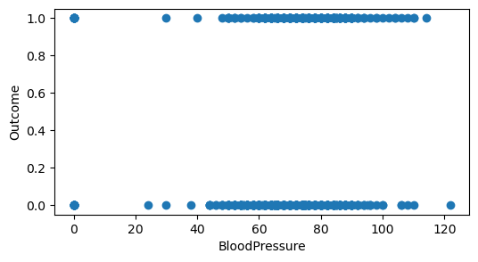

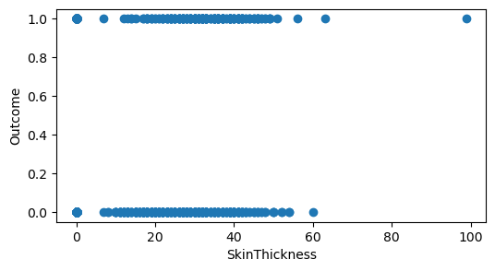

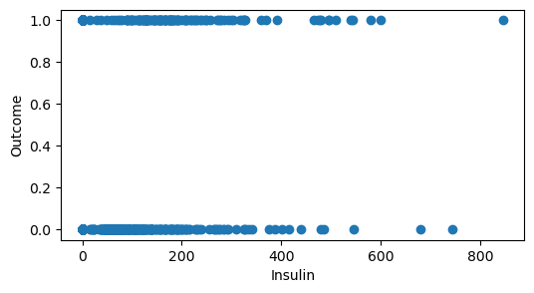

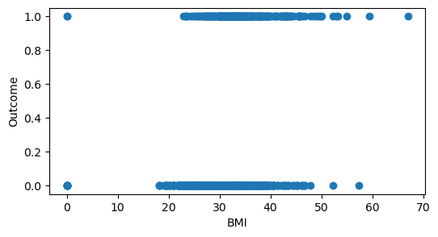

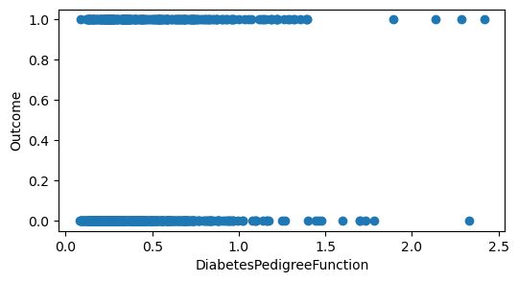

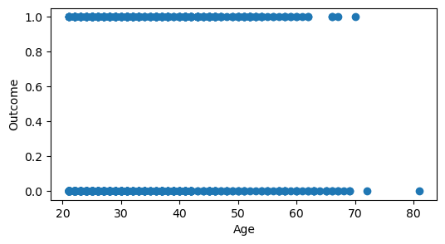

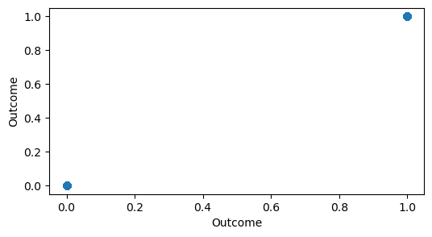

In [24]:

*# Finding the relationship of each fature with others*

sns.pairplot(df, hue = 'Outcome')

plt.show()

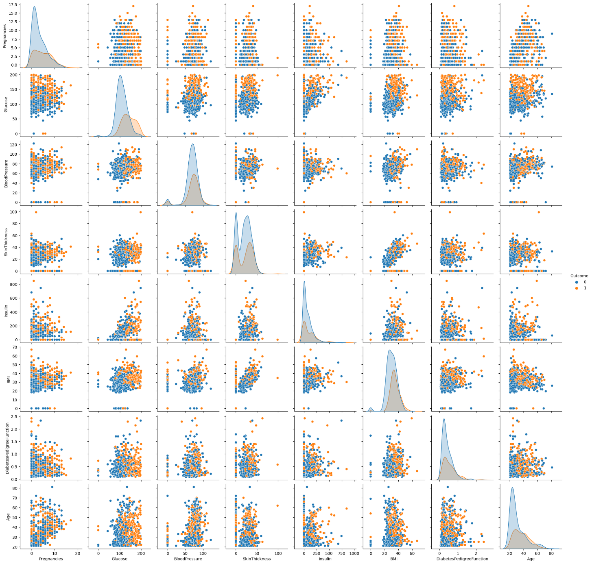

A correlation matrix is a table showing correlation coefficients between sets of variables. Each random variable (Xi) in the table is correlated with each of the other values in the table (Xj). This allows you to see which pairs have the highest correlation.

In [25]:

*# Findin the correlation between each features*

corr = df.corr()

corr

Out[25]:

|  | Pregnancies | Glucose | BloodPressure | SkinThickness | Insulin | BMI | DiabetesPedigreeFunction | Age | Outcome |
| --- | --- | --- | --- | --- | --- | --- | --- | --- | --- |
| Pregnancies | 1.000000 | 0.129459 | 0.141282 | -0.081672 | -0.073535 | 0.017683 | -0.033523 | 0.544341 | 0.221898 |
| Glucose | 0.129459 | 1.000000 | 0.152590 | 0.057328 | 0.331357 | 0.221071 | 0.137337 | 0.263514 | 0.466581 |
| BloodPressure | 0.141282 | 0.152590 | 1.000000 | 0.207371 | 0.088933 | 0.281805 | 0.041265 | 0.239528 | 0.065068 |
| SkinThickness | -0.081672 | 0.057328 | 0.207371 | 1.000000 | 0.436783 | 0.392573 | 0.183928 | -0.113970 | 0.074752 |
| Insulin | -0.073535 | 0.331357 | 0.088933 | 0.436783 | 1.000000 | 0.197859 | 0.185071 | -0.042163 | 0.130548 |
| BMI | 0.017683 | 0.221071 | 0.281805 | 0.392573 | 0.197859 | 1.000000 | 0.140647 | 0.036242 | 0.292695 |
| DiabetesPedigreeFunction | -0.033523 | 0.137337 | 0.041265 | 0.183928 | 0.185071 | 0.140647 | 1.000000 | 0.033561 | 0.173844 |
| Age | 0.544341 | 0.263514 | 0.239528 | -0.113970 | -0.042163 | 0.036242 | 0.033561 | 1.000000 | 0.238356 |
| Outcome | 0.221898 | 0.466581 | 0.065068 | 0.074752 | 0.130548 | 0.292695 | 0.173844 | 0.238356 | 1.000000 |

In [26]:

*# Headmap*

sns.heatmap(corr, annot = True)

plt.show()

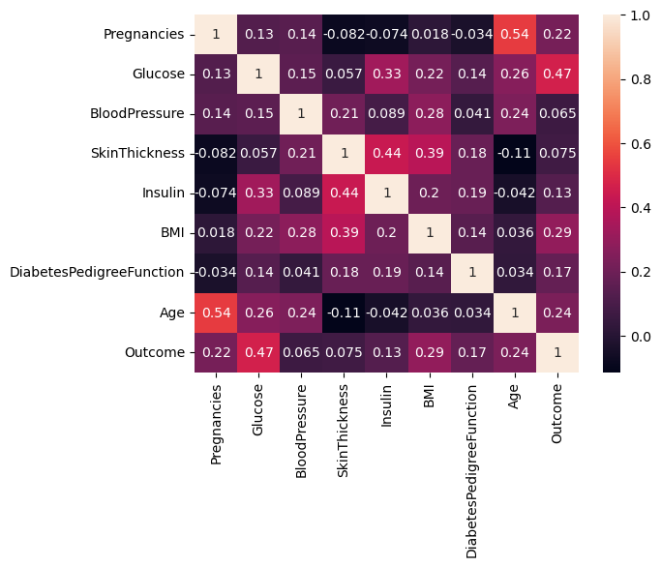

# **FEATURES:**

**Feature like Glucose, Blood Pressure, Skin Thickness, Insulin, BMI contains values as 0 which is not correct.  
So we change 0 with NaN and then replace nan value form our datasets.**

In [27]:

*# Replacing zero values with NaN*

dataset = df

dataset[["Glucose", "BloodPressure", "SkinThickness", "Insulin", "BMI"]] = dataset[["Glucose", "BloodPressure", "SkinThickness", "Insulin", "BMI"]].replace(0, np.NaN)

In [28]:

*# Count of NaN*

dataset.isnull().sum()

Out[28]:

Pregnancies 0

Glucose 5

BloodPressure 35

SkinThickness 227

Insulin 374

BMI 11

DiabetesPedigreeFunction 0

Age 0

Outcome 0

dtype: int64

In [29]:

*# Replacing NaN with mean values*

dataset["Glucose"].fillna(dataset["Glucose"].mean(), inplace = True)

dataset["BloodPressure"].fillna(dataset["BloodPressure"].mean(), inplace = True)

dataset["SkinThickness"].fillna(dataset["SkinThickness"].mean(), inplace = True)

dataset["Insulin"].fillna(dataset["Insulin"].mean(), inplace = True)

dataset["BMI"].fillna(dataset["BMI"].mean(), inplace = True)

In [30]:

dataset.isnull().sum()

Out[30]:

Pregnancies 0

Glucose 0

BloodPressure 0

SkinThickness 0

Insulin 0

BMI 0

DiabetesPedigreeFunction 0

Age 0

Outcome 0

dtype: int64

In [31]:

*# divide dataset into target and features varaibles*

y = dataset['Outcome']

X = dataset.drop('Outcome', axis=1)

**SPLIT DATAINOT TRAINING AND TEST SET:**

In [32]:

*# Spliting data into train and test set and also kept target data ration same*

from sklearn.model_selection import train_test_split

X_train, X_test, y_train, y_test = train_test_split(X, y, test_size = 0.2, random_state = 42, stratify = y )

print("Shape of Training dataset: ", X_train.shape)

print("ShaXpe of Testing dataset: ", X_test.shape)

Shape of Training dataset: (614, 8)

ShaXpe of Testing dataset: (154, 8)

**FEATURE SCALING:**

In [33]:

*# Scaling our dataset*

from sklearn.preprocessing import StandardScaler

scaler = StandardScaler()

scaler.fit(X_train)

X_train_scaled = scaler.transform(X_train)

X_test_scaled = scaler.transform(X_test)

# **MODEL BUILDING AND PERFORMATION EVALUATION:**

# **CLASSIFICATION MODEL:**

# **1) DECISION TREE**

**PERFORMANCE EVALUATION:**

To measure the performance of a model, we need several elements :

This part is essential

**Confusion matrix** : also known as the error matrix, allows visualization of the performance of an algorithm :

* **true positive (TP)** : Diabetic correctly identified as diabetic
* **true negative (TN)** : Healthy correctly identified as healthy
* **false positive (FP)** : Healthy incorrectly identified as diabetic
* **false negative (FN)** : Diabetic incorrectly identified as healthy

**Metrics :**

* **Accuracy :** (TP +TN) / (TP + TN + FP +FN)
* **Recall :** TP / (TP + FN)
* **F1 score :** 2 x ((Precision x Recall) / (Precision + Recall))

# **DECISION TREE:**

In [34]:

*# Building Model For Decision Tree classifier*

from sklearn.tree import DecisionTreeClassifier

dt_model = DecisionTreeClassifier(max_depth=5, random_state=42)

*# scalling doest affect decision tree*

dt_model.fit(X_test, y_test)

y_pred = dt_model.predict(X_test)

In [35]:

*# getting all types of accuracy for decision tree*

dt_accuracy = accuracy_score(y_test,y_pred)

dt_recall = recall_score(y_test,y_pred)

dt_f1 = f1_score(y_test,y_pred)

print("Accuracy: ", dt_accuracy)

print("Recall: ", dt_recall)

print("F1: ", dt_f1)

Accuracy: 0.9285714285714286

Recall: 0.9074074074074074

F1: 0.8990825688073394

In [36]:

*# plotting counfusion metric for decision tree*

dt_cm = confusion_matrix(y_test, y_pred)

sns.heatmap(dt_cm, annot=True)

plt.show()

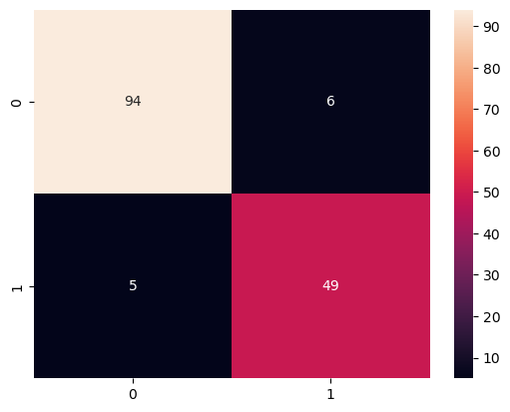

In [37]:

*# printing overall report for decision tree*

print(classification_report(y_test, y_pred))

precision recall f1-score support

0 0.95 0.94 0.94 100

1 0.89 0.91 0.90 54

accuracy 0.93 154

macro avg 0.92 0.92 0.92 154

weighted avg 0.93 0.93 0.93 154

# **CONCLUSION:**

Here Decision Tree Performs best

Example: Let's check whether the person have diabetes or not using some random values

In [38]:

y_predict = dt_model.predict([[1,148,72,35,79.799,33.6,0.627,50]])

print(y_predict)

if y_predict==1:

print("Diabetic")

else:

print("Non Diabetic")

[1]

Diabetic

In [ ]: