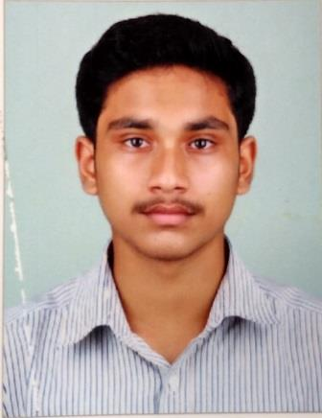
ROSHAN BABY

Permanent Address:
Kanniattukudy House
Kolenchery P.O.
Kolenchery
Ernakulam District
Kerala, India
Pin – 682311

Contact:
Mobile: +919539364244
Email:
roshanbaby1998@gmail.com

Personal Data:

Mother’s Name: Lissy Baby
Father’s Name : Baby KM
Date of Birth : 25-02-1998
Gender : Male
Marital Status : Single
Blood Group : A +ve

Languages Known:
English
Malayalam
Hindi

Hobbies:
Listening Songs
Watching Films
Body Building

CAREER OBJECTIVE:
To evolve into a hardworking and sincere profession and obtain a creative and challenging position in an organization that gives me an opportunity for self‐improvement and leadership, while contributing to the symbolic growth of the organization with my technical, innovative and logical skills.

PROFILE: Innovative outlook, hardworking with capacity to think independently and creatively ability to lead a team and also to work as part of it. Good problem solving abilities, excellent oral and written communicative skills.

ACADEMIC QUALIFICATION
Degree | Name of Institution | Board/University | % of Marks | Year
B.C.A | Yeldo Mar Baselios College, Kothamanagalam | MG UNIVERSITY | 79  (1,2,3,4 Sem) | Pursuing
XII | St.Peters HSS, Kolenchery | KERALA HSE | 79 | 2016
X | GHSS Kadayiruppu | Kerala State | 95 | 2014
MINI PROJECT

- Campus Recruitment System
- Technologies Used- Front End:VB6, Back End: SQL

TECHNICAL PROFICIENCIES
➢ Programming Languages – C, C++, COBOL, VB6,JAVA.
➢ Operating System Known – Windows.
➢ Proficient or familiar with a vast array of application software, concepts and technologies include MS Office, Photoshop etc.
PERSONAL STRENGTHS
❖ Ability to work as individual as well as in group.
❖ Hard Working and Reliable person with Quick learning ability.
❖ Adaptable and efficient in work situations with tight deadlines and challenging responsibilities.
❖ Good communications and management skills.

Place: Kolenchery Roshan Baby

