

A Report on
MediSathi AI: Smart Medication Scheduling & Tracking Platform
Under Subject of
Innovation and Design Thinking - I
(CEM2033C)
Semester - III
Department of Computer Engineering
Submitted by
Parmar Parth Pruthvirajsinh (2502031800026)
Roshan Bhai Modiya (2502031800031)
Quadri Mohmmad Uvaish Anish Ahemad (2502031800022)
Borse Charul Bhagwat (2502031800009)
Panchal Vaidehiben Manubhai (T2602180330018)
Prof. Kruti Sheth Dr. Vikas Tulshyan
Internal Guide Head of the Department
Silver Oak University, College of Technology
Ahmedabad, Gujarat

ACKNOWLEDGEMENT
We are heartily thankful to our supervisor, Prof. Kruti Sheth, whose encouragement, supervision and support from the preliminary to the concluding level enabled us to develop a clear understanding of Design Thinking as applied to real-world healthcare problems. Her guidance helped us move from a loosely defined idea to a structured, evidence-based solution concept for MediSathi AI.
We would like to extend our sincere gratitude to Dr. Vikas Tulshyan, Head of the Computer Engineering Department, Silver Oak University, College of Technology, Ahmedabad, for his continuous encouragement and motivation throughout this project.
We are also thankful to our fellow team members of 'HealthTech Innovators' for the collaborative effort, field research, and brainstorming sessions that shaped every stage of this report — from the AEIOU field observations to the final system architecture.
Last but not the least, we would like to mention here that we are greatly indebted to each and everybody who has been associated with our project at any stage but whose name does not find a place in this acknowledgement.
Yours Sincerely,
Team HealthTech Innovators

ABSTRACT
Medication non-adherence and improper dosage administration represent a major global healthcare problem, particularly among elderly patients, individuals with chronic illnesses, and multi-drug therapy consumers. Forgetfulness, complex prescription schedules, illegible doctor handwriting, and stock exhaustion frequently lead to missed doses, accidental over-dosing, and preventable hospital visits. India's elderly population alone is projected to cross 300 million by 2050, most of whom manage two or more long-term prescriptions largely on their own.
MediSathi AI is proposed as a purely software-driven, AI-first medical companion that replaces expensive hardware pill dispensers with computer vision, natural language processing, and automated workflow intelligence. The platform digitizes the entire medication lifecycle — from prescription scanning to voice-assisted reminders, inventory tracking, and second-course continuity alerts — and is designed to be usable by elderly, low-literacy, and visually impaired users through large touch targets and regional-language spoken alerts (Hindi, Gujarati, and English).
This report documents the Design Thinking process followed to arrive at MediSathi AI: field observations structured using the AEIOU framework, an Ideation Canvas synthesising those observations into four solution pillars, a working prototype described through wireframes and a system architecture diagram, and supporting canvases (Mind Map, Empathy, and Product Development) that validate the solution from the user's, the business's, and the technology's point of view. The report concludes with the current limitations of the concept and a four-phase roadmap for future enhancement, including wearable integration, e-pharmacy auto-refill, an AI drug-interaction engine, and a doctor-facing adherence dashboard.

LIST OF FIGURES
Figure No. | Figure Name | Page No.
3.1 | System Architecture / Technical Pipeline Diagram | —
3.2 | Prototype Screen — Today / Home (Dynamic Schedule & Voice Alerts) | —
3.3 | Prototype Screen — Prescription Scan & Review | —
3.4 | Prototype Screen — Supply Tracking & Second Course Alert | —
3.5 | Prototype Screen — Pill / Strip Scanner | —
4.1 | Mind Mapping Canvas | —

LIST OF TABLES
Table No. | Table Name | Page No.
2.1 | Hardware Requirements | —
2.2 | Software Requirements / Technology Stack | —
5.1 | AEIOU Canvas | —
5.2 | Ideation Canvas | —
5.3 | Empathy Canvas | —
5.4 | Product Development Canvas | —
A.1 | Competitive Landscape & Positioning | —

TABLE OF CONTENT
Chapter No. | Title |  | Page No.
 | ACKNOWLEDGEMENT |  | i
 | ABSTRACT |  | ii
 | LIST OF FIGURES |  | iii
 | LIST OF TABLES |  | iv
1 | INTRODUCTION |  | 1
 | 1.1 | Problem Summary
 | 1.2 | Purpose
 | 1.3 | Scope
 | 1.4 | Technical and Literature Review
2 | SYSTEM REQUIREMENT STUDY
 | 2.1 | User Characteristics
 | 2.2 | Hardware and Software Characteristics
 |  | 2.2.1 Hardware Requirements
 |  | 2.2.2 Software Requirements
3 | PROTOTYPE
 | 3.1 | Details of Prototype
 | 3.2 | Images of Prototype
4 | MIND MAPPING
 | 4.1 | Mind Mapping Canvas
5 | CANVAS
 | 5.1 | AEIOU Canvas
 | 5.2 | Ideation Canvas
 | 5.3 | Empathy Canvas
 | 5.4 | Product Development Canvas
6 | LIMITATION AND FUTURE ENHANCEMENT
7 | CONCLUSION
 | REFERENCES
 | APPENDIX

CHAPTER 1: INTRODUCTION

1.1 Problem Summary
Managing multiple prescribed medications is a significant cognitive burden for patients and their caregivers, and the problem intensifies with age and the number of concurrent conditions. Field observation of patients, pharmacies, and clinics (documented in detail in the AEIOU Canvas, Section 5.1) surfaced four recurring failure points in how medication is currently managed:
- Complex, handwritten prescriptions are difficult for laypeople and elderly patients to read correctly, leading to confusion over dosage amounts and timing.
- Standard phone alarms are context-blind — they do not know whether a pill should be taken with or after food, and they do not track remaining stock.
- Patients frequently run out of critical chronic medication without realising it, causing abrupt, unsafe gaps in multi-stage treatment plans.
- Existing automated pill dispensers cost between ₹12,000–₹40,000 ($150–$500), putting them out of reach for middle- and lower-income households.
These failure points combine to create a cycle of missed doses, accidental over-dosing, and avoidable emergency visits — a cycle that disproportionately affects the group least equipped to manage it: elderly, low-literacy, and visually impaired patients.

1.2 Purpose
The purpose of this project is to design a software-only AI healthcare agent that acts as a personalised medical companion — one that removes the need for expensive dispenser hardware while still solving the core compliance problem. Specifically, MediSathi AI aims to:
- Digitise prescriptions automatically using vision AI, eliminating manual data entry and handwriting-related errors.
- Deliver reminders that understand meal-timing context and are spoken aloud in the patient's own regional language.
- Track remaining medicine stock continuously and warn the patient before a course runs out, rather than after.
- Give family caregivers visibility into adherence without requiring them to be physically present at every dose time.

1.3 Scope
The current scope of MediSathi AI, as covered by this report and its prototype, includes four core features: (1) an Intelligent OCR & Prescription Parsing Engine, (2) Dynamic Schedule & Regional Voice Alerts, (3) Supply Tracking & Second Medication Phase Alerts, and (4) a Visual Pill & Strip Scanner for unknown-drug lookup. The project targets elderly chronic-illness patients, multi-drug-regimen patients, their family caregivers, and — indirectly — treating doctors and pharmacists.
Out of scope for the current phase (addressed instead under Future Enhancement, Section 6) are smartwatch/wearable integration, direct e-pharmacy re-order APIs, an AI drug-interaction safety engine, and a doctor-facing EHR-synced dashboard. The system is also designed around smartphone ownership by the patient or a co-resident caregiver; it does not address patients with no smartphone access at all.

1.4 Technical and Literature Review
Medication adherence has been studied extensively as a global health issue. The World Health Organization's guidance on adherence to long-term therapies identifies poor adherence as a key driver of avoidable disease burden, especially in chronic, non-communicable disease management (WHO, 2023). The United Nations Sustainable Development Goals similarly frame health-technology innovation as central to SDG 3 (Good Health & Well-Being) and SDG 9 (Industry, Innovation & Infrastructure).
On the technology side, recent work in the Journal of Medical Internet Research (JMIR, 2024) on AI applications in chronic disease management shows that multimodal large language models combined with OCR can reliably extract structured dosage information from handwritten clinical text, which directly supports the feasibility of MediSathi AI's prescription-parsing engine. Commercially, existing e-pharmacy platforms (Tata 1mg, Netmeds) and generic alarm applications were reviewed as part of this study; both were found to address only fragments of the problem — e-commerce fulfilment or simple time-based reminders — without solving OCR-based intake, multilingual voice delivery, or proactive stock-exhaustion alerts together in one place (see the competitive comparison in Appendix A.1).

CHAPTER 2: SYSTEM REQUIREMENT STUDY

2.1 User Characteristics
The system is designed around five user classes identified during field observation:
- Elderly chronic patients (60+ years): primary users; often have declining eyesight, limited smartphone fluency, and manage 2 or more concurrent prescriptions.
- Busy adult caregivers: family members who set up and monitor the schedule remotely, and who need early warning rather than constant manual check-ins.
- Multi-drug regimen patients: younger chronic-illness patients comfortable with smartphones but still at risk of timing/food-instruction errors.
- Doctors: indirect users who benefit from adherence history at follow-up visits (future-phase dashboard, Section 6).
- Pharmacists: indirect users referenced by the Pill/Strip Scanner's safety disclaimer, which always recommends pharmacist confirmation.
Because the primary user group skews elderly and low-literacy, the interface design principle followed throughout is 'large, spoken, and forgiving of error' rather than dense or text-heavy.

2.2 Hardware and Software Characteristics

2.2.1 Hardware Requirements
Component | Minimum Requirement
Patient / caregiver device | Android 9.0+ or iOS 14+ smartphone with a working rear camera (for prescription and pill scanning)
Connectivity | Intermittent internet access for OCR/AI calls and cloud sync; core alarms must work fully offline
Storage | Minimum 150 MB free device storage for the app and local (offline) database
Audio output | Functional speaker or connected audio output for spoken voice alerts
Server-side (cloud) | Standard cloud compute instance for the backend API, managed database, and push-notification service
Table 2.1 — Hardware Requirements

2.2.2 Software Requirements
Layer / Module | Technology & Framework Selected
Mobile application frontend | Flutter / React Native — cross-platform Android & iOS with a high-accessibility UI
Vision AI & OCR engine | Google Cloud Vision API + a Gemini multimodal vision model, for prescription and pill-image parsing
Local database & offline sync | SQLite / Realm DB — ensures local alarms trigger without an active internet connection
Notification & alarm system | Flutter Local Notifications API + Firebase Cloud Messaging (FCM)
Backend & database server | Python FastAPI / Node.js on Supabase or Firebase cloud infrastructure
Voice synthesis | On-device / cloud text-to-speech supporting Hindi, Gujarati, and English
Table 2.2 — Software Requirements / Technology Stack

CHAPTER 3: PROTOTYPE

3.1 Details of Prototype
The MediSathi AI prototype is structured as a four-tab mobile application — Today, Scan Rx, Stock, and Pill Scanner — reflecting the four core features defined for this phase of the project. The high-level technical pipeline connecting these screens to the backend is shown in Figure 3.1: the mobile app sends a photographed prescription or pill image to the Vision AI/OCR layer; parsed results are written to the backend API and local offline database; the notification and voice-alert engine reads the local schedule to fire reminders even without connectivity; and, where a dose remains unconfirmed, the caregiver-escalation module notifies a family member.
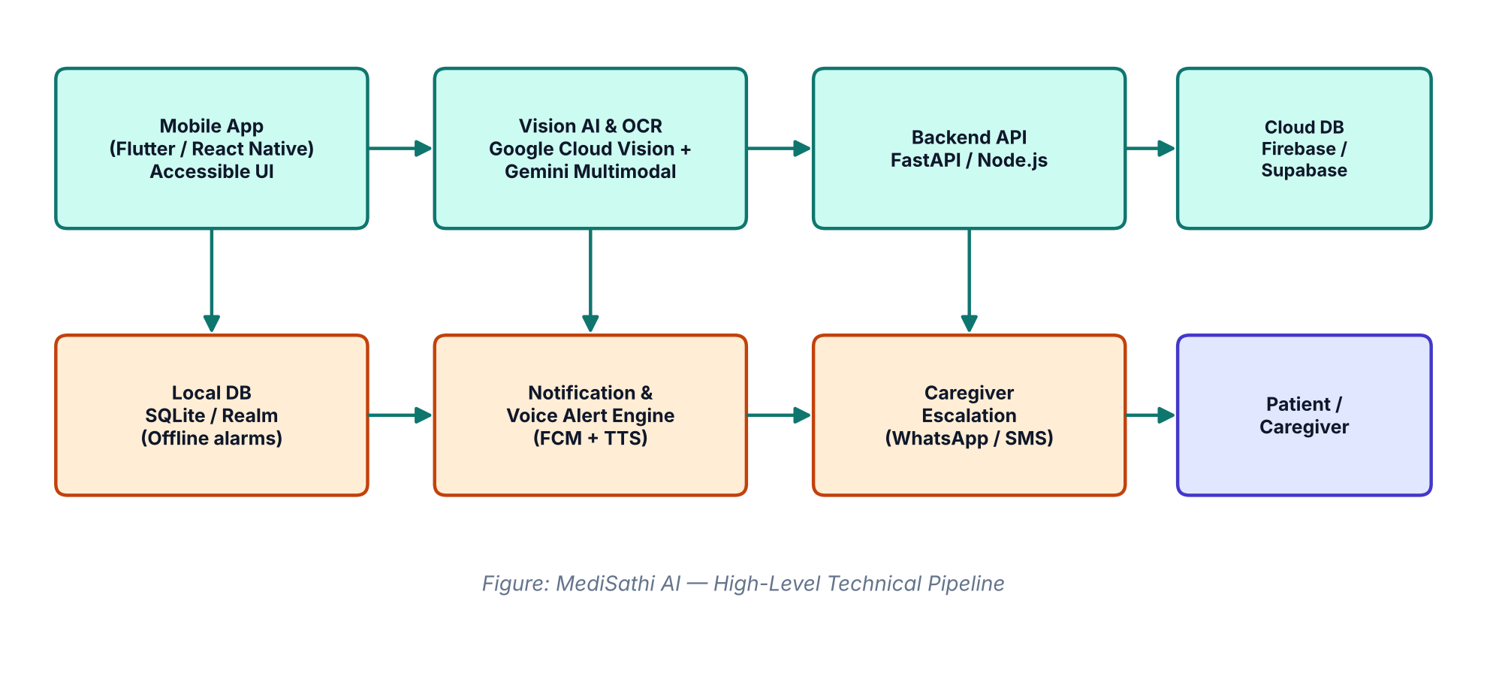
Figure 3.1 — System Architecture / Technical Pipeline Diagram
Each of the four core features maps to one primary screen in the prototype, detailed below:
- Today (Home): shows the day's doses grouped by time of day, a single large 'Pill Taken' confirmation button, and the spoken-language setting used for voice alerts.
- Scan Rx: lets the patient photograph a prescription; the OCR/AI engine returns editable medicine cards (name, dosage, frequency, food instruction, duration) for the patient or caregiver to confirm before saving.
- Stock: shows a colour-coded inventory bar per medicine (green/amber/red) and surfaces the Second Course Alert with direct 're-order' and 'book follow-up' actions once stock drops to 20% or 2 days of supply remain.
- Pill Scanner: lets the patient photograph an unlabelled pill or strip and returns a best-effort identification with an explicit safety disclaimer to confirm with a pharmacist.

3.2 Images of Prototype
The following wireframes illustrate the four primary screens of the prototype.
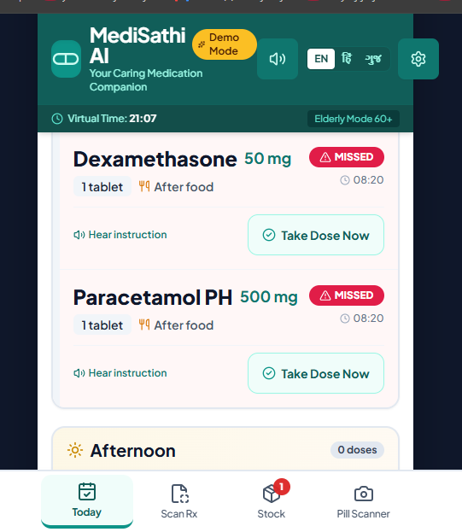
Figure 3.2 — Prototype Screen: Today / Home (Dynamic Schedule & Voice Alerts)

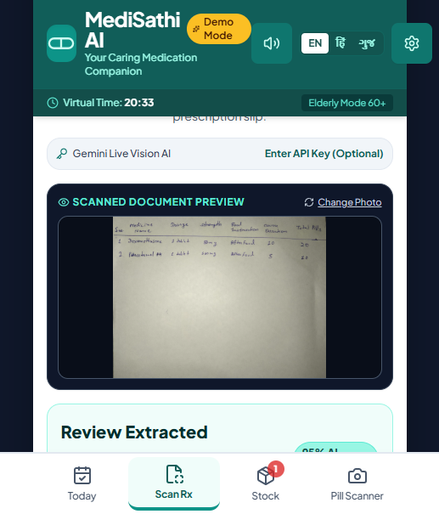
Figure 3.3 — Prototype Screen: Prescription Scan & Review
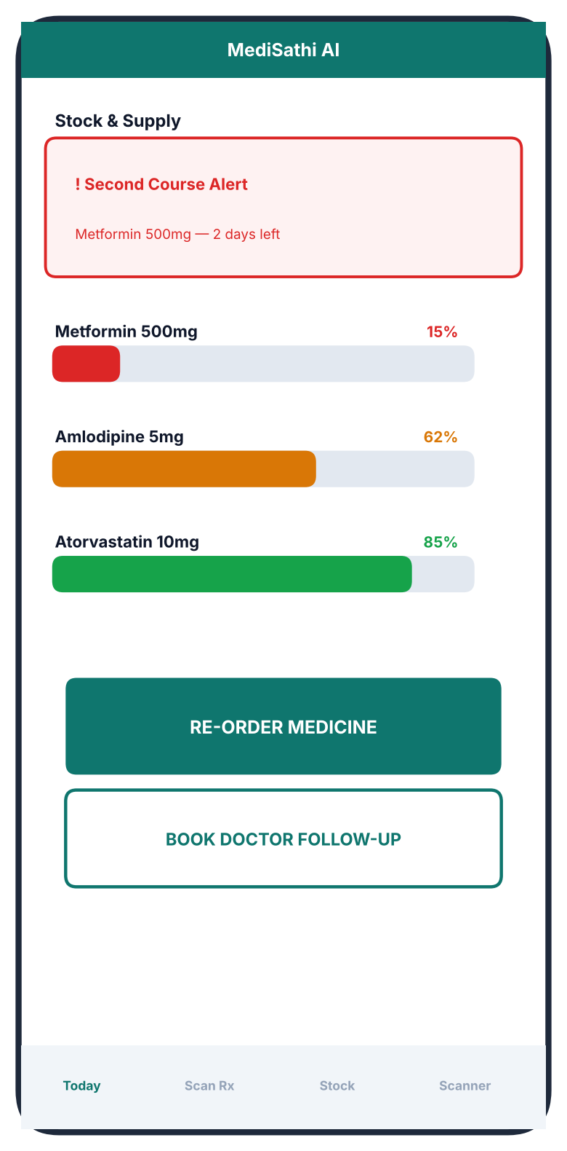
Figure 3.4 — Prototype Screen: Supply Tracking & Second Course Alert
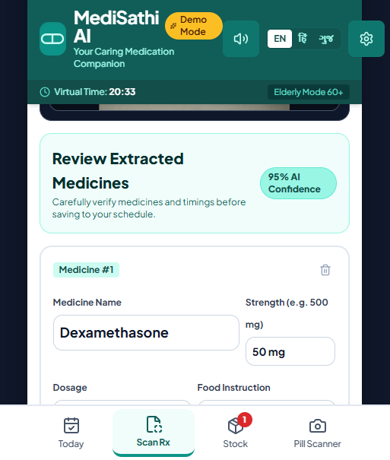
Figure 3.5 — Prototype Screen: Pill / Strip Scanner

CHAPTER 4: MIND MAPPING

4.1 Mind Mapping Canvas
The Mind Mapping exercise was used to break the single idea of 'an AI medication companion' into distinct, independently buildable capability branches before entering structured ideation. The central concept, MediSathi AI, radiates into six branches: Prescription OCR & Parsing, Dynamic Schedule & Voice Alerts, Supply Tracking & Second Course Alert, Pill/Strip Scanner, Caregiver Safety Net, and Multilingual Accessibility. The four branches shown with a solid outline in Figure 4.1 (OCR & Parsing, Dynamic Schedule & Voice Alerts, Supply Tracking, and Pill/Strip Scanner) were prioritised as the four core features built out for this phase of the project; Caregiver Safety Net and Multilingual Accessibility were treated as cross-cutting capabilities that support all four core features rather than standalone screens.
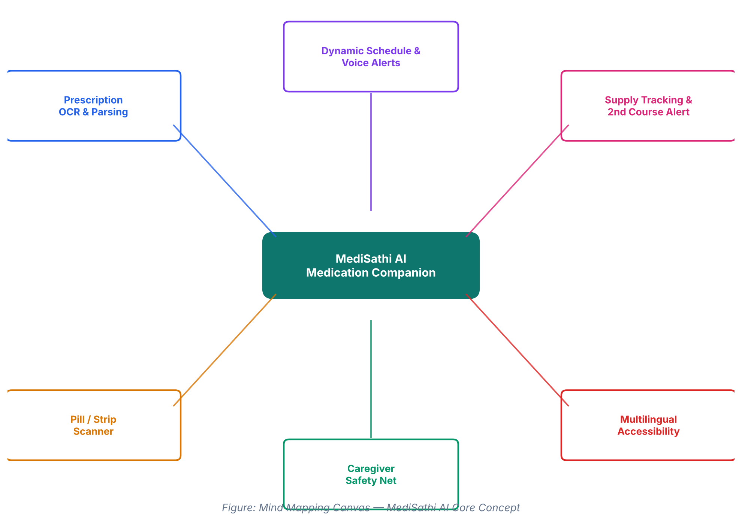
Figure 4.1 — Mind Mapping Canvas

CHAPTER 5: CANVAS

5.1 AEIOU Canvas
Field observations of patient behaviour in homes, clinics, and pharmacies were organised using the AEIOU framework (Activities, Environments, Interactions, Objects, Users) to systematically surface friction points before any solution was proposed.
Element | Field Observation / Data | Identified Pain Point & Insight
Activities (A) | Reading doctor prescriptions, organising pills into daily boxes, calling pharmacies for stock, setting alarm clocks. | High cognitive load; high error rate translating doctor handwriting into actual dose times; forgotten re-orders.
Environments (E) | Bedside tables, kitchens, dim living rooms, busy outpatient clinics, retail pharmacy counters. | Poor lighting for reading small print labels; chaotic home environments causing distraction at dose times.
Interactions (I) | Elderly patients asking children to read labels; caregivers reminding parents; frantic calls to doctors when pills run out. | Dependence on family members creates anxiety and friction; communication breaks down when caregivers are away.
Objects (O) | Paper prescriptions, multi-compartment pill boxes, foil blister packs, syrup bottles, smartphone alarms, paper logs. | Blister packs look visually identical; paper logs get lost; basic phone alarms are dismissed without taking pills.
Users (U) | Elderly chronic patients (60+), busy adult caregivers, multi-drug regimen patients, doctors, pharmacists. | Elders have declining eyesight and tech-phobia; caregivers lack real-time visibility into whether doses were taken.
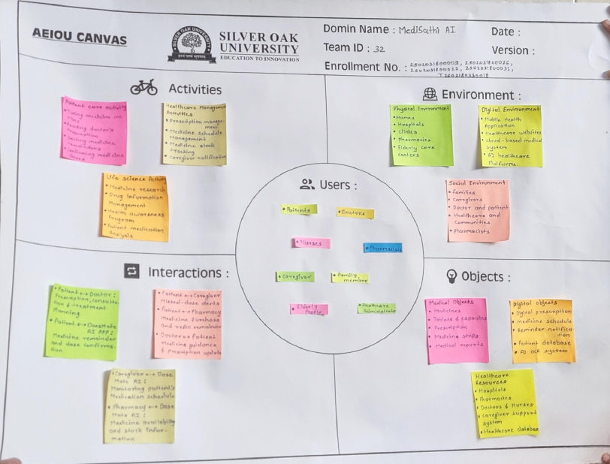
Table 5.1 — AEIOU Canvas

5.2 Ideation Canvas
Synthesising the AEIOU observations led to four structured ideation pillars, focused on creating a purely software-driven AI agent that eliminates costly hardware while solving the core compliance friction.
Pillar | Description
1. Vision-First Data Ingestion | Eliminate manual typing. The user photographs any handwritten or printed prescription, and Vision AI instantly parses medicine names, dosages, and durations into structured schedule data.
2. Proactive Dual-Phase Scheduling | Schedule daily dose times AND automatically project when the course supply will hit 80% depletion, triggering a second-stage course-continuity alert.
3. Multi-Modal Accessibility | Integrate regional voice alarms (Hindi, Gujarati, English) so elderly users do not need to read small text notifications.
4. Caregiver Safety Net | Provide automated escalation alerts (e.g., via WhatsApp/SMS) to family caregivers if a dose remains unconfirmed after 30 minutes.
Table 5.2 — Ideation Canvas

5.3 Empathy Canvas
An Empathy Canvas was built for the primary persona — an elderly, chronic-illness patient — to ground the four ideation pillars in a lived point of view, and to validate that the solution addresses emotional as well as functional needs.
Quadrant | Observation
Says | 'I don't always remember if I took my evening tablet or not.' / 'The doctor's writing is impossible to read.' / 'I don't want to keep bothering my son about this.'
Thinks | Worries about becoming a burden on family; fears forgetting a dose will lead to a health scare; is anxious about running out of medicine while alone at home.
Does | Relies on a paper pill organiser filled once a week; asks a family member to read new prescriptions aloud; sets a generic phone alarm that is often missed or dismissed.
Feels | Frustrated by dependence on others for something personal; anxious around dose timing and stock; relieved and more confident when a reminder is simple, spoken, and in their own language.
Table 5.3 — Empathy Canvas (Primary Persona: Elderly Chronic-Illness Patient)

5.4 Product Development Canvas
The Product Development Canvas consolidates the purpose, audience, experience, and business framing of MediSathi AI into a single reference view used to keep design and engineering decisions aligned.
Block | Content
Purpose | Why: reduce missed doses and preventable hospital visits caused by medication non-adherence. For: elderly and chronic-illness patients and their caregivers.
People | Elderly chronic patients, adult caregivers, multi-drug regimen patients; indirectly, doctors and pharmacists.
Product Experience | Point a phone camera at a prescription or pill; receive spoken, regional-language guidance; confirm a dose with one large button.
Product Functions | OCR prescription parsing, dual-phase scheduling, multilingual voice alerts, stock tracking, pill/strip identification, caregiver escalation.
Product Features | Editable OCR results, large single-tap confirmation, colour-coded stock bar, Second Course Alert, pharmacist-confirmation disclaimer on scans.
Business Goals | Replace a ₹12,000–₹40,000 hardware purchase with a free/low-cost software subscription; scale across regional languages; build an adherence-data asset for future healthcare partnerships.
Components | Mobile app (Flutter/React Native), Vision AI/OCR engine, local offline database, backend API, notification/voice-alert engine, caregiver-escalation module.
Metrics | Dose-confirmation rate, average time-to-confirmation, Second Course Alert response rate, reduction in self-reported missed doses, caregiver escalation response time.
Table 5.4 — Product Development Canvas

CHAPTER 6: LIMITATION AND FUTURE ENHANCEMENT

6.1 Limitations
- Prescription and pill-identification accuracy depends on image quality and on how clearly the original handwriting or print is formed; very poor handwriting may still require manual correction.
- OCR/AI parsing and pill identification require an internet connection; only already-scheduled alarms and dose logging work fully offline.
- The solution assumes the patient or a co-resident caregiver owns a smartphone with a working camera and speaker; it does not yet serve households with no smartphone access.
- Voice-alert accuracy and clarity can be affected by noisy home environments or device speaker quality.
- The Pill/Strip Scanner is a best-effort identification aid, not a certified diagnostic tool, and always requires pharmacist or doctor confirmation before use — this is a deliberate safety boundary, not a gap to be removed.
- The current prototype does not yet check for drug-to-drug interactions across a patient's full medicine list.

6.2 Future Enhancement Roadmap
A four-phase roadmap has been defined to extend MediSathi AI beyond the current four core features:
Phase | Timeline | Enhancement
Phase 1 | Months 1–3 | Smart Wearable Integration — syncing alerts with smartwatches (Apple Watch, Wear OS, Noise/boAt) for haptic wrist-vibration reminders.
Phase 2 | Months 4–6 | E-Pharmacy Auto-Refill Integration — direct API integration with Netmeds, Tata 1mg, and local pharmacies for one-click medicine re-ordering when stock hits 20%.
Phase 3 | Months 7–9 | AI Drug Interaction Engine — real-time safety checks warning users if a newly scanned drug conflicts with their existing active medication list.
Phase 4 | Months 10–12 | Doctor Dashboard & EHR Sync — generating adherence-compliance reports (PDFs) directly shareable with treating physicians at follow-up visits.
Table 6.1 — Future Enhancement Roadmap

CHAPTER 7: CONCLUSION
MediSathi AI redefines medication management by combining human-centric Design Thinking with practical, deployable artificial intelligence. By analysing real patient behaviour through the AEIOU framework and translating those insights into an intuitive, multi-modal mobile application, MediSathi AI is designed to eliminate missed doses, prevent stock exhaustion, and help elderly and chronic-illness patients maintain greater independence — without relying on expensive dispenser hardware.
The four core features prototyped in this report — Intelligent OCR & Prescription Parsing, Dynamic Schedule & Regional Voice Alerts, Supply Tracking & Second Course Alerts, and the Visual Pill & Strip Scanner — directly answer the pain points surfaced during field observation, while the Mind Mapping, Empathy, and Product Development canvases confirm that the solution remains grounded in the patient's and caregiver's real, lived experience rather than in assumption. The roadmap in Section 6.2 sets out a realistic path to extend the platform toward wearables, e-pharmacy integration, drug-interaction safety, and doctor-facing adherence reporting over the following year.

REFERENCES
[1] World Health Organization (WHO), "Adherence to Long-Term Therapies: Evidence for Action," WHO Guidelines, 2023.
[2] United Nations Sustainable Development Goals (SDGs), "Goal 3: Good Health and Well-Being & Goal 9: Innovation," UN Guidelines, 2023.
[3] Journal of Medical Internet Research (JMIR), "Artificial Intelligence Applications in Chronic Disease Management and Prescription Parsing," 2024.

APPENDIX

A.1 Competitive Landscape & Positioning
Unlike existing e-pharmacy platforms and basic alarm apps, MediSathi AI focuses on autonomous intake assistance rather than primary e-commerce sales.
Feature Capability | MediSathi AI | Tata 1mg / Netmeds | Standard Alarm Apps
Prescription OCR | Automated Vision AI parsing | Manual upload for order validation | None (manual text entry)
Voice Alarms | Multilingual regional voice (Hindi/Gujarati/English) | Text push notifications only | Generic system sound
Course Continuity Alert | Automated second-phase threshold alert | Generic re-order reminders | None
Pill Visual Recognition | AI camera scanner for loose pills | None | None
Table A.1 — Competitive Landscape & Positioning

A.2 Glossary of Abbreviations
Abbreviation | Full Form
OCR | Optical Character Recognition
AI / LLM | Artificial Intelligence / Large Language Model
FCM | Firebase Cloud Messaging
SDG | Sustainable Development Goal
EHR | Electronic Health Record
UI | User Interface
Table A.2 — Glossary of Abbreviations

