INFORMATION ABOUT THE DATABASE:

**1. Project Overview:**

The purpose of this database is to manage information about job postings for hourly employment opportunities for faculties in their lab or in their department. It will store details about various job positions, including their titles, descriptions, required skills, and other relevant information.

**2. Functional Requirements:**

- Store information about job postings.

- Allow users to view job postings.

- Allows faculty to add / close job positions

**3. ERD Diagram:**

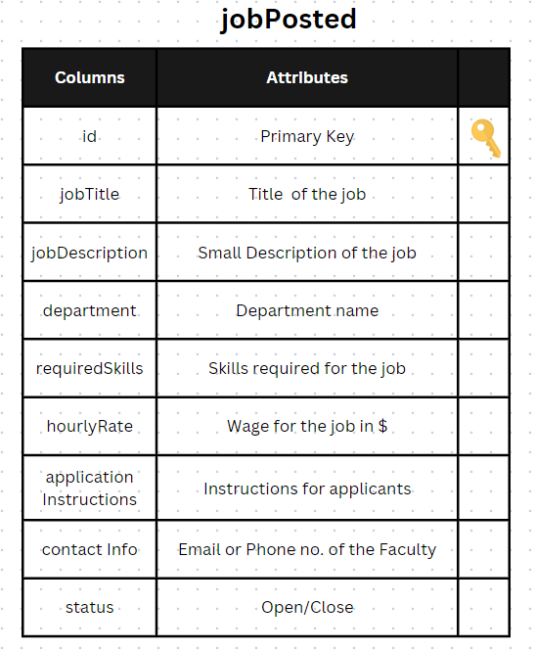

**4. Table:**

- `jobposted`

- `id` (Primary Key) (AUTO_INCREMENT)

- `jobTitle`

- `jobDescription`

- `department`

- `requiredSkills`

- `hourlyRate`

- `applicationInstructions`

- `contactInfo`

- `status`

**5. Data Types for Attributes:**

- `id`: INT (Auto-incrementing)

- `jobTitle`: VARCHAR(255)

- `jobDescription`: TEXT

- `department`: VARCHAR(100)

- `requiredSkills`: TEXT

- `hourlyRate`: DECIMAL(10, 2)

- `applicationInstructions`: TEXT

- `contactInfo`: VARCHAR(255)

- `status`: ENUM('open', 'close')

**6. Integrity Constraints:**

- `id`: NOT NULL, Unique

- `status`: CHECK ('open', 'close')