**Roll No:-03**

**Name:-ATTARDE KOMAL SUNIL**

**Assignment no:-1.1**

**Assignment:-Devloped program to understand the control structure of python(conditional statements)**

* if Statement:-

a = int(input(**"enter a first number"**))  
b = int(input(**"enter a second number"**))  
if a<b:  
 print(**"a is less then b "**)

* Output-

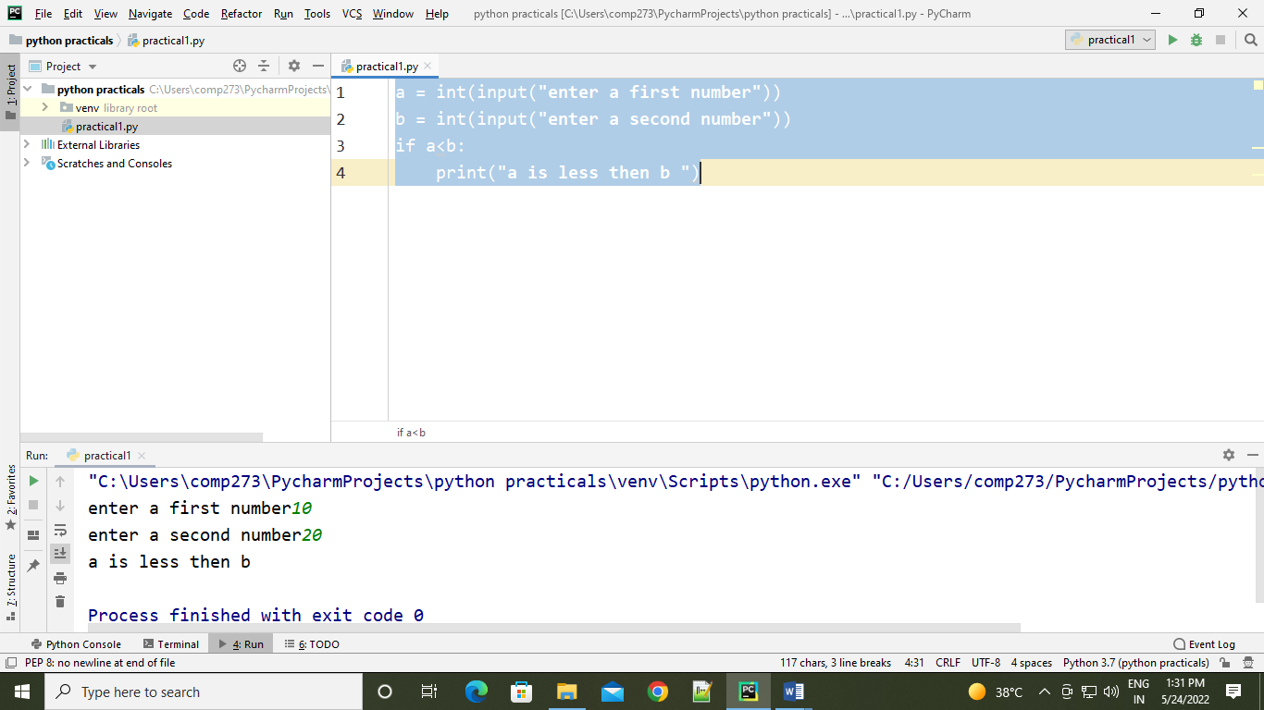

* If –else statement:-

a = int(input(**"enter a first number"**))  
b = int(input(**"enter a second number"**))  
if a<b:  
 print(**"a is less than b"**)  
else:  
 print(**"a is greater than b"**)

* Output:

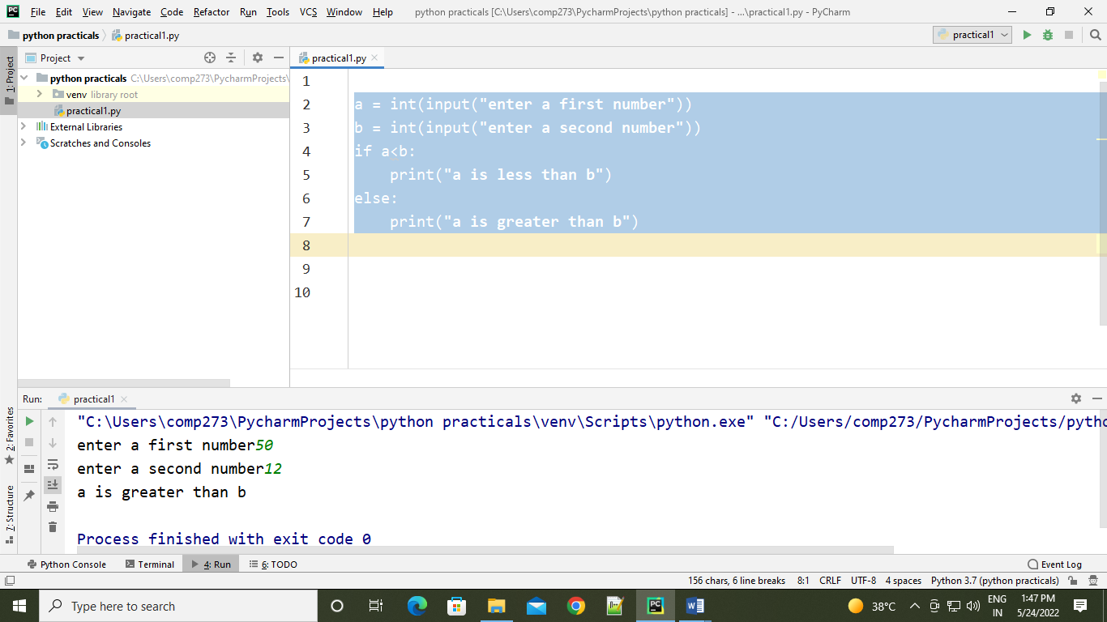

* elif statement:-

a = int(input(**"Enter 1st Number: "**))  
b = int(input(**"Enter 2nd Number: "**))  
if a < b:  
 print(**"a is greater than b"**)  
elif a > b:  
 print(**"a is greater than b"**)  
elif a == b:  
 print(**"both are equal"**)  
else:  
 print(**"Invalid"**)

Output:-

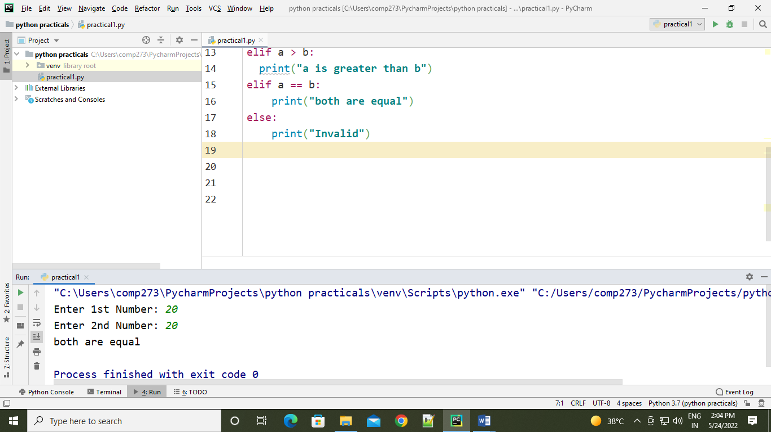

* Nested if-else:-

num = int(input(**"Enter a Number: "**))  
if num >= 0:  
 if num == 0:  
 print(**"Zero"**)  
 else:  
 print(**"Positive number"**)

* Output:-

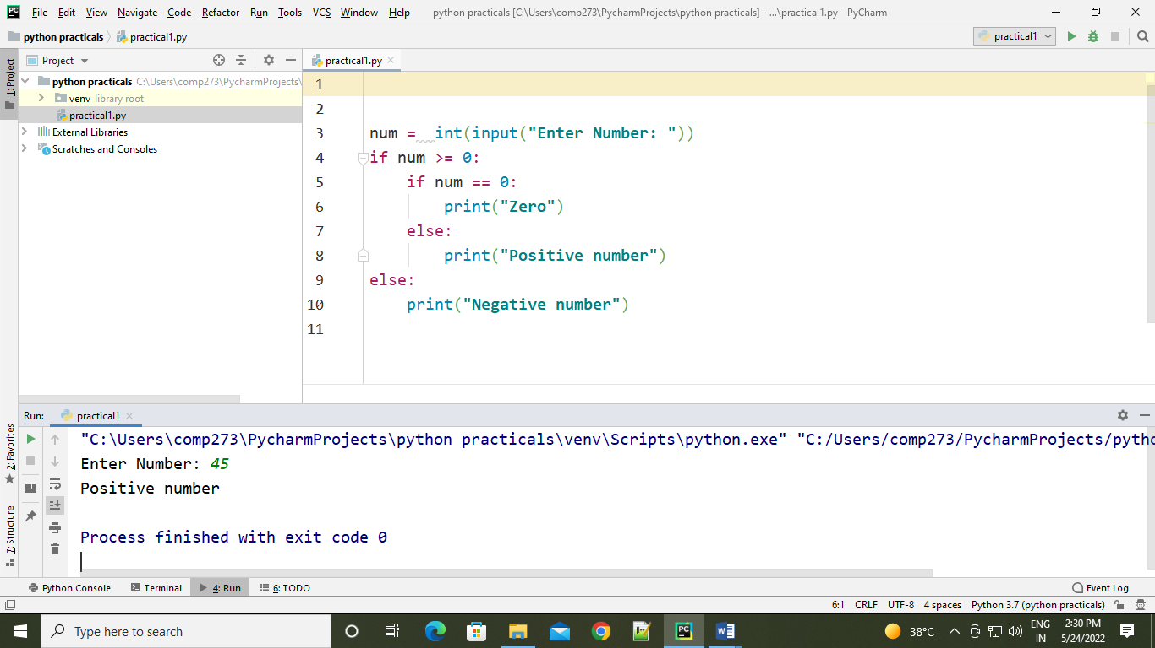

* if-elif-ladder:-

number = int(input(**"Enter the number"**))  
if number==10:  
 print(**"number is equals to 10"**)  
elif number==50:  
 print(**"number is equal to 50"**)  
elif number==100:  
 print(**"number is equal to 100"**)  
else:  
 print(**"number is not equal to 10 50 100"**)

* output:

