Task 8 – Sales Dashboard Insights
Submitted by : Roshani Ramdas Chorghe
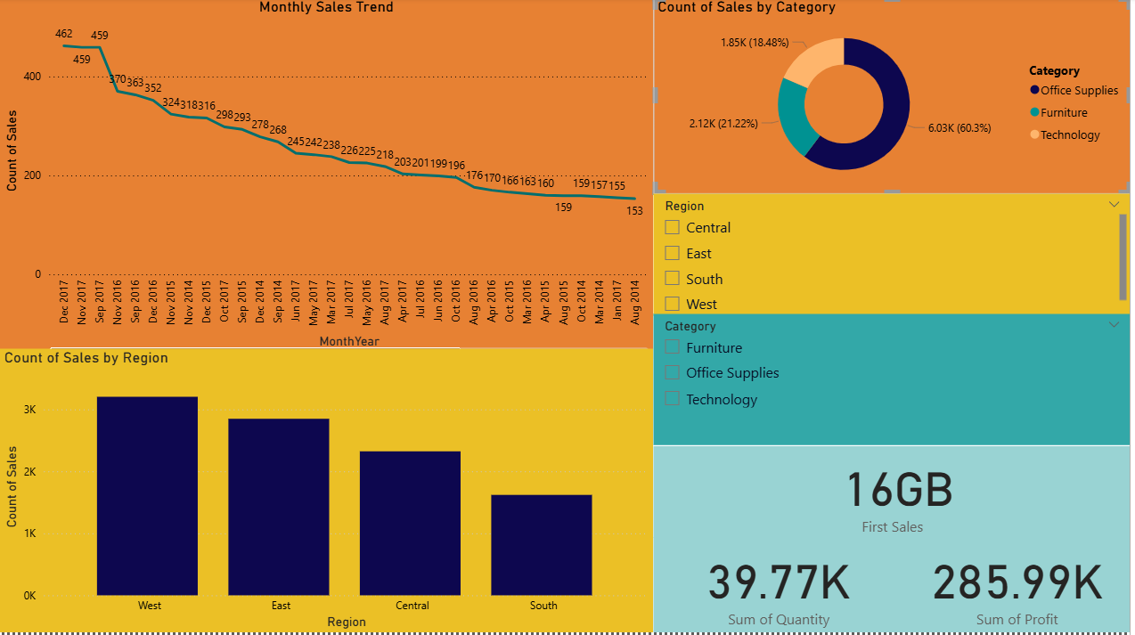
– Region Performance
The West region recorded the highest number of sales, while the South region showed the lowest performance. This indicates strong demand and higher customer activity in the West.
– Category Contribution
Among all the categories, Office Supplies contributed the highest sales share (about 60%), making it the top-performing category in the dataset.
– Monthly Sales Trend
The overall monthly sales trend is declining, showing a gradual drop over time. This could indicate reduced demand or seasonal variation.
– Profit Behaviour
Technology products generated higher profit margins compared to the other two categories, showing stronger profitability for tech items.

