All product:
Product Name: Tactical cotton pant IX7 series size: S, M, L, XL, XXL, XXXL Price: Rs.4200 Color: Khaki, Green, Gray
Product Name: Tactical cotton pant IX9 series size: S, M, L, XL, XXL, XXXL Price: Rs.4200 Color: Khaki, Green, Gray, Black, Desert Khaki
Product name: Wrinkle Tactical Pant IX7 and IX9 series sizes: S, M, L, XL, XXL, XXXL price: Rs.2950 Color: Gray, Black, Olive Green
Product name: Half Pant IX7 series size: S, M, L, XL, XXL, XXXL Price: 2450 color: Navi Blue, Grey, Khaki, Mate Black,
Product name: Half Pant IX9 series size: S, M, L, XL, XXL, XXXL Price: 2450 color: Navi Blue, Grey, Khaki, Mate Black,
Product name: Down Jacket Size: M, L, XL, XXL price: Rs.6000 color: Black, Gray, Green
product name: Ultra Down Jacket size: M, L, XL, XXL price: 5000 Color: Green, Black, gray, Brown

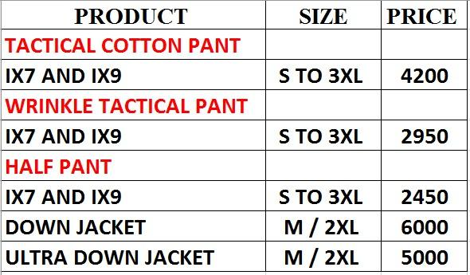

For Each Product

1. Tactical Cotton Pant IX7 Series
- Title: Tactical Cotton Pant IX7
- Content: Premium quality Tactical Cotton Pant (IX7 Series) available in sizes S, M, L, XL, XXL, XXXL Price: Rs.4200. Colors: Khaki, Green, Gray.
- Matches values: Tactical Cotton Pant IX7, IX7 pant, cotton IX7, Rs.4200, ix7

2. Tactical Cotton Pant IX9 Series
- Title: Tactical Cotton Pant IX9
- Content: Durable and stylish Tactical Cotton Pant (IX9 Series). Size:S, M, L, XL, XXL, XXXL. Price: Rs.4200. Colors: Khaki, Green, Gray, Black, Desert Khaki.
- Matches values: Tactical Cotton Pant IX9, IX9 pant, cotton IX9, Rs.4200, ix9

3. Wrinkle Tactical Pant IX7 & IX9
- Title: Wrinkle Tactical Pant IX7 & IX9
- Content: Wrinkle-free Tactical Pants in IX7 & IX9 designs. Sizes: S, M, L, XL, XXL, XXXL. Price: Rs.2950. Colors: Gray, Black, Olive Green.
- Matches values: Wrinkle Pant, Wrinkle Tactical Pant, IX7 wrinkle, IX9 wrinkle, Rs.2950, ix7, ix9

4. Half Pant IX7 Series
- Title: Half Pant IX7
- Content: Comfortable Half Pant (IX7 Series) for casual and tactical use. Sizes: S, M, L, XL, XXL, XXXL. Price: Rs.2450. Colors: Navy Blue, Grey, Khaki, Matte Black.
- Matches values: Half Pant IX7, IX7 shorts, Rs.2450, ix7

5. Half Pant IX9 Series
- Title: Half Pant IX9
- Content: Stylish Half Pant (IX9 Series) in multiple tactical colors. Sizes: S, M, L, XL, XXL, XXXL Price: Rs.2450. Colors: Navy Blue, Grey, Khaki, Matte Black.
- Matches values: Half Pant IX9, IX9 shorts, Rs.2450, ix9

6. Down Jacket
- Title: Down Jacket
- Content: Warm and lightweight Down Jacket. Sizes: M, L, XL, XXL. Price: Rs.6000. Colors: Black, Gray, Green.
- Matches values: Down Jacket, Rs.6000, winter jacket, jacket

7. Ultra Down Jacket
- Title: Ultra Down Jacket
- Content: Premium Ultra Down Jacket designed for extreme warmth and comfort. Sizes: M, L, XL, XXL. Price: Rs.5000. Colors: Green, Black, Gray, Brown.
- Matches values: Ultra Down Jacket, Rs.5000, ultra jacket, jacket

1. Tactical Cotton Pant IX7 & IX9
- Title: Tactical Cotton Pant
- Content: Tactical Cotton Pant IX7 & IX9 series. Size:S, M, L, XL, XXL, XXXL. Price: Rs.4200.
- Matches values: Tactical Cotton Pant, IX7 Pant, IX9 Pant, Rs.4200, ix7, ix9

2. Wrinkle Tactical Pant IX7 & IX9
- Title: Wrinkle Tactical Pant
- Content: Wrinkle-free Tactical Pant IX7 & IX9 series. Size: S, M, L, XL, XXL, XXXL. Price: Rs.2950.
- Matches values: Wrinkle Tactical Pant, Rs.2950, wrinkle pant, ix7, ix9

3. Half Pant IX7 & IX9
- Title: Tactical Half Pant
- Content: Comfortable Half Pants (IX7 & IX9). Size: S, M, L, XL, XXL, XXXL. Price: Rs.2450.
- Matches values: Half Pant, Rs.2450, IX7 Shorts, IX9 Shorts, ix7, ix9

4. Down Jacket
- Title: Down Jacket
- Content: Premium Down Jacket. Size: M, L, XL, XXL,. Price: Rs.6000.
- Matches values: Down Jacket, winter jacket, Rs.6000, jacket

5. Ultra Down Jacket
- Title: Ultra Down Jacket
- Content: High-quality Ultra Down Jacket. Size: M, L, XL, XXL. Price: Rs.5000.
- Matches values: Ultra Down Jacket, Rs.5000, jacket

Dealer Location Entries
Visit Our Stores or Contact a Dealer

We are the official distributor of premium tactical wear and outdoor gear.
You can shop online, and if you have any complaints, queries, or wish to visit a physical store, please refer to the list below for your nearest dealer:

1.
- Title: Fashion Hub - Baglung
- Content: Dealer: Fashion Hub, Baglung. Contact: 9857620000. Visit for offline purchases or product inquiries.
- Matches values: baglung, fashion hub, dealer in baglung, offline store baglung

2.
- Title: City Fashion - Ghorahi
- Content: Dealer: City Fashion, Ghorahi. Contact: 9847818322. You can visit the store for trying or buying our products.
- Matches values: ghorahi, city fashion, ghorahi store, ghorahi dealer

3.
- Title: Evergreen Store - Gwarko
- Content: Dealer: Evergreen Store, Gwarko. Contact: 9801218139. Visit for offline purchases or returns.
- Matches values: gwarko, evergreen, evergreen store, dealer gwarko

4.
- Title: Fashion Blast - By Pass
- Content: Dealer: Fashion Blast, By Pass. Contact: 9851128356. Reach out or visit for product demo and purchases.
- Matches values: bypass, fashion blast, bypass dealer

5.
- Title: First Trust and Try - Civil Mall KTM
- Content: Dealer: First Trust and Try, Civil Mall, Kathmandu. Contact: 9851068084. Drop by for fittings or to explore our collection.
- Matches values: civil mall, kathmandu store, trust and try, civil mall dealer

6.
- Title: My Shop - Itahari
- Content: Dealer: My Shop, Itahari. Contact: 9852046296. You can physically inspect and buy from this store.
- Matches values: itahari, my shop, dealer in itahari

7.
- Title: Abhisek Fancy - BG Mall
- Content: Dealer: Abhisek Fancy, BG Mall. Contact: 9841683335. Available for offline shopping and order queries.
- Matches values: bg mall, abhisek, abhisek fancy

8.
- Title: Friends Fashion Wear - Birtamod
- Content: Dealer: Friends Fashion Wear, Birtamod. Contact: 9852762617. Reach out for complaints, exchanges or purchases.
- Matches values: birtamod, friends fashion, dealer birtamod

9.
- Title: Rasunga Store - Lotse Mall
- Content: Dealer: Rasunga Store, Lotse Mall. Contact: 9867101781. Visit this store for full collection and assistance.
- Matches values: lotse mall, rasunga store, dealer lotse

10.
- Title: Increation Fancy Store - Asan
- Content: Dealer: Increation Fancy Store, Asan. Contact: 9706606315. Currently under follow-up — call before visiting.
- Matches values: asan, increation store, asan dealer

11.
- Title: Tag Your Identity - Kumaripati
- Content: Dealer: Tag Your Identity, Kumaripati. Contact: 9851001675. Store open for sales, trial, and support.
- Matches values: kumaripati, tag your identity, dealer kumaripati

12.
- Title: Selected Fancy Store - Banepa
- Content: Dealer: Selected Fancy Store, Banepa. Contact: 9849665372. Pending activation — call for availability.
- Matches values: banepa, selected fancy, banepa dealer

13.
- Title: Luga Suga Traders - Pepsicola
- Content: Dealer: Luga Suga Traders, Pepsicola. Contact: 9849169627. Pending confirmation — reach out for inquiry.
- Matches values: pepsicola, luga suga, luga suga traders

14.
- Title: Seto Pathar - Thamel
- Content: Dealer: Seto Pathar, Thamel. Contact: 9818779899. Pending store setup — please confirm before visiting.
- Matches values: thamel, seto pathar, dealer thamel
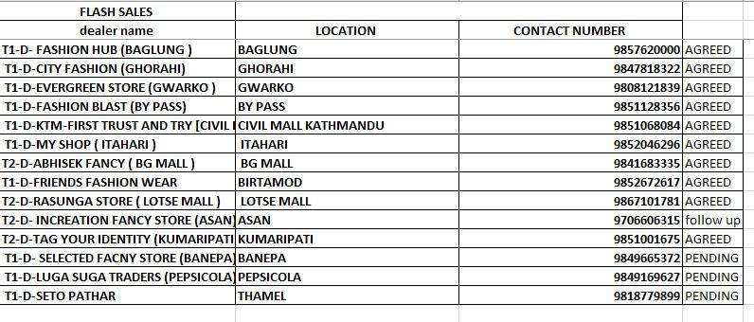

General Support Entry (for all locations)
- Title: Contact Gecko Gears Support
- Content: For online orders, complaints, or help with store locations:
📧 Email: geckogear9@gmail.com
🌐 Website: www.geckogears.com
📱 WhatsApp: +977 984-1435541
📞 Call: 970-3941862
We're here to help!
- Matches values: help, complaint, support, contact, gecko contact, phone number, whatsapp, gmail
ix7

Title: How to Order Products
Content:
🛒 Placing an Order is Easy!
Please send us the following details:
Name: [Your Name]
Contact Number: [Your Phone]
Location: [Delivery Address]
Product Name: [e.g., Tactical Cotton Pant IX7]
Size: [S / M / L / XL / XXL / XXXL]
Color: [Khaki / Green / Black / Gray / etc.]
📤 Send the above details to:
- 📧 Email: geckogear9@gmail.com
- 💬 WhatsApp: +977 984-1435541
- Phone no: 9865323747
- 🌐 Or place it directly via our website: www.geckogears.com
For any help, feel free to message us anytime. We're here to assist you! 😊
- Matches values: how to order, order now, buy product, want to buy, place order, purchase, how can I buy, I want to order

