**Question 1: Visualize Solution and PHP Coding**

1. **Flowchart or UML diagram on the reward system**

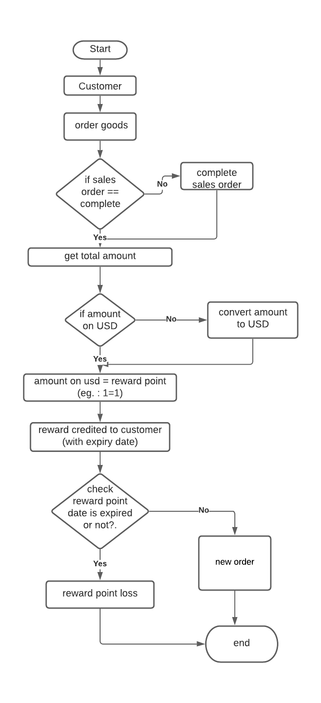

1. **Design MySQL database schema for this reward system**

-- Table structure for table `customers`

CREATE TABLE `customers` (

`id` bigint UNSIGNED NOT NULL,

`full_name` varchar(255) NOT NULL,

`contact_no` varchar(255) NOT NULL

)

-- Table structure for table `order`

CREATE TABLE `order` (

`id` bigint UNSIGNED NOT NULL,

`customer_id` bigint UNSIGNED NOT NULL,

`order_status` enum('complete','notComplete') NOT NULL,

`order_date` datetime NOT NULL

)

-- Table structure for table `order_products`

CREATE TABLE `order_products` (

`id` bigint UNSIGNED NOT NULL,

`order_id` bigint UNSIGNED NOT NULL,

`item_name` varchar(255) NOT NULL,

`price` decimal(8,2) NOT NULL

)

-- Table structure for table `points`

CREATE TABLE `points` (

`id` bigint UNSIGNED NOT NULL,

`order_id` bigint UNSIGNED NOT NULL,

`customer_id` bigint UNSIGNED NOT NULL,

`reward_points` varchar(255) NOT NULL,

`expiry_date` date NOT NULL,

`points_status` enum('used','notused') NOT NULL

)

// points_status indicate that point are used to by products

1. **PHP functions to credit user reward points after order completion**

<?php

function user_reward($amount,$status, $currency) {

if ($status = 'completion') {

if ($currency = 'USD') {

$credit = $amountOnUSD;

return $credit;

} else {

// $convertedamount = convert amount to USD

$credit = $convertedamount;

return $credit;

}

}

echo "order is not completed!"

}

**Question 2: MySQL Query**

SELECT count(order_table.order_id) as no_of_order,SUM(CASE

WHEN order_table.sales_type = "Normal"

THEN oder_products_table.normal_price

ELSE oder_products_table.promotion_price

END) as total_sales_amount FROM `order_table`

LEFT JOIN oder_products_table on oder_products_table.order_id = order_table.order_id

**Question 3 : Calculation**

<?php

function cal_percentage($amount) {

$count = $amount * (6/100);

return $count;

}

echo "the actual amount of GST in MYR for this Order: ".cal_percentage(5);