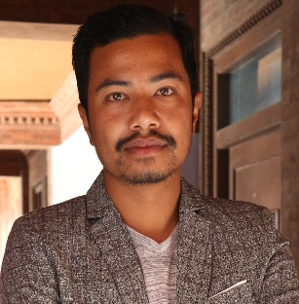

**Roshan Shrestha**

Email: roshan.stha5298@gmail.com

Address: Sudal-2, Bhaktapur

Phone: 9843318309

# Objective

# 

Self-motivated student with the ability to create new ideas to foster the goals of a company. Looking to gain opportunities to utilize my abilities and skills in ensuring efficiency.

# Some Personal Details

# 

Date of birth : 27th August, 1995

Gender : Male

Marital status : Single

Citizenship no. : 28-01-69-03540

Strength : Confident, Energetic, Creative and Dedicated

# Education

Bachelor in Computer Engineering

Khwopa Engineering College

Libali-2, Bhaktapur

Complete year: 2018

# Training/Certificates

# Java (45 hours) Khwopa Engineering College

# .net course in 8th semester

# Job Preference

# Looking for: Entry Level

# Job Categories: IT & Telecommunication

# Available for: Full Time

# Skill

Java, PHP, C & C++, Python, .NET

# Projects

Library Management System

MiniChat

Flip Card

Image Search

Nepali License Plate Recognition(NLPR)

# Participation

Khwopa Project Exhibation-2075 (Nepali license Plate Detector)

# Social Accounts

Facebook: https://www.facebook.com/shr.ros

Instagram: <https://www.instagram.com/roshan_shrestha27/>

# Other Information

Willing to travel outside of residing location during the job: Yes

Willing to temporarily relocate outside of residing location during the job period: Yes