Technologies

Backend : Spring Boot, Jpa, H2 ,Junit(added junits)

Create contact using post request

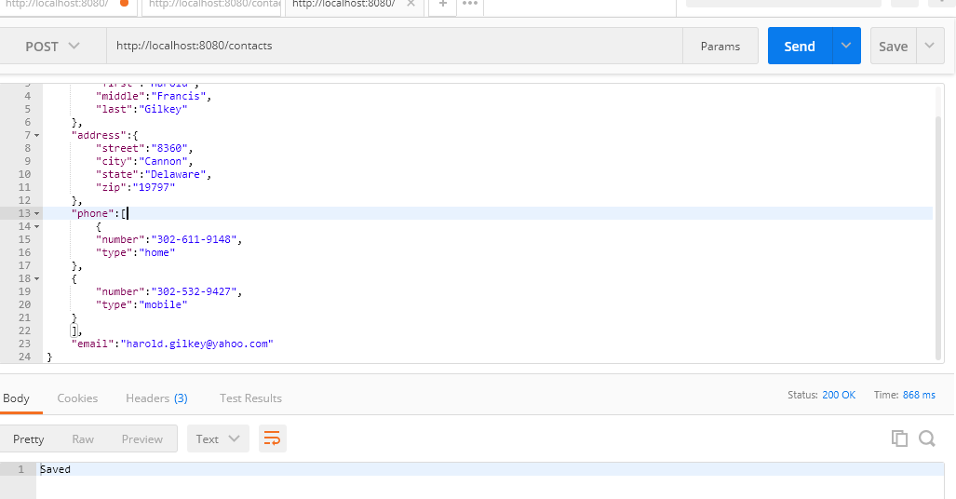

Get the details

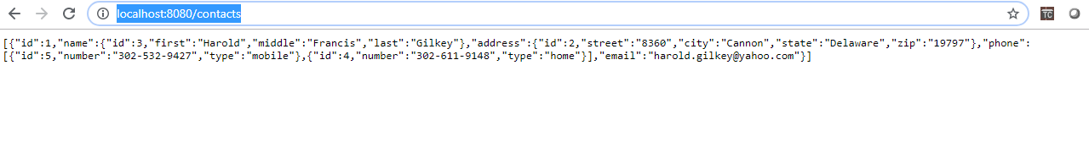

Get the details based on id

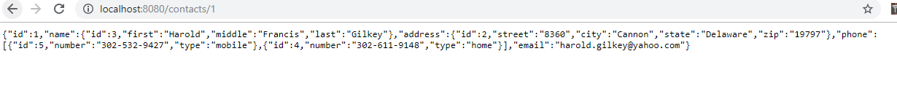

Delete the data based on id

