Landing Page
It should have a clear Login / Sign In button for users, or at least a Login button.
After a successful login, the Landing Page should change to show the user’s name instead of, for example, “Welcome”, and take me to the Dashboard

When choosing Sign Up, the screen must include a Confirm Password field to check that the passwords match.

After logging in, remove the Home button, because it goes to the landing page and is not needed. The StudyBuddy AI name is enough to take us back, or even without it.
Make Home go to the Dashboard page, and remove the Dash item from the navbar

After a successful login, the user goes back to the Landing Page instead of going directly to the Dashboard.

In Settings, there must be a username, generated from the email or entered at sign-up, that can be edited after registration and is shown on the screen.

It is not right that as soon as the AI Perspective is selected, the Study Sheet is created right away.
The user should choose the AI Perspective and the other settings, and then when they click “Generate Study Sheet”, the Study Sheet is created. This gives the user the freedom to make changes

Add the missing Popular Topics to the Roadmap.
In the Sheets there are topics such as: Nephrotic Syndrome, Myocardial Infarction, Pneumonia, and Pulmonology under Popular Topics, but these topics are not in the Roadmap.
Suggestion: add these topics to the Roadmap so the content is consistent between the two sections.

Make the three Steps cards smaller and more compact, or redesign their layout, to improve the page and reduce unnecessary empty space.

In Sheets, make topic selection work the same way in “Try a topic” and “Popular Topics” and “or start fresh”. All options should use the same Toggle behavior: clicking a topic selects it, and clicking it again deselects it.
For example, in Try a topic:
If you select it, it appears in the search box, and if you click it again, it is removed from the box — unlike “Try a topic” and “Popular Topics”

Make “Start Fresh” look visually different from “Popular Topics” to make clear that it creates the Study Sheet right away with the default settings. Since they show the same topics, the difference is not clear until you try it.

“Try a topic”: here, when we choose a topic, the page scrolls or does something like a refresh. This is not needed, especially because it does not behave like the others

Go Pro and the Logout button would be better in Settings, and maybe the theme too

Why does it say “location not recorded”? If it is shown, maybe the upload partly failed
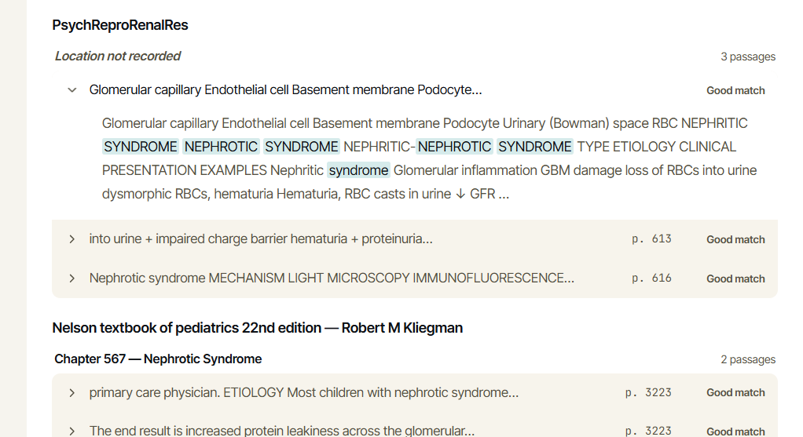

After generating the sheet, it is better to show the name of the generated topic.

The diagnosis is shown as if it fits all cases — one standard version that is not tailored to a specific topic or case. It should be more precise, because there are different cases, ages, diagnoses and other diseases that it depends on, and the treatment is based on that

You have a resend code button that should only work after one minute, and it shows a timer, but if I click the button it says code resent. This should only happen after the time is over, or the button should stay disabled.
Even after one minute, when I click Resend Code, the code does not arrive

A full hour for the OTP is too long from a security point of view
UI updates:
When the code is wrong, the message should not look like this (“token expired”). We can replace it with an error code message
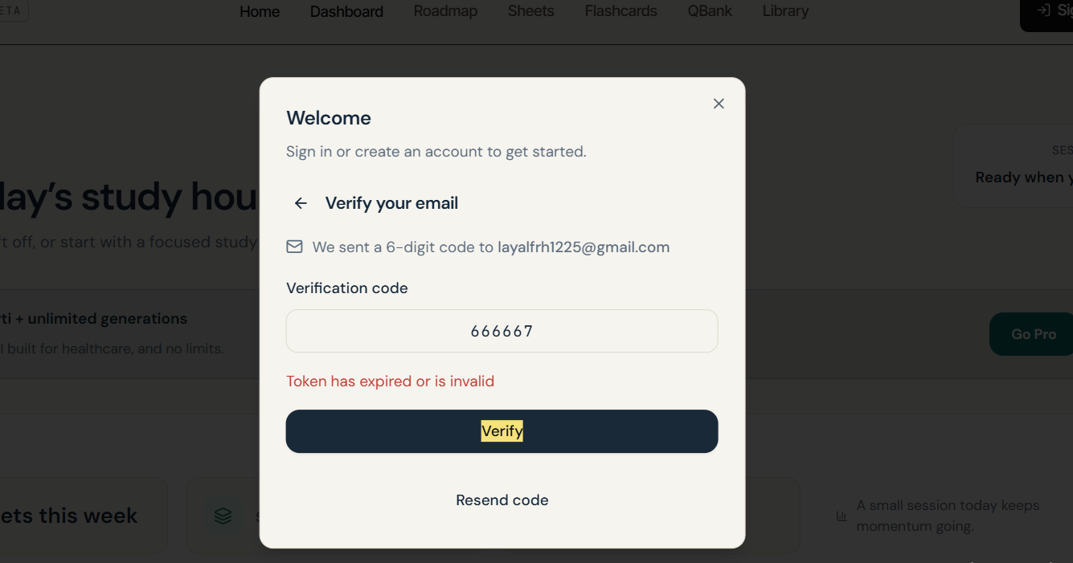
It is not very clear what the code is for
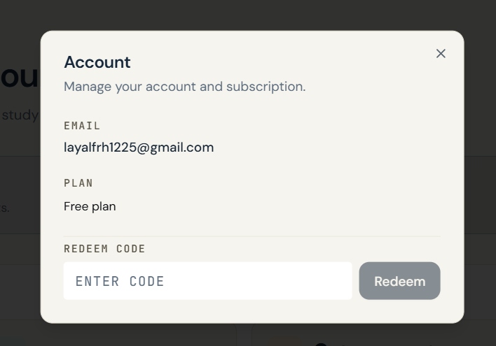
Here, a database error should not be shown. The error is real, but the message itself should not be shown to the user. It could be: Something went wrong while loading your results. Please try again.
This happens when you have a QBank session and want to see the summary
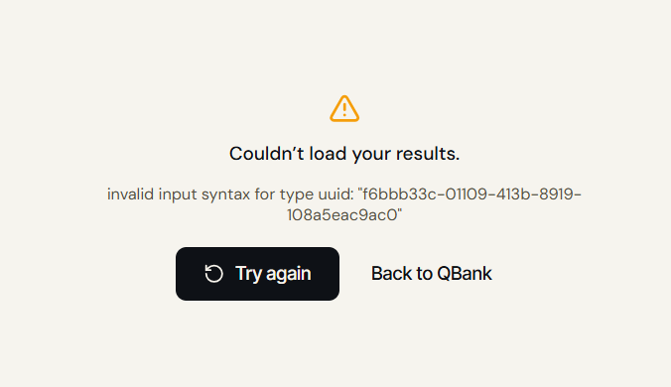

In the QBank, the system does not check whether the entered topic makes sense, and it generates random topics

In Flashcards, if the topic does not exist or is not medical, nothing is generated. This is correct, but it does not show what happened or where the problem is — only Recent Topics says it was not found.
A pop-up or error message should appear saying it is not a medical topic

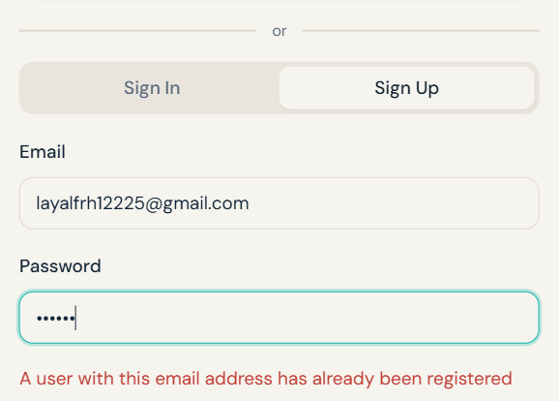
For security, the app should not show whether the email exists or not. You can say “the email or password is incorrect”

