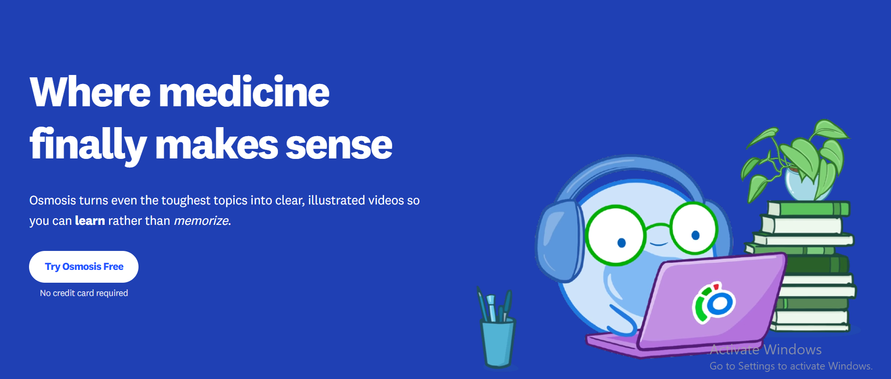

Landing Page
- Header: Make the logo and the site name a little bigger.
- Replace the Get Early Access button with Sign In and Start Free
- Section 1: You can change the section color or keep it as it is, like the image above. And instead of Start Free, use Get Early Access
- Under the first (hero) section, it is important to show the target exam, for example:

Your next topic. Understood, remembered, tested.
Build your understanding with AI-powered Study Sheets, go deeper where you need clarity, and put your knowledge into practice with Flashcards and a USMLE-style QBank.
For medical students · Step 1 & Step 2 - style practice
[Start Studying Free] [Watch Demo]
-
Or another option:
Prepare for USMLE with AI you can trust.
StudyBuddy turns your study material into sheets, flashcards, and practice questions, with answers grounded in cited medical sources.
Built by an MD for medical students across MENA.
Also, this image should preferably come from the Sheet page itself. 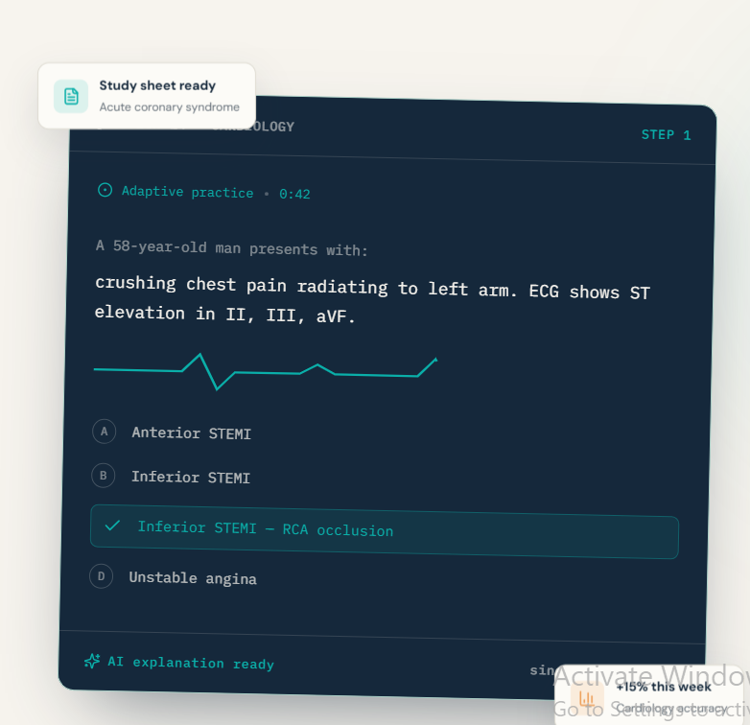So the same thing, but instead of this image, show a result generated from the Sheet.

Section 2
- Core tools: Show Study Sheets, Flashcards, QBank in a short and clear way, with a brief description for each tool, without too much text.
Study Sheets — Understand
Explore structured medical topics, add your notes, and dive deeper into difficult concepts.
Flashcards — Remember
Reinforce key concepts with spaced-repetition flashcards.
QBank — Apply
Practice USMLE-style questions with explanations that help you learn from each answer.

- Section 3 — Intro video: Add the demo video that explains the project.
For example:
Less time preparing to study. More time actually studying.
See the idea behind StudyBuddy AI.

Or:
Take three minutes to get to know StudyBuddy.

Section 4: if you don’t change the first image in Section 1, you can use an image from the Sheet page here Deep Dives and explain its features. Don’t rely on boxes everywhere; you could use bullet points instead
and the spaced-repetition idea and the other features.
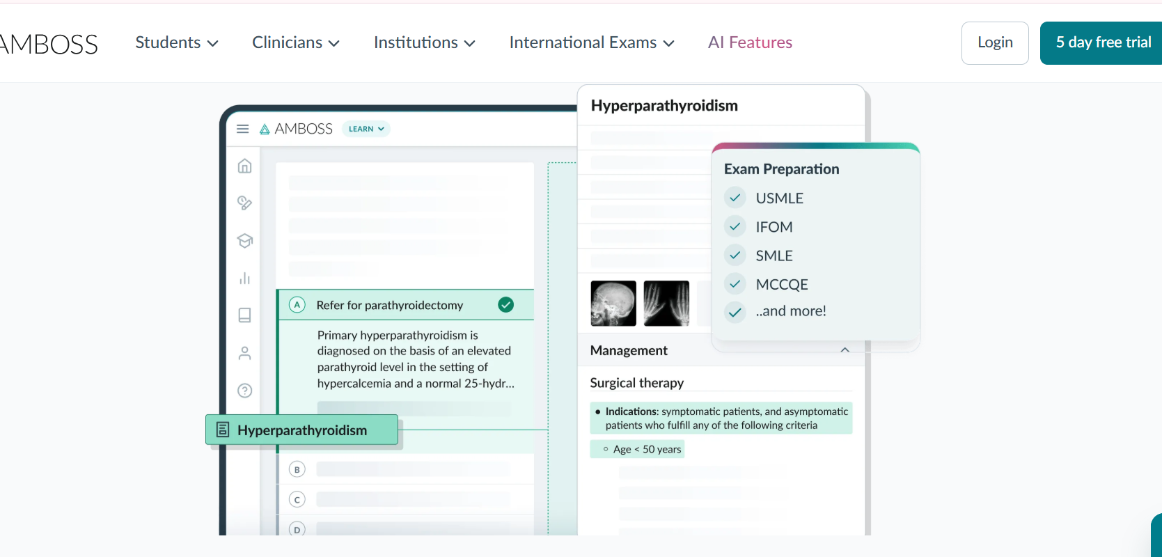 Like this — the image shows what you have.

Then Section 6 Medical sources: how the references appear and how the student can check them.

Pricing: real and clear features and limits. Also the anonymous (guest) plan and how many times it can be used.
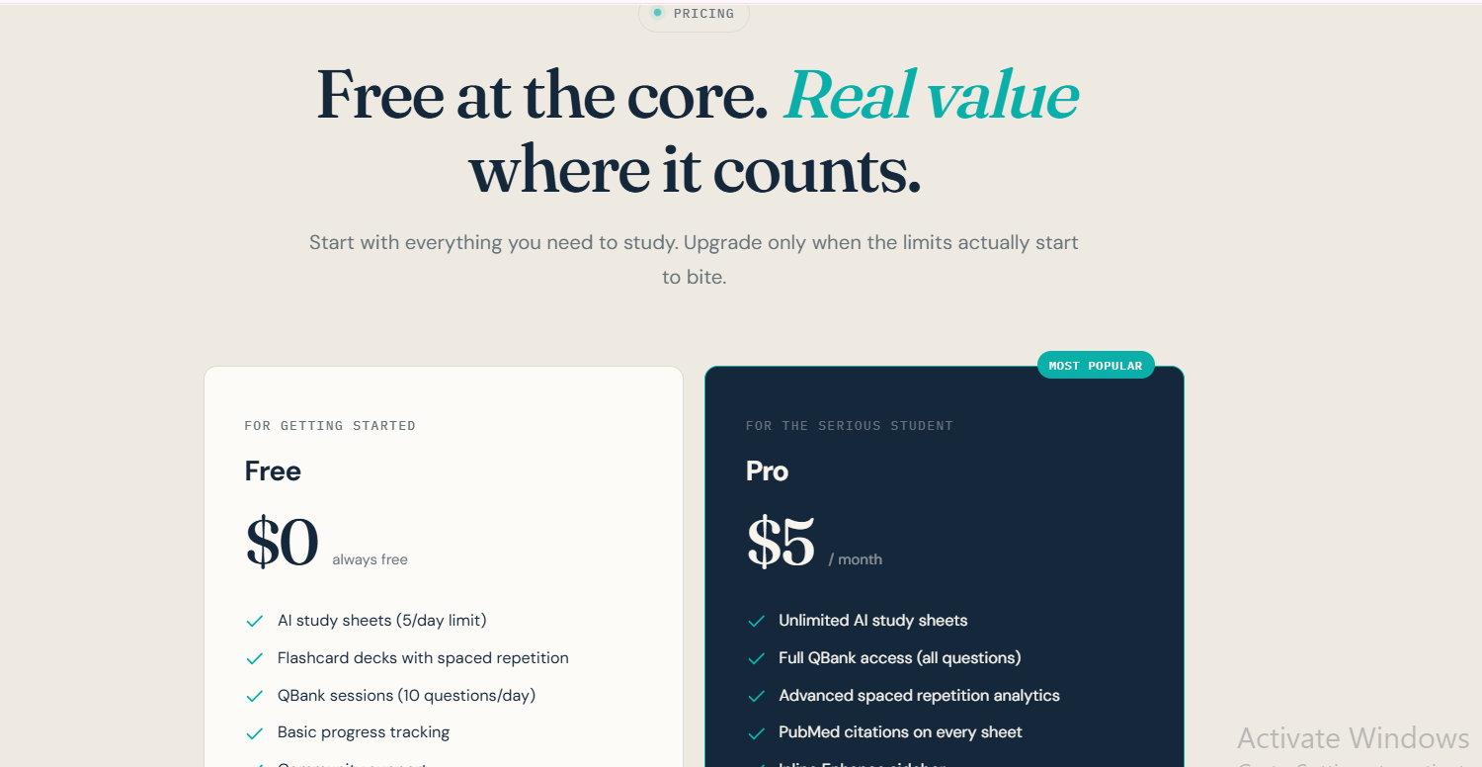Add the anonymous (guest) plan here

FAQ.
Call to action and footer.

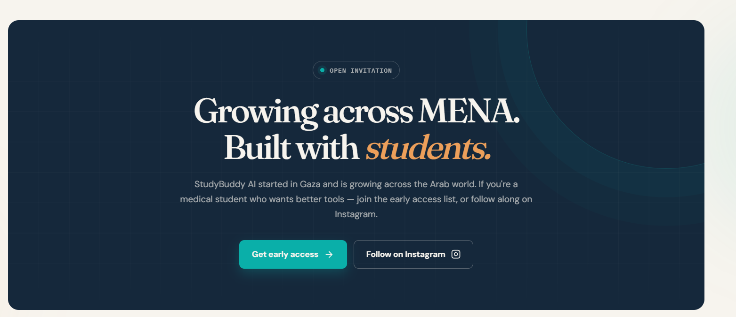Not this — just keep it simple.

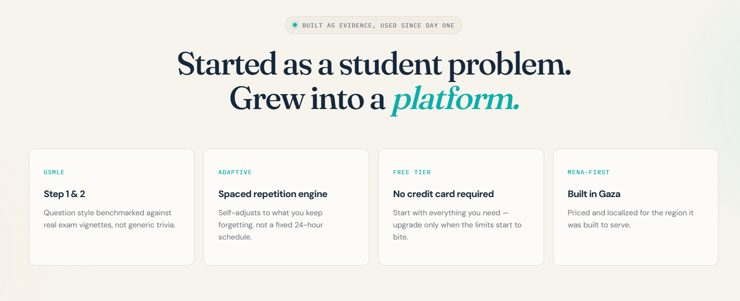Split this content according to the sections above. Putting all this text together is not right because it doesn’t fit.

Dashboard
Keep the general statistics and progress tracking, but show them visually instead of as a fixed list of numbers; for example, progress circles or colored bars that show how much the user has done and how much is left, with the number or percentage written clearly.

All indicators should be linked to the user’s real activity and update as they progress. It should be clear what each circle or percentage represents and what goal it is calculated against.

For example, boxes with the weekly statistics numbers
and a visual summary below
Examples:

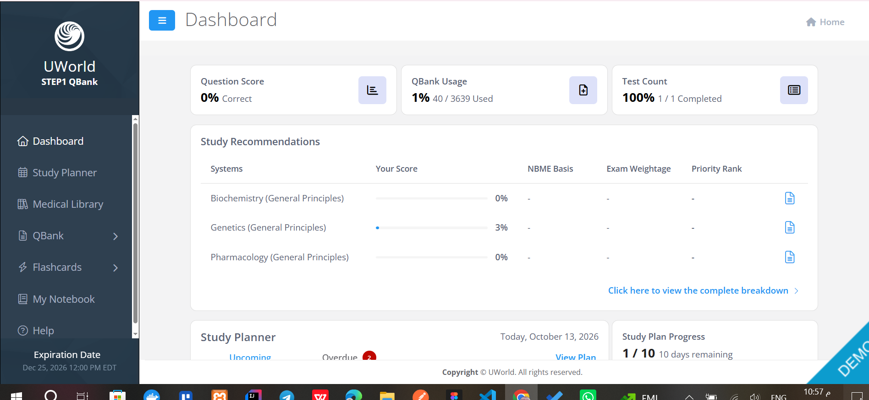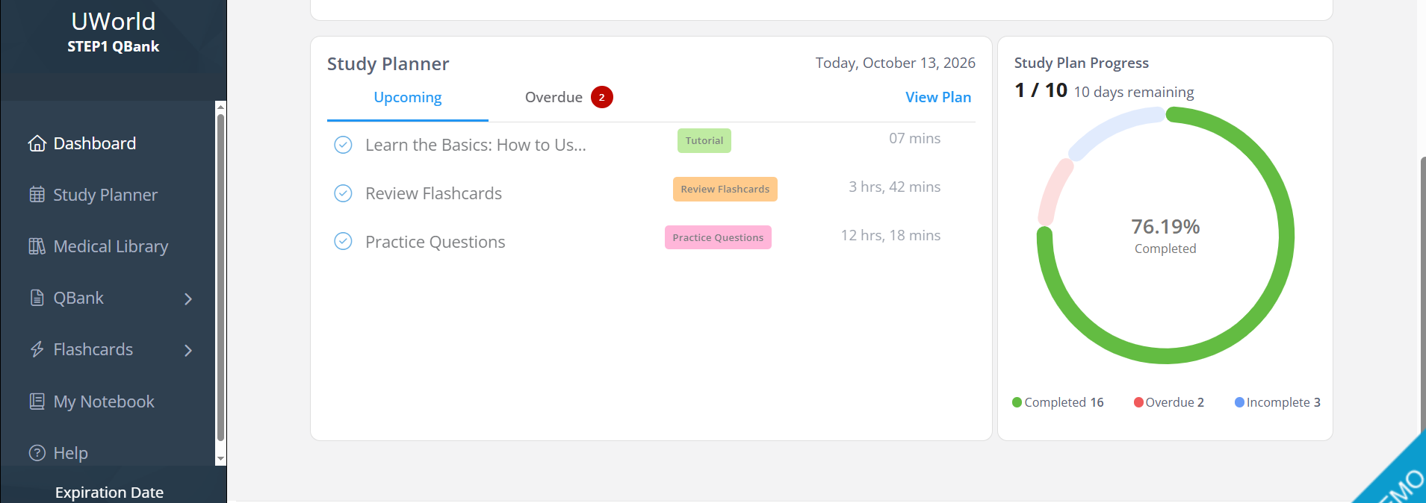

Then, from the statistics themselves: for example, if I click the Sheets box (how many were completed this week),
it opens something like this and shows statistics or the names of the sheets completed. For the QBank it may be better to just show how many questions and their difficulty
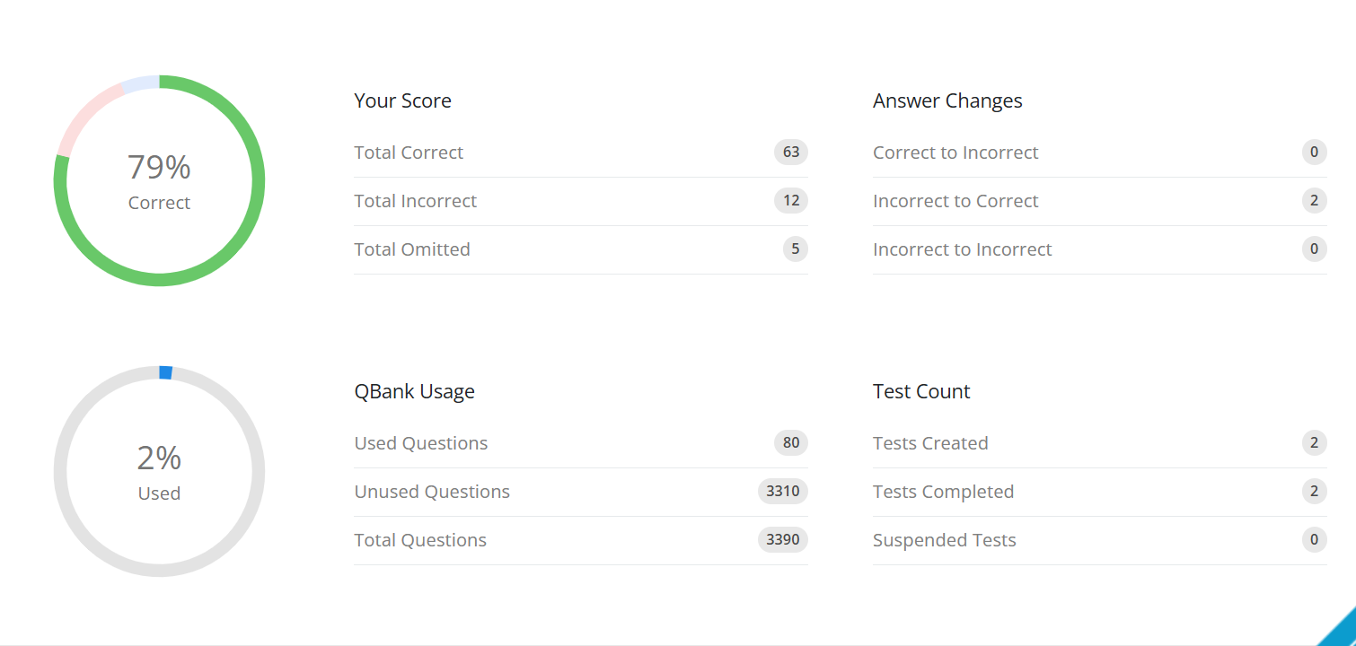

On the Dashboard page, don’t remove the tools as I said, but keep only the main ones. You could also add a Roadmap button in a different style and rename it, because the name suggests something else.

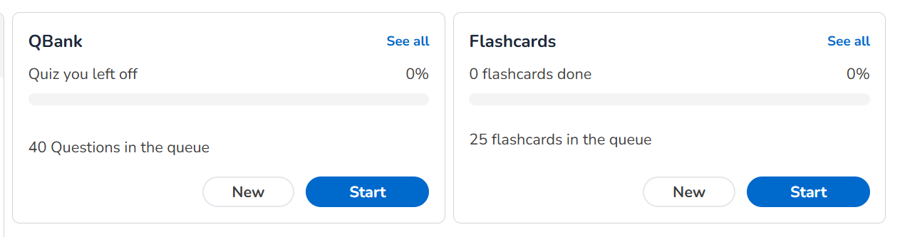
For example, in this style they don’t look like they are just mentioned, as on the landing page — make it clear that you can open them,
not just show their names.

Just remove all the extra stuff and start the page from the top.

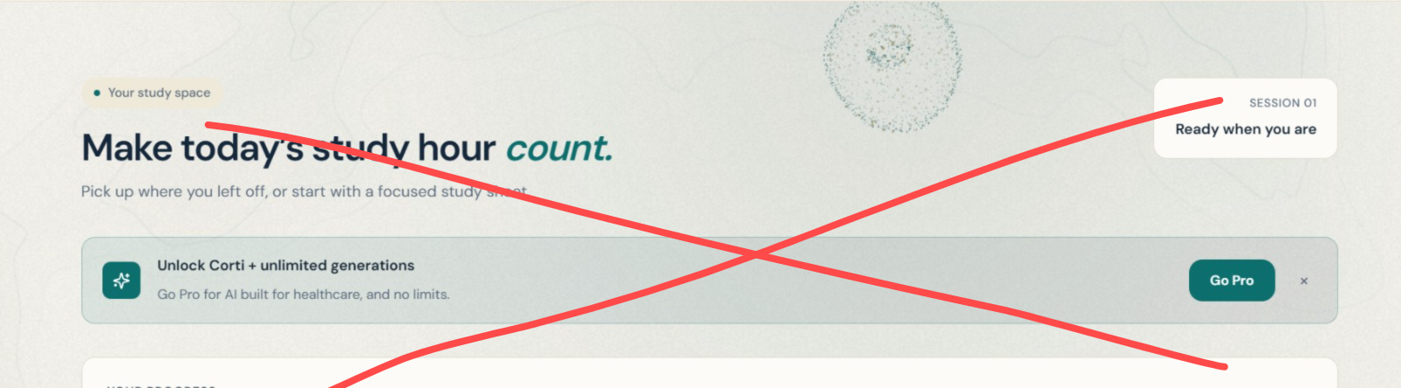

Roadmap page now
Remove 🔥 High yield

And here too

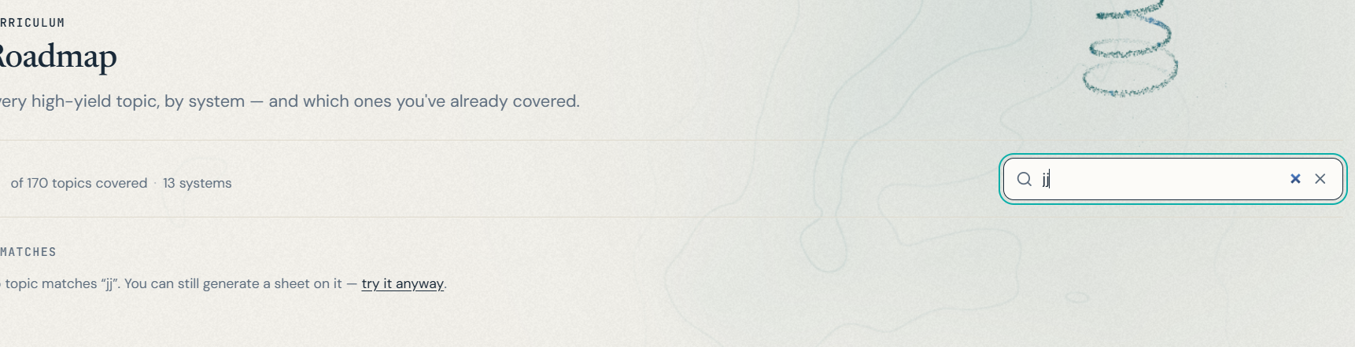

sheets

Entered a wrong topic, for example kkkk — it still shows you a medical topic as normal

Move this to the bottom

and put the Export button at the top, for both Word and PDF
and show it in a style that makes it stand out.

The name of the model used should not be shown at all, for example GPT-OSS 20B
You show it only if the user can customize and choose the model, but here they can’t

Inconsistent
Sometimes like this 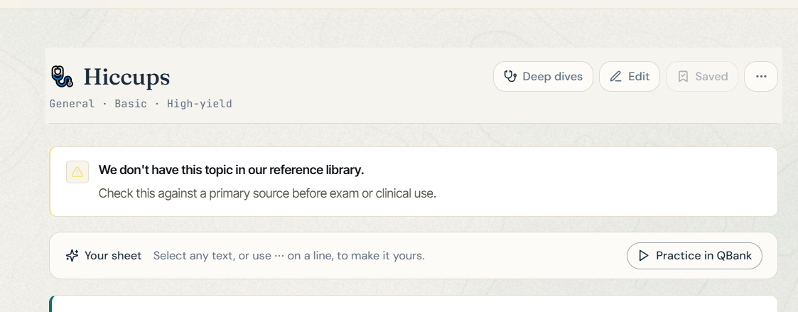
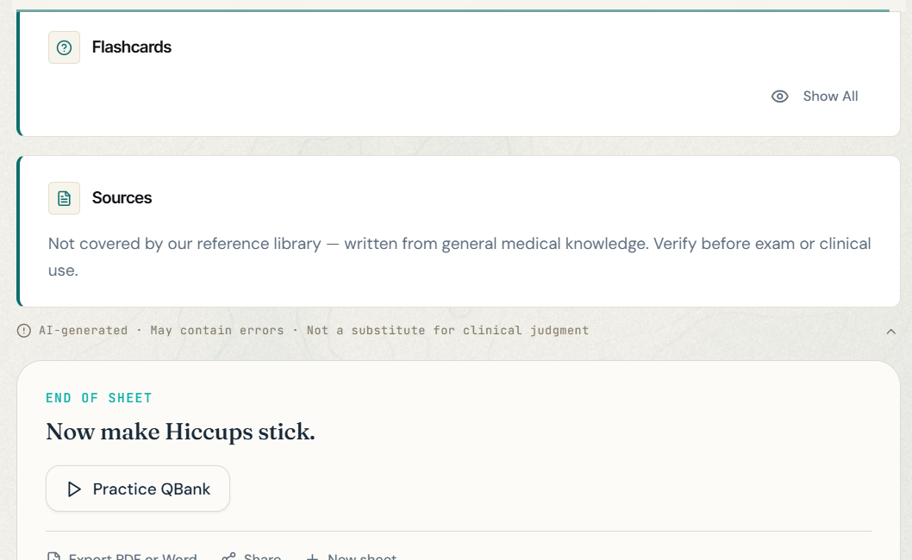
If there are none in the system, just write that there are no flashcards. There is no need for all this empty space

Sometimes like this

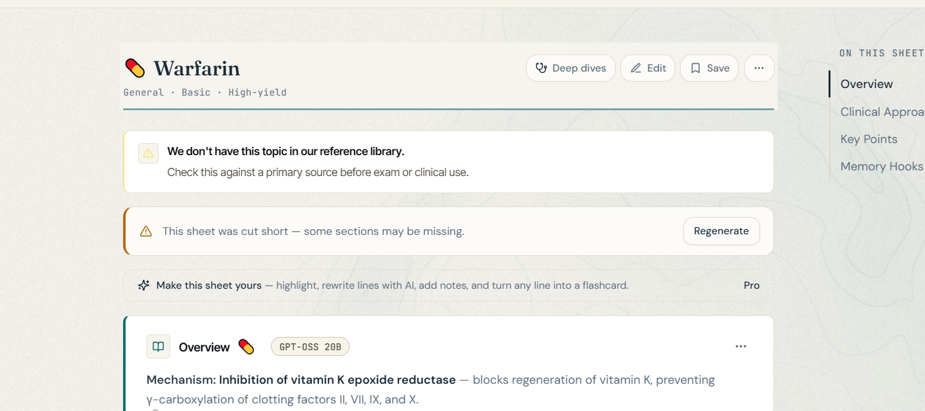

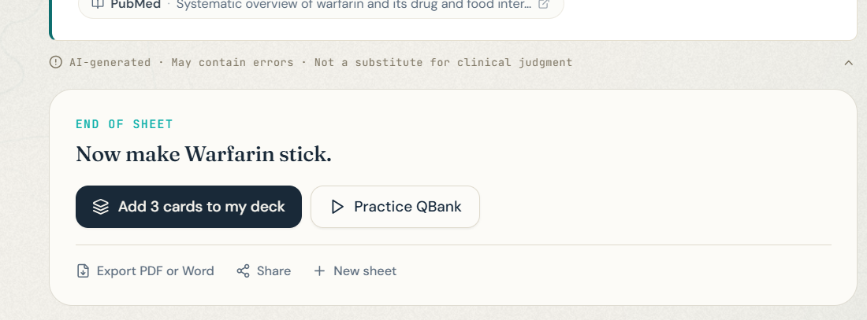

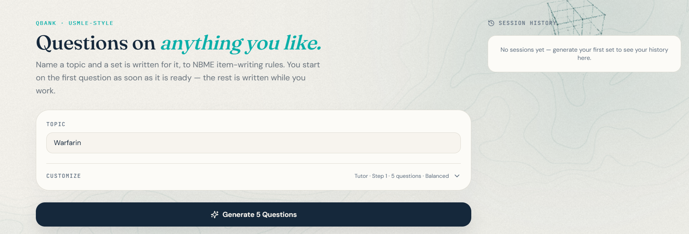The customization options must be shown clearly
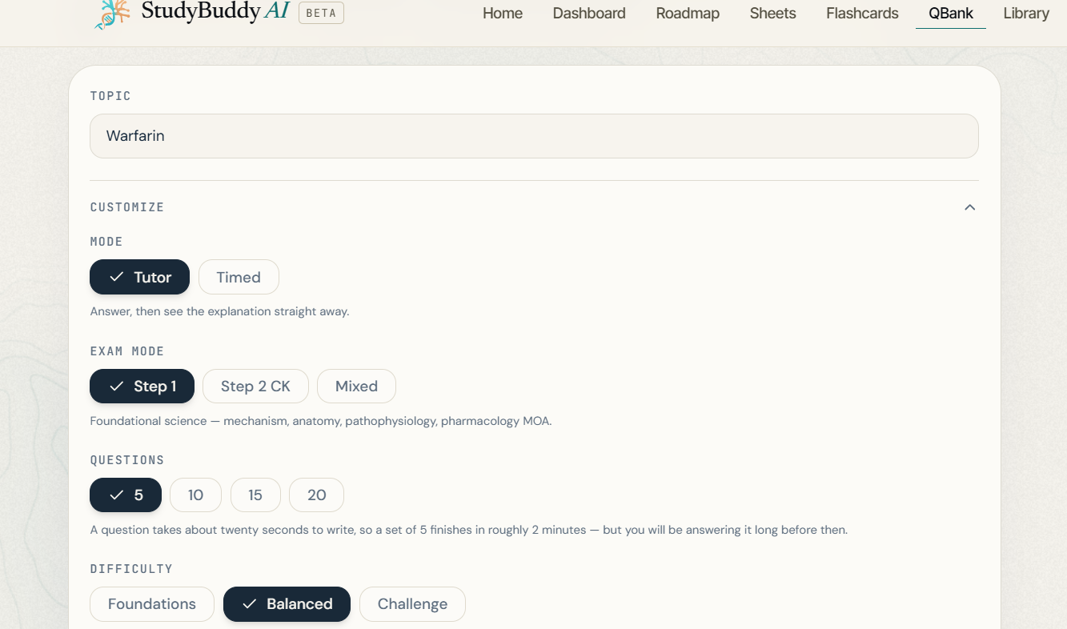

Remove the session history from here and make the page like this, for example, with the Generate button at the top

and the history can be accessed from the Dashboard

Also, for example, the whole question should be one block like this — much neater than having it split up

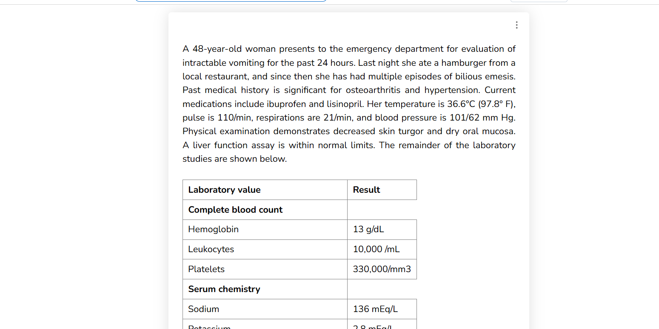
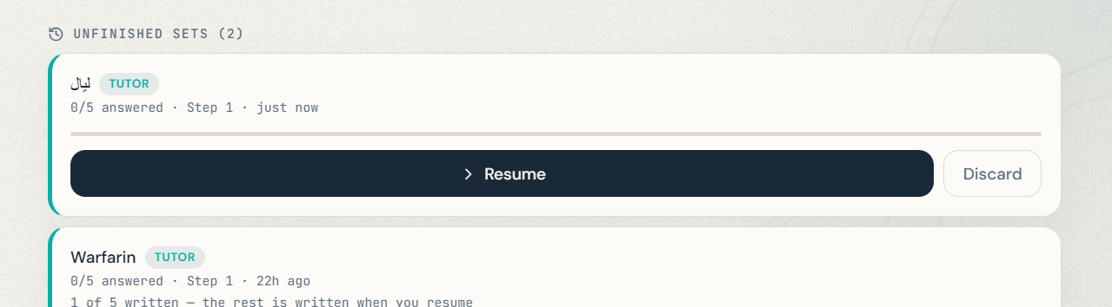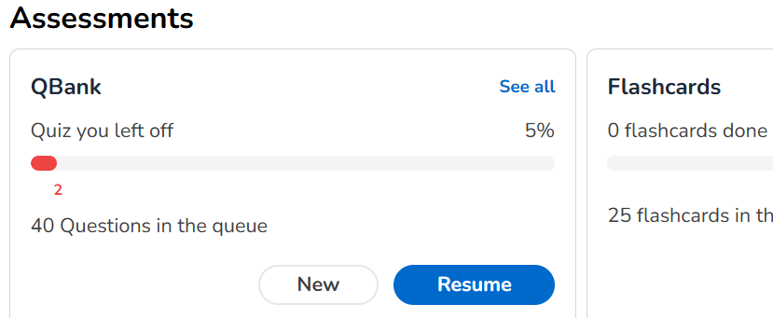For example, like this for the spacing

StudyBuddy AIBeta
HomeDashboardRoadmapSheetsFlashcardsQBankLibrary
Go Pro
Q1 of 4Tutor13:50
PrevNext
Flag
LabsCalc
Save & ExitEnd block
This set ended at 4 of 5 questions
4/5
The question generator on the server is out of date. Deploy the qbank-generate function and try again.

A technical message appears when generating QBank questions does not finish
During a 5-question session, only 4 questions appeared, with a message asking to update a function on the server.

In the QBank, if you type a random topic, it generates questions instead of saying the topic doesn’t exist.

FLASHCARDS

Not exactly like this, but the idea is that topics are shown with good space, not just on the side
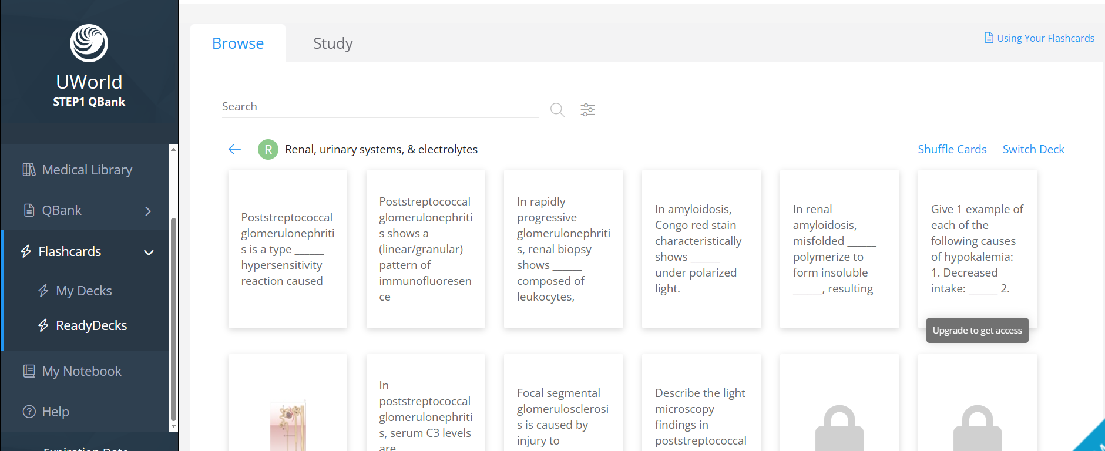

Remove
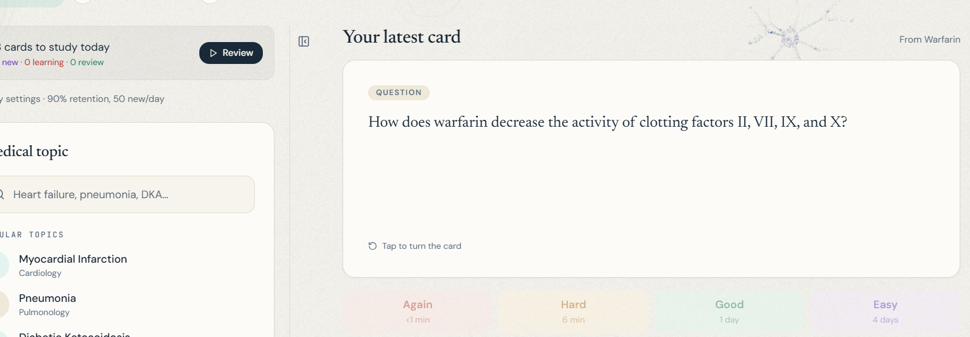

and remove the duration under the level, for example the number of days and so on

Again, showing the customization options first is very important

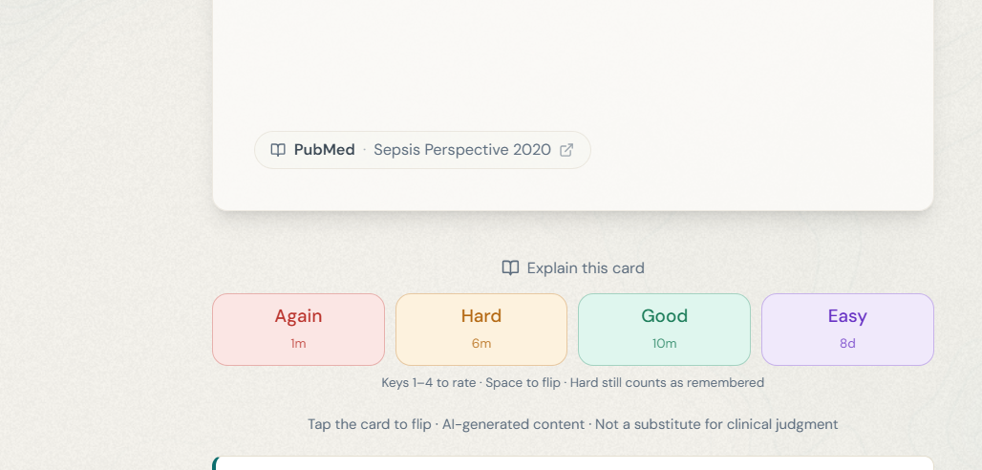The Explain button doesn’t look like it does anything; it should stand out more and look different

They are from the Library
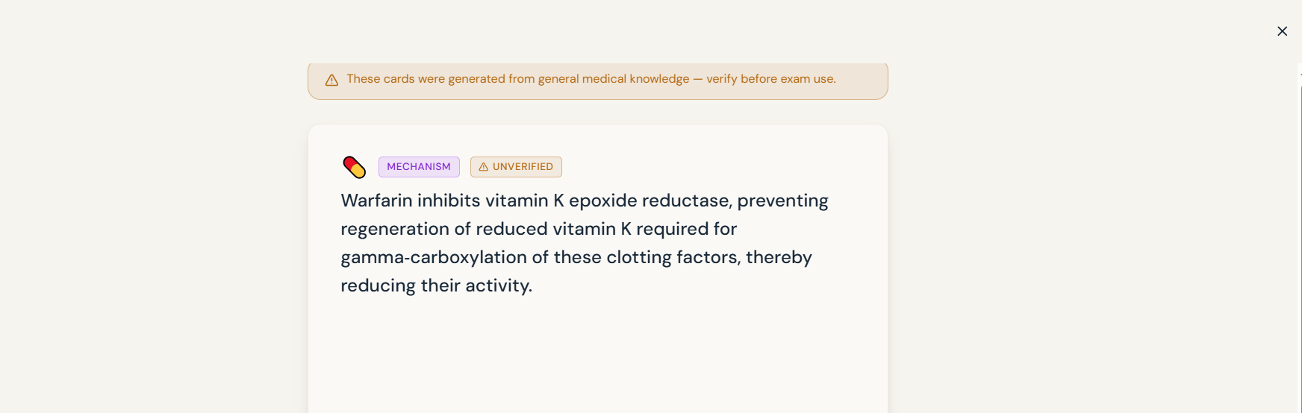The navbar disappears — make it clear how to cancel the session

A sheet opened from the Library should not be saved again

