**PROJECT-TEAM:4**

**MEMBERS:**

Navneet Gupta

Ragavan Rangaraj

Roshema Kasinathan

Umesh

**RENT AND DRIVE APPLICATION**

* Responsive SPA using Angular13.
* Application will support user and admin role. Use Angular either for admin or front end.
* Platform to hire cars from someone for specific time and drive.
* Admin will add cars brand and respective models. (Variants details can be added if required)
* User can see various cars options available to for rent.
* Car owner can add car detail under specific brand and model with the below mentioned information.
  + Make of cars.
  + Cost for a single day
  + Images.
  + Mileage.
  + Car Availability.
  + City and Area code/location.
* Security document and other information required.
* User can choose the car by applying filter make, brand and model.
* User can also apply filter on fuel and transmission type, millage etc.
* Once user shot list the car to rent, user can send enquiry for the car with schedule.
* Admin will add all offers and services details.

**Project Requirement**

1. Angular 13
2. JSON
3. Rest Web Services API

**MODULES :**

* + - 1. **HOME PAGE**
      2. **RENTER**
      3. **USER**
      4. **ADMIN**
      5. **FEEDBACK**
      6. **ADMIN LOGIN PAGE**
      7. **USER REGISTER AND LOGIN PAGE**
      8. **RENTER REGISTER**

**DESIGN:**

**ADMIN PAGE**

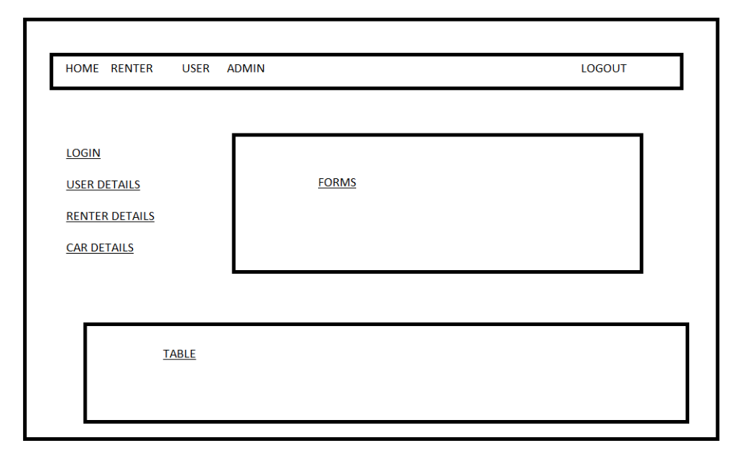

**HOME PAGE**

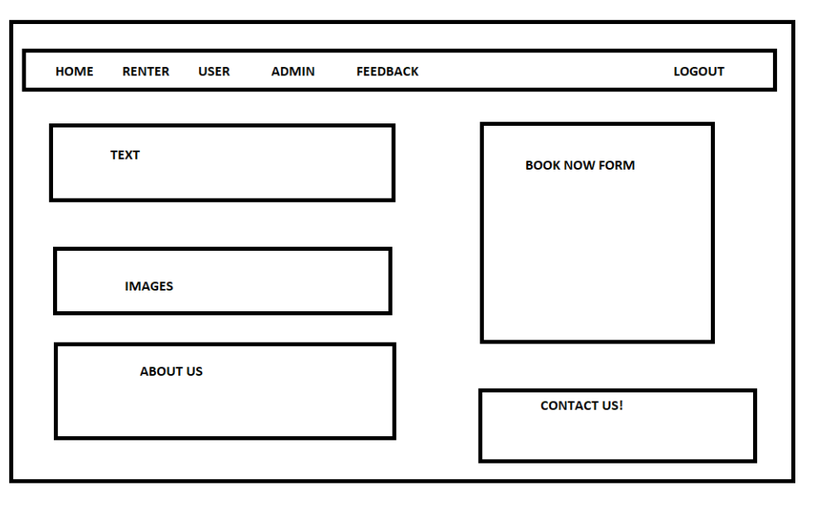

**USER MODULE**

1.USER PAGE

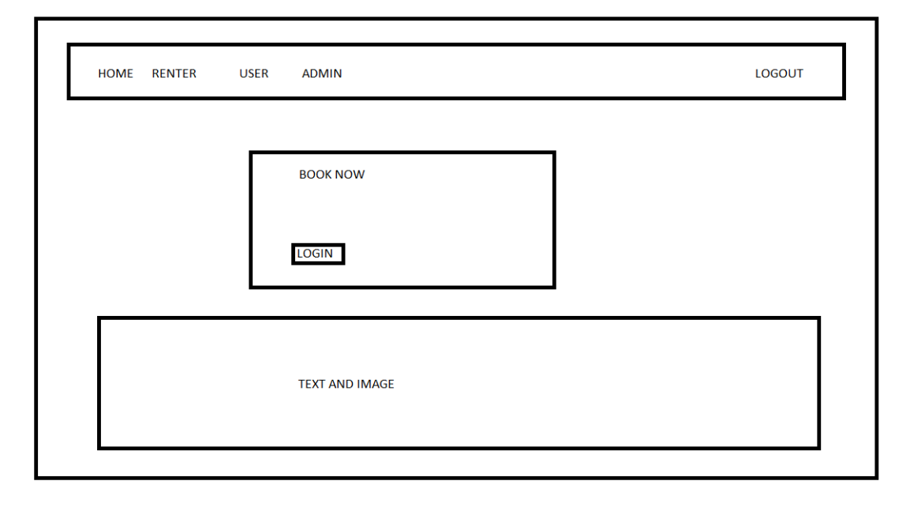

2. VEIW CAR DETAILS

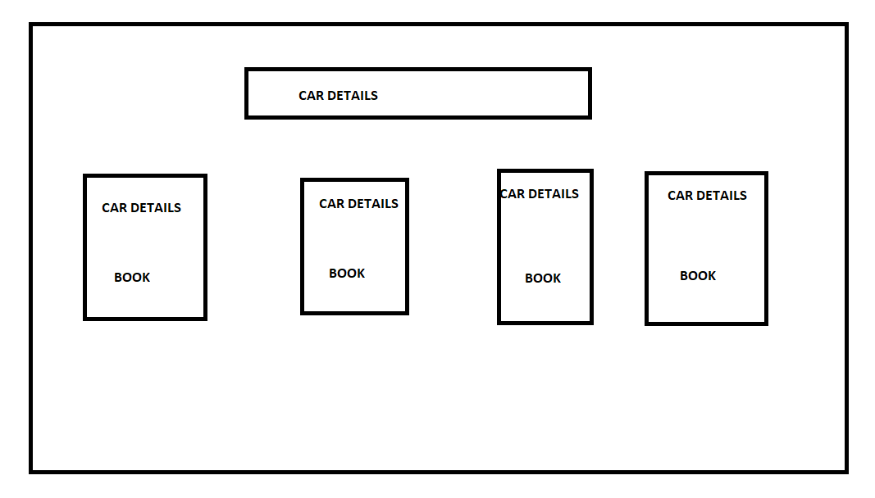

3. LOGIN PAGE

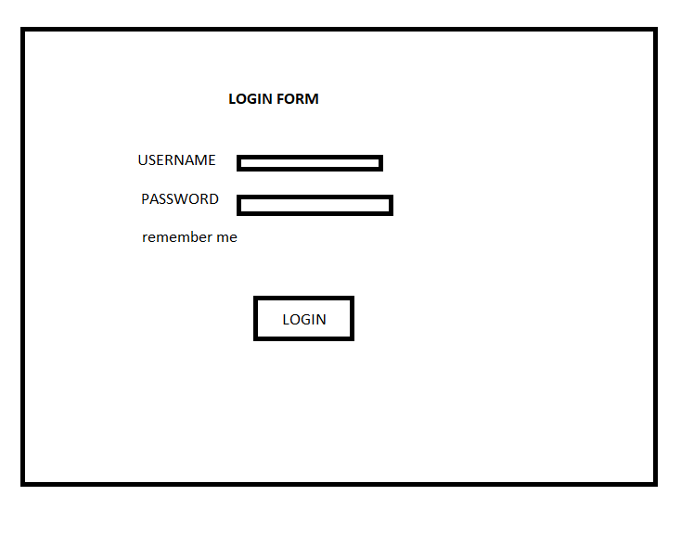

4.BOOKING PAGE

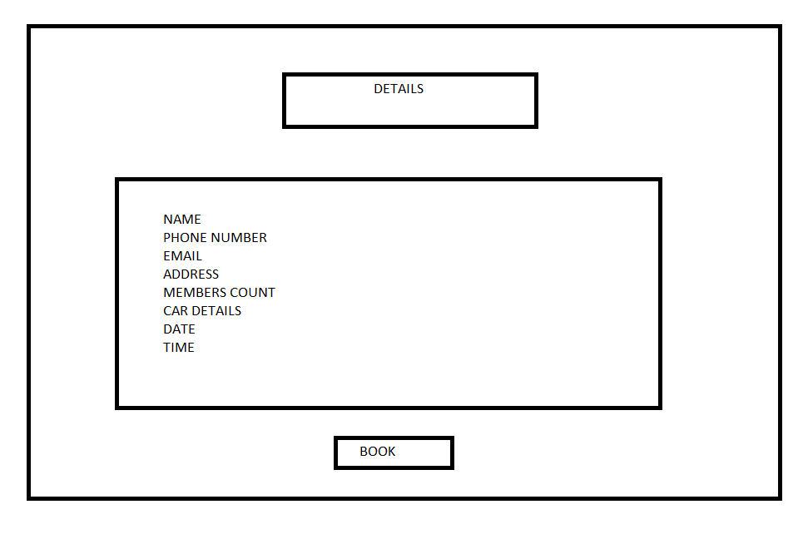

**FEEDBACK**

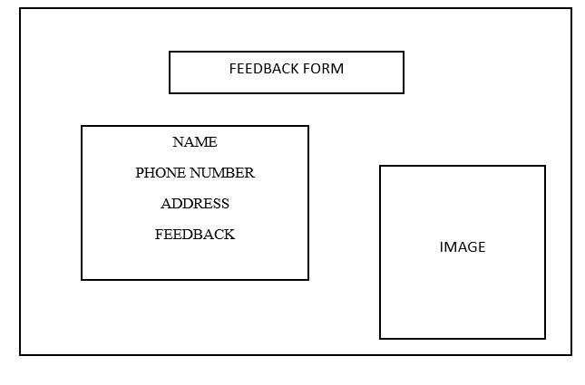

**RENTER MODULE:**

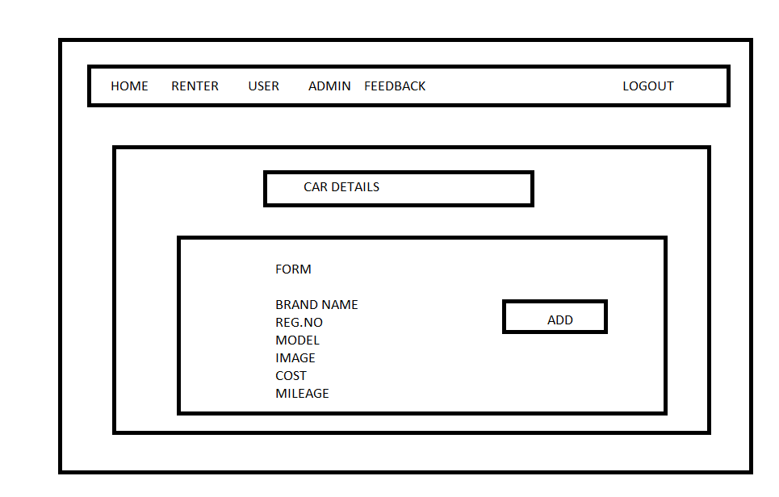

**USER REGISTRATION PAGE**

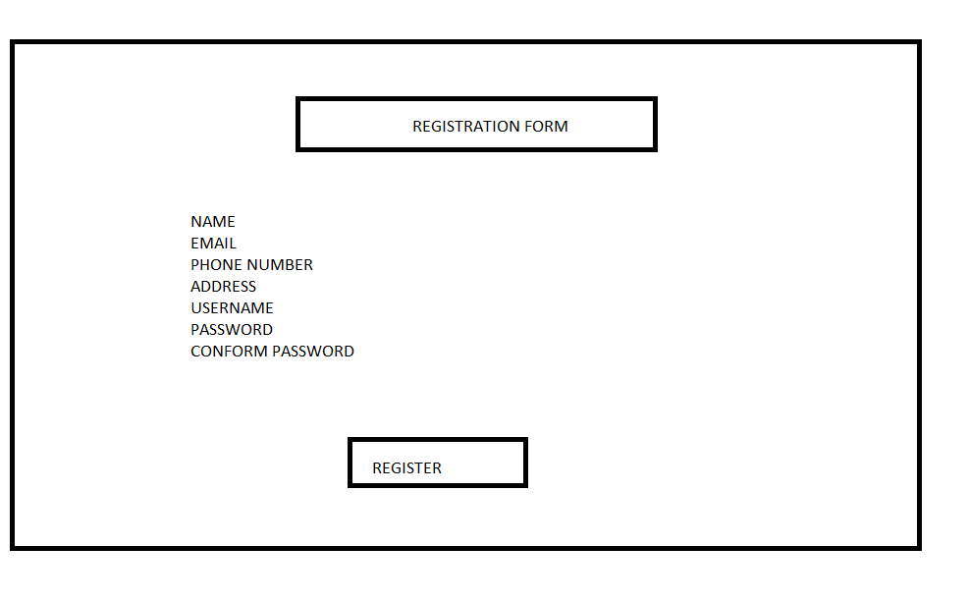

**RENTER REGISTRATION PAGE**

