RESEARCH TOPICS
ReACT(Reason + Act)
-Rethink, Research and act
-MultiStep planning with error recovery
ReDo Loop
Human In the Loop
Memory implementation for context awareness
Diagram:
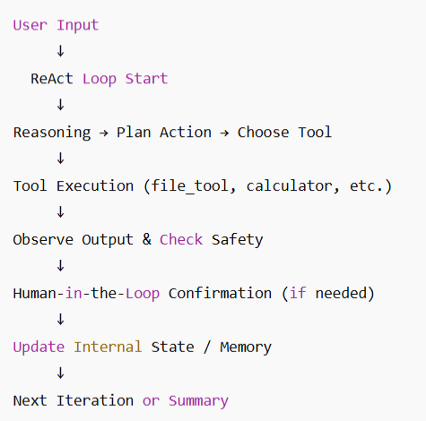

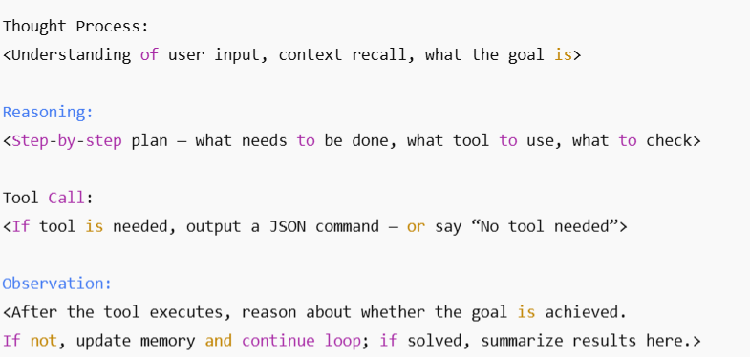

ReAct Loop understanding:
Ive observed that the loop depends on the function shouldContinue().
As we can see in https://langchain-ai.github.io/langgraph/how-tos/react-agent-from-scratch/#define-model-and-tools that this code is mentioned. Here we can see that the function depends on whether the agent had called a tool in the previous iteration or not.
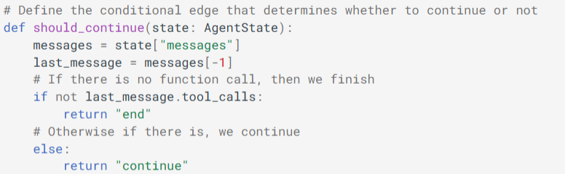
Diagram of ReAct Loop:
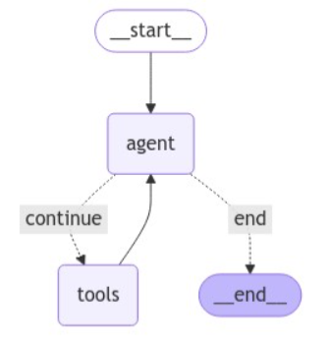

What “Each LLM call is stateless” means
When we say:
“Each LLM call is stateless”
We mean that the LLM does not automatically remember anything from previous calls. It treats each request independently, based entirely on the input it receives.
- The model does not store memory internally between requests.
- It only “knows” what you provide in the current API call: the system prompt, conversation messages, or any text you include.
- Once the call returns, the model forgets everything unless you pass it back in the next call.

Why it cannot be stateful by itself
LLMs like GPT, Llama, etc., are neural networks that generate output token by token. They do not have a database or internal persistent storage.
- They cannot retain knowledge of previous calls because each call is independent and stateless.
- If it could retain state, you would essentially be turning the model into a mini-database, which is not how inference works — the weights are fixed and only define general knowledge and reasoning patterns, not temporary memory.
In other words, the model’s “state” is just the parameters in its neural network — it’s fixed knowledge, not per-user memory.

Every time you send a request to an LLM:
- You include:
  - System prompt (persona, tools, instructions)
  - Conversation history / memory
  - Current user message
- The model reads all tokens sequentially to understand context.
- If you have N tokens in total, the time and cost of generating a response grows roughly linearly with N.
- You can think of it as O(n) time complexity, where n = total tokens (system prompt + history + user input).
- Very long histories mean:
  - Slower response generation
  - Higher token usage → higher cost
  - Risk of hitting the model’s context length limit
Memory:
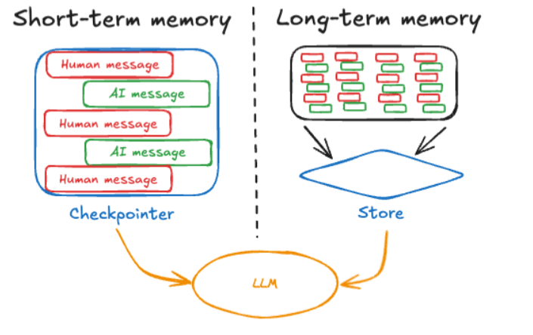
(diagram taken from links at the end)
Short term memory is session based while long term memory is across sessions.
In Brief:
Short-term memory: (Thread-scoped memory) For tracking conversation history of the current session for context awareness. Thread is a serial timeline of “checkpoints” of the conversation history. Each checkpoint is assigned a thread ID. A checkpoint is the state of the agent at a specific point in time.

simplified JSON representation of a thread (think of it as the full memory of a session):
{
"thread_id": "12345",
"name": "code-fix-session",
"created_at": "2025-10-10T14:00:00Z",
"archived": false,
"checkpoints": [
{
"run_id": "run-1",
"timestamp": "2025-10-10T14:05:00Z",
"user_prompt": "Create a TypeScript file hello.ts that prints 'Hello World'",
"ai_thoughts": [
"Plan: Create a new file",
"Plan: Write console.log('Hello World')"
],
"tool_calls": [
{
"tool": "create_file",
"args": { "filename": "hello.ts" },
"result": "File hello.ts created"
}
],
"ai_response": "I’ve created hello.ts with console.log('Hello World')"
},
{
"run_id": "run-2",
"timestamp": "2025-10-10T14:10:00Z",
"user_prompt": "Explain what hello.ts does",
"ai_thoughts": [
"Check contents of hello.ts",
"Explain the purpose of console.log"
],
"tool_calls": [
{
"tool": "read_file",
"args": { "filename": "hello.ts" },
"result": "console.log('Hello World')"
}
],
"ai_response": "The file hello.ts prints 'Hello World' to the console using console.log"
},
{
"run_id": "run-3",
"timestamp": "2025-10-10T14:20:00Z",
"user_prompt": "Add a goodbye message after Hello World",
"ai_thoughts": [
"Append console.log('Goodbye World') to hello.ts",
"Verify syntax"
],
"tool_calls": [
{
"tool": "append_file",
"args": { "filename": "hello.ts", "content": "console.log('Goodbye World');" },
"result": "Appended goodbye message"
}
],
"ai_response": "I’ve added console.log('Goodbye World') to hello.ts"
}
]
}
This thread is sent to the LLM every time so as the conversation gets lengthier, not only will it consume more and more tokens but it will also cause delay in response time since theres a lot of token to process on top the already large system prompt.
Super-step:
A whole task completion, user prompt + react loop + agents final answer
Ephemeral State is updated during the super state
Persistent State is updated at the end of each super step
ChatGPT token count
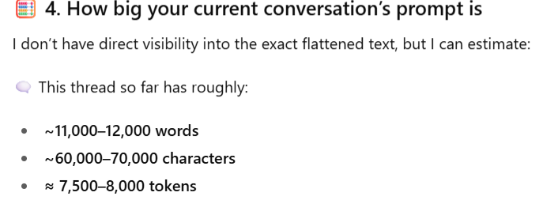
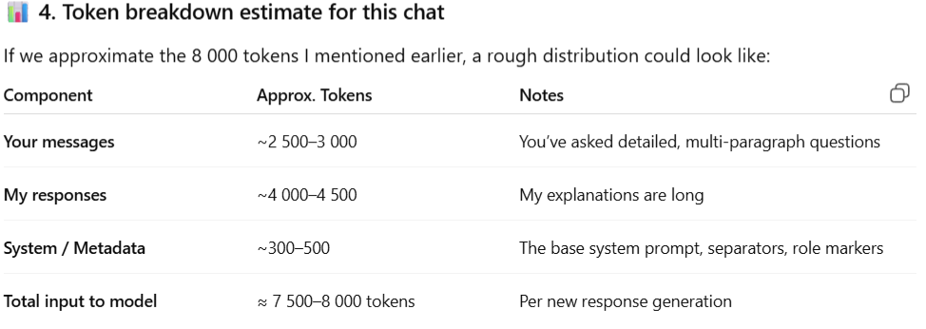
If a LLM with a straightforward prompt and simple history is using 8k tokens per request for a 10 messages long thread then it will definitely be a lot larger for a cli agent with a more complex, structured and verbose memory thread, larger prompts with necessary information required to make the responses smarter and implement proper contextual awareness of the repository.

BrainStorm draft section
Possible Strategies to reduce token usage while keeping context:

a) Summarization / condensation
- Periodically summarize older checkpoints into a short summary.
- Keep recent checkpoints in full detail.
- Example:
Summary:
User created hello.ts, AI explained it, added goodbye message. File prints Hello World + Goodbye World.
- Only the summary + last few runs are sent to the LLM.

b) Sliding window
- Only send the last N interactions in full detail.
- Older interactions are kept in storage but not sent every time.

c) Memory embedding / retrieval
- Store long-term memory in vector DB.
- Only retrieve relevant past interactions based on semantic similarity.
- This reduces the amount of text you actually send to the LLM.

d) Tool integration
- If previous tool outputs are stored externally (e.g., file content, test results), you can let the agent call a tool to retrieve that data rather than sending it all as text.
I think maybe utilizing the sliding window pattern and creating a tool to retrieve the full thread in case user references to something in the conversation outside the window.

File Summary System — Design Overview

Purpose
The FileSummary class provides a way for the AI agent to understand and track the purpose and state of files in a project directory.
It helps the agent avoid repeatedly reading large files and enables quick contextual awareness across multiple interactions or tool calls.

Proposed Class Structure
class FileSummary {
const FILE_SUMMARY_BASE_PROMPT = “…….if any files have “outdated” as summary, it means you need to run readFile() then later run updateSummary(arrayof string filenames)
eg: updateSummary([{“index.js” : “summary”}, {….}] then finally fetch summary of them to get the up to date summary”

// Get summary for all files in the directory
getDirectorySummary() {
// Implementation idea:
// - Scan all files in the current directory.
// - Fetch cached summaries if available.
// - Return a structured summary report.
}

updateSummary(takes array of string){
for(filename of fileNames){
//
}

// Get summary for multiple specific files
getMultipleFilesSummary(...fileNames: string[]) {
let summary: string[] = [];
let notFoundFiles: string[] = [];

for (const fileName of fileNames) {
// 1. Check if the file exists in the current directory.
// 2. If not found, add to `notFoundFiles` and skip.
// 3. Otherwise, fetch summary for that file.
const fileSummary = this.getFileSummary(fileName);
summary.push(fileSummary);
}

const response = {
summary,
not_Found: notFoundFiles,
};
return response;
}

// Get summary for a single file
getFileSummary(fileName: string) {
// Implementation idea:
// - compa re file modification time to detect outdated summaries, if outdated.
If outdated……return `${fileName}: outdated `
// - Check if a summary already exists in the cache or database.
// - If not found, return "file not found".
Return `${fileName}: ${fileSummary}`;
}
}

Problem Considerations
- Outdated Summaries:
Cached summaries can become stale if the actual file changes on disk after being summarized.
- File Name Changes:
If a file is renamed, the cached summary should either be remapped or deleted.
- Scalability:
For large directories, you can store summaries in a lightweight database (e.g., SQLite, JSON file, or Redis).

Detecting Outdated Summaries
To handle outdated summaries, you can use the file’s modification timestamp (mtime) from Node.js.
import fs from "fs";

const actualModified = fs.statSync(fileName).mtime.toISOString();

Explanation
- fs.statSync(fileName)
  - From Node’s fs module.
  - Returns a Stats object containing info about the file (size, timestamps, etc.).
Example:
Stats {
size: 1250,
mtime: 2025-10-13T14:00:00.000Z,
birthtime: 2025-10-13T13:45:00.000Z
}
- .mtime
  - Represents the last modified time of the file.
- .toISOString()
  - Converts the timestamp into a standardized ISO string format, like:
  - "2025-10-13T14:00:00.000Z"
  - Easier to store and compare.

How It’s Used
You can compare the file’s real modification time with your cached record:
if (actualModified > cachedSummary.lastUpdated) {
console.log("⚠️ Summary outdated — needs to be refreshed.");
}
This lets your agent know when to regenerate file summaries automatically.

Example Test Code
Try running this simple snippet in Node.js:
import fs from "fs";

const stats = fs.statSync("./yourFile.ts");
console.log("Last modified:", stats.mtime.toISOString());
Output:
Last modified: 2025-10-13T14:00:00.000Z
This timestamp is exactly what your caching mechanism uses to detect outdated summaries.

Study Report: Token Usage Constraints in CLI Agent with ReAct Loops
Objective:
To analyze the token usage in a CLI agent running ReAct loops, especially when sending a system prompt, user prompts, AI thought processes, and tool call results, and to devise a strategy to mitigate token consumption.

Observations and Constraints:
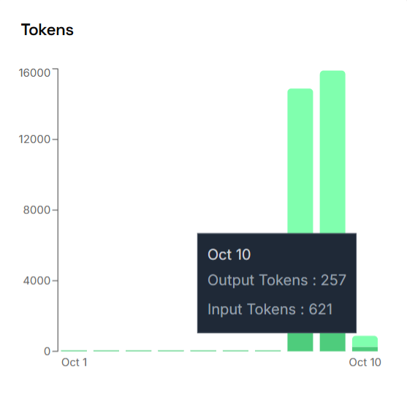
- System Prompt:
  - Original system prompt size: ~600 tokens
  - Sent on every single API call to the LLM to ensure proper behavior and tool usage.
- Thread / Conversation Window:
  - Including full conversation history or multiple checkpoints could quickly accumulate tokens.
  - For example, sending 10 checkpoints, each with user prompt, AI thought process, tool calls, and partial code output, could reach 4,000–6,000 tokens easily.
- Token Limits:
  - Using llama-3.3-70b-versatile with a 12K tokens per request limit, a naive approach of sending full history and system prompt is inefficient and risks hitting the limit during multi-step tasks.

Estimation Method:
- Average tokens per checkpoint:
  - User prompt: ~75 tokens
  - AI thought process: ~325 tokens
  - Tool calls / summaries: ~75 tokens
  - Total per checkpoint: ~475 tokens
- Sliding window approach (last 5 checkpoints):
  - 5 × 475 = 2,375 tokens
- Reduced system prompt:
  - Halved from 600 → 300 tokens
- Estimated total tokens per request:
  - 2,375 + 300 = ~2,675 tokens
  - Including small code references → ~2,775 tokens
✅ This brings the token usage down to a manageable ~3k tokens per request, well under the model limit.

Solution to Mitigate Token Usage:
- Minimized System Prompt:
  - Keep only essential instructions for tool usage and safety rules.
  - Avoid sending verbose explanations every request.
- Sliding Window of Conversation History:
  - Send only the last N messages (checkpoints) needed for context instead of full thread.
  - Summarize older messages if needed for long-term context.
- Send Summaries Instead of Full Code:
  - Include only tool call results or code references, not full code snippets, to save tokens.
- Outcome:
  - Token usage reduced from potentially 6,000–12,000 tokens per request to ~3,000 tokens per request.
  - Enables multi-step ReAct operations, file creation, and explanations without hitting request limits.

Conclusion:
By combining a halved system prompt, a sliding window of recent checkpoints, and sending summarized tool outputs instead of full code, the CLI agent can efficiently operate within token limits, supporting multi-step ReAct loops and tool calls while keeping total tokens per request around 3k. This approach balances context preservation and token economy.

Research:
https://medium.com/%40larazounak/openai-api-response-time-increases-linearly-with-tokens-87b02f3da069
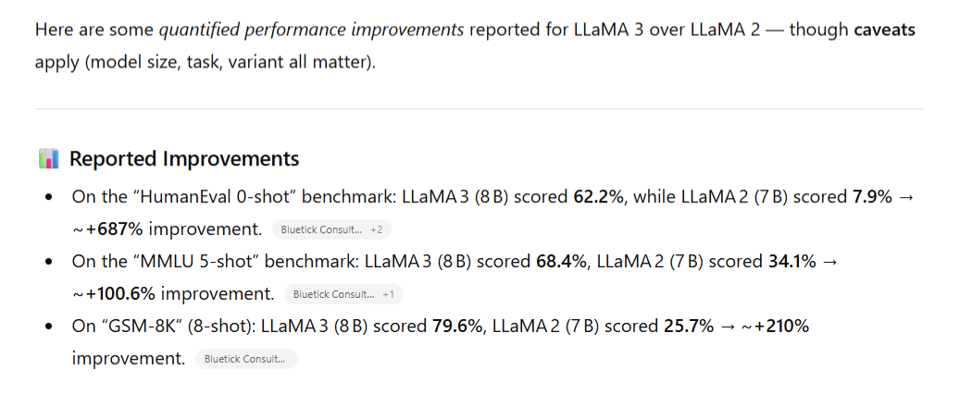

Concepts to Research / Explain
- ReAct vs. Chain-of-Thought (CoT): CoT is reasoning only; ReAct includes acting in the environment.
- Error Handling & Rollback: How to safely revert failed operations in CLI agents.
- Structured Output Enforcement: JSON formatting, escaping special characters, and strict system prompts.
- Agent Evaluation Metrics: Tool usage success rate, error correction rate, multi-step execution efficiency
Early problems:
- Not so Strict prompt issues:
when i say "Can you do this" it responds yes with steps that it can take to accomplish that but it doesnt execute untill i tell it to do so
-JSON output issue:
Tools will only execute if LLM returns a JSON and sometimes it doesn’t for some reason
-JSON special character parsing issue:
Special characters like “ and { seems to break the JSON object as it acts as closing characters, breaking the JSON.
-Multi step issue:
Uncertain if the

Start->
ReAct loop start-> understand problem -> come up with solution -> test and ensure safety -> if problem, store prompt to send to ai (by ai) on next iteration -> loop
After completion, summarize everything in short-> end

Article on ReAct:
https://medium.com/@gauritr01/part-1-react-ai-agents-a-guide-to-smarter-ai-through-reasoning-and-action-d5841db39530
Docs on creating ReAct agent from scratch:
https://langchain-ai.github.io/langgraph/how-tos/react-agent-from-scratch/
Reading material on Tool Augmented AI:
https://www.linkedin.com/pulse/tool-augmented-reasoning-agentic-ai-how-learning-act-artemiou-61q2f/
Videos on explanation of Ai Agents:
https://www.youtube.com/shorts/BF2k_fKuCVM
Github reference material links:
https://github.com/woodx9/build-your-claude-code-from-scratch
O(n) time complexity for response time of LLM where n represents number of tokens
https://medium.com/%40larazounak/openai-api-response-time-increases-linearly-with-tokens-87b02f3da069
Article on Memory:
https://langchain-ai.github.io/langgraph/concepts/memory/

