RESEARCH TOPICS

ReACT (Reason + Act)
- Rethink, Research and act
- MultiStep planning with error recovery
ReDo Loop
Human In the Loop
Memory implementation for context awareness
Diagram:
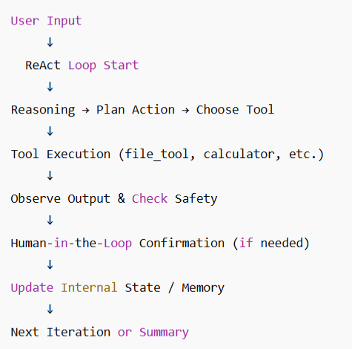
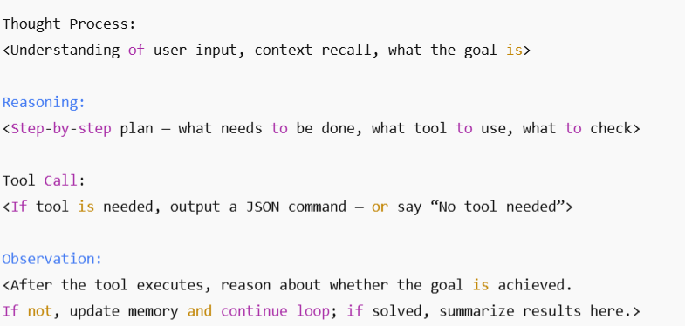

ReAct Loop Understanding
I've observed that the loop depends on the function shouldContinue(). As seen in the LangGraph documentation (https://langchain-ai.github.io/langgraph/how-tos/react-agent-from-scratch/#define-model-and-tools), the function depends on whether the agent had called a tool in the previous iteration or not.

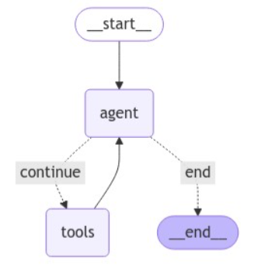

Each LLM call is stateless
When we say 'Each LLM call is stateless', we mean that the LLM does not automatically remember anything from previous calls. It treats each request independently, based entirely on the input it receives.
• The model does not store memory internally between requests.
• It only “knows” what you provide in the current API call: the system prompt, conversation messages, or any text you include.
• Once the call returns, the model forgets everything unless you pass it back in the next call.
________________________________________________________________________________

Why it cannot be stateful by itself
LLMs like GPT, Llama, etc., are neural networks that generate output token by token. They do not have a database or internal persistent storage.
• They cannot retain knowledge of previous calls because each call is independent and stateless.
• If it could retain state, you would essentially be turning the model into a mini-database, which is not how inference works — the weights are fixed and only define general knowledge and reasoning patterns, not temporary memory.
In other words, the model’s “state” is just the parameters in its neural network — it’s fixed knowledge, not per-user memory.
________________________________________________________________________________
Every time you send a request to an LLM:
1. You include:
o System prompt (persona, tools, instructions)
o Conversation history / memory
o Current user message
2. The model reads all tokens sequentially to understand context.
• If you have N tokens in total, the time and cost of generating a response grows roughly linearly with N.
• You can think of it as O(n) time complexity, where n = total tokens (system prompt + history + user input).
• Very long histories mean:
o Slower response generation
o Higher token usage → higher cost
o Risk of hitting the model’s context length limit

Memory
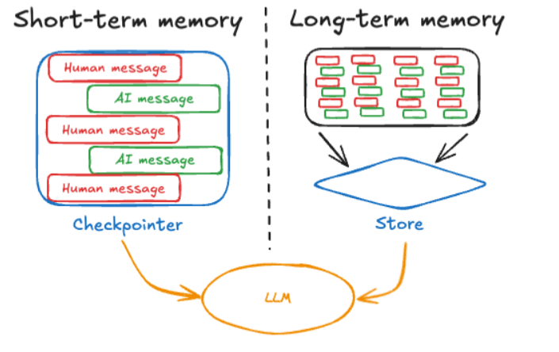
Short term memory is session based while long term memory is across sessions.

In Brief:
Short-term memory: (Thread-scoped memory) For tracking conversation history of the current session for context awareness. Thread is a serial timeline of “checkpoints” of the conversation history. Each checkpoint is assigned a thread ID. A checkpoint is the state of the agent at a specific point in time.
Simplified JSON representation of a thread (think of it as the full memory of a session):
{
"thread_id": "12345",
"name": "code-fix-session",
"created_at": "2025-10-10T14:00:00Z",
"archived": false,
"checkpoints": [
{
"run_id": "run-1",
"timestamp": "2025-10-10T14:05:00Z",
"user_prompt": "Create a TypeScript file hello.ts that prints 'Hello World'",
"ai_thoughts": [
"Plan: Create a new file",
"Plan: Write console.log('Hello World')"
],
"tool_calls": [
{
"tool": "create_file",
"args": { "filename": "hello.ts" },
"result": "File hello.ts created"
}
],
"ai_response": "I’ve created hello.ts with console.log('Hello World')"
},
{
"run_id": "run-2",
"timestamp": "2025-10-10T14:10:00Z",
"user_prompt": "Explain what hello.ts does",
"ai_thoughts": [
"Check contents of hello.ts",
"Explain the purpose of console.log"
],
"tool_calls": [
{
"tool": "read_file",
"args": { "filename": "hello.ts" },
"result": "console.log('Hello World')"
}
],
"ai_response": "The file hello.ts prints 'Hello World' to the console using console.log"
},
{
"run_id": "run-3",
"timestamp": "2025-10-10T14:20:00Z",
"user_prompt": "Add a goodbye message after Hello World",
"ai_thoughts": [
"Append console.log('Goodbye World') to hello.ts",
"Verify syntax"
],
"tool_calls": [
{
"tool": "append_file",
"args": { "filename": "hello.ts", "content": "console.log('Goodbye World');" },
"result": "Appended goodbye message"
}
],
"ai_response": "I’ve added console.log('Goodbye World') to hello.ts"
}
]
}
This thread is sent to the LLM every time so as the conversation gets lengthier, not only will it consume more and more tokens but it will also cause delay in response time since there’s a lot of tokens to process on top of the already large system prompt.

