# IAM – Final project -Installation and configuration of openLDAP

Step-1:

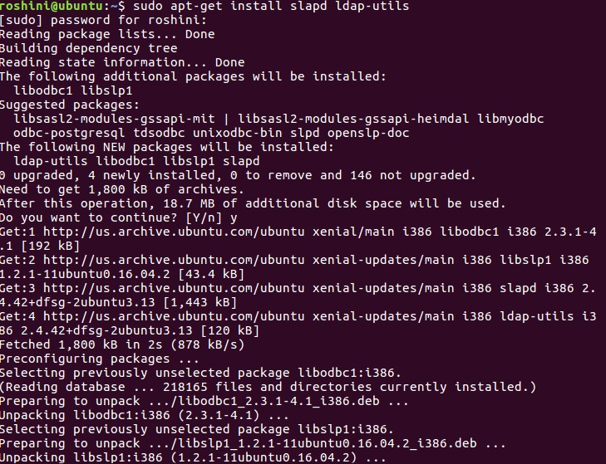

Step-2:

Step-3:

Step-4:

Step-5:

Step-6:

Change the dc to Vijayakumar and run on phpldapadmin to set up the LDAP client.

Step-7:

Step-8:

Step-9:

Step-10:

Here the LDAP and the PHP is installed and configured successfully . we login into the DN and after logging in three groups are been created -Finance, DEVops, HR and separate users are created for each group .

