**Submitted by:**

**Name: B. ROSHINI**

**E-mail:** [**roshini_bugginni@srmap.edu.in**](mailto:roshini_bugginni@srmap.edu.in)

**Phone Number: 9908464861**

**CASE STUDY PROBLEM:**

An Indian IT Service and product company has an employee base of 5000+ resources all over the globe. Around 73% of the resources are based out of India (Mumbai, Pune, Hyderabad and Ahmedabad). Total employee strength includes 690 contractors out of which 60% are in India, 5% in Australia and 7% in Asia Pacific centres. These contractors are on an average 1.4 times costlier than permanent employees.

Its customers are across 35 countries mainly in the US (32%), Middle-east (27%), and Europe (20%).

Its main business is providing IT solutions and Annual Maintenance Services. Though they provide IT solutions in all the domains, 46% of their revenue comes from the BFSI sector, 21% is from the Healthcare sector and the rest from other sectors like Retail, Public sector, Manufacturing, Travel, Entertainment etc.

Its product-based business is providing pre-made softwares and applications for companies. The three products they offer are DevOps bundle, cybersecurity and digital marketing. 90% of revenue comes from the digital marketing product.

It enjoys a good margin from BFSI (42%) and Retail (39%) sectors and also from business in the US (48%) and Europe (44%) region. The margin is very low in business in India (9%) and other Asia Pacific countries (14%).

It is finding it difficult to be at par with its competitors on a year-on-year margin improvement rate which is 11% v/s 26% by other comparable IT companies in India. To address this, it is thinking of acquiring smaller organizations which specialise in niche technologies and having a larger customer base which will help them in increasing its employee base and expand the business with cross-sell opportunities.

Will the acquisition help in the improvement of margins? If yes, then why? If not, then what alternate strategy should the company follow?

**INSTRUCTION SET:**

1. Identify the root problem and use the MECE (mutually exclusive, comprehensively exhaustive) principle, discussed already in the module videos, to break down the problem.
2. Using the profitability tree down structure, divide it in two parts ‘Revenue’ and ‘Cost’.
3. Further branching can be done according to your logic but do keep in mind that those parameters shouldn’t overlap. Eg. Revenue and profit are overlapping parameters.
4. For revenue, 60% of it comes from IT solutions and maintenance, and rest comes from its products.
5. The company is looking forward to investing in India, US and Europe. See the potential growth for different sectors in these geographical locations.
6. In the US and Europe, the healthcare sector seems promising and the same for India with the BFSI sector. Explore other options and see what could be done differently.
7. Finally, provide recommendations for where the company should invest and what kind of acquisitions it should do.

**ROOT PROBLEM:**

The primary cause of the Indian IT service and product company's inability to attain a year-on-year margin improvement rate equal to other Indian IT firms, which is 11% compared to 26% by other comparable IT companies in India. This suggests that the firm is having difficulty improving its profitability and remaining competitive in the market.

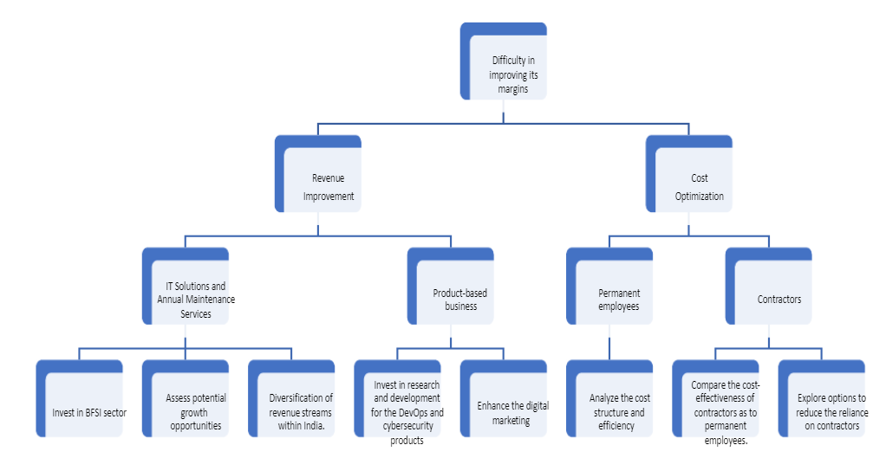

**MECE BREAKDOWN:**

To address this problem, let's break it down using the MECE principle:

1. **Revenue Improvement**
   * IT Solutions and Maintenance (60% of revenue)
     + BFSI Sector
     + Healthcare Sector
     + Other Sectors
   * Product-Based business (40% of revenue)
     + DevOps bundle
     + Cybersecurity & Digital Marketing (90% of product revenue)
2. **Cost Optimization**
   * Employee Cost (including contractors)
   * Other Operating Expenses

**Revenue Analysis:**

1. **IT Solutions and Maintenance:**

* **BFSI Sector:** Look at expanding IT solutions and maintenance services in the BFSI sector by using the company's experience and reputation in this industry. Revenue can be increased by targeting new BFSI clients and broadening the area of services.
* **Healthcare Sector:** Invest in healthcare-specific IT solutions and services in the United States and Europe. Increase income from this market by forming partnerships and alliances with healthcare organizations.
* **Other Sectors:** Identify prospective development opportunities in other industries and offer customized IT solutions to meet their unique demands, expanding the client base and diversifying revenue.

1. **Product-Based Business:**

* **Digital Marketing Product:** Continue to invest in the development and marketing of the digital marketing product, with a worldwide focus on attracting new clients. To maximize income from this product, look at options for upselling and cross-selling to current clients.
* **DevOps Bundle and Cybersecurity:** Allocate resources to improve the DevOps bundle and cybersecurity solutions' features and capabilities. Conduct market research to determine client needs and adapt goods to meet those demands to improve adoption and revenue.

**Cost Optimization Analysis:**

1. **Permanent Employee Cost:**
   * **Operational Efficiency:** Take steps to improve operational efficiency, which can result in cost savings. Reduce waste and duplication by streamlining procedures and workflows.
   * **Cost-effective Alternatives:** Outsource certain non-core operations to locations with cheaper labour costs to reduce expenses while maintaining service quality.
2. **Contractor Management:** Determine the necessity for contractors and optimize their use. Determine areas where permanent workers may do duties that were previously assigned to contractors, lowering total expenses.

**Potential Growth for Different Sectors:**

1. **India:**

* **BFSI Sector:** By supplying specialized IT solutions and services suited to the particular demands of financial institutions, the firm may further improve its position in the BFSI industry. To meet the sector's changing expectations, this might include sophisticated analytics, digital transformation, and cybersecurity solutions.
* **Healthcare Sector:** While the BFSI sector is robust, the organization may also capitalize on India's burgeoning healthcare industry. The country's healthcare industry is rapidly digitizing and adopting technology, offering the potential for IT service providers to offer solutions in electronic health records, telemedicine, healthcare analytics, and patient interaction platforms.
* **E-commerce and Retail:** In recent years, India's e-commerce and retail sectors have grown significantly. The organization may provide IT solutions to assist e-commerce platforms, supply chain management, inventory optimization, and improving the consumer experience. Government and Public Sector: With the Indian government's emphasis on digital projects, the firm has the potential to supply IT solutions for e-governance, smart cities, and public service delivery.

1. **US and Europe:**

The US and Europe are lucrative markets for IT services, and the company can focus on specific sectors to drive growth in these regions.

* **Healthcare Sector:** The healthcare industry in the United States and Europe is technologically advanced, with a constant demand for IT solutions to improve patient care, data security, and operational efficiency. Electronic health records, telemedicine solutions, health information exchanges, and healthcare analytics are all possible targets for the organization.
* **Banking and Financial Services:** Like India, the BFSI industry in the United States and Europe has enormous development potential. Advanced banking software solutions, payment processing systems, fraud protection tools, and regulatory compliance solutions are all available from the organization.
* **Manufacturing and Industry 4.0:** As part of the continuing Industry 4.0 transformation, manufacturers in the United States and Europe are looking for IT solutions for process automation, IoT integration, predictive maintenance, and supply chain optimization.
* **Cybersecurity Services:** As cyber risks become more prevalent, there is a growing demand for cybersecurity services in both areas. The organization may broaden its cybersecurity products to meet the specific demands of enterprises across industries.

**Will the acquisition help in the improvement of margins? If yes, then why? If not, then what alternate strategy should the company follow?**

Let's examine the possible impact on income and expenses to see if the purchase of smaller organizations can assist increase margins. We'll also look at the company's present difficulties and how well this plan is working to overcome them.

1. **Revenue Analysis:**

Acquiring smaller organizations that specialize in specialist technology and have a bigger client base might result in various revenue-related benefits:

* **Increased Customer Base:** Acquiring companies with a larger customer base can expand the IT service and product company's reach, enabling cross-selling opportunities for its existing products and services. This can result in increased revenue from both the IT solutions and maintenance business and the product-based business.
* **Access to New Markets:** If the acquired companies operate in different geographic regions or industries, it can open doors to untapped markets, allowing the IT company to diversify its revenue streams and reduce reliance on specific sectors and regions.
* **Access to New Markets:** If the acquired companies operate in different geographic regions or industries, it can open doors to untapped markets, allowing the IT company to diversify its revenue streams and reduce reliance on specific sectors and regions.

1. **Cost Analysis:**

While the acquisition may offer revenue benefits, it's essential to consider its impact on costs:

* **Integration Costs:** Acquiring and integrating smaller organizations can involve significant costs, including due diligence expenses, legal fees, and integration efforts. These costs can initially impact the company's financials.
* **Operational Efficiency:** The success of the acquisition depends on how effectively the company integrates the new resources and optimizes their productivity. Inefficiencies during integration can lead to increased operational costs.

**Addressing Margin Improvement:**

The company's main challenge is achieving a year-on-year margin improvement rate comparable to other IT companies in India (11% vs. 26%). While acquisitions can contribute to revenue growth, they may not directly address the root cause of the margin challenge. To address the margin improvement issue effectively, the company should consider the following alternate strategies:

1. **Cost Optimization and Efficiency Improvement:** Instead of solely focusing on acquisitions, the company should assess its current cost structure and identify areas for optimization. This may involve streamlining operations, reducing redundant expenses, and enhancing employee productivity.
2. **Investment in Research and Development:** Investing in research and development can lead to the creation of innovative products and solutions. New, unique offerings can potentially command higher margins and strengthen the company's competitive advantage.
3. **Strategic Pricing and Contract Management:** Reviewing pricing strategies and contract management practices can help the company negotiate more profitable deals and avoid revenue leakage.
4. **Client Retention and Satisfaction:** Improving customer retention and satisfaction can lead to repeat business and positive word-of-mouth referrals, reducing customer acquisition costs and contributing to sustained revenue growth.
5. **Focus on High-Margin Markets and Products:** The company should prioritize its efforts on high-margin markets, such as the US and Europe, and focus on its high-margin products, like digital marketing. This targeted approach can yield better financial results.
6. **Enhanced Sales and Marketing Efforts**: A stronger sales and marketing strategy can help the company attract higher-value clients and effectively communicate the value of its products and services, leading to improved revenue and margins.

**Potential Strategies and Recommendations**:

Based on the analysis, I recommend the following potential strategies:

1. **Investment in Promising Sectors:** The company should invest in the promising sectors in each geographic region to maximize revenue and margin potential. This includes

* India: Further investment in the BFSI sector, considering its potential growth.
* US and Europe: Capitalizing on the growth potential of the Healthcare sector.

2. **Product Focus and Cross-Selling:** Since digital marketing products bring in 90% of revenue, the company should continue to focus on this area and explore opportunities for cross-selling the other two products (DevOps bundle and cybersecurity) to existing customers.

3. **Acquisitions in Niche Technologies:** To address the margin improvement challenge, the company should consider acquiring smaller organizations that specialize in niche technologies. These acquisitions can provide access to a larger customer base and offer cross-selling opportunities, leading to potential revenue growth and improved margins.

4. **Geographic Expansion:** The company should strategically expand its presence in the US and Europe to tap into the higher-margin markets and leverage the potential growth in the Healthcare sector.

5. **Efficient Cost Management:** Since contractors are 1.4 times costlier than permanent employees, the company should focus on optimizing its workforce mix and try to minimize the dependency on contractors where possible.

**Conclusion:**

Overall, Acquiring smaller organizations with specialized technologies and broader customer bases, along with a strategic focus on promising sectors and geographic expansion, can significantly enhance an Indian IT company's margins and competitiveness. To achieve sustainable margin growth, the company should prioritize cost optimization, invest in research and development, refine pricing strategies, enhance customer satisfaction, and target high-margin markets and products. A comprehensive approach that incorporates these strategies will bolster financial performance and strengthen competitiveness. Additionally, effective cost management and customer-centric initiatives are crucial for sustainable growth and profitability.