TASK 3: SECURE CODING REVIEW

Project Title
Secure Coding Review Using Bandit Static Analysis Tool

Objective
Perform a secure coding review on a Python application, identify vulnerabilities using Bandit, and apply remediation measures.

Tools Used
Python 3.14.6, Bandit 1.9.4, Notepad/VS Code, Command Prompt

Programming Language
Python

Vulnerable Code
import os
user_input = input("Enter command: ")
os.system(user_input)

Bandit Scan Result (Vulnerable Code)
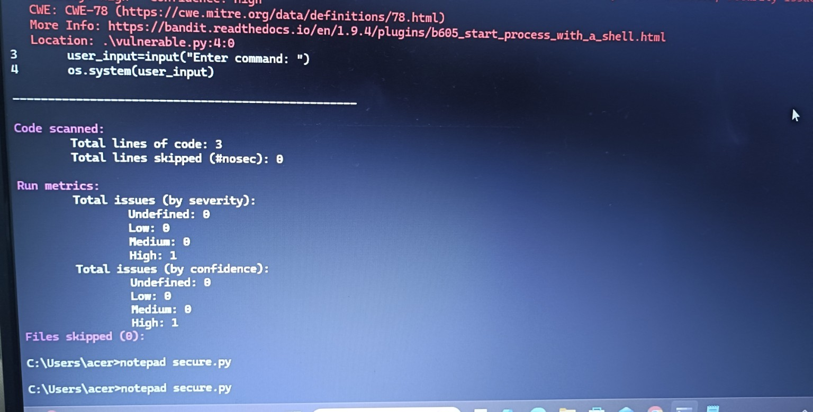

Vulnerability Identified
Command Injection Vulnerability (B605)
Severity: High
Confidence: High
CWE-78

Remediation Steps
Removed os.system(), validated input, used subprocess.run(shell=False), and allowed only safe commands.

Secure Code
import subprocess
allowed_commands = ["dir"]
user_input = input("Enter command: ")
if user_input in allowed_commands:
subprocess.run([user_input], shell=False)
else:
print("Command not allowed")

Bandit Scan Result (Secure Code)
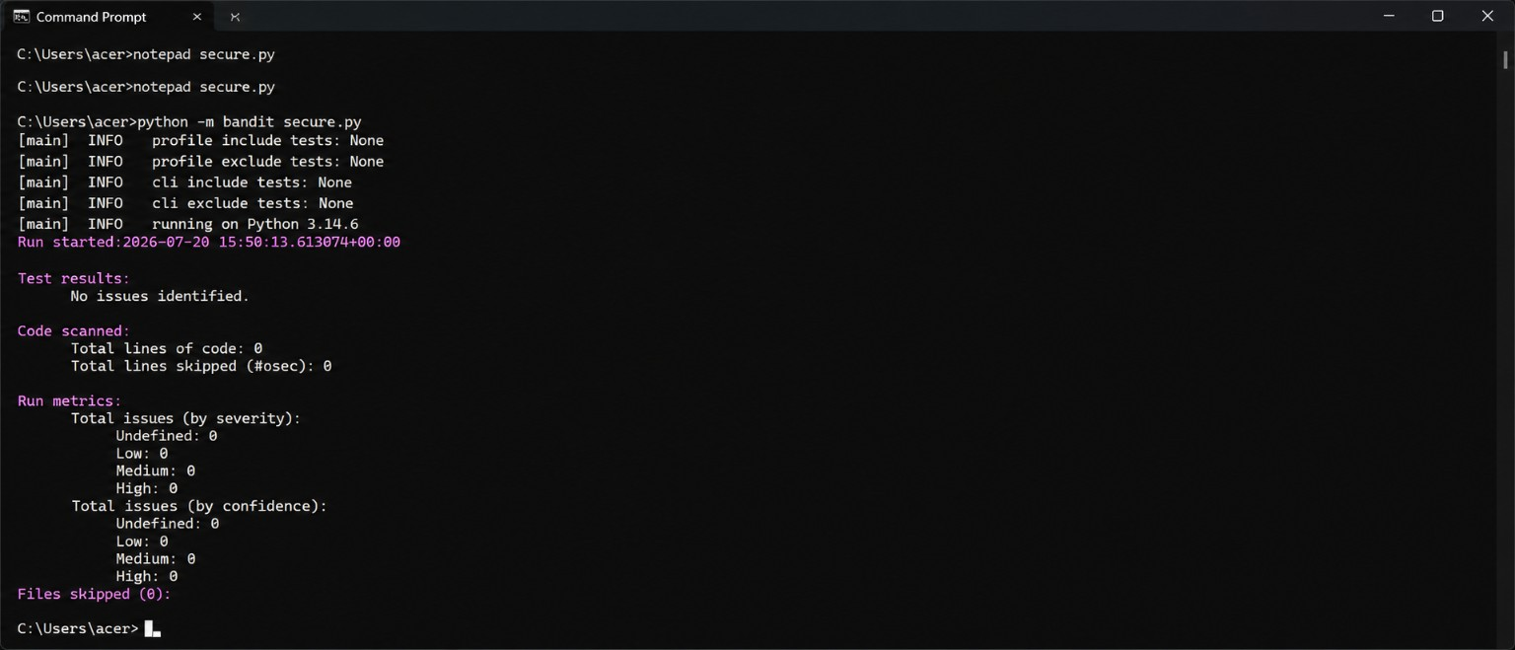

Conclusion
The vulnerability was successfully identified and fixed. After remediation, Bandit reported 'No issues identified'.

