AWS CLI Installation, Kubectl and eksctl installation done.
AWS configuration – completed and verified.
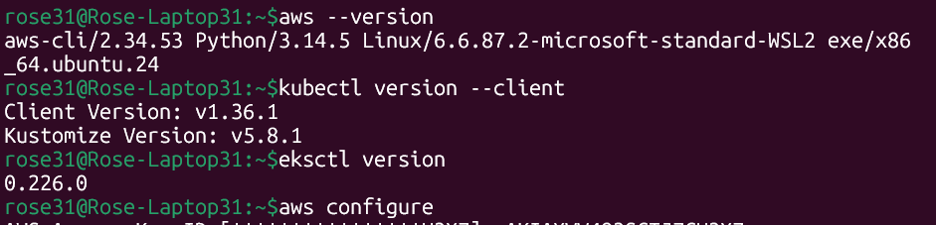
Created the EKS Cluster:
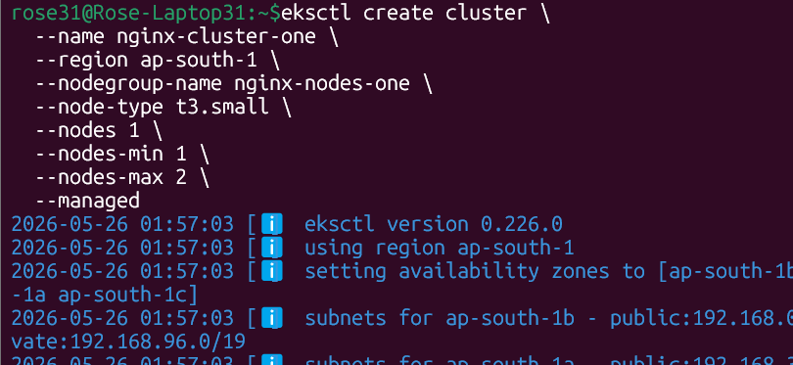
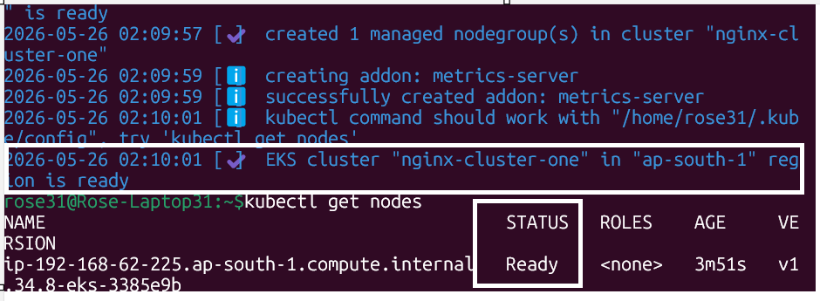

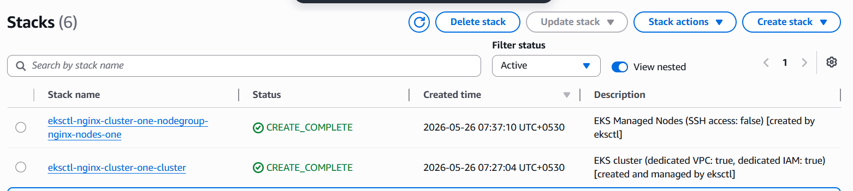
Created the nginx Deployment and Exposed:
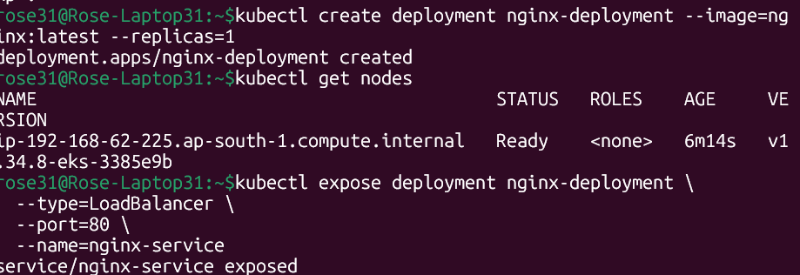

Accessed nginx application outside the cluster:
