Installed and Launched Jenkins:
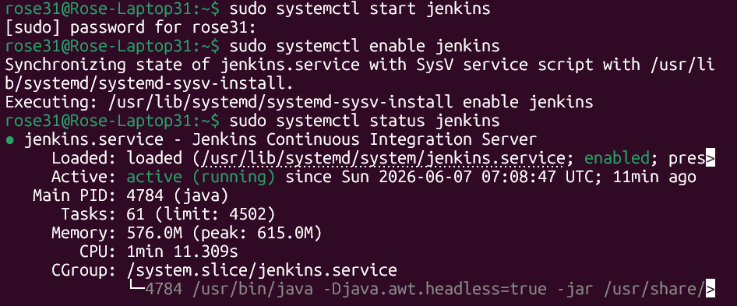

User created:
‘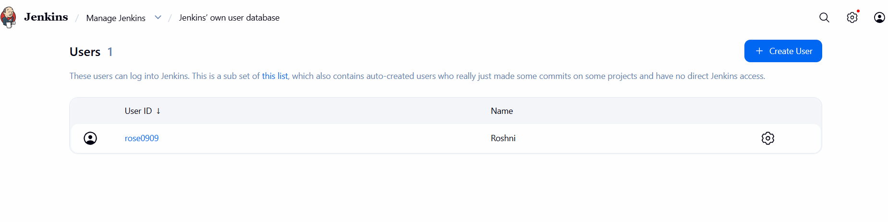

Created a freestyle project:
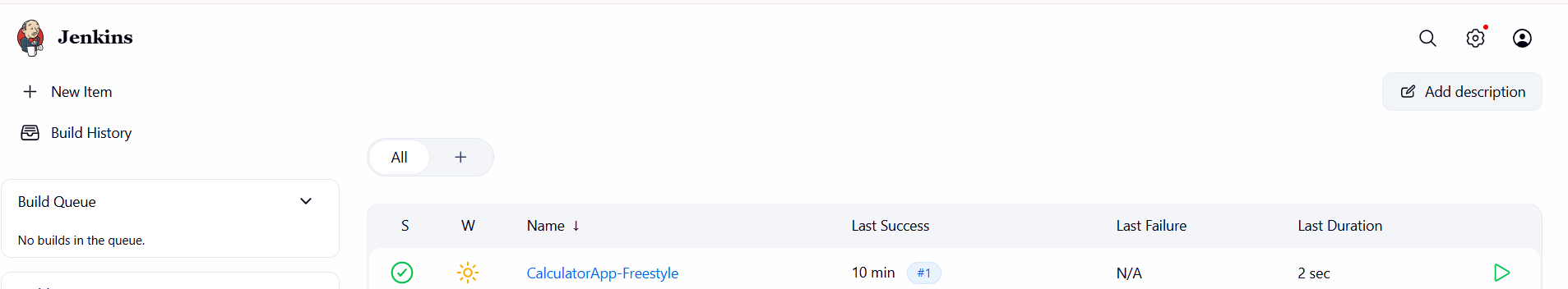

Added required files in GITHUB to host calculator website:

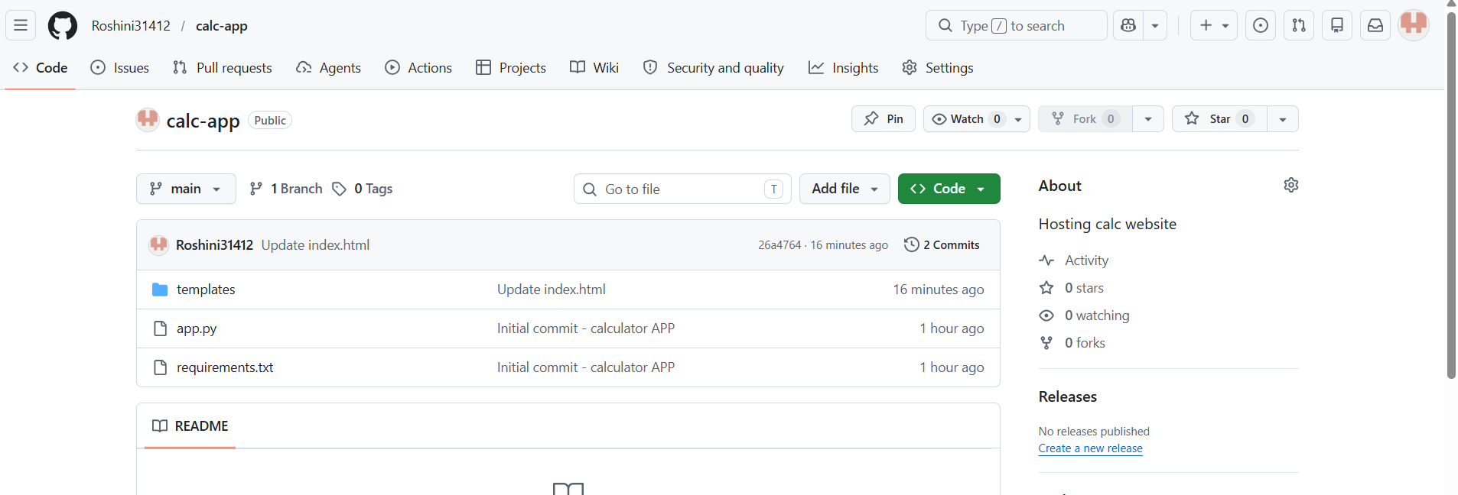
Linked GitHub repository to Jenkins and Added Build Step:

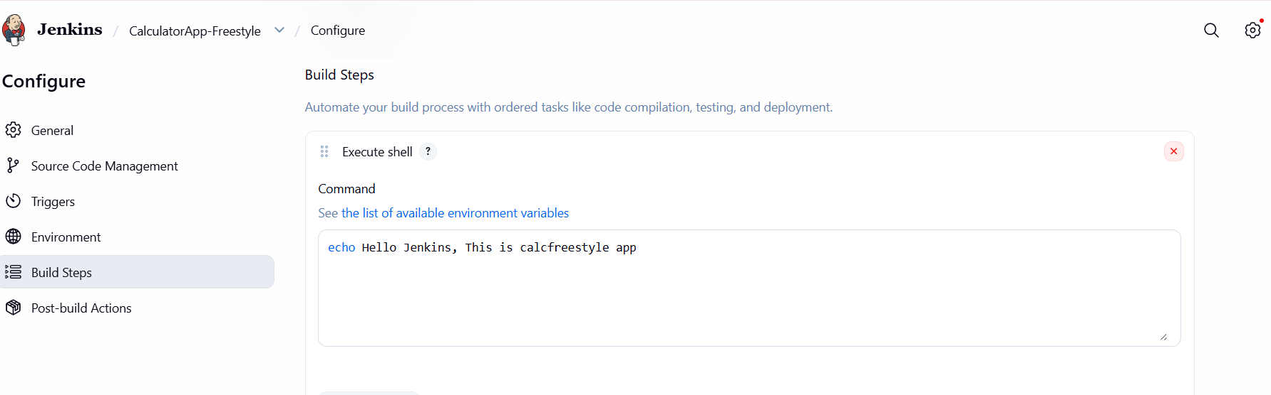
Saved and Build done:
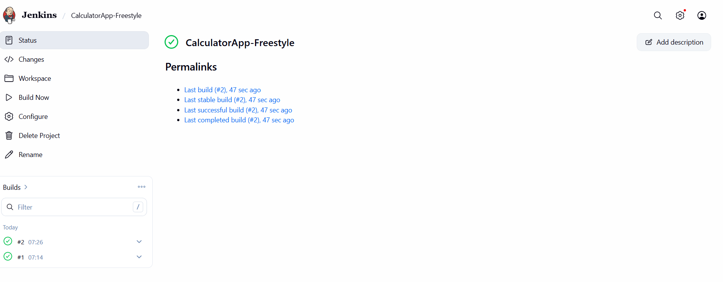
Console Output:

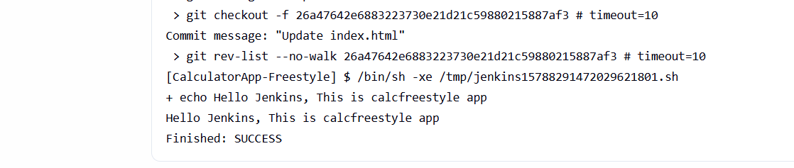

In Browser:
