- IP address of a particular domain :
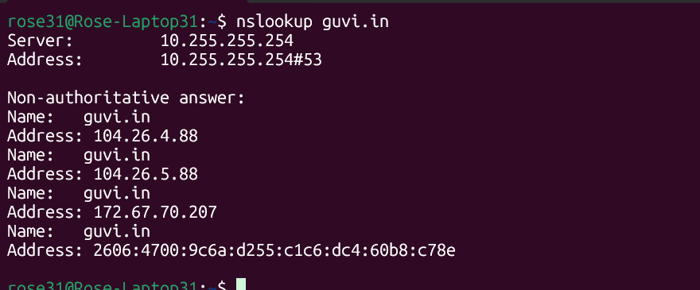
- To find my CPU/memory usage of my server:

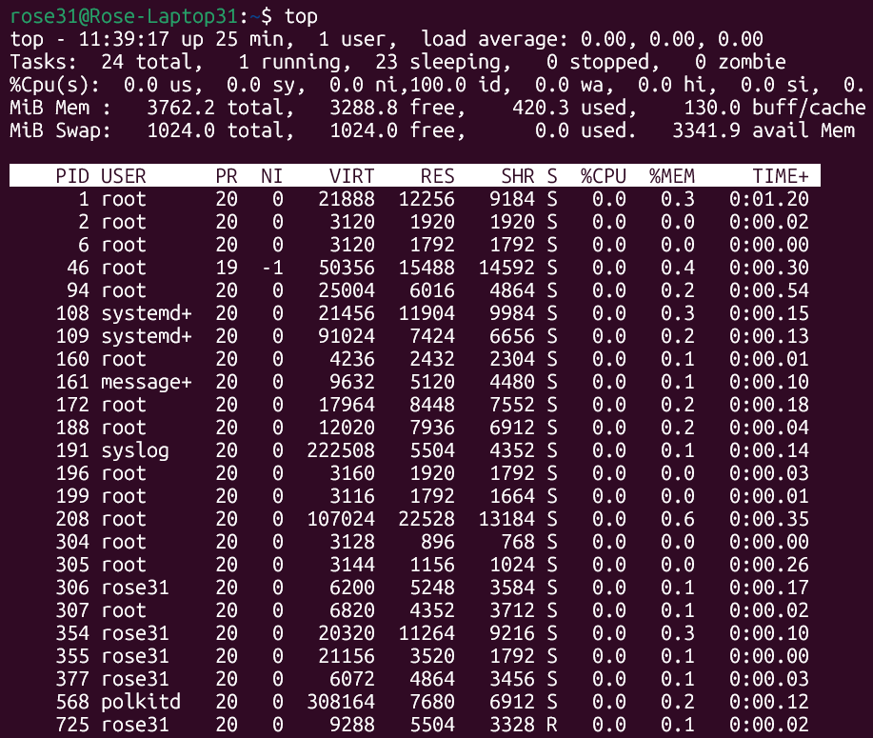

- Test the connectivity between 2 nodes:

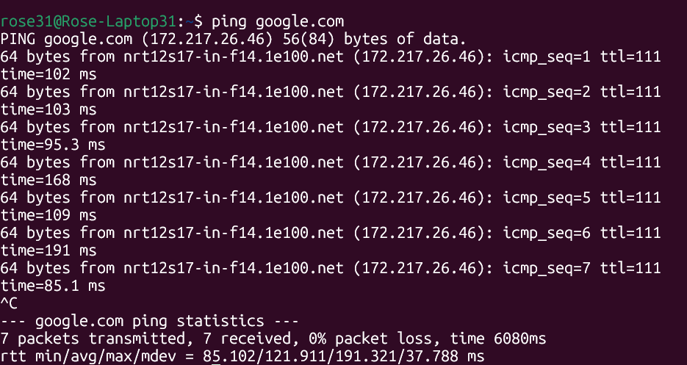

- To Check whether my port is open or not:- Port 9000 is not accessible and it is not visible in below outputs.

