Terraform installed and AWS credentials entered
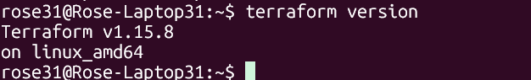
Initialization success and Configuration valid:
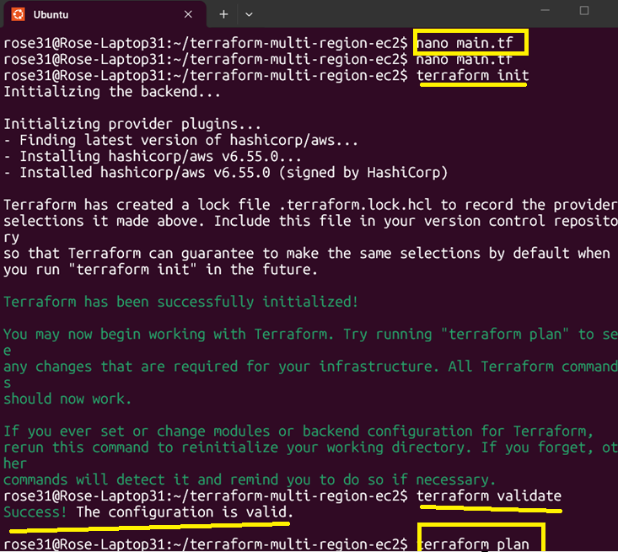

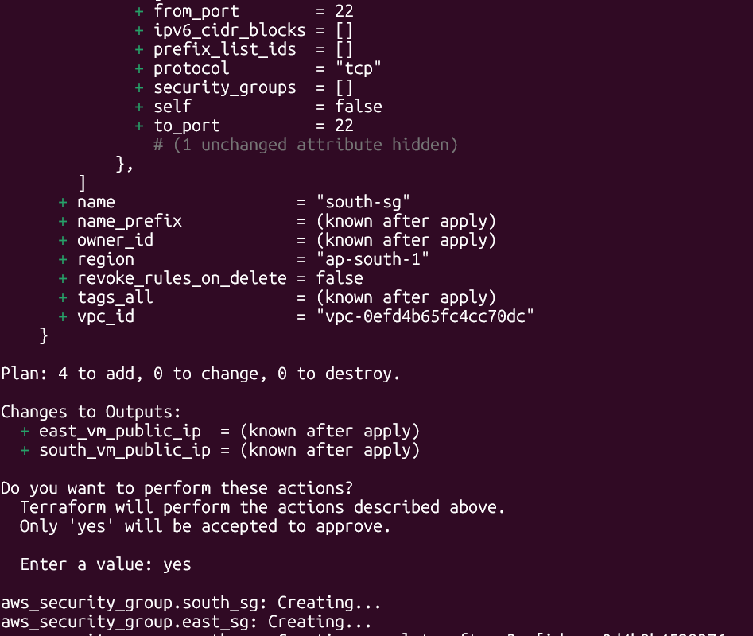
Resources created:
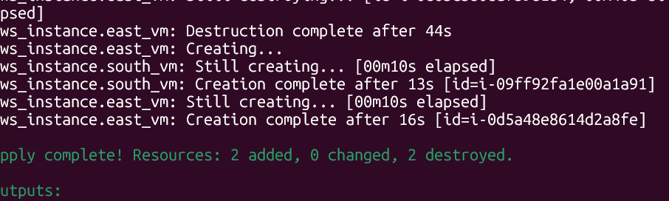

Public IPs displayed
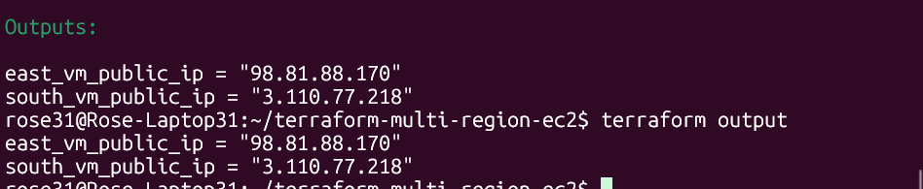
Output :
1 Instances created in AP-SOUTH-1
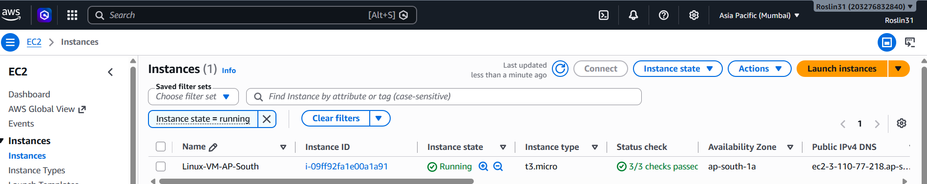

Another Instances created in EAST-US
