1. Create a shell script to print the HTTP error code of (TRIED: GOOGLE.COM) & print, the success/failure message based on the error code response:

The file google.sh was created, required permissions were given, and the output is displayed in the screenshot below.

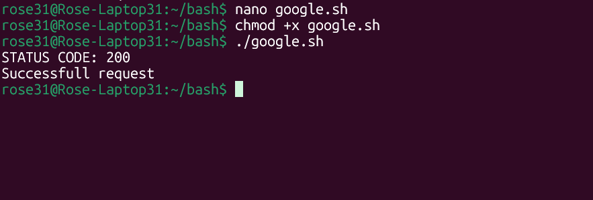
Script:
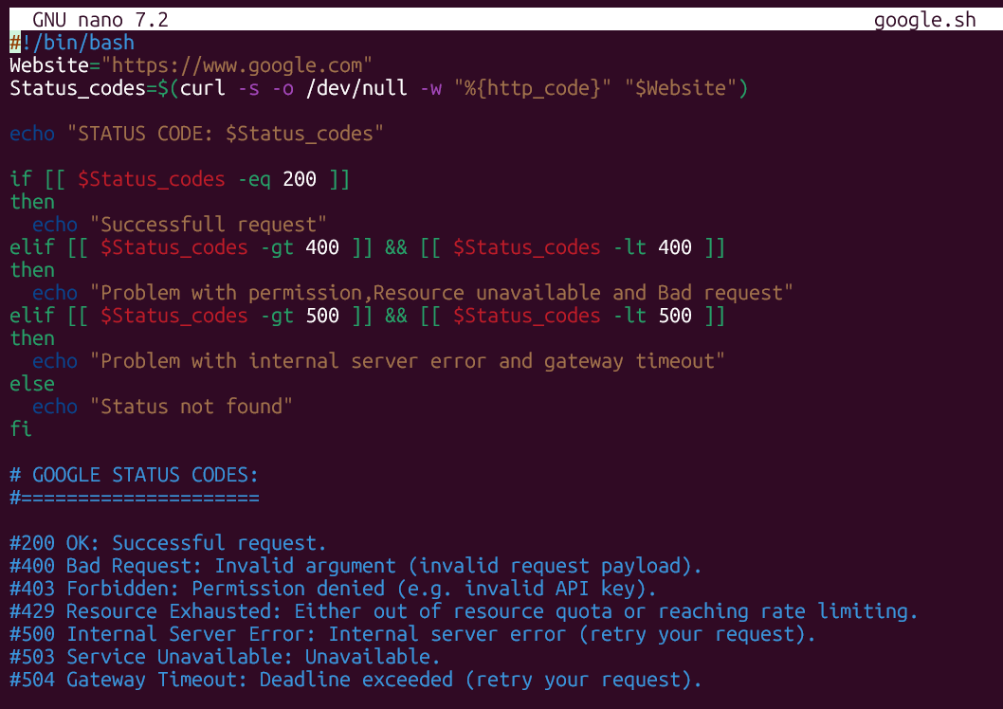
After changing website URL, received message “STATUS NOT FOUND” .
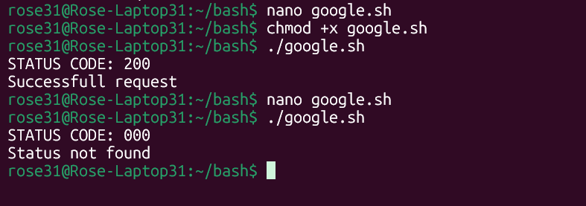
Script:
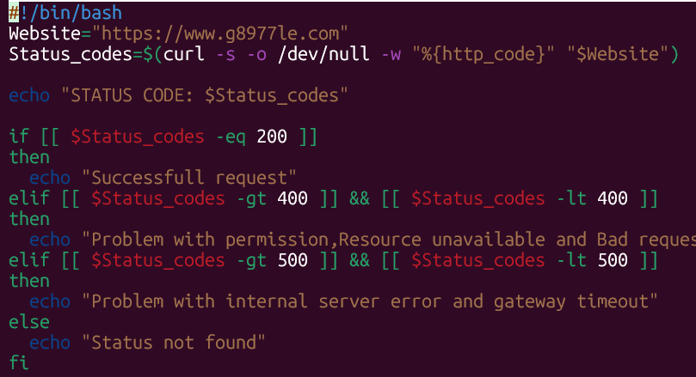

2. Given a file, replace all occurrence of the word "give" with "learning" from 5th line till the end in only those lines that contain the word "welcome"
From Sentence 5 Words are replaced

