Docker:
Created an EC2 instance:
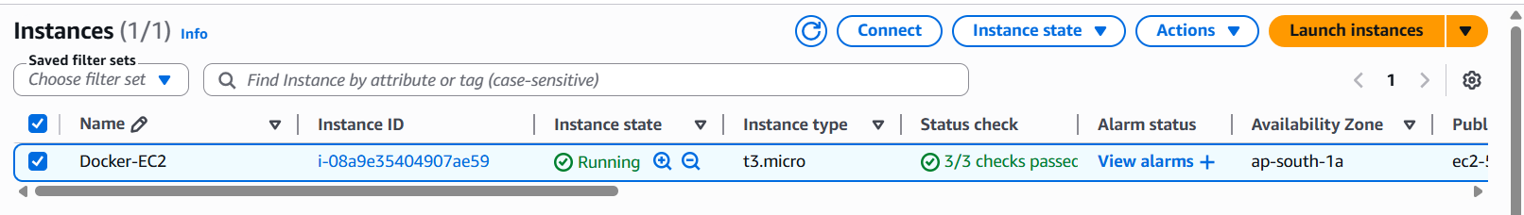
Installed Docker on the EC2 instance:

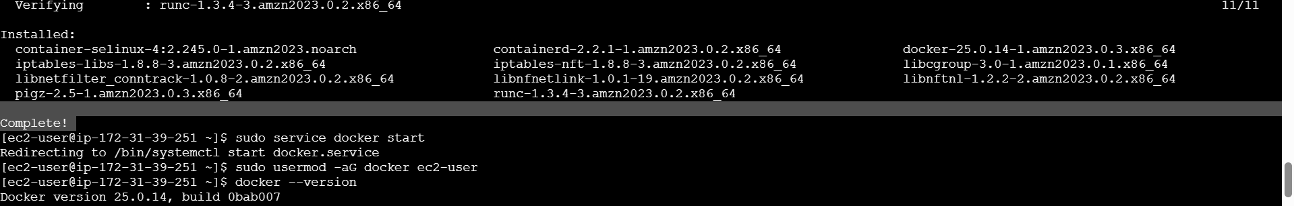

Practiced the following commands:
