Dockerfile & Project Files:
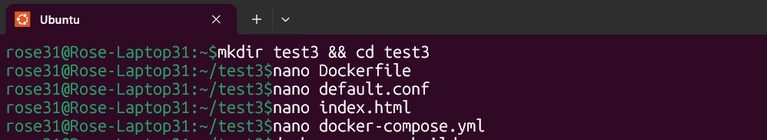
Compose Build:
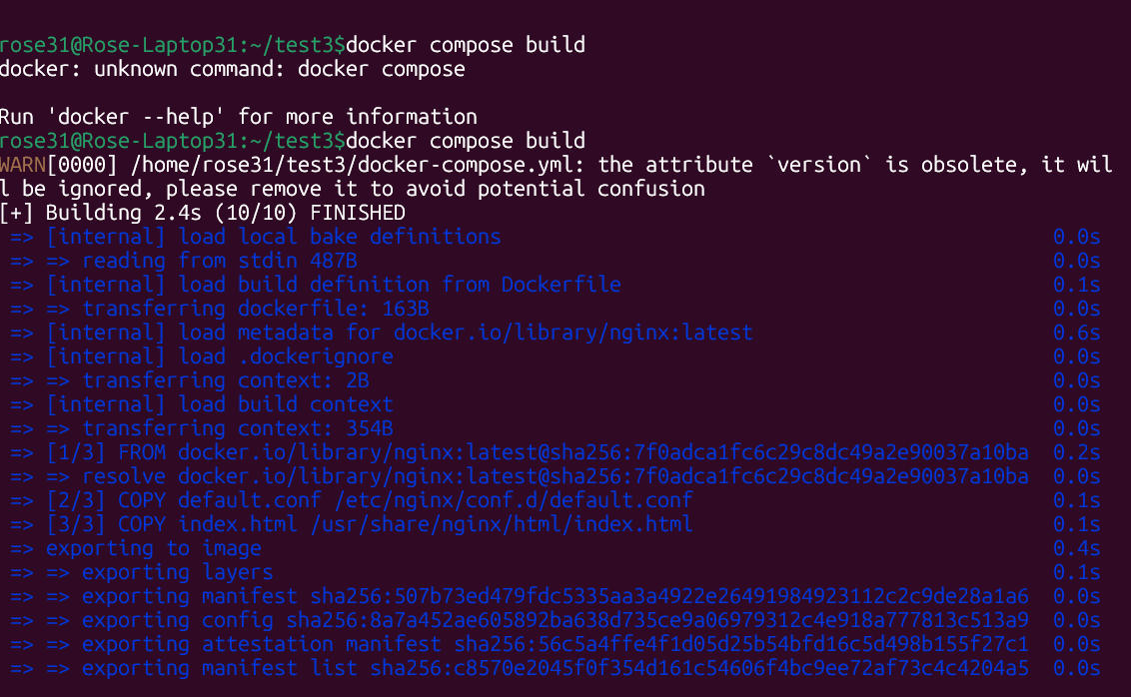
Compose Up & Container Status

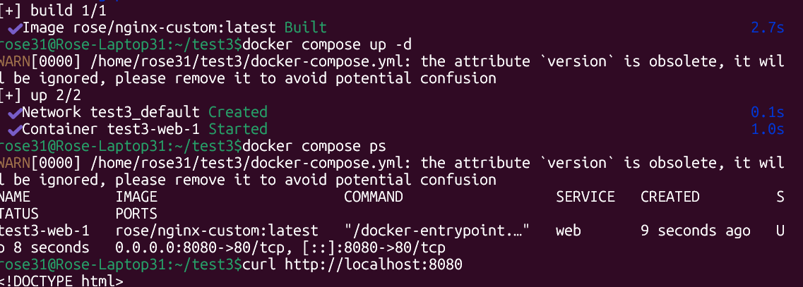

Website Verification:
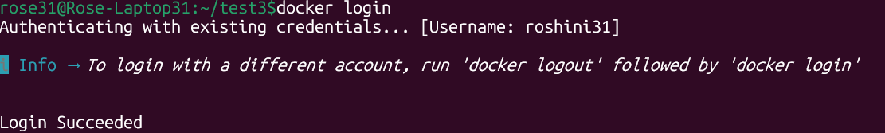

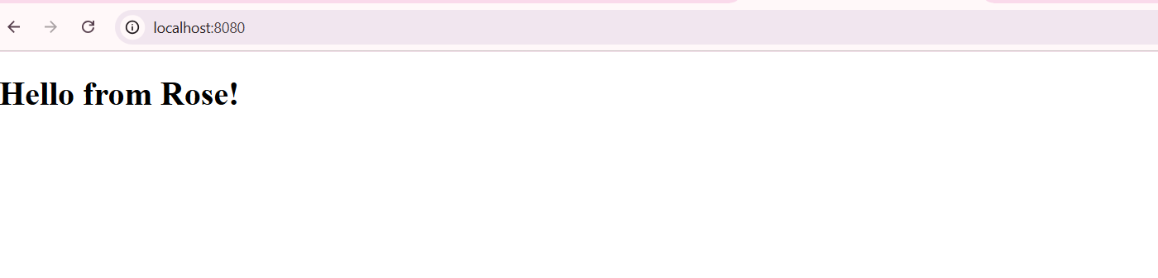
Local Image List:
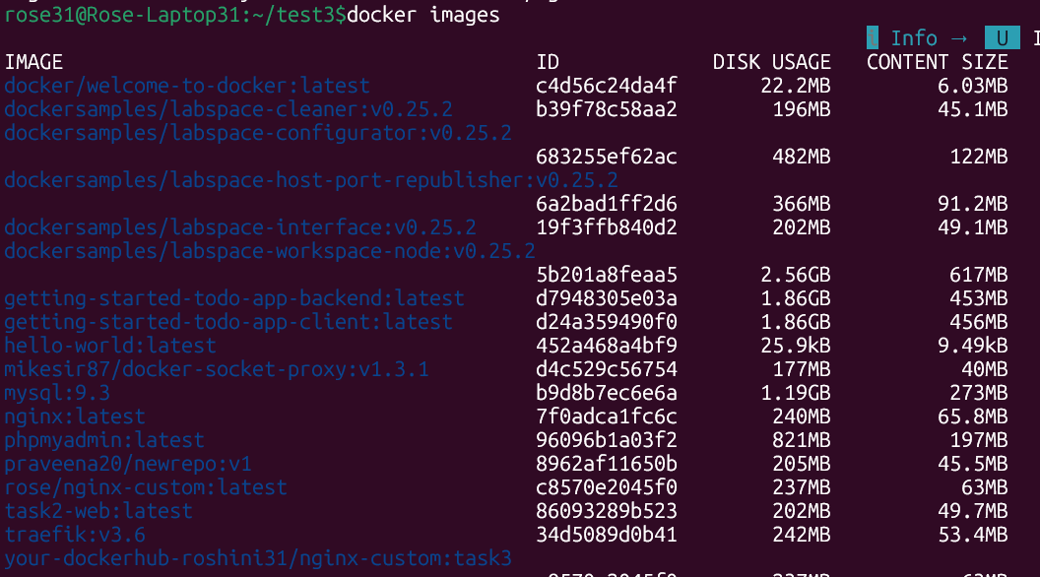

Docker Hub Push:
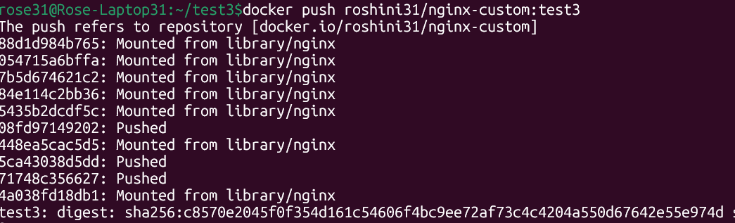

Docker Hub Repository Page
