TASK:
EC2 Instance Launch
- Linux EC2 and Windows EC2:
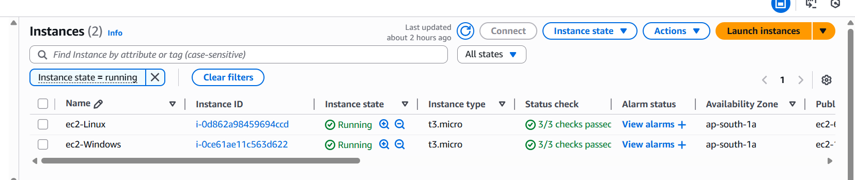

NGINX Web Server Running
Linux: Output from EC2-LINUX:
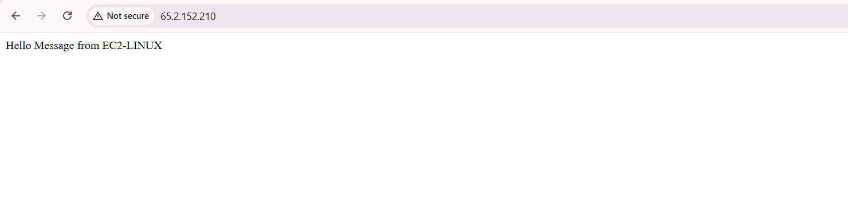 Windows: Output from EC2-LINUX: (NGINX Default page)
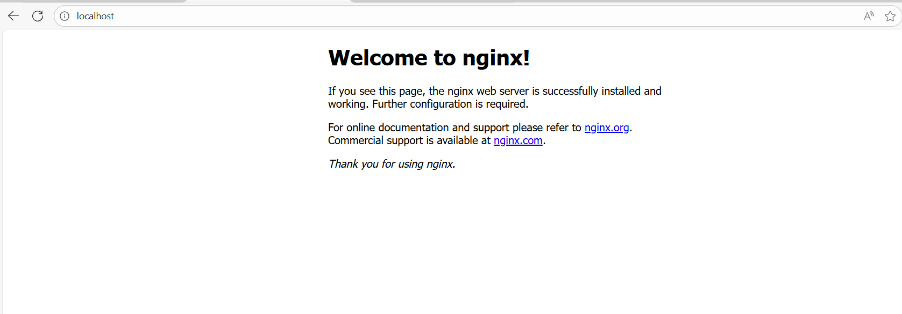

EBS Volume Creation
Before: 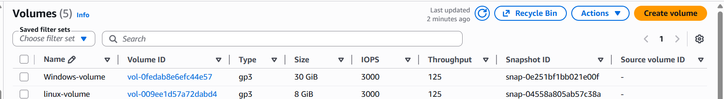
After:
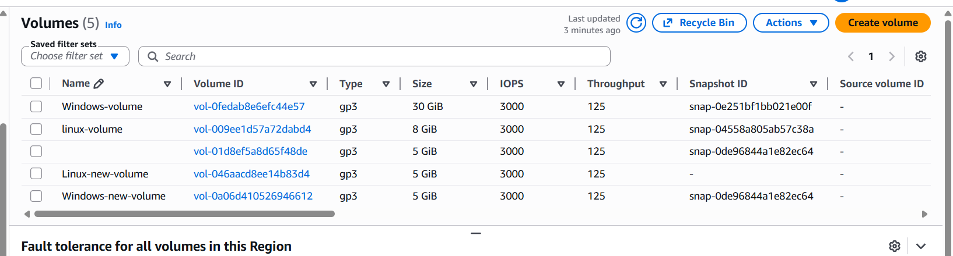

Resources Attached:

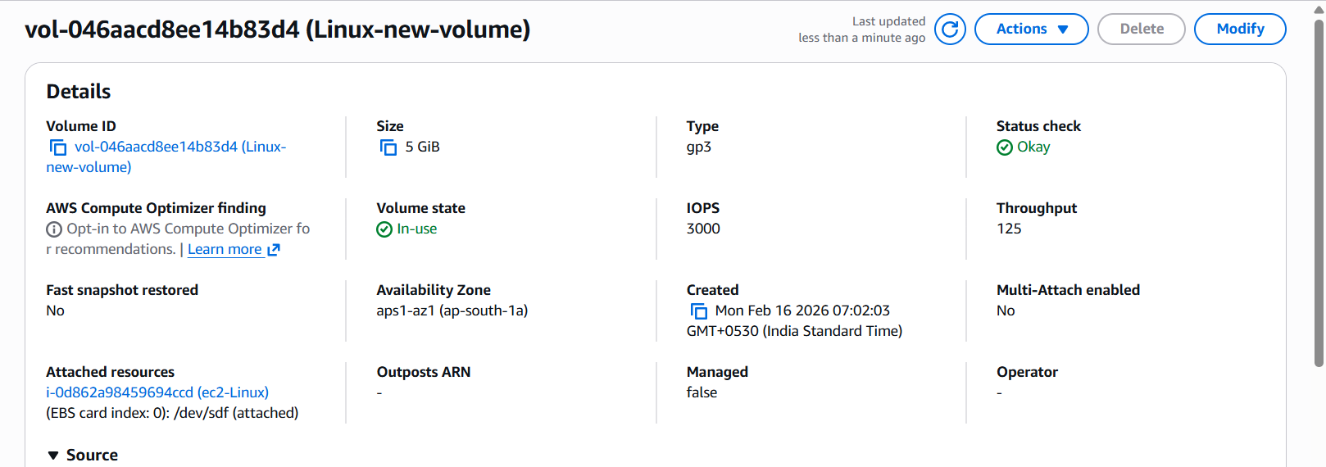

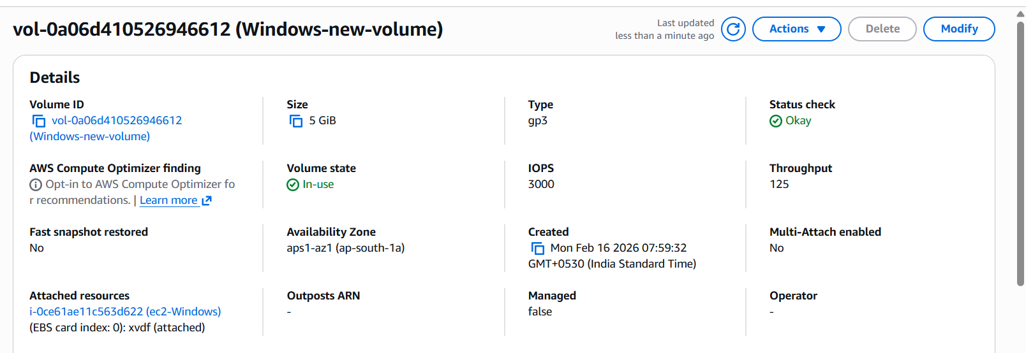

Linux Volume Setup:
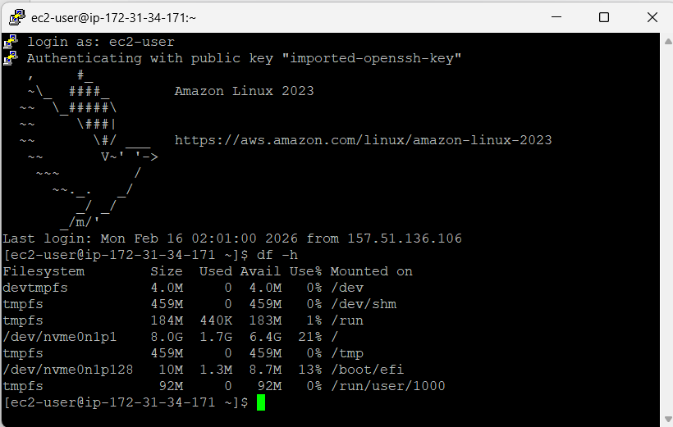

Windows Volume Setup:
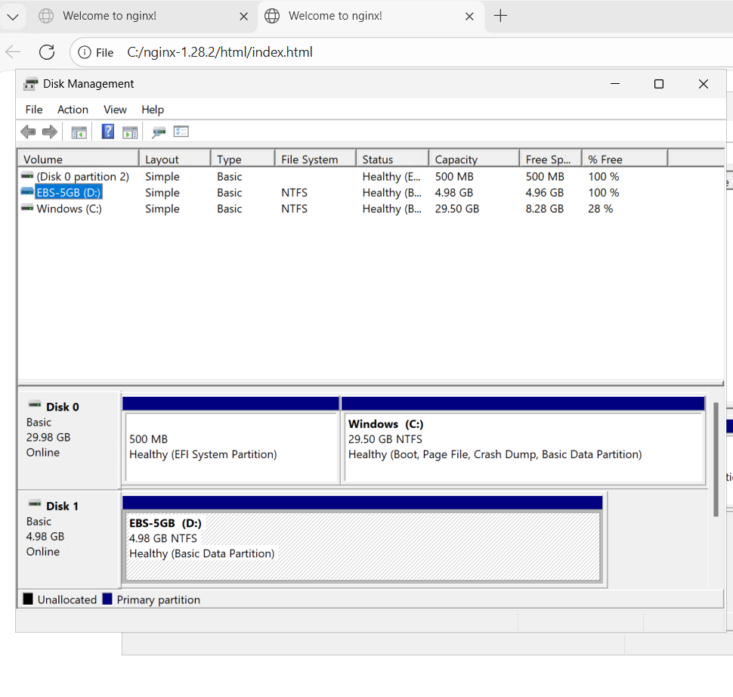
Snapshot Creation:
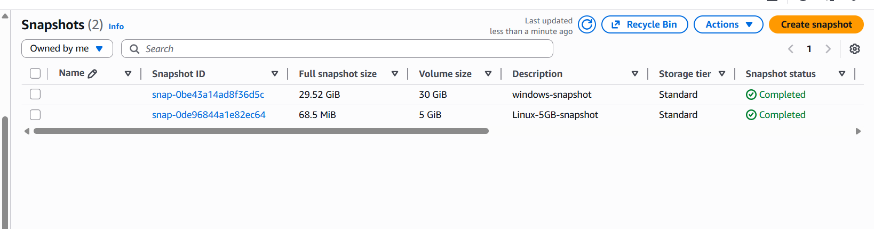

Volume created from snapshot:

