Terraform installed and AWS credentials entered
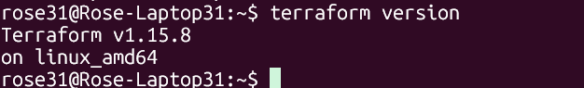

Terraform script:

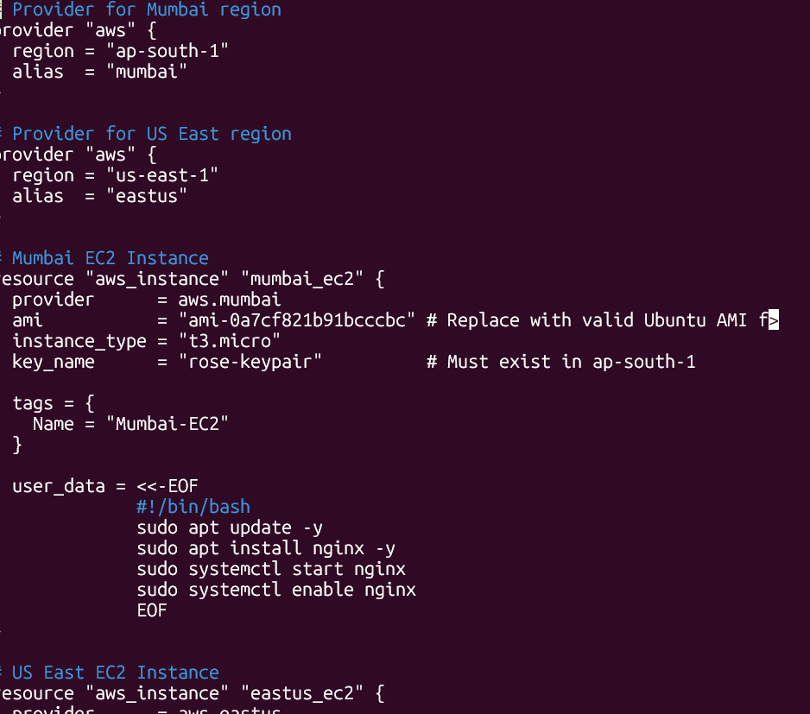
Initialization success and Configuration valid:
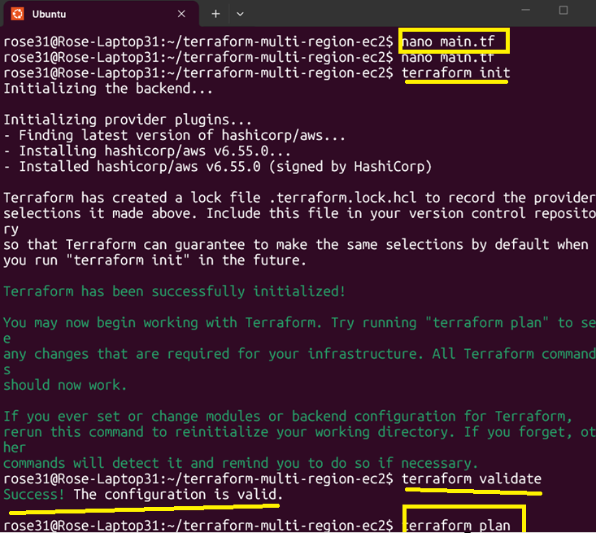

Resources created:

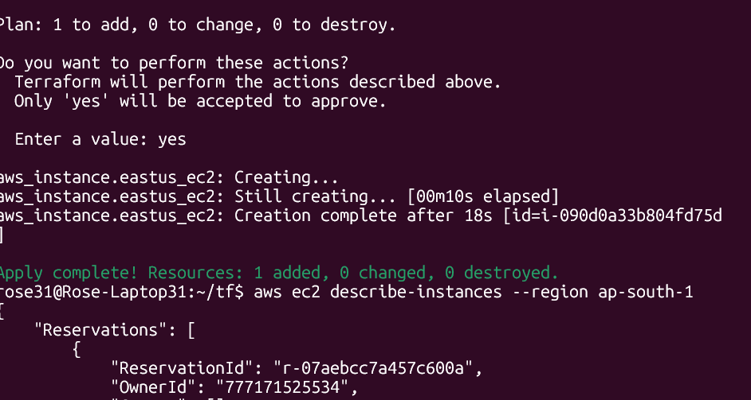

Output :

AWS - EC2 in Region 1 : EC2-Mumabi (15.206.186.165)

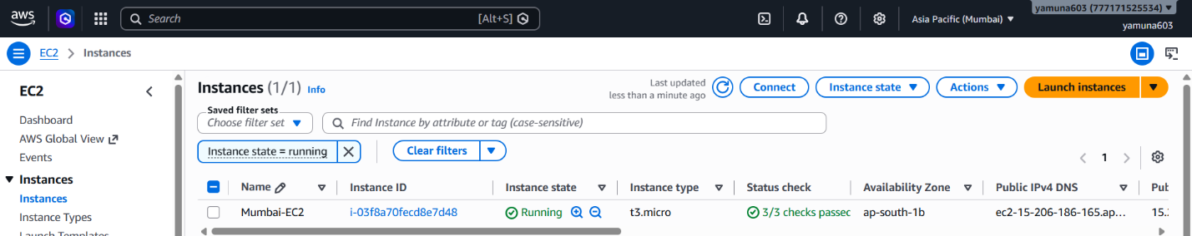

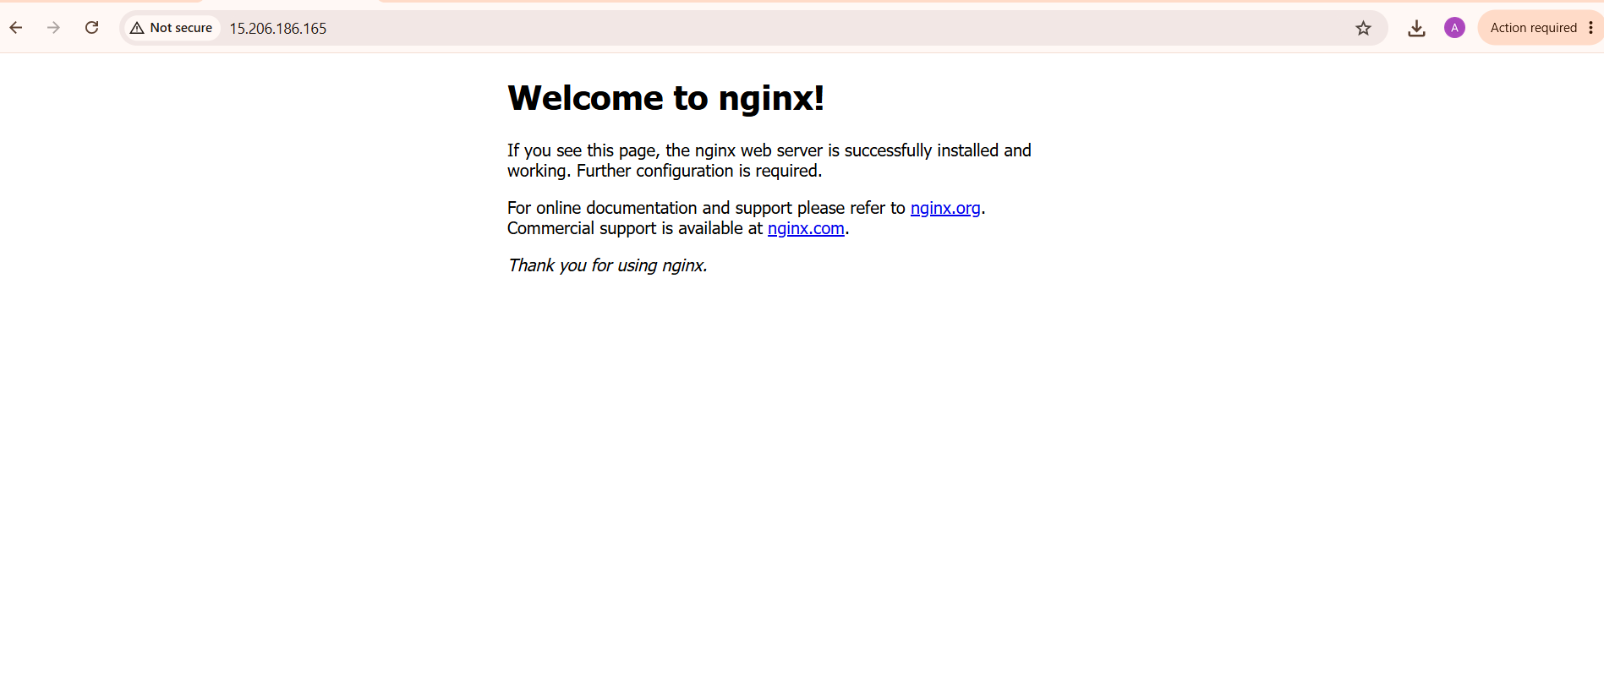

AWS - EC2 in Region 2 (EAST-US) : EC2-EASTUS (54.197.17.252)

