AWS
Created windows EC2 instance named (EC2-Windows):

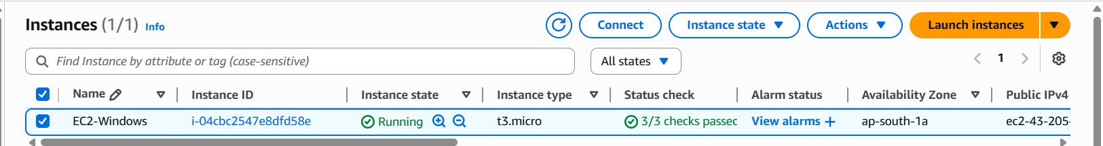

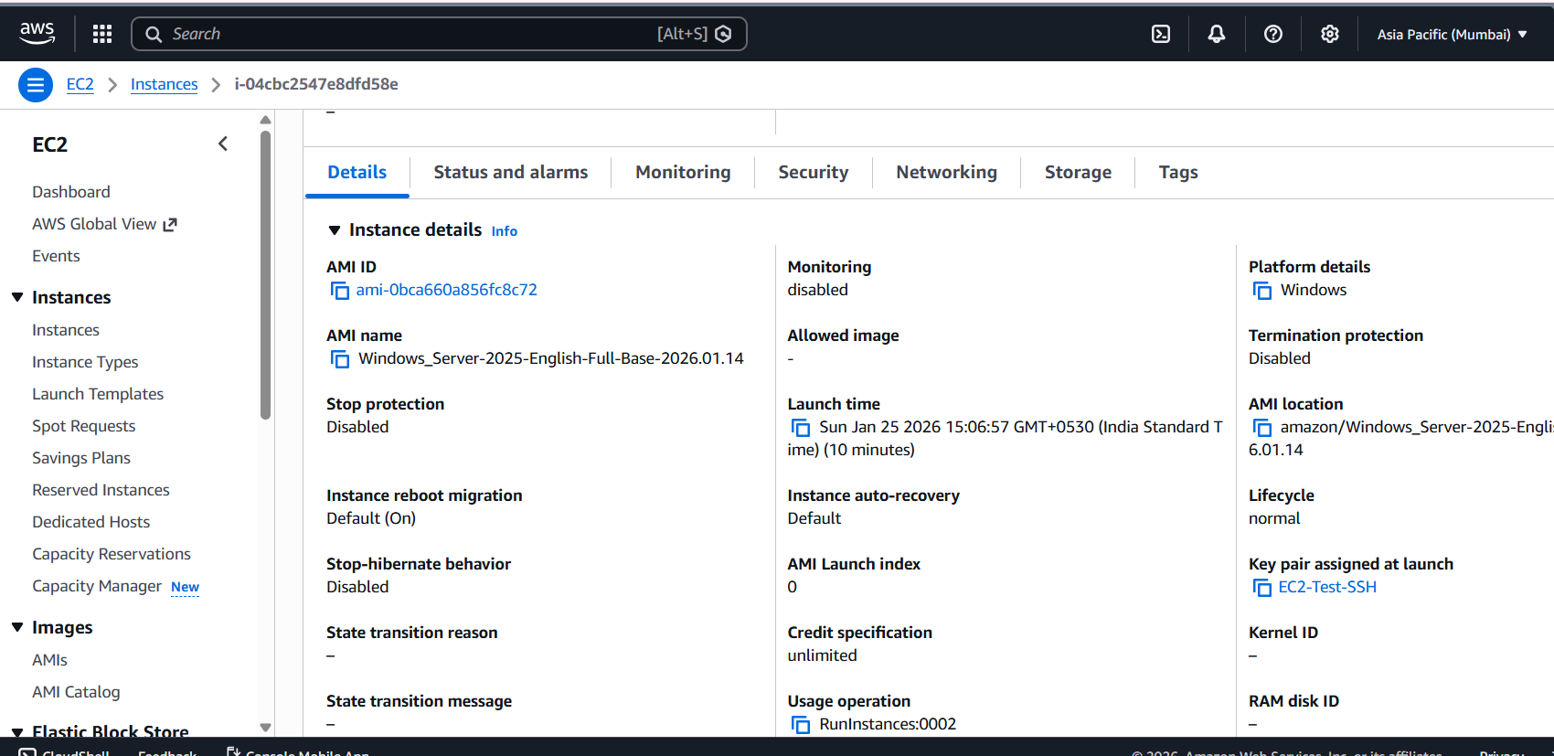

Accessed the EC2 through RDP (Entered Username and password) , ran Command Prompt, and retrieved the output:
